

The Website Specification Requirement for

RESTAURANT GATEWAY

Prepared by Group 2 – SE0707

AnNT – SE02473

ThangPQ – SE02855

HaNS – SE02618

HaiDT – SE02856

Date Created: 20-09-2013

# Table of Contents

Table of Contents 2

1. Introduction 6

1.1 Purpose 6

1.2 System Purpose 6

1.3 Definitions, Acronyms and Abbreviations 7

1.4 Document Conventions 7

1.5 Intended Audience and Reading Suggestions 8

1.6 Project Scope 8

References 8

2. Overall Description 9

2.1 Product/System Perspective 9

2.2 System/Product Features 12

2.3 User requirements 14

2.4 User Classes and Characteristics 14

2.5 Operating Environment 15

2.6 Design and Implementation Constraints 15

2.7 User Documentation 15

2.8 Assumptions and Dependencies 16

2.9 Apportioning of Requirements 17

3. Specific Requirements 17

3.1 Functional Requirements Specification 18

Use case Diagram 18

a) All Users 21

b) Administrator: 34

c) Restaurant Manager 54

d) Customers 73

3.1 Non-Functional Requirements Specification 77

QoS: 77

Usability 77

Reliability 77

Performance 78

Supportability 78

Design Constraints Architectural 78

Database 78

Browser 79

Development Requirement: 79

**Revision History**

|  |  |  |  |
| --- | --- | --- | --- |
| **Name** | **Date** | **Reason For Changes** | **Version** |
| AnNT | 23rd Sep | Create new and add Introduction | 1.0 |
| HaNS | 25th Sep | Add Overall Description | 1.0 |
| ThangPQ | 26th Sep | Add Scenarios of Funtional Requirements | 1.0 |
| HaNS | 5th Oct | Change Scenario to Use case | 1.0 |
| ThangPQ | 6th Oct | Update Scenario | 1.0 |
| HaNS | 6th Oct | Update Funtinal Requirement | 1.1 |
| HaiDT | 7th Oct | Add Context, Problem Diagram, Use case Diagram | 1.1 |
| AnNT | 8th Oct | Add Non-Funtional Requirement | 1.2 |
| ThangPQ | 10th Oct | Check All and edit Requirement | 1.3 |

# Introduction

## 1.1 Purpose

This document provides prescription and description about behaviors of Restaurant Gateway website to have clear and thorough understanding of the website to be developed.

## 1.2 System Purpose

* + Make a new method for people to find a place and have dinner.
  + People can reserve a table in a restaurant by this website.
  + People can share information and comment about the feeling when they come to a restaurant.
  + Help restaurant manager interact with customer.
  + A good method for restaurant manager to get report from customer and improve their services.

## 1.3 Definitions, Acronyms and Abbreviations

|  |  |  |
| --- | --- | --- |
| **No.** | **Term** | **Description** |
| **1.** | RG | Restaurant Gateway: An online market for restaurants to introduce their services and for customers to find the appropriate services. |
| **2.** | Restaurants | Refer to people who have permission to post a topic of a restaurant or manage a restaurant. |
|  |  |  |
|  |  |  |
|  |  |  |
|  |  |  |
|  |  |  |

## 1.4 Document Conventions

* When writing this document it was inherited that all requirements have the same priority.
* First there is presented an overall view about RG and then all features and functions are analyzed in detail.

## 1.5 Intended Audience and Reading Suggestions

This requirement document contains general information about RG, main classes and use cases, functions, features and special technologies. It describes in detail all that RG needs to work properly and with safety

## 1.6 Project Scope

The Restaurant Gateway Web must be designed to run on any browsers. It provides GUI for restaurants to publish their services, change their information or to pronounce their promotion campaign for customers who care. And customers can search for the restaurant, leave a comment, rate for the service and even reserve the table.

Requirement statements in this document are both functional and non-functional.

## References

* The main textbook material is “Software engineering” 9th Edition by Ian Sommerville.
* Software Requirements Specification example and template on Courses Management System – FPT University.
* Template System Requirement Spec IEEE830 v1.2.

# Overall Description

## 2.1 Product/System Perspective

RG is a new website designed to improve efficient of interaction between restaurants and customers by Internet. Customer do not have to go to a restaurant to make an reservation and the they can find information about a restaurant easier. With the website, the restaurants have a new method to advertise their business and be closer with their customer.

Each person has their account and password to login to the website and at different level of privilege, they can only access to their supported function.

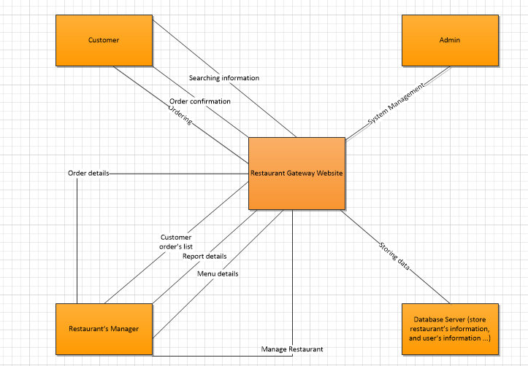

Figure 1. Context Diagram

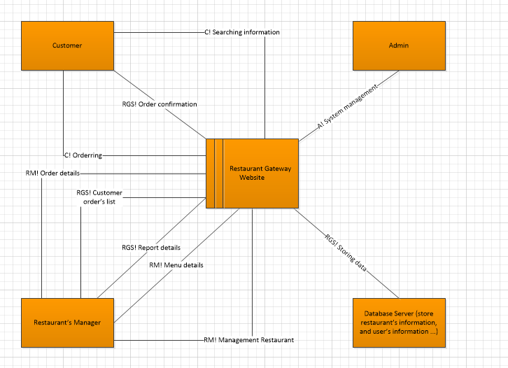

Figure 2. Problem Diagram

## 2.2 System/Product Features

* **Public features for all kinds of user:**
  + **Search:** User can search for information they want.
  + **View topic:** User can come to the website and read all topics has posted.
* **Restaurants/Advertisers: Publish, change information, delete information, create account for manager of the restaurants, view the report to see the number of customer who read about their restaurant, change password, comment and rate.**

This features are used for user who works in restaurant and has permission to manage business or advertise. They can publish information about their restaurant to our website and try to attract customers come to their place. After a period of time, if they have any information is changed, they can update this information in website. They can also see the number of customer who read about their restaurant in the website. Before they can use all of the features, they have to create their own account and update information for admin and customer to contact. They can change password at any time they want. And when they have an account, they can comment and rate the topic. They can also feedback a comment in their post is not true to the admin.

* **Customers: create account, change password, personal information, reserve the table, cancel reservation, pay deposits, comment and rate a service, feedback to the admin, view the report of the restaurant they care about, add restaurant to a favorite list.**

For customers who will use this website, they can create their account, update information and change password like the restaurant/advertiser. Their accounts are set as a customer account. They can reserve a table in a restaurant. They can comment and rate restaurant’s services. And they also can feedback to admin if the information published is not true. They can see report about the restaurant they care. After all, if they like the restaurant, they can add it to their favorite list.

* **Admin/Moderator: manage the number of the restaurants and customers, delete invalid comments, delete the post of the restaurant in case they are not true.**

Admins are people who have permission to manage all the topics and users in the website. They can delete posts and comments in website.

## 2.3 User requirements

**For administrator:** Have expert or high knowledge about website.

**For customers:** The website is designed as easier as possible for all people who have basic knowledge about computer and can use Internet.

**For moderator:** They must have ability to manage a website and basic knowledge about database and HTML.

**For restaurants:** They just need basic knowledge about computer.

## 2.4 User Classes and Characteristics

**Administrator:** users that are familiar with programming and can personalize their database, using command line options and generally can use features and maybe expand their use by adding more functions.

**Website Moderator:** users are people who manage behaviors of other users who are not admin and mod.

**Restaurant:** users who post a topic in website to advertise a restaurant. They manage information in their topic and all of reservation for their restaurant.

**Customer:** users who come to the website to find a restaurant or reverse in a restaurant.

## 2.5 Operating Environment

The website is implemented by Java, HTML, CSS. It can run on any operating system and the latest version of browser.

All new releases contain:

RGateway.zip with Type: Zip.

## 2.6 Design and Implementation Constraints

* **Timing Requirement:** This constraint is used for reservation. The time is set up by restaurants. It is used to manage reservation and customers can not reserve if time is out of this limit.
* **Security:** Features can be used when users have permission.
* This website use Microsoft SQL Server as Data format.

## 2.7 User Documentation

*By downloading Restaurant Gateway Website project, the user also gets:*

*•* *A compiled HTML Help file with a tutorial and full help on all features provided.*

## 2.8 Assumptions and Dependencies

|  |  |  |  |
| --- | --- | --- | --- |
| # | Description | Note | Type |
| **Assumptions** |  |  |  |
| 1 | There is no need to customize the current APIs to adapt with the new HTML5 application. | N/A | Technical |
| 2 | Acceptance testing of the system as per the acceptance test cases developed by stakeholders | N/A | Quality management |
| 3 | The following tasks are out of scope:  - Design graphics assets (icons, images, etc)  - Data migration or big change on the current database structure  - Create user manual and/or training documents. | N/A | Requirement |
| 4 | The number of users to be handled with the the website will be very high (50 people or more). | N/A | Technical |
| **Dependancies** |  |  |  |
|  | N/A | N/A |  |

## 2.9 Apportioning of Requirements

* Pay online when reserve.

# Specific Requirements

## Functional Requirements Specification

## Use case Diagram

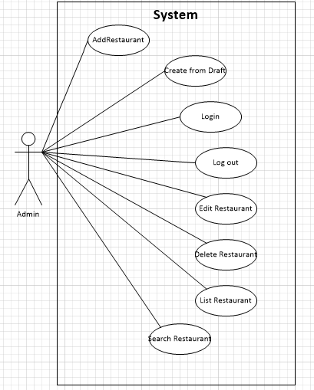Figure 3. Use case Administrator.

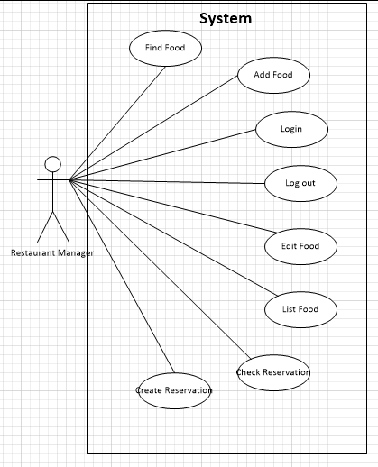

Figure 4. Use case Restaurant Manager.

### 

Figure 5. Use Case Customer.

### a) All Users

##### UC – 01. Login

* Screen design:

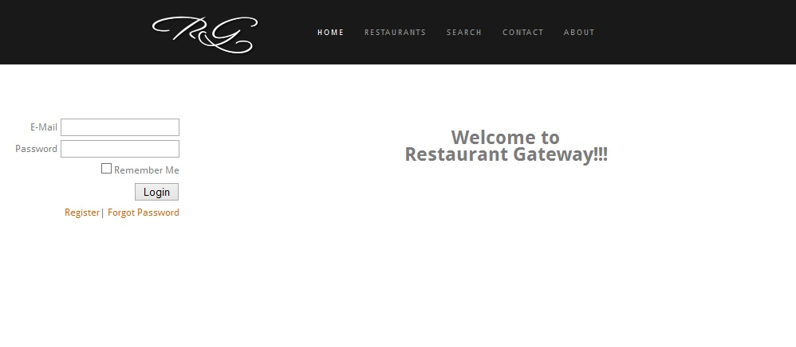

|  |  |  |  |  |  |
| --- | --- | --- | --- | --- | --- |
|  | **Field Name** | **Type** | **Mandatory** | **Max Length** | **Description** |
| 1 | User Name | Text | Yes | 20 |  |
| 2 | Password | Text | Yes | 20 | Display "*" instead of clear character |
| 3 | Login | Button |  |  | Go to home page |

* Use case Specification:

|  |  |  |  |  |
| --- | --- | --- | --- | --- |
| **Use Case ID** | | | **UC-01** | |
| **Use Name** | | | **Login** | |
| **Actor** | | | RG Users | |
| **Description** | | | The function allows an user to be able to login in the software when he/she have registered an account and his/her account is still active. | |
| **Precondition** | | |  | |
| **Trigger** | | |  | |
| **Post-Condition** | | |  | |
| **Main flows** | | | | |
| ***Step*** | ***Actor*** | | ***Action*** | |
| *1* | User | | Open browser, access homepage/login.html | |
| *2* | RG | | Display Login screen with the following fields:  - Email  - Password  - Login and Close button | |
| *3* | User | | Enter Email & password into Email & Password fields on the Login screen, then click on Login button. Click Submit to validate . | |
| *4* | RG | | Validate the entered user name & password and then display Management webpage. | |
|  |  | |  | |
| **Alternative flows** | | | | |
| **AT1** | | At step 2 in the main flows**,** if there is an internal error in the system, | | |
| **Sub step** | | **Actor** | | **Action** |
| 2.1 | | RG | | Display "Error" page with message "Internal System Error, please contact with administrator" |
| **AT2** | | At step 4 in the main flows**,** if RG failed to validate email & password | | |
| **Sub step** | | **Actor** | | **Action** |
| 4.1 | | RG | | Display "Login" page with message "Your email or password is not correct." |

##### UC – 02. Logout

* Screen design:

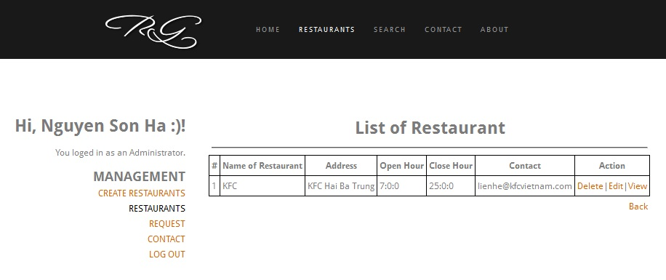

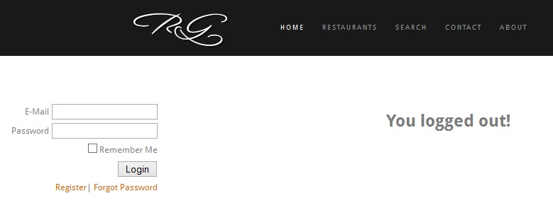

|  |  |  |  |  |  |
| --- | --- | --- | --- | --- | --- |
|  | **Field Name** | **Type** | **Mandatory** | **Max Length** | **Description** |
| Side bar | | | | | |
| 1 | User Name | Text | Yes | 20 |  |
| 2 | Password | Text | Yes | 20 | Display "*" instead of clear character |
| 3 | Login | Button |  |  | Go to home page |

* Use case Specification:

|  |  |  |
| --- | --- | --- |
| **Use Case ID** | | **UC-02** |
| **Use Name** | | **Logout** |
| **Actor** | | RG Users |
| **Description** | | The function allows an user to be able to log out the website. |
| **Precondition** | | User logged in. |
| **Trigger** | |  |
| **Post-Condition** | |  |
| **Main flows** | | |
| ***Step*** | ***Actor*** | ***Action*** |
| *1* | User | In side bar, click on Log out hyperlink |
| *2* | RG | Log out the account and display [Log out] page |

##### UC – 03. Create Account

* 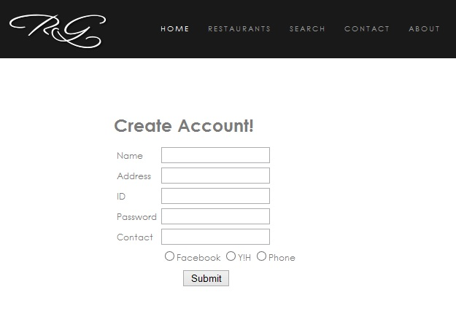Screen design:

|  |  |  |  |  |  |
| --- | --- | --- | --- | --- | --- |
| **#** | **Field Name** | **Type** | **Mandatory** | **Max Length** | **Description** |
| 1 | Name | Text |  | 30 |  |
| 2 | Address | Text |  | 30 |  |
| 3 | ID | Text |  |  | ID to login |
| 4 | Password | Password |  |  | Characters are replaced by “*” |
| 6 | Contact | Text |  |  |  |
| 7 | List Type | Radio |  |  | Y!H, FB, Phone |
| 8 | Submit | Button |  |  |  |
|  |  |  |  |  |  |

* Use case Specification:

|  |  |  |  |  |
| --- | --- | --- | --- | --- |
| **Use Case ID** | | | **UC-03** | |
| **Use Name** | | | Create account | |
| **Actor** | | | RG Users | |
| **Description** | | | The function allows a user to create their own account | |
| **Precondition** | | |  | |
| **Trigger** | | |  | |
| **Post-Condition** | | |  | |
| **Main flows** | | | | |
| ***Step*** | ***Actor*** | | ***Action*** | |
| *1* | User | | In side bar of [Home page], choose [Register] hyperlink. | |
| *2* | RG | | Display [Create Account] Page | |
| *3* | User | | Enter Information then click Submit | |
| *4* | RG | | Validate and redirect to [Home page] | |
| **Alternative flows** | | | | |
| **AT1** | | At step 1, 3 in the main flows**,** if there is an internal error in the system, | | |
| **Sub step** | | **Actor** | | **Action** |
| 1.1 | | RG | | Display "Error" page with message "Internal System Error, please contact with administrator" |
| **AT2** | | At step 4 in the main flows**,** if the input is invalid | | |
| **Sub step** | | **Actor** | | **Action** |
| 4.1 | | RG | | Display Error message "Your input is invalid." |

* Business Rules:

|  |  |
| --- | --- |
| ***#*** | ***Rule Description*** |
| *BR01* |  |

##### UC – 04. Search restaurant

* Screen design:

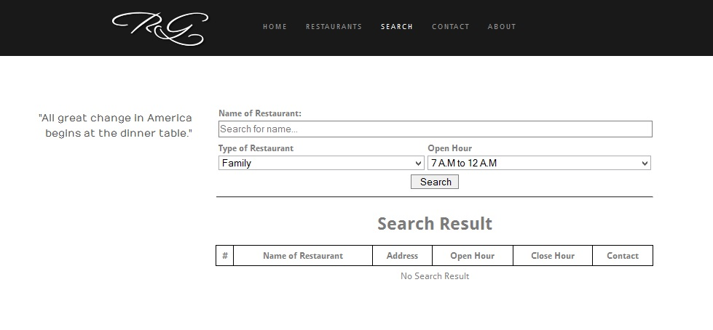

|  |  |  |  |  |  |
| --- | --- | --- | --- | --- | --- |
| **#** | **Field Name** | **Type** | **Mandatory** | **Max Length** | **Description** |
| 1 | Restaurants List | Table |  |  | List all restaurants in data. |
| 2 | Name | Text |  | 30 |  |
| 3 | Type | Select |  |  | All type in database |
| 4 | Start Hour | Select |  |  | Search in a range of hour |
| 6 | Search | Button |  |  |  |

* Use case Specification:

|  |  |  |  |  |
| --- | --- | --- | --- | --- |
| **Use Case ID** | | | **UC-04** | |
| **Use Name** | | | Search Restaurant | |
| **Actor** | | | RG Users | |
| **Description** | | | The function allows a user to search for a restaurant or a specific type of restaurant. | |
| **Precondition** | | |  | |
| **Trigger** | | |  | |
| **Post-Condition** | | |  | |
| **Main flows** | | | | |
| ***Step*** | ***Actor*** | | ***Action*** | |
| *1* | User | | Choose Search Tab | |
| *2* | RG | | Display [Search] Page | |
| *3* | User | | Enter Information then click Search | |
| *4* | RG | | Validate and display Result. | |
| **Alternative flows** | | | | |
| **AT1** | | At step 1, 3 in the main flows**,** if there is an internal error in the system, | | |
| **Sub step** | | **Actor** | | **Action** |
| 1.1 | | RG | | Display "Error" page with message "Internal System Error, please contact with administrator" |
| **AT2** | | At step 4 in the main flows**,** if user does not input anything | | |
| **Sub step** | | **Actor** | | **Action** |
| 4.1 | | RG | | Display "Error" page with message "You need input at least one information to search. " |

* Business Rules:

|  |  |
| --- | --- |
| ***#*** | ***Rule Description*** |
| *BR01* |  |

##### UC – 05 View information’s retaurants.

* 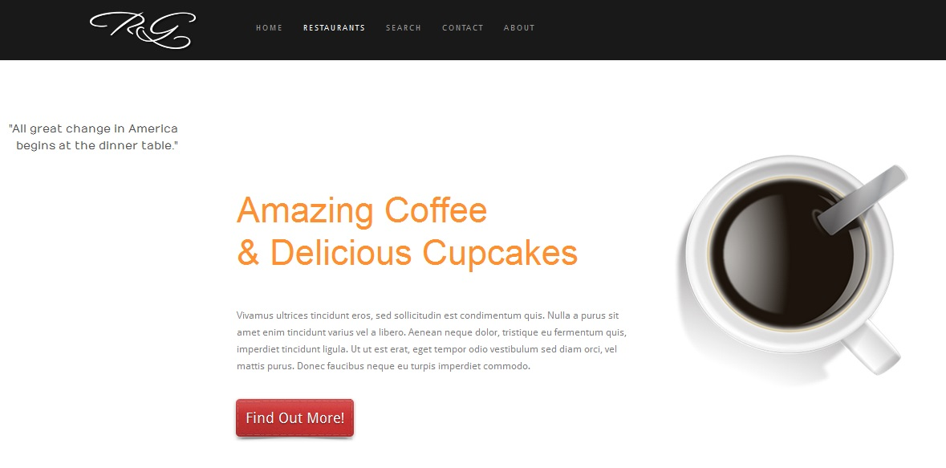Screen design:

|  |  |  |  |  |  |
| --- | --- | --- | --- | --- | --- |
| **#** | **Field Name** | **Type** | **Mandatory** | **Max Length** | **Description** |
| 1 | Restaurants List | Table |  |  | List all restaurants in data. |
| 2 | Find Out More | Hyperlink |  |  | Redirect to Detail information of Restaurant. |

* Use case Specification:

|  |  |  |  |  |
| --- | --- | --- | --- | --- |
| **Use Case ID** | | | **UC-05** | |
| **Use Name** | | | View information Restaurant | |
| **Actor** | | | RG Users | |
| **Description** | | | The function allows a user find all restaurants based on Location. | |
| **Precondition** | | |  | |
| **Trigger** | | |  | |
| **Post-Condition** | | |  | |
| **Main flows** | | | | |
| ***Step*** | ***Actor*** | | ***Action*** | |
| *1* | User | | Choose [Restaurants] Page. And Select a random restaurant in list | |
| *2* | RG | | Display Information Restaurant | |
| **Alternative flows** | | | | |
| **AT1** | | At step 1 in the main flows**,** if there is an internal error in the system, | | |
| **Sub step** | | **Actor** | | **Action** |
| 1.1 | | RG | | Display "Error" page with message "Internal System Error, please contact with administrator" |

* Business Rules

|  |  |
| --- | --- |
| ***#*** | ***Rule Description*** |
| *BR01* |  |

### b) Administrator:

#### I - Manage

UC – 06. Add new restaurant

* Screen design:

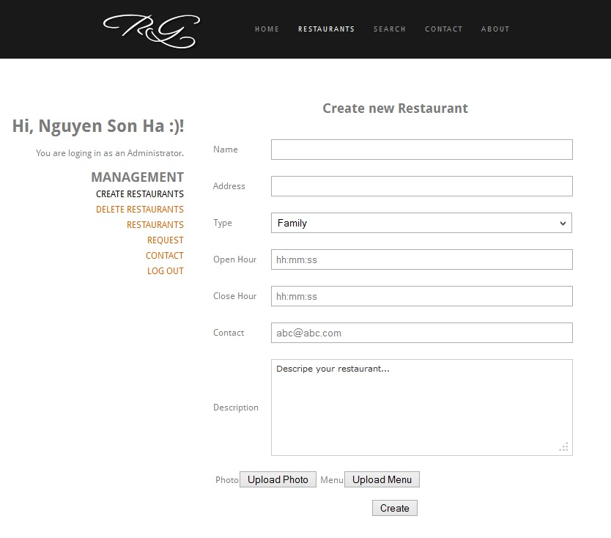

|  |  |  |  |  |  |
| --- | --- | --- | --- | --- | --- |
| **#** | **Field Name** | **Type** | **Mandatory** | **Max Length** | **Description** |
| 1 | Restaurant Name | Text | Yes | 30 |  |
| 2 | Type | Text | Yes | 30 |  |
| 3 | Address | Text | Yes | 200 |  |
| 4 | Open Hour | Text | Yes | 20 | Format hh:mm:ss dd/MM/yyyy |
| 5 | Close Hour | Text | Yes | 20 | Format hh:mm:ss dd/MM/yyyy |
| 6 | Description | Text | Yes |  | Optional |
| 7 | Upload Photo | Button |  |  |  |
| 8 | Upload Menu | Button |  |  |  |
| 9 | Submit | Button |  |  |  |
| 10 | Contact | Text |  |  |  |

* Use case Specification:

|  |  |  |  |  |
| --- | --- | --- | --- | --- |
| **Use Case ID** | | | **UC-06** | |
| **Use Name** | | | Add new restaurant | |
| **Actor** | | | RG Administrator | |
| **Description** | | | The function allows a admin to be able to create a new topic about his restaurant. | |
| **Precondition** | | | User loged in as an administrator. | |
| **Trigger** | | |  | |
| **Post-Condition** | | |  | |
| **Main flows** | | | | |
| ***Step*** | ***Actor*** | | ***Action*** | |
| *1* | Admin | | Click on [Add new restaurant] button. | |
| *2* | RG | | Display [Add new restaurant] with the following fields:  Textbox: Name, Type, Address, Open Hour, Close Hour.  Textarea: Description.  Button: Upload Photo, Upload Menu. | |
| *3* | Admin | | Enter information to validate then click on [Submit] button. | |
| *4* | RG | | Validate all input then show pop up display request user to confirm action. | |
| *5* | Admin | | User click on [Confirm] button. | |
| *6* | RG | | System send information of restaurant via email to Restaurant’s email.  Pop up closes, back to [Add new restaurant] page with blank textboxes. | |
| **Alternative flows** | | | | |
| **AT1** | | At step 2 in the main flows**,** if there is an internal error in the system, | | |
| **Sub step** | | **Actor** | | **Action** |
| 2.1 | | RG | | Display "Error" page with message "Internal System Error, please contact with administrator" |
| **AT2** | | At step 4 in the main flows**,** if RG failed to validate name | | |
| **Sub step** | | **Actor** | | **Action** |
| 4.1 | | RG | | Display [Add new restaurant] with error message: “ Your restaurant’s name can’t be blank and the length exceed 30 characters.” |
| **AT3** | | At step 4 in the main flows**,** if RG failed to validate type. | | |
| **Sub step** | | **Actor** | | **Action** |
| 4.1 | | RG | | Display [Add new restaurant] with error message: “ Your restaurant’s type can’t be blank and the length exceed 30 characters.” |
| **AT4** | | At step 4 in the main flows**,** if RG failed to validate Address. | | |
| **Sub step** | | **Actor** | | **Action** |
| 4.1 | | RG | | Display [Add new restaurant] with error message: “ Your restaurant’s Address can’t be blank and the length exceed 200 characters.” |
| **AT5** | | At step 4 in the main flows**,** if RG failed to validate Open Hour or Close Hour. | | |
| **Sub step** | | **Actor** | | **Action** |
| 4.1 | | RG | | Display [Add new restaurant] with error message: “ Your restaurant’s hour can’t be blank and the format must be  hh:mm:ss dd/MM/yyyy.” |

* Business Rules:

|  |  |
| --- | --- |
| ***#*** | ***Rule Description*** |
| *BR01* |  |
| *BR02* |  |

##### UC – 07 . Edit restaurant

* Screen design:

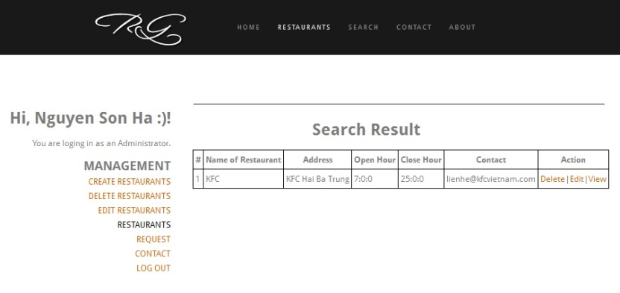

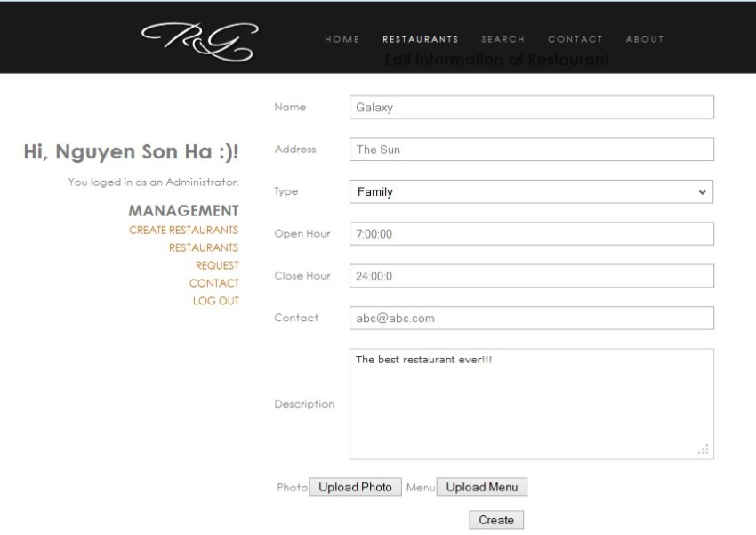

|  |  |  |  |  |  |
| --- | --- | --- | --- | --- | --- |
| **#** | **Field Name** | **Type** | **Mandatory** | **Max Length** | **Description** |
| 1 | Restaurant Name | Text | Yes | 30 |  |
| 2 | Type | Text | Yes | 30 |  |
| 3 | Address | Text | Yes | 200 |  |
| 4 | Open Hour | Text | Yes | 20 | Format hh:mm:ss dd/MM/yyyy |
| 5 | Close Hour | Text | Yes | 20 | Format hh:mm:ss dd/MM/yyyy |
| 6 | Description | Text | Yes |  | Optional |
| 7 | Upload Photo | Button |  |  |  |
| 8 | Upload Menu | Button |  |  |  |
| 9 | Submit | Button |  |  |  |
| 10 | Contact | Text |  |  | Y!M, FB, Twitter |

* Use case Specification:

|  |  |  |  |  |  |
| --- | --- | --- | --- | --- | --- |
| **Use Case ID** | | | **UC-07** | | |
| **Use Name** | | | Edit restaurant | | |
| **Actor** | | | RG Administrator | | |
| **Description** | | | The function allows a admin to be able to edit information about an existed restaurant in database. | | |
| **Precondition** | | | Have at least a restaurant in database and user loged in as an administrator. | | |
| **Trigger** | | |  | | |
| **Post-Condition** | | |  | | |
| **Main flows** | | | | | |
| ***Step*** | ***Actor*** | | ***Action*** | | |
| *1* | Admin | | Choose [Restaurants] in Side bar. | | |
| *2* | RG | | Display Management Screen including:   * List of restaurants in database. * The button view, delete, edit. | | |
| *3* | Admin | | User click on a restaurant they want to see detail.  Restaurant’s page opens with detail information | | |
| *4* | RG | | Restaurant’s page opens with detail information including: Restaurant name, Type, Address, Open hour, Close hour, Images, Menu.  Button: Edit, Delete. | | |
| *5* | User | | User click on [Edit] button on restaurant’s page | | |
| *6* | RG | | Pop up opens and display textboxes with data filled in about restaurant’s information | | |
| *7* | *Admin* | | User edit information in each textbox to validate then click on submit. | | |
| *8* | *RG* | | System validate and send new information of restaurant via email to Restaurant’s email then pop up closes, back to Management page with list of restaurants . | | |
| **Alternative flows** | | | | | |
| **AT1** | | At step 1, 3 in the main flows**,** if there is an internal error in the system, | | | |
| **Sub step** | | **Actor** | | **Action** | |
| 2.1 | | RG | | Display "Error" page with message "Internal System Error, please contact with administrator" | |
| **AT2** | | At step 6 in the main flows**,** if RG failed to validate name | | | |
| **Sub step** | | **Actor** | | **Action** | |
| 4.1 | | RG | | Display [Edit restaurant] with error message: “ Your restaurant’s name can’t be blank and the length exceed 30 characters.” | |
| **AT3** | | At step 8 in the main flows**,** if RG failed to validate type. | | | |
| **Sub step** | | **Actor** | | **Action** | |
| 8.1 | | RG | | Display [Edit restaurant] with error message: “ Your restaurant’s type can’t be blank and the length exceed 30 characters.” | |
| **AT4** | | At step 8 in the main flows**,** if RG failed to validate Address. | | | |
| **Sub step** | | **Actor** | | | **Action** |
| 8.1 | | RG | | | Display [Edit restaurant] with error message: “ Your restaurant’s Address can’t be blank and the length exceed 200 characters.” |
| **AT5** | | At step 6 in the main flows**,** if RG failed to validate Open Hour or Close Hour. | | | |
| **Sub step** | | **Actor** | | | **Action** |
| 8.1 | | RG | | | Display [Edit restaurant] with error message: “ Your restaurant’s hour can’t be blank and the format must be  hh:mm:ss dd/MM/yyyy.” |

* Business Rules:

|  |  |
| --- | --- |
| ***#*** | ***Rule Description*** |
| *BR01* |  |
| *BR02* |  |

##### UC – 08. Delete restaurant

* Screen design:

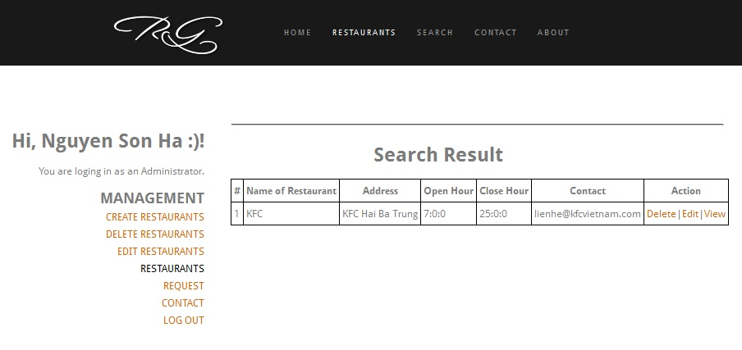

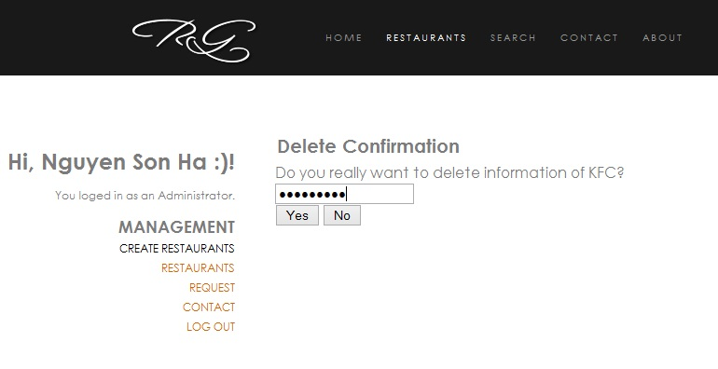

|  |  |  |  |  |  |
| --- | --- | --- | --- | --- | --- |
| **#** | **Field Name** | **Type** | **Mandatory** | **Max Length** | **Description** |
| 1 | Enter your password to delete this information” | Label |  |  | “ |
| 2 | Password | Text |  |  | Display with “*” characters. |
| 3 | Yes | Button |  |  | Confirm to delete |
| 4 | No | Button |  |  | Redirect to [Manage] Page |

* Use case Specification:

|  |  |  |  |  |
| --- | --- | --- | --- | --- |
| **Use Case ID** | | | **UC-09** | |
| **Use Name** | | | Delete restaurant | |
| **Actor** | | | RG Administrator | |
| **Description** | | | The function allows a admin to be able to delete information of an existed restaurant in database. | |
| **Precondition** | | | Have at least a restaurant in database and user loged in as an administrator. | |
| **Trigger** | | |  | |
| **Post-Condition** | | |  | |
| **Main flows** | | | | |
| ***Step*** | ***Actor*** | | ***Action*** | |
| *1* | Admin | | Choose Restaurants in Account tab. | |
| *2* | RG | | Display Restaurants Screen including:   * List of restaurants in database. * The button view, delete, edit. | |
| *3* | Admin | | Click on [Delete] button | |
| *4* | RG | | Pop up opens and display a confirm. | |
| *5* | *Admin* | | Enter Password then click to [Yes] button. | |
| *6* | *RG* | | Validate and delete the restaurant then redirect to [Manage] Page | |
| **Alternative flows** | | | | |
| **AT1** | | At step 1, 3, 5 in the main flows**,** if there is an internal error in the system, | | |
| **Sub step** | | **Actor** | | **Action** |
| 1.1 | | RG | | Display "Error" page with message "Internal System Error, please contact with administrator" |
| **AT2** | | At step 8 in the main flows**,** if RG failed to validate password | | |
| **Sub step** | | **Actor** | | **Action** |
| 8.1 | | RG | | Display [Manage] page with error message: “ Wrong password!” |
|  | |  | |  |

* Business Rules:

|  |  |
| --- | --- |
| ***#*** | ***Rule Description*** |
| *BR01* |  |
| *BR02* |  |

##### UC – 10. List all restaurants as Administrators

* Screen design:

|  |  |  |  |  |  |
| --- | --- | --- | --- | --- | --- |
| **#** | **Field Name** | **Type** | **Mandatory** | **Max Length** | **Description** |
| 1 | Restaurants List | Table |  |  | List all restaurants in data. |
| 2 | Delete | Hyperlink |  |  | For each restaurant |
| 3 | Edit | Hyperlink |  |  | For each restaurant |
| 4. | Search bar | Text |  |  | In side bar. |
| 5 | View | Button |  |  | For each reastaurant. |

* Use case Specification:

|  |  |  |  |  |
| --- | --- | --- | --- | --- |
| **Use Case ID** | | | **UC-10** | |
| **Use Name** | | | View Restaurant as Administrators | |
| **Actor** | | | RG Administrator | |
| **Description** | | | The function allows a admin to be able to View information of all | |
| **Precondition** | | | Have at least a restaurant in database and user loged in as an administrator. | |
| **Trigger** | | |  | |
| **Post-Condition** | | |  | |
| **Main flows** | | | | |
| ***Step*** | ***Actor*** | | ***Action*** | |
| *1* | User | | Choose Management in Account tab. | |
| *2* | RG | | Display Management Screen including:   * List of restaurants in database. * The button view, delete, edit. | |
| *3* | User | | Choose View of the restaurant they want to see. | |
| *4* | RG | | Display Restaurant’s page. | |
| **Alternative flows** | | | | |
| **AT1** | | At step 1, 3 in the main flows**,** if there is an internal error in the system, | | |
| **Sub step** | | **Actor** | | **Action** |
| 1.1 | | RG | | Display "Error" page with message "Internal System Error, please contact with administrator" |

* Business Rules:

|  |  |
| --- | --- |
| ***#*** | ***Rule Description*** |
| *BR01* |  |
| *BR02* |  |

##### UC – 11. Create from draft.

* 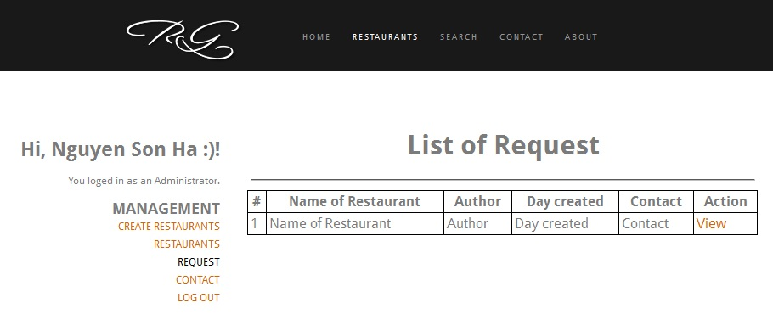Screen design

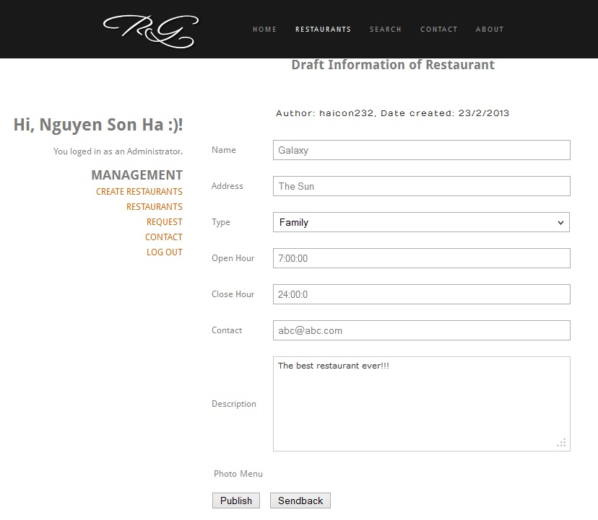

|  |  |  |  |  |  |
| --- | --- | --- | --- | --- | --- |
| **#** | **Field Name** | **Type** | **Mandatory** | **Max Length** | **Description** |
| 1 | Information | Table |  |  |  |
| 2 | Publish | Button |  |  |  |
| 3 | Send Back | Button |  |  |  |

* Use case Specification:

|  |  |  |  |  |
| --- | --- | --- | --- | --- |
| **Use Case ID** | | | **UC-11** | |
| **Use Name** | | | Create Restaurant from draft | |
| **Actor** | | | RG Administrator | |
| **Description** | | | The function allows a admin to be able to create a topic from the draft that the restaurant manager send to them. | |
| **Precondition** | | | Have at least a restaurant in database and user loged in as an administrator. | |
| **Trigger** | | |  | |
| **Post-Condition** | | |  | |
| **Main flows** | | | | |
| ***Step*** | ***Actor*** | | ***Action*** | |
| *1* | User | | Choose Management in Account tab. | |
| *2* | RG | | Display Management Screen. | |
| *3* | User | | Choose Request. | |
| *4* | RG | | Display [View Request] Page. | |
| *5* | User | | Choose View to see detail | |
| *6* | RG | | Display [Request Detail] Page. | |
| *7* | User | | Edit information if need then Choose Publish. | |
| *8* | RG | | Validate and publish information. | |
| **Alternative flows** | | | | |
| **AT1** | | At step 1, 3, 5 in the main flows**,** if there is an internal error in the system, | | |
| **Sub step** | | **Actor** | | **Action** |
| 1.1 | | RG | | Display "Error" page with message "Internal System Error, please contact with administrator" |

* Business Rules:

|  |  |
| --- | --- |
| ***#*** | ***Rule Description*** |
| *BR01* |  |
| *BR02* |  |

### c) Restaurant Manager

#### I. Manage

##### UC – 12. Add new item.

* 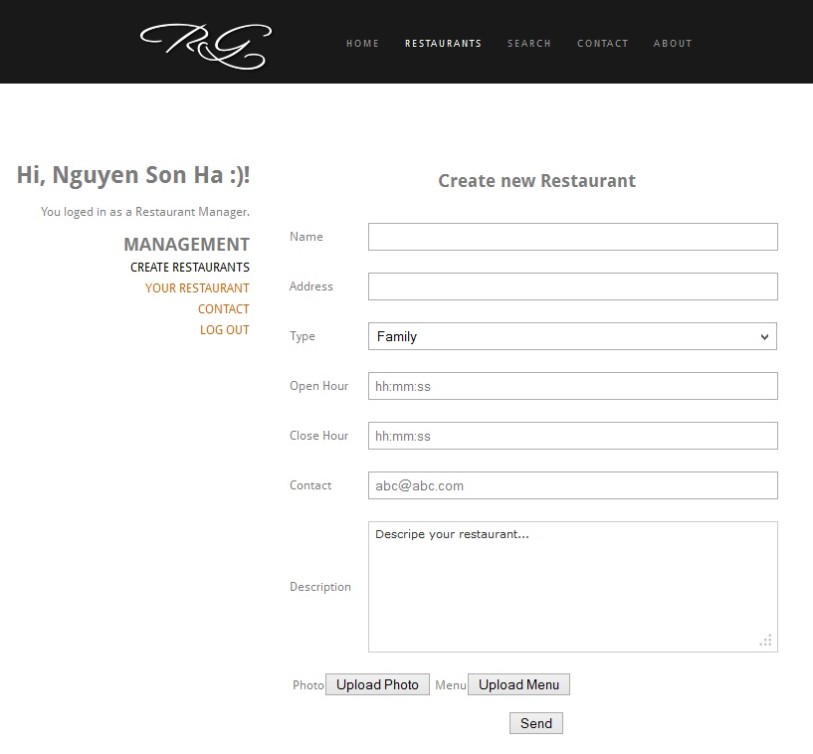Screen design:

|  |  |  |  |  |  |
| --- | --- | --- | --- | --- | --- |
| # | Field Name | Type | Mandatory | Max Length | Description |
| 1 | Restaurant Name | Text | Yes | 30 |  |
| 2 | Type | Text | Yes | 30 |  |
| 3 | Address | Text | Yes | 200 |  |
| 4 | Open Hour | Text | Yes | 20 | Format hh:mm:ss dd/MM/yyyy |
| 5 | Close Hour | Text | Yes | 20 | Format hh:mm:ss dd/MM/yyyy |
| 6 | Description | Text | Yes |  | Optional |
| 7 | Upload Photo | Button |  |  |  |
| 8 | Upload Menu | Button |  |  |  |
| 9 | Submit | Button |  |  |  |
| 10 | Contact | Text |  |  |  |

* Use case Specification:

|  |  |  |  |  |
| --- | --- | --- | --- | --- |
| **Use Case ID** | | | **UC-12** | |
| **Use Name** | | | Add new restaurant | |
| **Actor** | | | RG Restaurants Manageger Administrator | |
| **Description** | | | The function allows a manager to be able to create a new topic about his restaurant. | |
| **Precondition** | | | User loged in as an manager. | |
| **Trigger** | | |  | |
| **Post-Condition** | | |  | |
| **Main flows** | | | | |
| ***Step*** | ***Actor*** | | ***Action*** | |
| *1* | User | | Click on [Add new restaurant] button. | |
| *2* | RG | | Display [Add new restaurant] with the following fields:  Textbox: Name, Type, Address, Open Hour, Close Hour.  Textarea: Description.  Button: Upload Photo, Upload Menu. | |
| *3* | User | | Enter information to validate then click on [Submit] button. | |
| *4* | RG | | Validate all input then show pop up display request user to confirm action. | |
| *5* | User | | User click on [Confirm] button. | |
| *6* | RG | | RG send information to Administrator as a draft to be piblished.  Pop up closes, back to [Add new restaurant] page with blank textboxes. | |
| **Alternative flows** | | | | |
| **AT1** | | At step 2 in the main flows**,** if there is an internal error in the system, | | |
| **Sub step** | | **Actor** | | **Action** |
| 2.1 | | RG | | Display "Error" page with message "Internal System Error, please contact with administrator" |
| **AT2** | | At step 4 in the main flows**,** if RG failed to validate name | | |
| **Sub step** | | **Actor** | | **Action** |
| 4.1 | | RG | | Display [Add new restaurant] with error message: “ Your restaurant’s name can’t be blank and the length exceed 30 characters.” |
| **AT3** | | At step 4 in the main flows**,** if RG failed to validate type. | | |
| **Sub step** | | **Actor** | | **Action** |
| 4.1 | | RG | | Display [Add new restaurant] with error message: “ Your restaurant’s type can’t be blank and the length exceed 30 characters.” |
| **AT4** | | At step 4 in the main flows**,** if RG failed to validate Address. | | |
| **Sub step** | | **Actor** | | **Action** |
| 4.1 | | RG | | Display [Add new restaurant] with error message: “ Your restaurant’s Address can’t be blank and the length exceed 200 characters.” |
| **AT5** | | At step 4 in the main flows**,** if RG failed to validate Open Hour or Close Hour. | | |
| **Sub step** | | **Actor** | | **Action** |
| 4.1 | | RG | | Display [Add new restaurant] with error message: “ Your restaurant’s hour can’t be blank and the format must be  hh:mm:ss dd/MM/yyyy.” |

* Business Rules:

|  |  |
| --- | --- |
| ***#*** | ***Rule Description*** |
| *BR01* |  |
| *BR02* |  |

##### UC – 13. Edit item

* 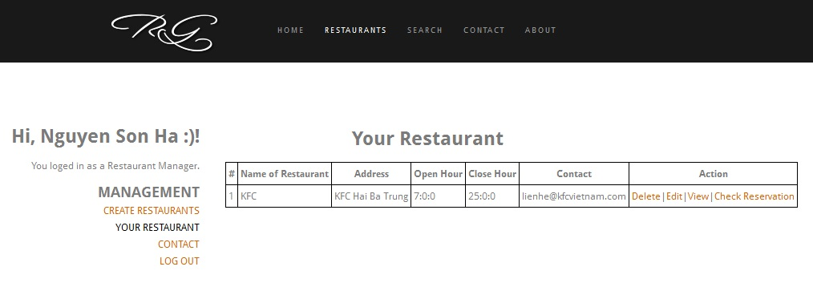Screen design:

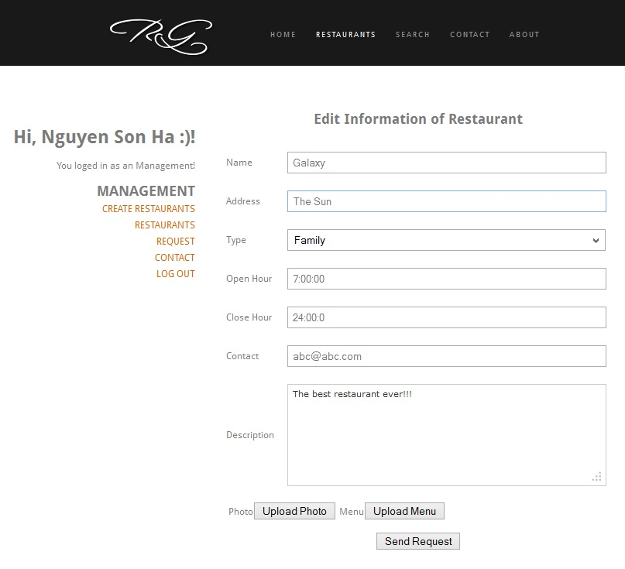

|  |  |  |  |  |  |
| --- | --- | --- | --- | --- | --- |
| **#** | **Field Name** | **Type** | **Mandatory** | **Max Length** | **Description** |
| 1 | Restaurant Name | Text | Yes | 30 |  |
| 2 | Type | Text | Yes | 30 |  |
| 3 | Address | Text | Yes | 200 |  |
| 4 | Open Hour | Text | Yes | 20 | Format hh:mm:ss dd/MM/yyyy |
| 5 | Close Hour | Text | Yes | 20 | Format hh:mm:ss dd/MM/yyyy |
| 6 | Description | Text | Yes |  | Optional |
| 7 | Upload Photo | Button |  |  |  |
| 8 | Upload Menu | Button |  |  |  |
| 9 | Submit | Button |  |  | ` |
| 10 | Contact | Text |  |  | Y!M, FB, Twitter |

* Use case Specification:

|  |  |  |  |  |  |
| --- | --- | --- | --- | --- | --- |
| **Use Case ID** | | | **UC-13** | | |
| **Use Name** | | | Edit restaurant – Option 1 | | |
| **Actor** | | | RG Manager | | |
| **Description** | | | The function allows a manager to be able to edit information about an existed restaurant in database. | | |
| **Precondition** | | | own at least a restaurant in database and user loged in as an manager. | | |
| **Trigger** | | |  | | |
| **Post-Condition** | | |  | | |
| **Main flows** | | | | | |
| ***Step*** | ***Actor*** | | ***Action*** | | |
| *1* | User | | Choose Management in Account tab. | | |
| *2* | RG | | Display Management Screen including:   * List of restaurants in database. * The button view, delete, edit. | | |
| *3* | User | | Click on [Edit] button | | |
| *4* | RG | | Pop up opens and display textboxes with data filled in about restaurant’s information | | |
| *5* | *User* | | User edit information in each textbox to validate then click on submit. | | |
| *6* | *RG* | | System validate and send new information of restaurant via email to Restaurant’s email and Administrator’s Request Box then pop up closes, back to Management page with list of restaurants . | | |
| **Alternative flows** | | | | | |
| **AT1** | | At step 1, 3 in the main flows**,** if there is an internal error in the system, | | | |
| **Sub step** | | **Actor** | | **Action** | |
| 1.1 | | RG | | Display "Error" page with message "Internal System Error, please contact with administrator" | |
| **AT2** | | At step 6 in the main flows**,** if RG failed to validate name | | | |
| **Sub step** | | **Actor** | | **Action** | |
| 6.1 | | RG | | Display [Edit restaurant] with error message: “ Your restaurant’s name can’t be blank and the length exceed 30 characters.” | |
| **AT3** | | At step 6 in the main flows**,** if RG failed to validate type. | | | |
| **Sub step** | | **Actor** | | **Action** | |
| 6.1 | | RG | | Display [Edit restaurant] with error message: “ Your restaurant’s type can’t be blank and the length exceed 30 characters.” | |
| **AT4** | | At step 6 in the main flows**,** if RG failed to validate Address. | | | |
| **Sub step** | | **Actor** | | | **Action** |
| 6.1 | | RG | | | Display [Edit restaurant] with error message: “ Your restaurant’s Address can’t be blank and the length exceed 200 characters.” |
| **AT5** | | At step 6 in the main flows**,** if RG failed to validate Open Hour or Close Hour. | | | |
| **Sub step** | | **Actor** | | | **Action** |
| 6.1 | | RG | | | Display [Edit restaurant] with error message: “ Your restaurant’s hour can’t be blank and the format must be  hh:mm:ss dd/MM/yyyy.” |
| **AT2** | | At step 6 in the main flows**,** if RG failed to validate email & password | | | |
| **Sub step** | | **Actor** | | **Action** | |
| 6.1 | | RG | | Display "Login" page with message "Your email or password is not correct." | |

* Business Rules

|  |  |
| --- | --- |
| ***#*** | ***Rule Description*** |
| *BR01* |  |
| *BR02* |  |

##### UC – 14. List items as Manager

* Screen design:



|  |  |  |  |  |  |
| --- | --- | --- | --- | --- | --- |
| **#** | **Field Name** | **Type** | **Mandatory** | **Max Length** | **Description** |
| 1 | Restaurent List | Table |  |  | Restaurants publisher bu this Manager |
| 2 | View | Button |  |  |  |
| 3 | Edit | Hyperlink |  |  |  |
| 4 | Delete | Hyperlink |  |  |  |
| 5 | Check Reservation | Hyperlink |  |  |  |

* Use case Specification:

|  |  |  |  |  |
| --- | --- | --- | --- | --- |
| **Use Case ID** | | | **UC-14** | |
| **Use Name** | | | View | |
| **Actor** | | | RG Manager | |
| **Description** | | | The function allows a manager to be able to View information of all restaurant he(or she) created. | |
| **Precondition** | | | Own at least a restaurant in database and user loged in as an manager. | |
| **Trigger** | | |  | |
| **Post-Condition** | | |  | |
| **Main flows** | | | | |
| ***Step*** | ***Actor*** | | ***Action*** | |
| *1* | User | | Choose Management in Account tab. | |
| *2* | RG | | Display Management Screen. | |
| *3* | User | | Select [View] button. | |
| *4* | RG | | Display View Page. | |
| **Alternative flows** | | | | |
| **AT1** | | At step 1, 3 in the main flows**,** if there is an internal error in the system, | | |
| **Sub step** | | **Actor** | | **Action** |
| 1.1 | | RG | | Display "Error" page with message "Internal System Error, please contact with administrator" |

* Business Rules:

|  |  |
| --- | --- |
| ***#*** | ***Rule Description*** |
| *BR01* |  |
| *BR02* |  |

##### UC - 15. Check order

* Screen design:

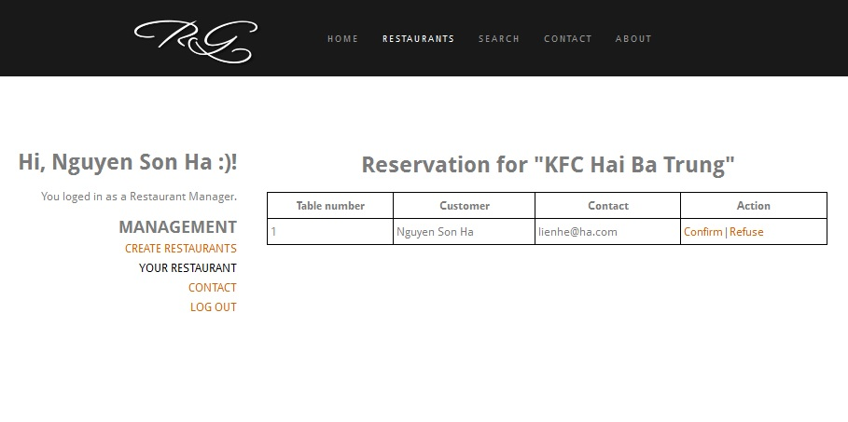

|  |  |  |  |  |  |
| --- | --- | --- | --- | --- | --- |
| **#** | **Field Name** | **Type** | **Mandatory** | **Max Length** | **Description** |
| 1 | Restaurent List | Table |  |  | Restaurants publisher bu this have |
| 2 | Reserve | Hyperlink |  |  |  |

* Use case Specification:

|  |  |  |  |  |
| --- | --- | --- | --- | --- |
| **Use Case ID** | | | **UC-15** | |
| **Use Name** | | | Check Order | |
| **Actor** | | | RG Manager | |
| **Description** | | | The function allows a manager to be able to check for the reservation for each day. | |
| **Precondition** | | | own at least a restaurant in database and user loged in as an manager. | |
| **Trigger** | | |  | |
| **Post-Condition** | | |  | |
| **Main flows** | | | | |
| ***Step*** | ***Actor*** | | ***Action*** | |
| *1* | User | | Choose Management in Account tab. | |
| *2* | RG | | Display Management Screen. | |
| *3* | User | | Select [Reserve] button. | |
| *4* | RG | | Display All Restaurant have Reserve. | |
| *5* | User | | Select a restaurant in list | |
| *6* | RG | | Display all Reservation of this restaurant. | |
| **Alternative flows** | | | | |
| **AT1** | | At step 1, 3 in the main flows**,** if there is an internal error in the system, | | |
| **Sub step** | | **Actor** | | **Action** |
| 1.1 | | RG | | Display "Error" page with message "Internal System Error, please contact with administrator" |

* Business Rules:

|  |  |
| --- | --- |
| ***#*** | ***Rule Description*** |
| *BR01* |  |
| *BR02* |  |

##### UC - 16. Create Reservation for each day.

* 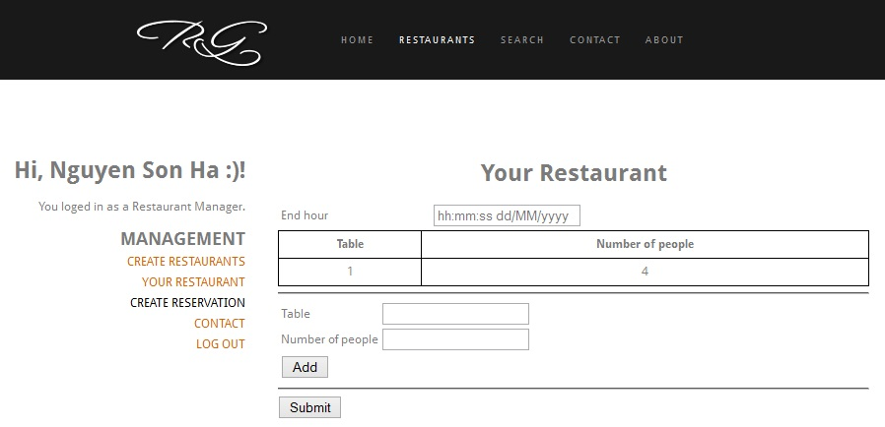Screen design:

|  |  |  |  |  |  |
| --- | --- | --- | --- | --- | --- |
| **#** | **Field Name** | **Type** | **Mandatory** | **Max Length** | **Description** |
| 1 | End hour | Text |  |  | Format: hh:mm:ss dd/MM/yyyy |
| 2 | Describe | Table |  |  | List of table to reserve |
| 3 | Submit | Button |  |  |  |
| 4 | Table | Text |  |  | The index of table |
| 5 | Number of People | Text |  |  | Number of people who can attend in the table. |
| 6 | Add | Button |  |  |  |

* Use case Specification:

|  |  |  |  |  |
| --- | --- | --- | --- | --- |
| **Use Case ID** | | | **UC-16** | |
| **Use Name** | | | Create Reservation | |
| **Actor** | | | RG Manager | |
| **Description** | | | The function allows a manager to be able to create the reservation for each day. | |
| **Precondition** | | | own at least a restaurant in database and user loged in as an manager. | |
| **Trigger** | | |  | |
| **Post-Condition** | | |  | |
| **Main flows** | | | | |
| ***Step*** | ***Actor*** | | ***Action*** | |
| *1* | User | | Choose [Create Reversation] in Account tab. | |
| *2* | RG | | Display [Create Reservation] page. | |
| *3* | User | | Enter end hour. Add the table for customer to reserve then click button Submit. | |
| *4* | RG | | Validate information and update a reservation session. | |
| **Alternative flows** | | | | |
| **AT1** | | At step 1, 3 in the main flows**,** if there is an internal error in the system, | | |
| **Sub step** | | **Actor** | | **Action** |
| 1.1 | | RG | | Display "Error" page with message "Internal System Error, please contact with administrator" |
| **AT2** | | At step 4 in the main flows**,** if there is some wrong with the input. | | |
| **Sub step** | | **Actor** | | **Action** |
| 1.1 | | RG | | Display "Error" page with message "Wrong Input." |

### d) Customers

##### UC – 17. View Reservation.

* 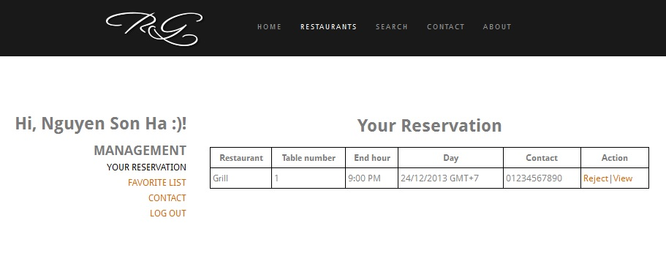Screen design:

Screen definition:

|  |  |  |  |  |  |
| --- | --- | --- | --- | --- | --- |
| **#** | **Field Name** | **Type** | **Mandatory** | **Max Length** | **Description** |
| 1 | Your Reservation | Table |  |  | List information about customer reserve. |

* Use case Specification:

|  |  |  |  |  |
| --- | --- | --- | --- | --- |
| **Use Case ID** | | | **UC-17** | |
| **Use Name** | | | View Customer’s Reservation | |
| **Actor** | | | RG Customer | |
| **Description** | | | The function allows a customer to view information of their reservation. | |
| **Precondition** | | | User logged in. | |
| **Trigger** | | |  | |
| **Post-Condition** | | |  | |
| **Main flows** | | | | |
| ***Step*** | ***Actor*** | | ***Action*** | |
| *1* | User | | Choose [Your Reversation] in Account tab. | |
| *2* | RG | | Display [View Reservation] page. | |
| **Alternative flows** | | | | |
| **AT1** | | At step 1 in the main flows**,** if there is an internal error in the system, | | |
| **Sub step** | | **Actor** | | **Action** |
| 1.1 | | RG | | Display "Error" page with message "Internal System Error, please contact with administrator" |

##### UC – 18. Reserve.

* Screen design: designing, not done.
* Use case Specification:

|  |  |  |  |  |
| --- | --- | --- | --- | --- |
| **Use Case ID** | | | **UC-12** | |
| **Use Name** | | | Reserve | |
| **Actor** | | | RG Manager | |
| **Description** | | | The function allows a user reserve | |
| **Precondition** | | | Have at least a restaurant in database and user loged in. | |
| **Trigger** | | |  | |
| **Post-Condition** | | |  | |
| **Main flows** | | | | |
| ***Step*** | ***Actor*** | | ***Action*** | |
| *1* | User | | Choose [Restaurant] tab. | |
| *2* | RG | | Display list of Restaurants. | |
| *3* | User | | Select a Restaurent. | |
| *4* | RG | | Display Restaurent’s Page | |
| *5* | User | | Select [Reserve] button | |
| *6* | RG | | Display [Reservation] page. | |
| *7* | User | | Enter Input. Select [Submit] button. | |
| *8* | RG | | Validate and send this Reservation to Restaurent’s Manager. Then, redirect to HomePage | |
| **Alternative flows** | | | | |
| **AT1** | | At step 1, 3, 5 in the main flows**,** if there is an internal error in the system, | | |
| **Sub step** | | **Actor** | | **Action** |
| 1.1 | | RG | | Display "Error" page with message "Internal System Error, please contact with administrator" |
| **AT2** | | At step 8 in the main flows**,** if there is an internal error in the system, | | |
| **Sub step** | | **Actor** | | **Action** |
| 1.1 | | RG | | Display "Error" page with message "Wrong Input." |

## 3.1 Non-Functional Requirements Specification

## QoS:

### Usability

#### Requirement of training time

* Normal users: have basic knowledge about computer.
* Power users: 30 minutes.

#### Requirement of task time

* Login within 5 seconds.
* Search within 5 seconds.
* Response within 10 seconds.

### Reliability

#### Defect Rate

* Minor bugs:
  + Reports provide information in the wrong fields or records that are needed.
* Significant bugs:
  + Data is stored in the wrong fields or record
  + Database cannot provide reports during working hour
* Critical bugs:
  + Loss of any data
  + Database is inaccessible during working hours

### Performance

* Response time for a query
  + A query for any information should be responded in less than 7 seconds after checking restaurants’ information in the database.
* Response time for a modification
  + A modification of any fields should be responded in 2 second.
* Capacity
  + The system can handle up to 100 users and 50 queries / modifications at a time.
* Degradation mode
  + In degradation mode, the system should allow users to get the information from the database.

### Supportability

* Backups
  + The system shall provide ability to back up data.
* Errors
  + The system shall keep a log of all system errors.

## Design Constraints Architectural

### Database

* The system shall use the MySQL Database, which is open source and free.

### Browser

* The Development environment shall be firefox.

### Development Requirement:

* should be operational within 1 month
* should provide solution for reserve a table in restaurant.
* Maintainable.
* Portable in many browser.
* Reuse templates.