Step 1: Open a new 2D (Render Pipeline) Project in unity.

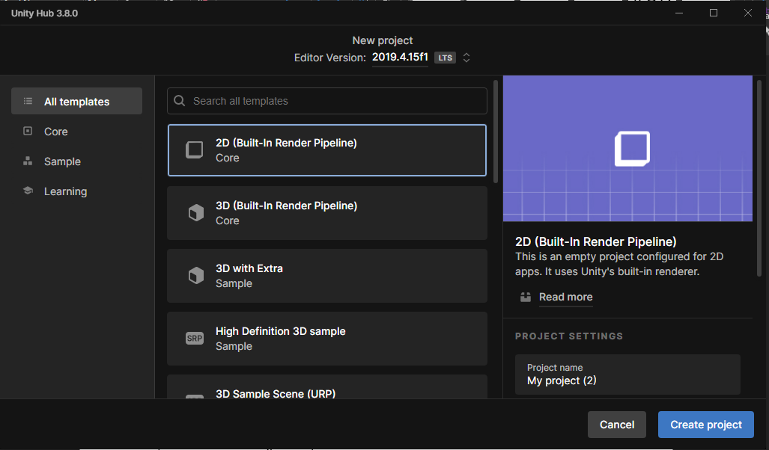

Step 2: Create a new Game Object, after that again create a new game object by right clicking on the existing game object in order to make a child game object.

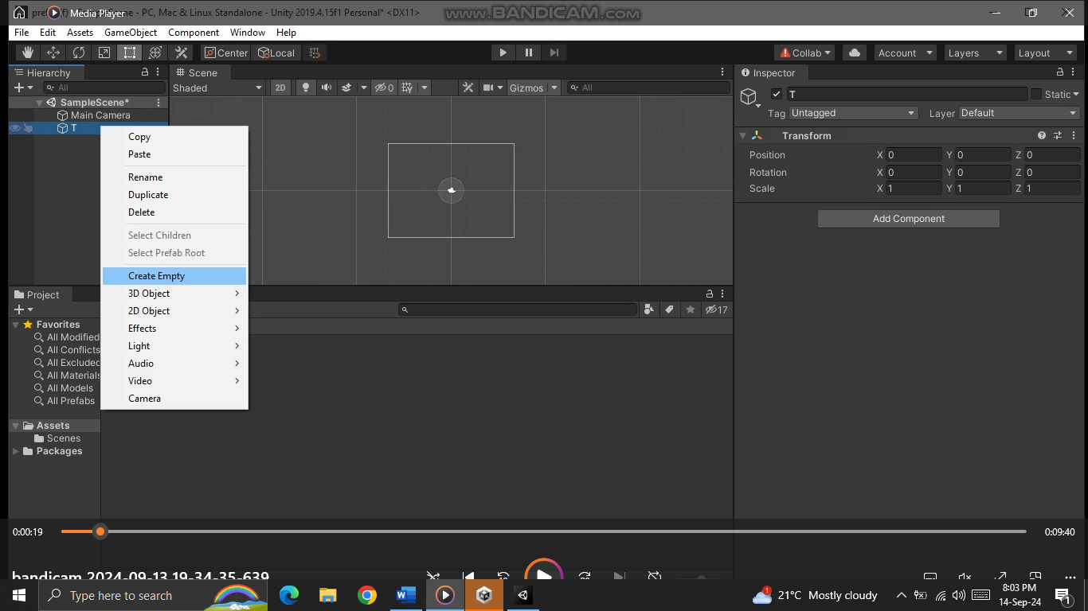

Step 3: Add a new sprite render to the child game object to add image to it.

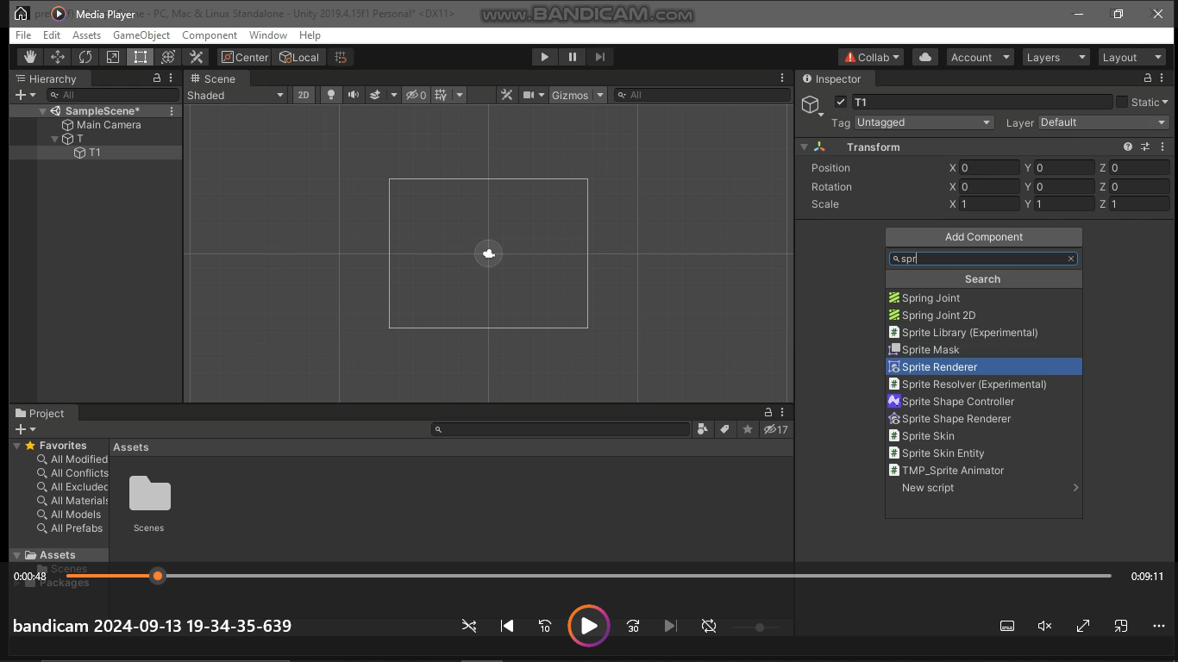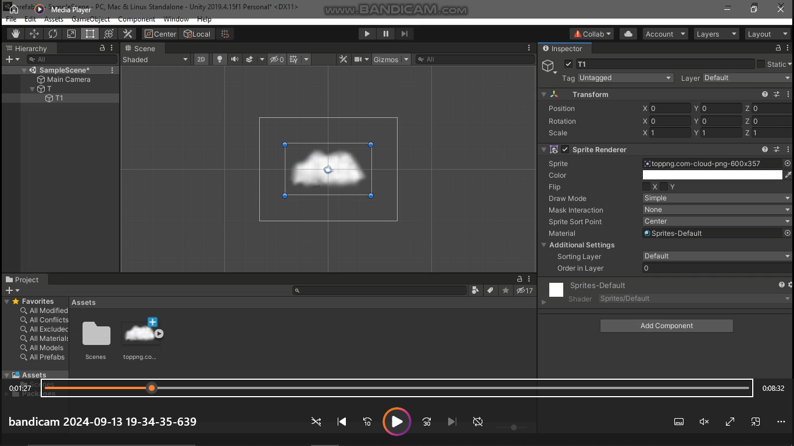

Step 4: Duplicate the child object to create the second game object change the image reposition the 2nd Child game object

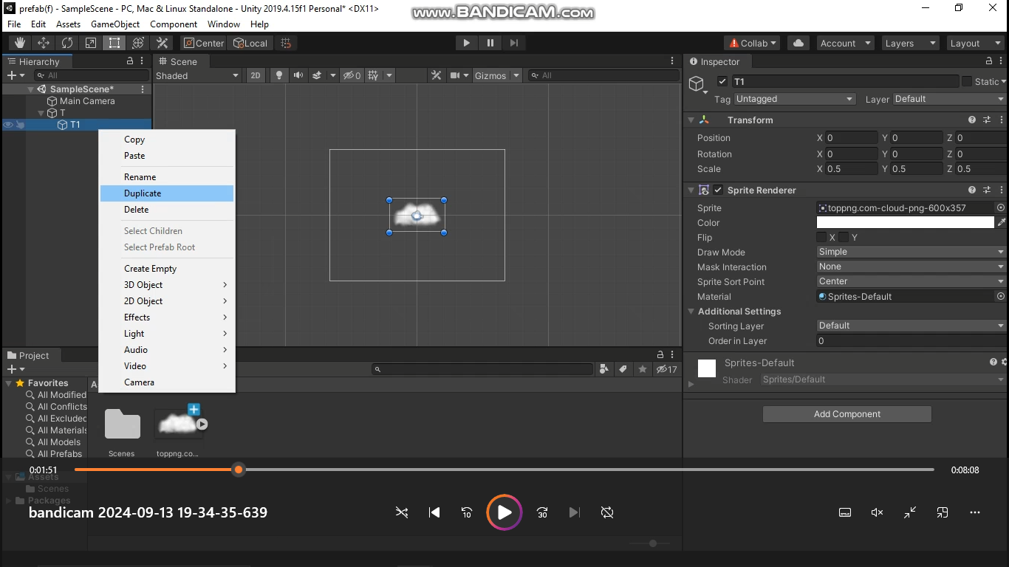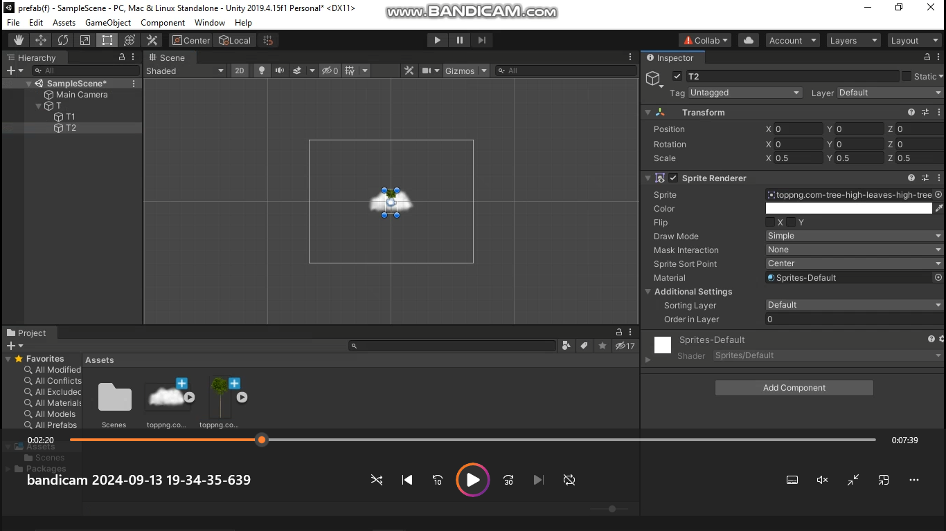

Step 5: Select the Parent object, add a new Script and type the following code in that script:

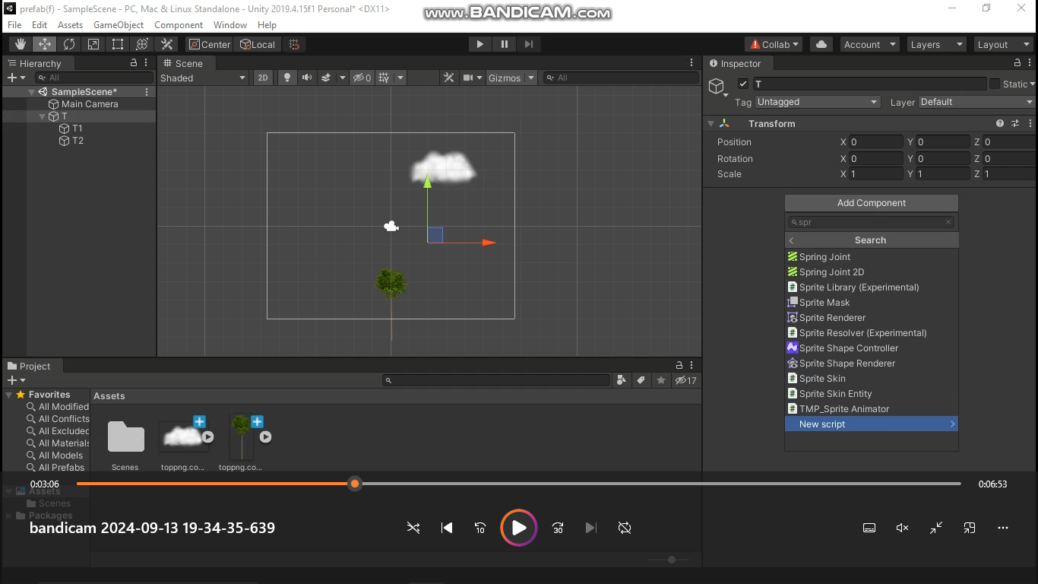using System.Collections;

using System.Collections.Generic;

using UnityEngine;

public class T : MonoBehaviour

{

public float moveSpeed = 5;

// Start is called before the first frame update

void Start()

{

}

// Update is called once per frame

void Update()

{

transform.position = transform.position + (Vector3.left \* moveSpeed) \* Time.deltaTime;

}

}

Step 6: Drag the parent Game Object in the Assets panel. This will create a pre-fab. Delete the Parent game Object in hierarchy Panel.

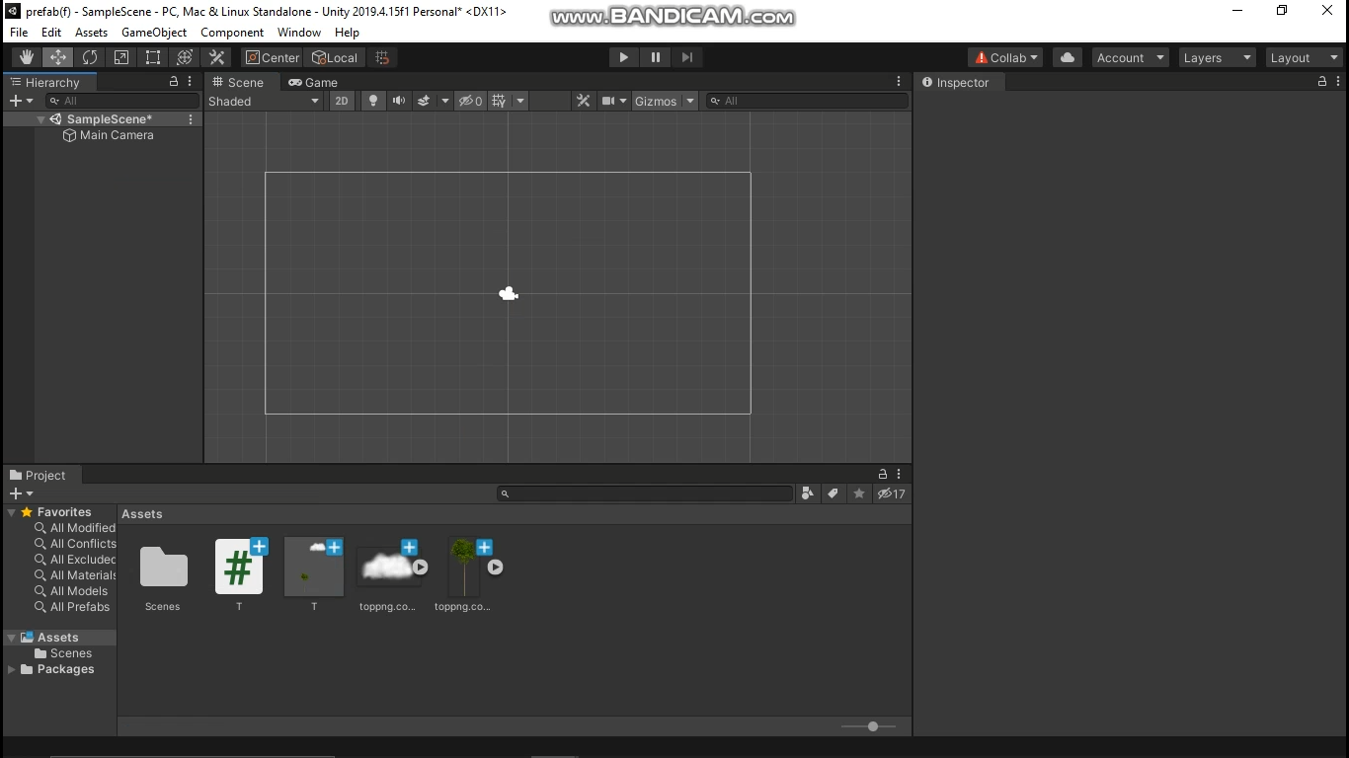

Step 7: Now Create a New Game Object add a new script to it and type the following code:

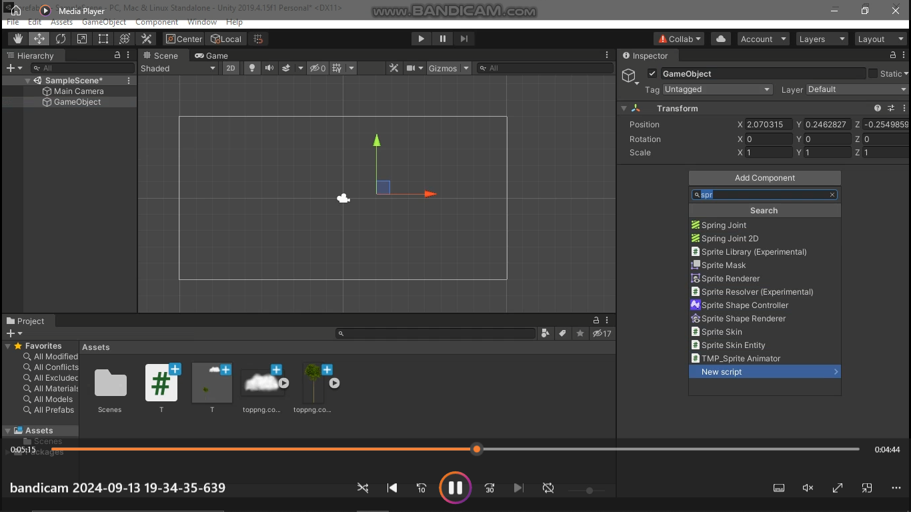

using System.Collections;

using System.Collections.Generic;

using UnityEngine;

public class TS : MonoBehaviour

{

public GameObject T;

public float spwanRate = 2;

private float timer = 0;

public float heightOffset = 0;

// Start is called before the first frame update

void Start()

{

spwanT();

}

// Update is called once per frame

void Update()

{

if (timer < spwanRate)

{

timer = timer + Time.deltaTime;

}

else

{

spwanT();

timer = 0;

}

}

void spwanT()

{

float lowestPoint = transform.position.y - heightOffset;

float highestPoint = transform.position.y + heightOffset;

Instantiate(T, new Vector3(transform.position.x, Random.Range(lowestPoint, highestPoint), 0), transform.rotation);

}

}

Step 8: If incase the pre-fab was not loaded into the new game objects script then you can manually drag and drop it into the new custom field made under the script column

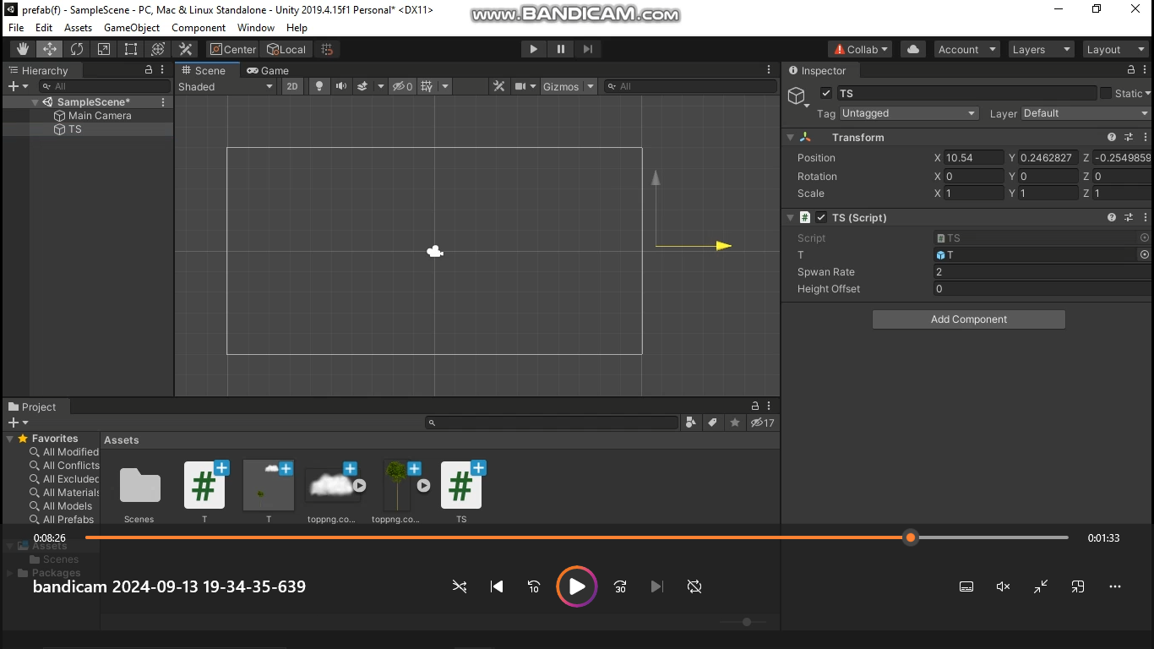

Step 9: Run the Scene

