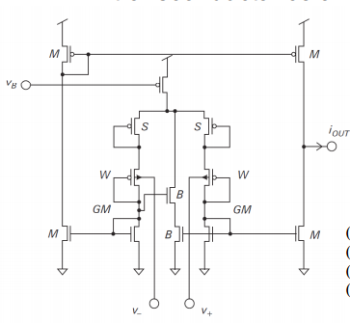

Inner part

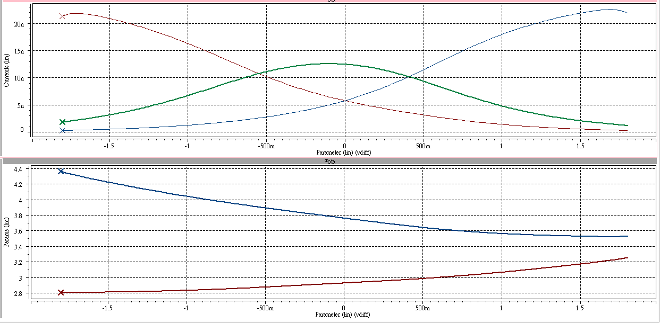

enlargement

Outter part

Reduce “m of outterpmos”: current in “positive region”(vdiff > 0) drops

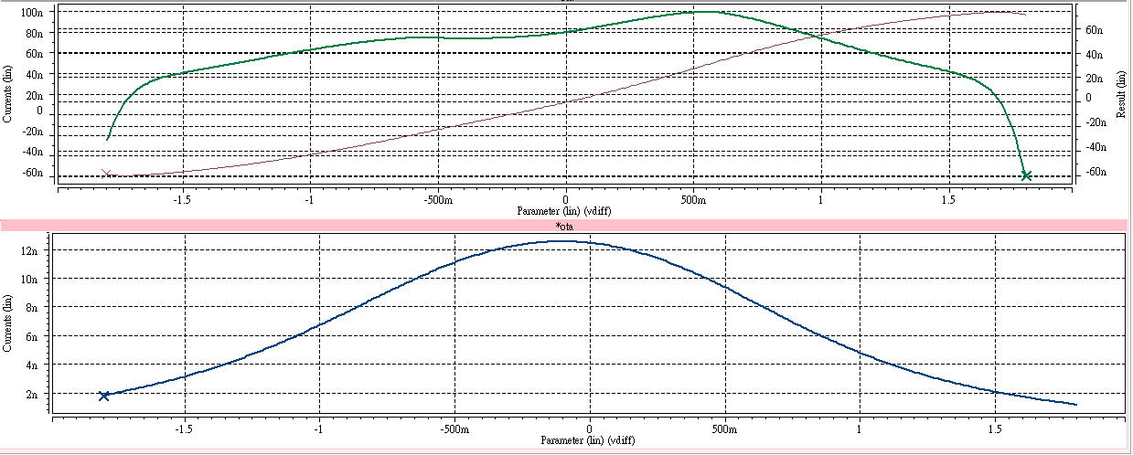

output current

Bump current

gm

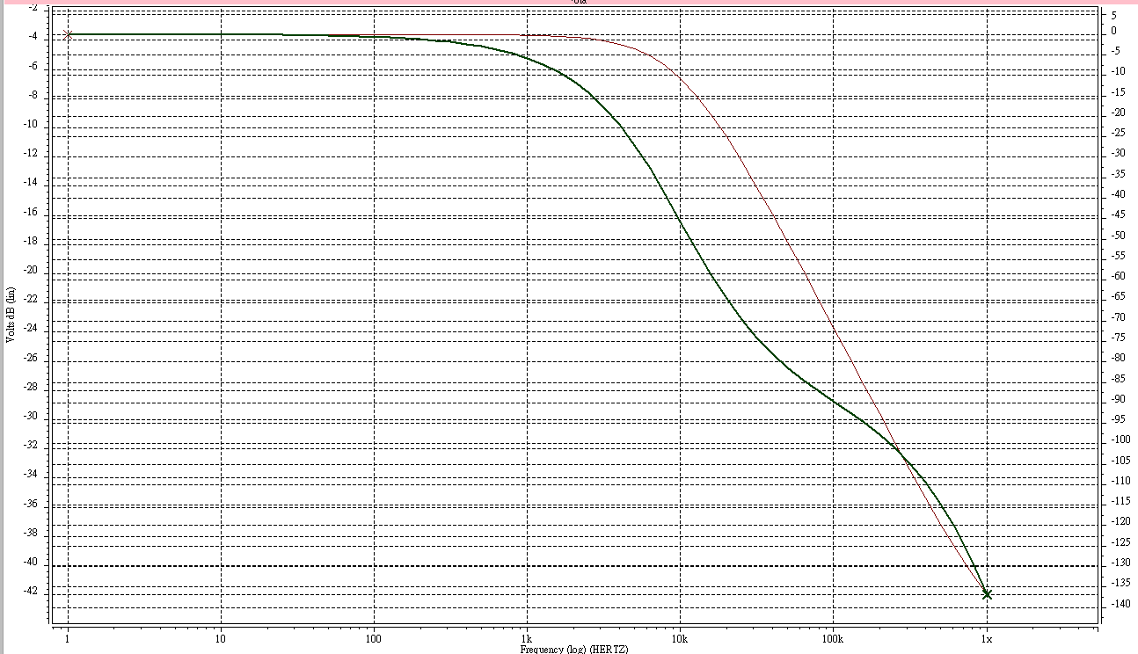

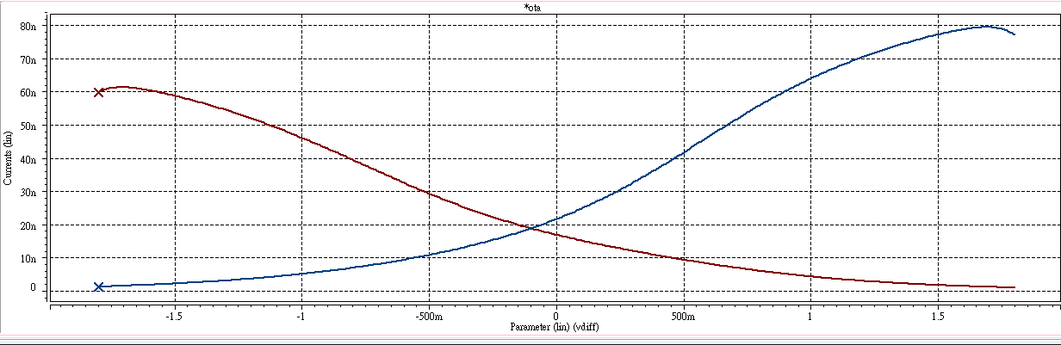outter current