ALLOTMENT SITE & PLOT COMPETITION 2018
SATURDAY 14 JULY

The competition is run annually to find best kept allotment plot and allotment site in the Borough. It is an opportunity for us to compete together in a friendly competition between allotments societies in the borough and plot holders.
Cash prizes and trophies are presented during an informal social evening which winners of the competition, their friends and families are invited attend.
I urge you to take part, especially if you have never done so before. No site or plot is perfect so please give it a go. Promote the plot competition among your members and encourage them to enter. And don’t forget to enter your own site this year.
There are two categories in the site competition one for large and the other for small sites. We need more small sites to participate so if your site is 250 poles or less please do take up the challenge; you are in with an excellent chance of winning. Small sites are listed in the competition schedule.
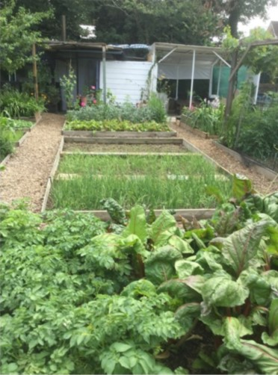
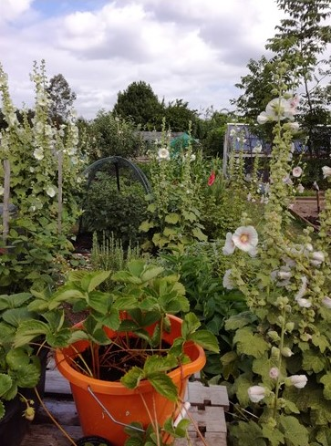
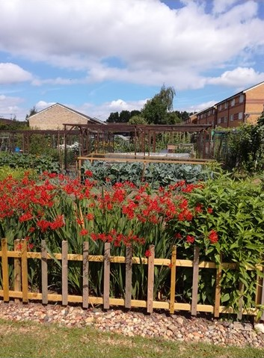
Please send your Site & Plot entries on the attached form no later than Fri 29 June Jun_____________________

Also, The Ted Green Award is given to the society showing the most outstanding allotment community initiative during the previous twelve months.

Details will follow in July. Judging will take place in September.

Rules for the site competition
- The competition is open to any allotment society paying subscriptions to the BAF and small sites which registered but may be exempt from paying subs.
- A representative of the site must meet the judges at a pre-arranged place and time for judging and to then be available during site judging to answer any questions. Failure to with this may disqualify the society from the Competition.

Rules for the plot competition
- For the purpose of the Competition the term 'PLOT shall mean an area of land, rented and cultivated by an individual, with the assistance of his/her household. The area of the plot put forward for judging should be one single numbered plot; the area need not be the whole of the land he/she rents. It must, however, be in one unit only and clearly defined at the perimeter by an accessible path. It will be the duty of an Officer of the Site concerned to outline the boundaries of the plot to be judged.
- Any member of an allotment society is eligible to enter the plot competition.
- Each society entering the plot competition should select a best plot for judging. After the best plot has been entered for the competition, assessment by Federation judges will take place to determine the best plots to go forward into the finals. Final judging will usually take place the following weekend.
- Points will be awarded in accordance with the Barnet Federation’s published mark sheets.
- Trophies are awarded to the top three in each category. Monetary prizes and trophies are awarded for best plots

THE JUDGES DECISION IN BOTH COMPETITIONS IS FINAL
No correspondence or discussion will be entered into in regard to the results

Competition Secretary: Isobel Exell
39 Asmuns Hill
London NW11 6EX
13 May 2018 Phone: 020 8731 9964
Email: barnetallotmentfederation:gmail.com
Dear Society Secretary
SCHEDULE FOR PLOT AND SITE COMPETITION 2018

These competitions take place annually in July. Monetary prizes and trophies are awarded for the best individual plot and sites in the Borough.

The BAF Committee hope that you will encourage your members to take part in the plot and site competitions. The details are as follows:

PLOT COMPETITION

PLOT COMPETITION  ENTRIES FRIDAY 29 JUNE | Your committee submits 1 plot for the competition.  Plot submitted to be notified on the application form and returned to the Competition Secretary by FRIDAY 29 JUNE
PRELIMINARY PLOT  SATURDAY 14 JULY | Federation Judges will judge plots which have been entered to establish the best 3 plots in the Borough
FINAL PLOT  SATURDAY 21 JULY | The best plots will then be judged by an independent judge to determine the best plot in the Borough

SITE COMPETITION

SITE COMPETITION  ENTRIES FRIDAY 29 JUNE | Your committee submits the site for the competition in either the large or small category.  Site submitted to be notified on the application form and returned to the Competition Secretary by FRIDAY 29 JUNE
PRELIMINARY SITE  SATURDAY 14 JULY | Federation Judges will determine the best 3 large sites and best 3 small sites in the Borough in accordance with the pointing system
FINAL SITE  SATURDAY 21 JULY | The best large site and best small site in the Borough will then be selected by an independent judge

Spare copies of the rules and entry form can be downloaded from the website http://barnetallotments.org.uk
Please send your entries to the Competition Secretary as soon as possible.
Regards
Isobel Exell – Competition Secretary

SMALL SITES - Not exceeding 250 poles.

Abbots Road | Edgware
Barfield Ave | Whetstone
Brent Place | Finchley
Brent Way | Finchley
Frith Manor | North Finchley
Fursby Avenue | Finchley
Needham Terrace | Cricklewood
Nethercourt Ave | Finchley
Simmons Way | Whetstone
Stanhope Road | Barnet
Thornfield Ave | Mill Hill
Tretawn Gardens | Mill Hill
Tudor Road | New Barnet

