<https://djangoforbeginners.com/hello-world/>

<https://docs.python.org/3/library/venv.html>  
<https://packaging.python.org/guides/installing-using-pip-and-virtual-environments/>

In the Cortana search box, type in “cmd” then click “Run as administrator”:  
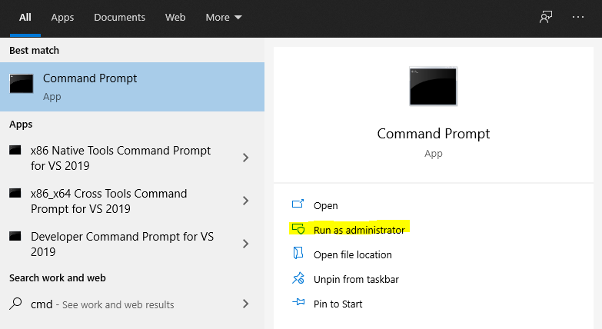

Navigate to your project folder by using:  
> cd <folder name>  
> dir/w (to list the directory contents… similar to ls in Mac/Linux terminal. The /w switch causes the contents to be listed in several columns, wider, rather than in one long list.)

Windows:

1. Navigate to project folder.
2. ~~> virtualenv venv~~ (it seems like this command only needs to be done once per command prompt session)  
   If this command doesn’t work, you probably need to install virtualenv by running the following command:  
   > py -m pip install –user virtualenv  
     
   If “virtualenv venv” continues to not work, try this one:  
     
   > py -m venv env
3. > venv\scripts\activate (same for this)  
     
   If you used “py -m venv env” in the previous step, use this command instead:  
     
   > .\env\Scripts\activate

You should see something like this:

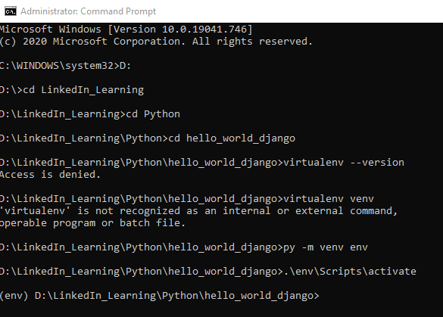

I went ahead and added a .gitignore file to my project directory that contained the following:

.DS_Store

node_modules

.tmp

npm-debug.log

wisdompets/db.sqlite3

__pycache__/

*.py[cod]

Here is what I have so far in my project folder:

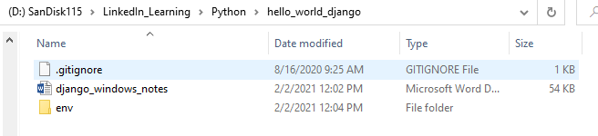

The env folder that you see what automatically created by the command “py -m venv env”.  
Then the command “.\env\Scripts\activate” told it to use that folder.

Now, keep in mind that we will not be committing this folder to GitHub because of:



which it says on the website, <https://packaging.python.org/guides/installing-using-pip-and-virtual-environments/>

so we will add this folder to the .gitignore file:

I think we just add a new line “env” ~~or “env/”~~

.DS_Store

node_modules

.tmp

npm-debug.log

wisdompets/db.sqlite3

__pycache__/

*.py[cod]

env

Back in the cmd window, in the virtual environment, install Django using pip:

> pip install django~=3.1.0

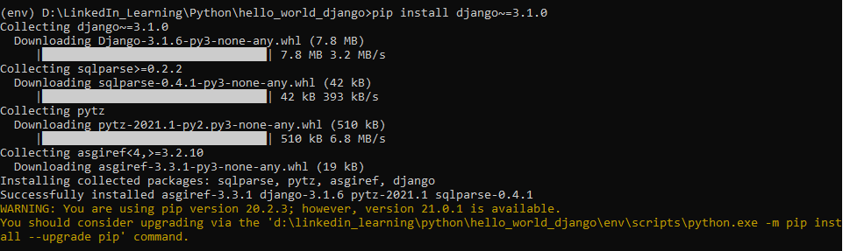

> cd env\scripts

> python.exe -m pip install –upgrade pip  
  
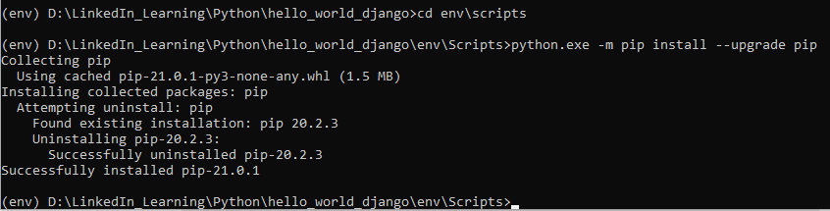

> python.exe django-admin.py startproject config D:\LinkedIn_Learning\Python\hello_world_django  
> cd ..

> cd ..

> dir/w  
  
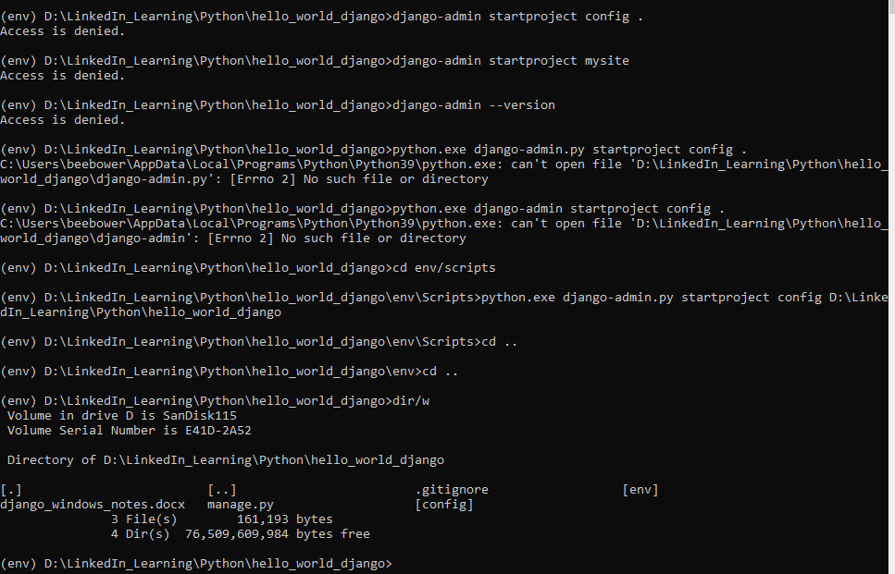

So it looks like when I initially tried to run “django-admin startproject config .” it was trying to use a different python.exe instead of the virtual environment’s python.exe.  
I’ll have to look into how this is corrected later.  
I bet this is easier on a Mac or Linux in terminal.

> python manage.py runserver  
  
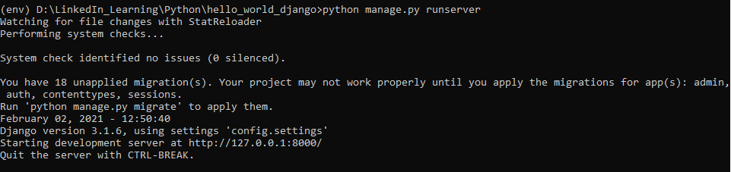  
  
Then go to <http://127.0.0.1:8000/> in the browser.

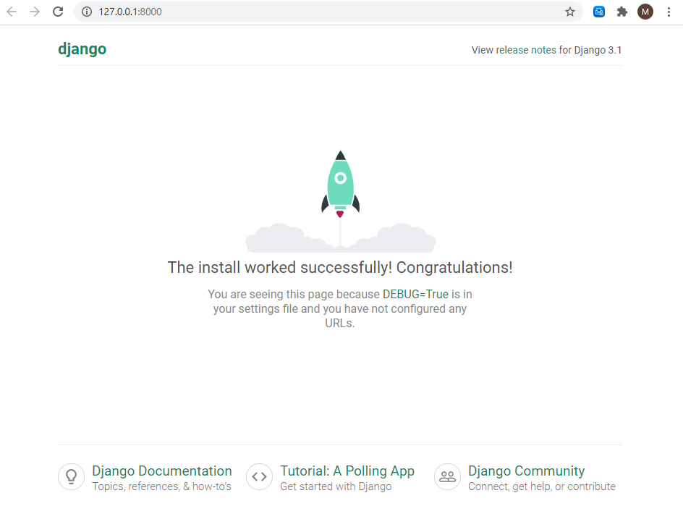

CTRL-Pause/Break causes the server to stop, and returns you to a prompt in the cmd window.

(env) > git –version

If this is not recognized, then you’ll probably need to go to <https://git-scm.com/download/win> to download Git for Windows.

After installing, you’ll need to close the cmd window and reopen it (in admin mode).

Navigate again to your project folder.

Activate the virtual environment:  
> .\env\Scripts\activate  
> git –version  
  
