Safe Real-Time Optimization Under Unmeasured Disturbances:
A Finite-Sample, Distribution-Free Constraint-Satisfaction Guarantee
Bien Don Busico
Mapua Malayan Colleges Mindanao, Davao City, Philippines
bienbusico@gmail.com
Abstract
Real-time optimization (RTO) drives a process against a product-quality constraint it cannot measure online, so it must subtract a back-off from the specification. Conformal prediction is an attractive, distribution-free way to size that back-off from data, yet we prove that the guarantee it provides does not survive the optimization. We show that an RTO respecting a marginally valid conformal back-off carries no coverage guarantee at the operating point it selects: the realized constraint-violation probability can exceed the nominal level by an arbitrary factor, because the optimizer settles on the active boundary where the margin is least conservative relative to the local risk. This is a constraint-space analogue of the winner’s curse. We then prove that conditional calibration restores a finite-sample, distribution-free guarantee. An a-posteriori recalibration at the selected point achieves exact validity, and, when fresh calibration data at that point are unavailable, a calibration made uniform over the decision set guarantees a realized violation no worse than the nominal level plus a term of order $\sqrt{d/n}$ that is small for the low-dimensional decisions typical of RTO. On a rigorous DWSIM Peng-Robinson debutanizer twin, a marginally valid back-off realizes roughly five times the nominal violation, the conditional method tracks a plant-aware oracle at near-oracle profit, and the a-posteriori inflation factor is an interpretable data-adequacy diagnostic that bounds the safe operating regime.
Safe Real-Time Optimization Under Unmeasured Disturbances: A Finite-Sample, Distribution-Free Constraint-Satisfaction Guarantee
Bien Don Busico
Mapua Malayan Colleges Mindanao, Davao City, Philippines
bienbusico@gmail.com
Index Terms— Real-time optimization, chance-constrained control, conformal prediction, safe learning, constraint back-off, distribution-free guarantees, process control.

Introduction
Real-time optimization (RTO) recomputes the operating point of a process to maximize an economic objective as conditions drift. Its value comes from pushing the process against its constraints; a distillation column earns more as it drives a product composition to the edge of specification. The constraints that matter most, however, are often on quality variables that are not measured online. A laboratory assay or an inferential estimate stands in for a true composition the controller never sees in real time. To operate safely against such a constraint, an RTO must subtract a back-off from the specification: a margin that absorbs the gap between the model’s nominal prediction and the realized quality under an unmeasured disturbance. Sizing that margin is the central difficulty of RTO under uncertainty. Set it too small and the process violates specification whenever the disturbance is adverse; set it too large and the economic benefit of the optimization is given away.
Conformal prediction is an appealing tool for the job. It turns any predictor into an interval with a finite-sample, distribution-free coverage guarantee, assuming only that the data are exchangeable, with no Gaussian residuals and no parametric disturbance law [1], [2], [3]. Taking the upper edge of a conformal interval as the back-off appears to deliver exactly what a chance constraint asks: coverage of the realized quality at the nominal level, learned from data. This paper shows that the guarantee does not survive contact with the optimizer, and it supplies a back-off construction, with proof, that restores it.
The failure is structural. A conformal margin guarantees coverage on average over the calibration distribution of operating points, but the optimizer does not sample that distribution. It deliberately seeks the boundary of the feasible region, where the margin is tightest relative to the local risk and therefore where coverage is worst. The argmax is a selection operator, and it selects for under-coverage. The conformal-predictive-programming literature [4] observed abstractly that a decision optimized against sampled constraints is no longer independent of them; our concern is the concrete consequence for a control layer, namely a safety hazard of provable and quantified severity, and the construction that removes it. Theorem 1 shows that marginal validity implies no nontrivial bound on the realized violation at the selected operating point. This is a constraint-space analogue of the winner’s curse in post-selection inference.
What repairs it is conditional validity, and we prove two guarantees for it (Theorem 2). A back-off recalibrated a-posteriori at the selected operating point, with an independent calibration batch, achieves exact finite-sample validity because the selection is then independent of the calibration data. When such a batch is unavailable and the same historical data must serve both optimization and calibration, a calibration made uniform over the decision set restores validity up to a term of order $\sqrt{d/n}$, which is small for the low-dimensional decisions characteristic of RTO. A back-off built from conformalized quantile regression [5] is the practical route to this conditional target, and the a-posteriori inflation factor it requires is an observable diagnostic of calibration adequacy (Corollary 1).
We demonstrate the theory on a rigorous DWSIM Peng-Robinson debutanizer twin. A marginally valid back-off, including a locally adaptive heteroscedastic one, realizes roughly five times the nominal violation across the disturbance range; a plant-aware oracle holds the target by construction, confirming that the failure lies in the back-off and not in the chance-constrained formulation; the conditional method tracks the oracle at near-oracle profit; and the inflation factor climbs from near unity to nearly sixfold before the method exhausts its calibration data, bounding the safe operating regime. We are explicit that the contribution is calibrated safety, not profit: at a well-controlled feed every method earns within half a percent of the deterministic optimum, so the value of the method is the violation it removes.
The contributions are as follows.
- C1. We prove that optimizing against a marginally valid conformal back-off carries no coverage guarantee at the selected operating point: the realized violation can exceed the nominal level by an arbitrary factor (Theorem 1).
- C2. We prove that conditional calibration restores a finite-sample, distribution-free guarantee: a-posteriori recalibration achieves exact validity, and uniform calibration guarantees a realized violation of at most the nominal level plus an $O\left(\sqrt{d/n}\right)$ term (Theorem 2), and we tie the required inflation factor to calibration adequacy (Corollary 1).
- C3. We validate the theory on a rigorous distillation RTO twin, quantifying the fivefold failure of marginal back-offs, the near-oracle safety and profit of the conditional method, and the inflation factor as a data-adequacy diagnostic that bounds the safe regime.
The remainder of the paper is organized as follows. Section 2 formalizes the chance-constrained RTO and the conformal back-offs. Section 3 proves the selection effect and its repair. Section 4 describes the twin and the experimental design, Section 5 reports the results, and Section 6 draws the design rule, the limitations, and the bridge to a closed-loop realization.

Related work
RTO under uncertainty classically addresses plant-model mismatch through modifier adaptation, which corrects the optimizer with measured gradients [6], [7], and through chance-constrained programming, which bounds constraint violation under an assumed disturbance law [8], [9], [10]. Both presuppose a model of the uncertainty. Conformal prediction removes that assumption, guaranteeing finite-sample coverage under exchangeability alone [1], [2], [3], with conditional and covariate-shift extensions [5], [11], [12], [13], [14]. Its use inside optimization is recent [4], [15]: conformal predictive programming recognizes that optimization couples the decision to the sampled constraints. We contribute the control-theoretic consequence of that coupling, a proof that marginal back-offs are unsafe at the optimum, and a proven repair with an accompanying diagnostic.

Problem Formulation and Conformal Back-Offs

Chance-constrained RTO under an unmeasured disturbance
We consider steady-state RTO of a distillation column whose product-quality constraint cannot be measured online (Fig. 1). The decision is the operating point $u=\left(R,D\right)$, with $R$ the reflux ratio and $D$ the distillate molar flow; the admissible set is the box $U=\left[0.8,3.0\right]×\left[33,37\right]$, with $D$ in kmol h$​^{−1}$. The plant is subject to an exogenous disturbance $z$, the feed light-key (n-butane) mole fraction, neither manipulated nor measured in real time, modeled as a truncated normal $z∼F_{σ}=N\left(z_{0},σ_{z}^{2}\right)|_{\left[z_{lo},z_{hi}\right]}$ with $z_{0}=0.35$, $\left[z_{lo},z_{hi}\right]=\left[0.30,0.40\right]$, and $σ_{z}$ the disturbance magnitude (swept in Section 4; the operationally realistic value is $σ_{z}≈0.006$).
The constrained quantity is the bottoms light-key composition $g\left(u,z\right)=x_{B}\left(R,D,z\right)$, which must satisfy $g\left(u,z\right)≤\overset{‾}{g}$ with $\overset{‾}{g}=0.02$. Because $g$ is unmeasured, the optimizer sees only a nominal model $\hat{g}\left(u\right)=x_{B}\left(R,D,z_{0}\right)$. The economic objective $π\left(u\right)$ is an operating profit with two product streams valued by mass less the reboiler energy (Section [sec:methods-twin]). The principled formulation is a chance constraint,
$$\max_{u∈U} π\left(u\right) \text{s.t.} P_{z∼F_{σ}}​\left[ g\left(u,z\right)≤\overset{‾}{g} \right]≥1−α,$$
with miss level $α=0.10$. Writing $Q_{1−α}^{z}\left[g\left(u,⋅\right)\right]$ for the $\left(1−α\right)$-quantile of $g\left(u,z\right)$, [eq:chance] is equivalent to $Q_{1−α}^{z}\left[g\left(u,⋅\right)\right]≤\overset{‾}{g}$. RTO has no access to this quantile, so it enforces a surrogate by subtracting a back-off $C\left(u\right)≥0$ from the spec applied to the nominal model,
$$\max_{u∈U} π\left(u\right) \text{s.t.} \hat{g}\left(u\right)+C\left(u\right)≤\overset{‾}{g}.$$
The entire content of an uncertainty-aware RTO lies in how $C\left(u\right)$ is constructed: the back-off is correct when $\hat{g}\left(u\right)+C\left(u\right)≥Q_{1−α}^{z}\left[g\left(u,⋅\right)\right]$, so that any $u$ feasible in [eq:backoff] is feasible in [eq:chance].
A benchmark is the oracle. Because $g\left(u,z\right)$ is monotone increasing in $z$ at every $u$ (verified on the twin), the conditional quantile collapses to $Q_{1−α}^{z}\left[g\left(u,⋅\right)\right]=g\left(u,z_{1−α}\right)$ with $z_{1−α}=F_{σ}^{−1}\left(1−α\right)$, giving the oracle back-off $C_{orc}\left(u\right)={\left[g\left(u,z_{1−α}\right)−\hat{g}\left(u\right)\right]}_{+}$. The oracle needs the true plant response and is not deployable; it makes the realized violation at any active optimum equal to $α$, which we use to confirm the chance-constraint machinery is sound.

Conformal constraint back-offs
Assume a calibration set of plant evaluations $\{\left(u_{i},z_{i},g_{i}\right)\}_{i=1}^{n}$ with $u_{i}∼Unif\left(U\right)$, $z_{i}∼F_{σ}$, $g_{i}=g\left(u_{i},z_{i}\right)$; in deployment these are historical operating records. Define residuals $r_{i}=g_{i}−\hat{g}\left(u_{i}\right)$. For a one-sided upper bound at level $1−α$, the split-conformal quantile of scores $\{s_{i}\}$ is the order statistic
$${\hat{Q}}_{1−α}\left(\{s_{i}\}\right)=s_{\left(k\right)}, k=⌈\left(n+1\right)\left(1−α\right)⌉,$$
which is $+∞$ if $k>n$. We compare four constructions of $C\left(u\right)$, all floored at zero. The fixed margin ignores the operating point, $C_{fix}={\hat{Q}}_{1−α}\left(\{r_{i}\}\right)$; it is marginally valid but spends the same margin everywhere. The normalized, locally adaptive back-off scales the score by a Gaussian-process spread estimate $\hat{s}\left(u\right)$ fit to $\{\left|r_{i}\right|\}$ [2], $C_{nrm}\left(u\right)={\hat{Q}}_{1−α}\left(\{r_{i}/\hat{s}\left(u_{i}\right)\}\right) \hat{s}\left(u\right)$; it is the back-off a soft-sensor interval supplies, marginally but not conditionally valid. Conformalized quantile regression (CQR) [5] is the conditional construction: fit a gradient-boosted quantile regressor ${\hat{q}}_{1−α}\left(u\right)$, form scores $E_{i}=g_{i}−{\hat{q}}_{1−α}\left(u_{i}\right)$, and set $C_{cqr}\left(u\right)={\left[{\hat{q}}_{1−α}\left(u\right)+{\hat{Q}}_{1−α}\left(\{E_{i}\}\right)−\hat{g}\left(u\right)\right]}_{+}$. Because ${\hat{q}}_{1−α}\left(u\right)$ estimates the conditional quantile at each $u$, $C_{cqr}$ tracks the local risk, and the conformal correction restores finite-sample marginal validity on top.

The Selection Effect and Its Repair
This section makes precise the failure of marginal back-offs under optimization and proves that conditional calibration repairs it. Throughout, let $M\left(u\right)≜P_{z∼F_{σ}}\left[g\left(u,z\right)>\hat{g}\left(u\right)+C\left(u\right)\right]$ be the realized miss of the back-off at $u$. Because any $u$ feasible in [eq:backoff] satisfies $\hat{g}\left(u\right)+C\left(u\right)≤\overset{‾}{g}$, the event $\{g\left(u,z\right)>\overset{‾}{g}\}$ is contained in $\{g\left(u,z\right)>\hat{g}\left(u\right)+C\left(u\right)\}$, so the specification-violation probability is bounded by the miss, $P_{z}\left[g\left(u,z\right)>\overset{‾}{g}\right]≤M\left(u\right)$. Controlling $M$ at the selected point controls the chance constraint [eq:chance].
Definition 1 (Marginal and conditional validity). A back-off $C$ is marginally valid at level $α$ over a reference distribution $ρ$ on $U$ if $E_{u∼ρ}\left[M\left(u\right)\right]≤α$. It is conditionally valid at level $α$ on $S⊆U$ if $M\left(u\right)≤α$ for every $u∈S$.
Split and normalized conformal back-offs are marginally valid by construction [1], [2], but the conditional miss varies over $U$ [12]. The next result shows this gap is a safety failure once an optimizer is in the loop.
Theorem 1 (Marginal validity is vacuous at the optimum). Fix $α∈\left(0,1\right)$. For every $κ∈\left[1,1/α\right]$ there is an instance $\left(g,\hat{g},π,C\right)$ with $C$ marginally valid at level $α$ over $ρ=Unif\left(U\right)$ for which the RTO solution $u^{⋆}=arg\max_{u∈U}\{π\left(u\right):\hat{g}\left(u\right)+C\left(u\right)≤\overset{‾}{g}\}$ satisfies $M\left(u^{⋆}\right)=κα$. Consequently marginal validity alone implies no bound on $M\left(u^{⋆}\right)$ tighter than the trivial $M\left(u^{⋆}\right)≤1$.
Proof. Partition $U=A∪B$ with $ρ\left(A\right)=1/κ∈\left[α,1\right]$, admissible since $κ∈\left[1,1/α\right]$. The miss $M\left(u\right)$ is continuous and strictly decreasing in $C\left(u\right)$ from $P_{z}\left[g\left(u,z\right)>\hat{g}\left(u\right)\right]$ to $0$; choose $C$ so that $M\left(u\right)=κα$ on $A$ (attainable whenever $κα≤1$) and $M\left(u\right)=0$ on $B$. Then $E_{u∼ρ}\left[M\left(u\right)\right]=ρ\left(A\right)κα+ρ\left(B\right)⋅0=α$, so $C$ is marginally valid. Place the profit so its constrained maximizer lies in $A$: set $\hat{g}\left(u\right)+C\left(u\right)=\overset{‾}{g}−ϵ$ on $A$ with $π$ increasing toward that boundary and strictly smaller on $B$. Then $u^{⋆}∈A$ and $M\left(u^{⋆}\right)=κα$. As $κ$ ranges over $\left[1,1/α\right]$ with $κα≤1$, no bound better than $M\left(u^{⋆}\right)≤1$ follows. ◻
Theorem 1 is the winner’s curse in constraint space. The optimizer takes, among points feasible under the back-off, the most profitable, which presses hardest on the spec where the margin is tightest relative to the local risk; averaging coverage over $U$ hides that point. The fivefold inflation reported in Section 5 is one realization, and it is not cured by an adaptive width, because a smooth heteroscedastic scale still leaves pockets of under-coverage the optimizer finds. The repair is to control the conditional miss at the selected point. We give two guarantees, according to whether fresh calibration data can be obtained there.
Assumption 1 (Exchangeable calibration). For a fixed operating point $u$, the calibration disturbances and the deployment disturbance are i.i.d. draws from $F_{σ}$. Residuals are almost surely finite.
Theorem 2 (Conditional calibration restores finite-sample validity). Let $u^{⋆}$ be produced by any selection rule using a dataset $D_{n}$.
- A-posteriori recalibration. Draw a fresh sample $z_{1}′,…,z_{m}′\overset{\text{iid}}{∼}F_{σ}$ independent of $D_{n}$, and set the back-off at $u^{⋆}$ to the split-conformal quantile [eq:quantile] of the fresh residuals $\{g\left(u^{⋆},z_{j}′\right)−\hat{g}\left(u^{⋆}\right)\}_{j=1}^{m}$. Then under Assumption 1, $$\begin{matrix}P\left[g\left(u^{⋆},z\right)≤\hat{g}\left(u^{⋆}\right)+C\left(u^{⋆}\right)\right] & ≥\frac{⌈\left(1−α\right)\left(m+1\right)⌉}{m+1} \\ & ≥1−α,\end{matrix}$$ so $M\left(u^{⋆}\right)≤α$, distribution-free and finite-sample.
- Data-reuse, uniform calibration. Suppose instead the same $D_{n}$ builds $C\left(⋅\right)$ within a back-off class $C$ of covering number $N\left(C,ε\right)$ and selects $u^{⋆}$. Calibrate $C$ so the empirical miss on $D_{n}$ is at most $α−Δ$ uniformly over $U$, with $$Δ=\sqrt{\frac{logN\left(C,ε\right)+log\left(2/δ\right)}{2n}}+εL,$$ where $L$ is a Lipschitz constant of $u↦M\left(u\right)$. Then with probability at least $1−δ$ over $D_{n}$, $M\left(u^{⋆}\right)≤α$ simultaneously for every $u^{⋆}∈U$, hence for the data-selected optimum.
Proof. (a) Conditional on $D_{n}$, the point $u^{⋆}$ is fixed and independent of the fresh sample, so the residuals $R_{j}′=g\left(u^{⋆},z_{j}′\right)−\hat{g}\left(u^{⋆}\right)$ and the deployment residual $R′=g\left(u^{⋆},z\right)−\hat{g}\left(u^{⋆}\right)$ are i.i.d. by Assumption 1. Split-conformal validity [1], [2] gives $P\left[R′≤R_{\left(k\right)}′\right]≥k/\left(m+1\right)$ with $k=⌈\left(1−α\right)\left(m+1\right)⌉$; taking $C\left(u^{⋆}\right)=R_{\left(k\right)}′$ and complementing gives the claim. The selection is independent of the calibration sample and does not enter.
(b) Let $\hat{M}\left(u\right)=\frac{1}{n}\sum_{i=1}^{n}{1}\{g\left(u_{i},z_{i}\right)>\hat{g}\left(u_{i}\right)+C\left(u_{i}\right)\}$ be the empirical miss and $M\left(u\right)$ its population value. Over an $ε$-cover of $C$ of size $N\left(C,ε\right)$, Hoeffding’s inequality and a union bound give, with probability $≥1−δ$, $\sup_{C∈C}\left|\hat{M}−M\right|≤\sqrt{\left(logN\left(C,ε\right)+log\left(2/δ\right)\right)/\left(2n\right)}$; Lipschitz continuity of $M$ adds the discretization term $εL$, so $\sup_{u∈U}\left|\hat{M}\left(u\right)−M\left(u\right)\right|≤Δ$. Calibrating $\hat{M}\left(u\right)≤α−Δ$ for all $u$ yields $M\left(u\right)≤α$ for all $u$, hence for $u^{⋆}∈U$ regardless of how it was chosen from $D_{n}$. ◻
For the low-dimensional decisions typical of RTO, $u∈R^{d}$ with small $d$ and a finite-dimensional back-off class, $logN\left(C,ε\right)=O\left(dlog\left(1/ε\right)\right)$, so optimizing $ε$ gives $Δ=\tilde{O}\left(\sqrt{d/n}\right)$: the uniform guarantee costs only a mild inflation of the calibration level (here $d=2$). Part (a) is the tighter route when the plant can be run at $u^{⋆}$ to collect a calibration batch before committing; part (b) is the guarantee when only historical design data are available. The CQR back-off of Section 2.2 is the practical instantiation, targeting the conditional quantile so the systematic selection gap of Theorem 1 vanishes and only the finite-sample term remains.
Corollary 1 (The inflation factor as a data-adequacy diagnostic). Let $C_{0}$ be the conditional back-off and $κ^{⋆}=min\{κ≥1:M\left(u^{⋆}\left(κ\right)\right)≤α\}$ the smallest multiplier of $C_{0}$ that certifies the target at the resolved optimum $u^{⋆}\left(κ\right)=arg\max_{u}\{π\left(u\right):\hat{g}\left(u\right)+κC_{0}\left(u\right)≤\overset{‾}{g}\}$. Then $κ^{⋆}→1$ when $C_{0}$ is already conditionally valid (Theorem 2 with $Δ→0$), $κ^{⋆}$ increases as the calibration sample shrinks relative to the disturbance spread, and the instance is certifiably infeasible when no finite $κ$ attains $M≤α$. Thus $κ^{⋆}$ is an observable surrogate for the calibration adequacy $Δ$.
Operationally, $κ^{⋆}$ is found by the a-posteriori search: after solving [eq:backoff] with $C_{0}$, inflate the back-off by $κ$, re-solve, and take the smallest $κ$ whose resolved optimum meets the target on held-out data, using a fixed validation sample so the search is monotone and deterministic and an independent test sample for the reported violation; when even the largest feasible $κ$ violates, the instance is declared infeasible, the honest outcome when the data cannot certify the target. Section 5 shows $κ^{⋆}$ climbing from near unity to nearly sixfold before the conditional method exhausts its calibration data, which is the empirical face of Corollary 1.
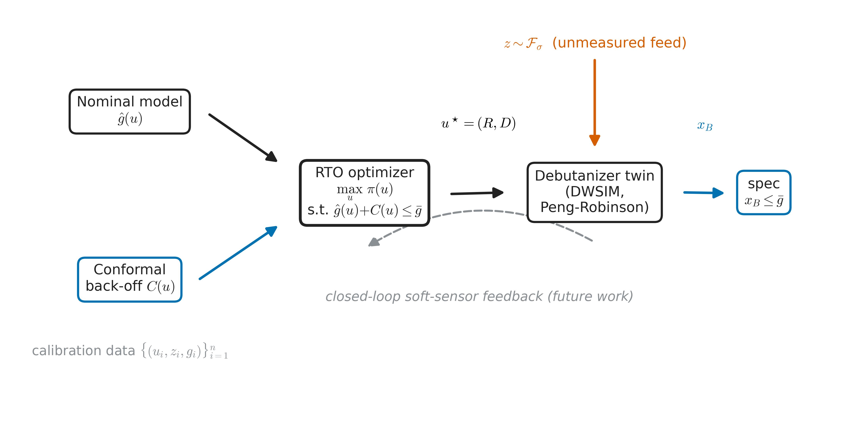
Chance-constrained RTO with a conformal constraint back-off. The nominal model and the back-off feed the optimizer, which sets $\left(R,D\right)$ on the twin. The constrained bottoms composition $x_{B}$ is not measured online; a closed-loop soft-sensor feedback path (grey, dashed) is left to future work. The back-off $C\left(u\right)$ is one of the fixed, normalized, or CQR constructions of Section 2.2; the twin is a nine-stage binary n-butane/n-hexane column.

Process Twin and Experimental Design
The plant is a rigorous DWSIM 9.0.5 model of a debutanizer [16], reduced to the binary n-butane/n-hexane system (light key and stabilized-gasoline proxy) under the Peng-Robinson equation of state [17], with nine equilibrium stages (condenser indexed $0$, reboiler $8$), feed on stage $4$, top pressure $4.7$ bar, a $0.4$ bar column drop, and feed $100$ kmol h$​^{−1}$. The model is driven from Python through DWSIM’s automation interface; a feed-composition campaign over a grid in $\left(z,R,D\right)$ yields the plant evaluations. The binary reduction keeps every twin state checkable against first-principles vapor-liquid equilibrium and matches the soft-sensor physics proxy of the companion work [18].
Two Gaussian-process surfaces stand in for the plant in [eq:backoff]. The truth surface $g\left(u,z\right)=x_{B}\left(R,D,z\right)$ is fit on the full campaign and supplies the realized bottoms composition used to score violations and define the oracle; the nominal surfaces $\hat{g}\left(u\right)$, distillate purity, and reboiler duty are fit on the nominal ($z_{0}=0.35$) sweep and define the optimizer’s model and objective. All GPs use a Matérn-$5/2$ kernel on standardized inputs with a maximum-a-posteriori regularization of the log-hyperparameters and a fixed optimizer seed for reproducibility. Operating profit values the overhead at the light-key (LPG) price and the bottoms at the stabilized-gasoline price, both by mass, less the reboiler energy cost; because gasoline outvalues the light key per unit mass, profit rises as the column rides the bottoms-composition spec from below, making the constraint economically active and the back-off width a direct cost.
We sweep the disturbance magnitude $σ_{z}∈\{0.006,0.010,0.015,0.020,0.025\}$, from the operationally realistic $0.006$ to more than four times that, and for each solve [eq:backoff] with the fixed, normalized, CQR, and oracle back-offs at $α=0.10$. Realized violation is a Monte-Carlo estimate on an independent test disturbance sample; the a-posteriori inflation uses a separate validation sample.

Results

The selection effect is real and large
The normalized back-off, marginally valid and adaptive in width, is the method a soft-sensor interval would supply. Under optimization it realizes a violation of $0.429$ at the realistic disturbance, rising to $0.488$ across the range, roughly five times the $0.10$ target (Fig. 2, Table 1). The optimizer settles in the low-$D$ corner near $R≈2.83$, $D≈33.7$, close to the deterministic optimum, precisely where the adaptive margin under-covers the conditional quantile. The fixed margin over-violates more modestly, between $0.11$ and $0.19$, and becomes infeasible beyond $σ_{z}=0.010$ as the spec back-off it must add exceeds the achievable range. This is Theorem 1 in the data: marginal validity does not transfer to the selected operating point.
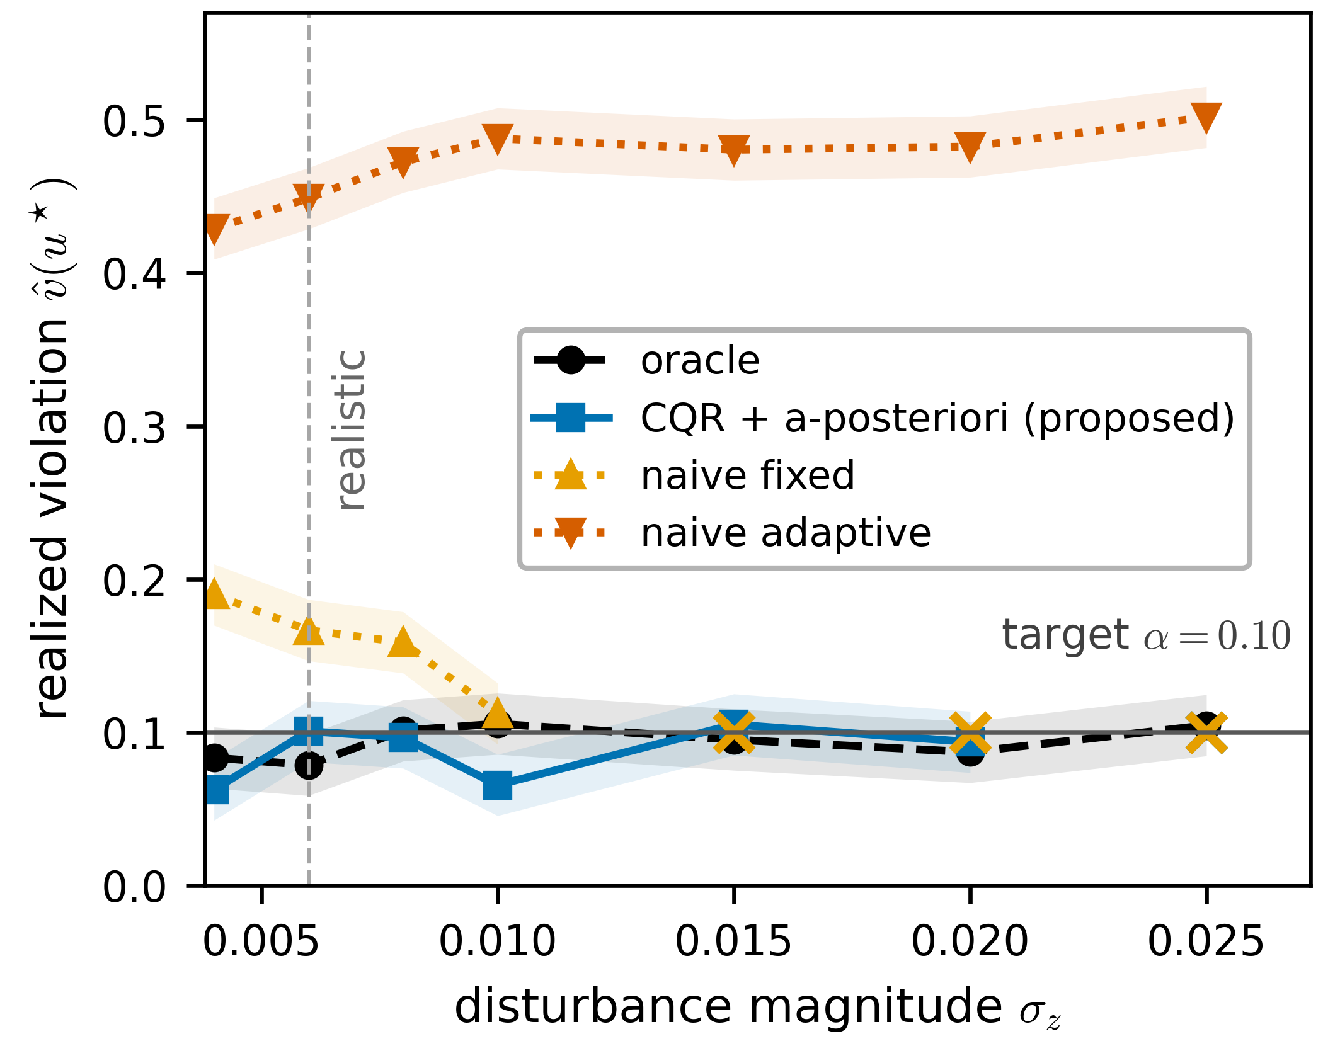
Realized constraint-violation rate versus disturbance magnitude $σ_{z}$ for the four back-offs, with the nominal target $α=0.10$ and the realistic $σ_{z}$ marked. Marginal back-offs (fixed, normalized) violate well above target; CQR with a-posteriori calibration tracks the oracle. Shaded band is the Monte-Carlo uncertainty.

The oracle isolates the cause
The oracle back-off, which knows the true conditional quantile, holds the realized violation at $0.079$ at the realistic disturbance and near $α$ throughout, at a setpoint that backs the column off to $R=3.00$, $D=34.3$. Because the oracle satisfies the chance constraint by construction while the marginal methods do not, the failure lies in the back-off, not in the chance-constrained formulation [eq:chance]. This is the empirical counterpart of the oracle’s role in the theory.

Conditional calibration restores safety at near-oracle profit
The CQR back-off with a-posteriori calibration holds the realized violation between $0.063$ and $0.105$ for $σ_{z}≤0.020$, within about $0.01$ of the target and of the oracle, backing the setpoint from $D≈34.3$ at $σ_{z}=0.006$ to $D≈36.6$ at $σ_{z}=0.020$ as the disturbance grows. Where the conditional quantile alone is slightly optimistic, the a-posteriori step closes the gap: at $σ_{z}=0.006$ an inflation $κ^{⋆}=1.53$ restores the target. This is Theorem 2 in the data, with the CQR construction supplying conditional validity and the a-posteriori step supplying the residual finite-sample correction.

The inflation factor bounds the safe regime
The method is not unconditionally safe, and the inflation factor is the signal (Fig. 3). Because the calibration budget scales with the disturbance ($n_{cal}=1500max\left(1,σ_{z}/0.006\right)$), $κ^{⋆}$ does not climb monotonically; it is near unity where the conditional quantile is adequate, rises where it is locally optimistic ($κ^{⋆}=1.53$ at $σ_{z}=0.006$ and $κ^{⋆}=5.78$ at $σ_{z}=0.015$), and at $σ_{z}=0.025$, more than four times the realistic disturbance, no finite inflation certifies the target and the instance is declared infeasible. Its excursions and the terminal infeasibility both mark where the conditional estimate can no longer certify safety, making data inadequacy a readable property of the method rather than a silent failure, as Corollary 1 predicts.
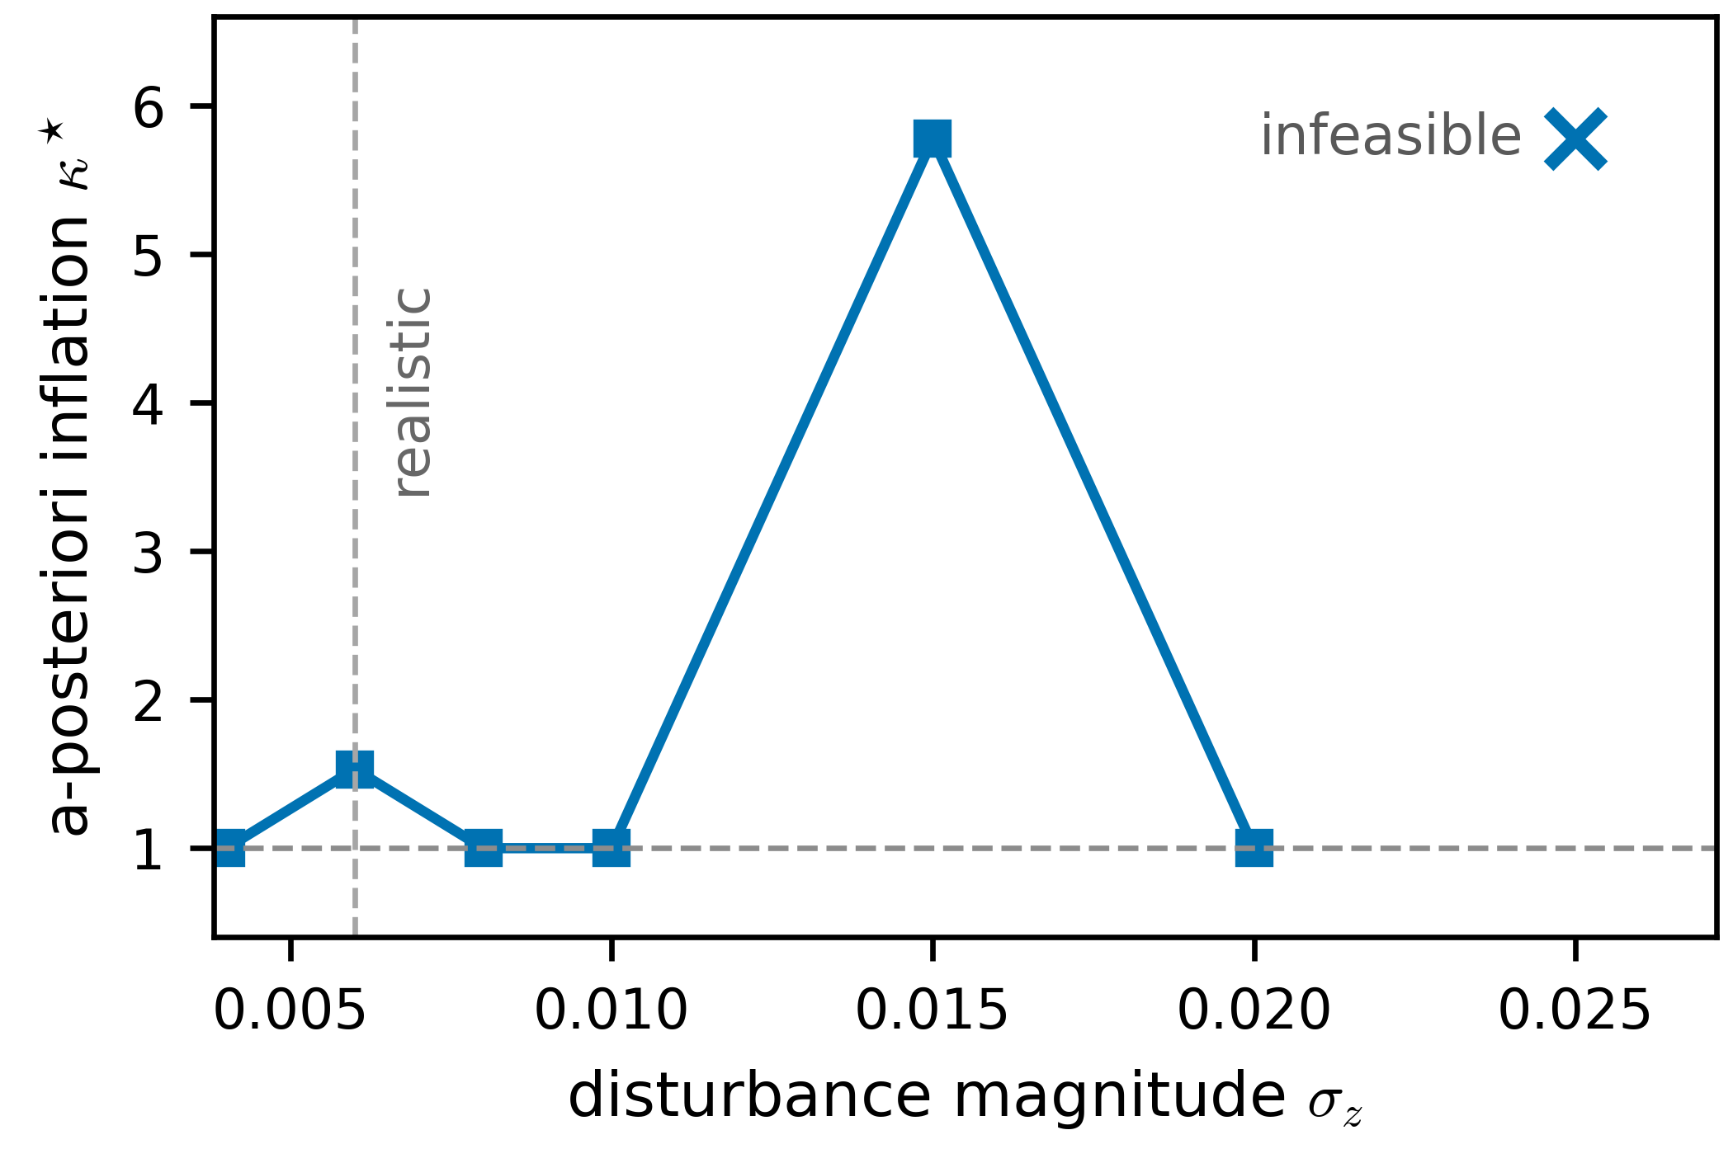
A-posteriori inflation factor $κ^{⋆}$ for the CQR method versus $σ_{z}$. The margin is stretched (rising $κ^{⋆}$) before the method becomes infeasible; the dashed horizontal line marks $κ^{⋆}=1$ (no tightening). This makes $κ^{⋆}$ a data-adequacy diagnostic.

Calibrated safety, not profit
At the realistic disturbance every method lies within half a percent of the deterministic optimum in profit (Table 1); the constraint is barely active there, so there is little profit to separate the methods. The value of the conditional method is therefore the violation it removes, not any profit it adds: it converts a fivefold constraint breach into a calibrated one at negligible economic cost.

Twin validation and reproducibility
The truth surface is validated by leave-one-feed-composition-out interpolation, fitting on all $z≠0.375$ and predicting the held-out $z=0.375$ slice, giving $R^{2}=0.917$ and a mean absolute error of $0.0053$ in $x_{B}$, comfortably below the specification. Monte-Carlo estimation moves individual violation rates by at most $±0.01$ to $0.02$ across platforms while leaving the regime structure, the fivefold failure, and the data-starvation boundary intact.
Regime map over disturbance magnitude $σ_{z}$. For each method: operating profit (USD h$​^{−1}$), realized violation $\hat{v}$, a-posteriori inflation $κ^{⋆}$, and setpoint $\left(R^{⋆},D^{⋆}\right)$. INF denotes an infeasible instance; the realistic disturbance is $σ_{z}=0.006$.
$σ_{z}$ | method | profit | $\hat{v}$ | $κ^{⋆}$ | $R^{⋆}$ | $D^{⋆}$
0.006 | fixed | 5381 | 0.167 | 1.00 | 3.00 | 34.1
 | normalized | 5394 | 0.449 | 1.00 | 2.83 | 33.7
 | CQR | 5376 | 0.101 | 1.53 | 3.00 | 34.3
 | oracle | 5374 | 0.079 | 1.00 | 3.00 | 34.3
0.010 | fixed | 5356 | 0.112 | 1.00 | 2.93 | 34.8
 | normalized | 5396 | 0.488 | 1.00 | 2.93 | 33.7
 | CQR | 5335 | 0.066 | 1.00 | 2.60 | 35.3
 | oracle | 5351 | 0.106 | 1.00 | 2.80 | 34.9
0.015 | fixed | — | INF | — | — | —
 | normalized | 5396 | 0.481 | 1.00 | 3.00 | 33.7
 | CQR | 5298 | 0.105 | 5.78 | 3.00 | 36.2
 | oracle | 5310 | 0.095 | 1.00 | 2.43 | 35.9
0.020 | fixed | — | INF | — | — | —
 | normalized | 5394 | 0.483 | 1.00 | 3.00 | 33.7
 | CQR | 5282 | 0.094 | 1.00 | 2.37 | 36.6
 | oracle | 5288 | 0.087 | 1.00 | 2.20 | 36.5
0.025 | fixed | — | INF | — | — | —
 | normalized | 5396 | 0.502 | 1.00 | 3.00 | 33.7
 | CQR | — | INF | — | — | —
 | oracle | 5271 | 0.105 | 1.00 | 2.23 | 36.9

Discussion

The design rule
The result is narrow in its case study but general in mechanism. Nothing in Theorem 1 is specific to distillation or to feed disturbance: it follows whenever a conformal interval is placed inside an optimization. First, split and normalized conformal back-offs guarantee coverage on average and are unsafe at the optimum. Second, the optimizer is a selection operator, so conditional validity, not marginal validity, is the binding requirement. The portable rule is to size the margin conditionally and to read the a-posteriori inflation as the signal that the data can no longer certify the target.

Limitations
The plant is a simulation twin, rigorous but not a real column; the mechanism is structural and should transfer, but the specific magnitudes are twin-specific. The guarantees of Theorem 2 assume exchangeable calibration (Assumption 1); a real feed stream is autocorrelated and drifts, which breaks exchangeability. The weighted and beyond-exchangeability conformal machinery [11], [13], [14] lifts this assumption and is the route to a plant guarantee under drift; developing it, together with a closed-loop realization in which an online soft sensor supplies the constrained estimate and the disturbance evolves in time, is the natural next step. Finally, the a-posteriori step of part (a) requires an independent calibration draw at the selected point; in deployment this is a held-out window of operating data, and its size sets the residual gap of Theorem 2.

Conclusion
Real-time optimization must subtract a back-off from a quality specification to protect a constraint it cannot measure, and conformal prediction is the natural distribution-free way to size it. We proved that the natural choice is unsafe under optimization: a marginally valid back-off carries no coverage guarantee at the operating point the optimizer selects, a constraint-space winner’s curse. We then proved that conditional calibration restores a finite-sample, distribution-free guarantee, exactly under a-posteriori recalibration and up to an $O\left(\sqrt{d/n}\right)$ term under uniform calibration, and that the required inflation factor is an observable data-adequacy diagnostic. On a rigorous debutanizer twin the theory holds: marginal back-offs realize fivefold violations, the conditional method tracks a plant-aware oracle at near-oracle profit, and the inflation factor bounds the safe operating regime. The mechanism and its remedy apply to any conformal interval used as a hard optimization constraint, which makes conditional calibration a general design requirement for safe data-driven optimization.

Biography

Bien Don Busico was born in Butuan City, Philippines, in 2000. He received the B.S. degree in chemical engineering from Mapua Malayan Colleges Mindanao, Davao City, Philippines, in 2025. He is currently pursuing the M.S. degree in chemical engineering with the University of the Philippines Diliman, Quezon City, Philippines.
He is a board-certified Chemical Engineer and the developer of the Integrated Process Intelligence System (IPIS), an open-source framework for guaranteed-safe, data-driven process operation; its companion modules, including a physics-informed drift-adaptive soft sensor, similarity-calibrated conformal prognostics, and a composed closed-loop coverage certificate, are under review at the Journal of Process Control, Reliability Engineering & System Safety, and Computers & Chemical Engineering. His research interests include distribution-free uncertainty quantification, real-time optimization under uncertainty, and safe data-driven control of process systems.
[1] V. Vovk, A. Gammerman, and G. Shafer, Algorithmic learning in a random world. New York: Springer, 2005.
[2] J. Lei, M. G’Sell, A. Rinaldo, R. J. Tibshirani, and L. Wasserman, “Distribution-free predictive inference for regression,” Journal of the American Statistical Association, vol. 113, no. 523, pp. 1094–1111, 2018.
[3] A. N. Angelopoulos and S. Bates, “A gentle introduction to conformal prediction and distribution-free uncertainty quantification,” Foundations and Trends in Machine Learning, vol. 16, no. 4, pp. 494–591, 2023.
[4] Y. Zhao, X. Yu, M. Sesia, J. V. Deshmukh, and L. Lindemann, “Conformal predictive programming for chance constrained optimization,” arXiv preprint arXiv:2402.07407, 2024.
[5] Y. Romano, E. Patterson, and E. J. Candès, “Conformalized quantile regression,” in Advances in neural information processing systems (NeurIPS), 2019.
[6] A. Marchetti, B. Chachuat, and D. Bonvin, “Modifier-adaptation methodology for real-time optimization,” Industrial & Engineering Chemistry Research, vol. 48, no. 13, pp. 6022–6033, 2009.
[7] B. Chachuat, B. Srinivasan, and D. Bonvin, “Adaptation strategies for real-time optimization,” Computers & Chemical Engineering, vol. 33, no. 10, pp. 1557–1567, 2009.
[8] P. Li, H. Arellano-Garcia, and G. Wozny, “Chance constrained programming approach to process optimization under uncertainty,” Computers & Chemical Engineering, vol. 32, no. 1–2, pp. 25–45, 2008.
[9] E. Bradford, L. Imsland, and E. A. del Río-Chanona, “Nonlinear model predictive control with explicit back-offs for gaussian process state space models,” in Proceedings of the 58th IEEE conference on decision and control (CDC), 2019, pp. 4747–4754.
[10] E. Bradford, L. Imsland, D. Zhang, and E. A. del Río-Chanona, “Stochastic data-driven model predictive control using gaussian processes,” Computers & Chemical Engineering, vol. 139, p. 106844, 2020.
[11] I. Gibbs and E. J. Candès, “Adaptive conformal inference under distribution shift,” in Advances in neural information processing systems (NeurIPS), 2021.
[12] I. Gibbs, J. J. Cherian, and E. J. Candès, “Conformal prediction with conditional guarantees,” arXiv preprint arXiv:2305.12616, 2023.
[13] R. J. Tibshirani, R. Foygel Barber, E. J. Candès, and A. Ramdas, “Conformal prediction under covariate shift,” in Advances in neural information processing systems (NeurIPS), 2019.
[14] R. F. Barber, E. J. Candès, A. Ramdas, and R. J. Tibshirani, “Conformal prediction beyond exchangeability,” Annals of Statistics, vol. 51, no. 2, pp. 816–845, 2023.
[15] Y. Zhang, S. Park, and O. Simeone, “Bayesian optimization with formal safety guarantees via online conformal prediction,” IEEE Journal of Selected Topics in Signal Processing, 2024.
[16] D. W. G. Medeiros, “DWSIM: Open-source chemical process simulator (version 9.0.5).” https://dwsim.org, 2024.
[17] D.-Y. Peng and D. B. Robinson, “A new two-constant equation of state,” Industrial & Engineering Chemistry Fundamentals, vol. 15, no. 1, pp. 59–64, 1976.
[18] B. Busico, “When does a calibrated soft sensor keep its promise? A negative-control study of validity without accuracy under drift and delayed labels,” 2026.

