Chapter 4: High Level Database Models

E/R Diagram, The Entity/Relationship Model

Entities – the objects of the database. For example in a movie database, the movies can represent entities, the actors and stars can be entities, or the studios can be an entity.
Attributes – the attributes are the properties of an entity, such as movies.name or stars.name or studios.name and so on.
Relationships – the connection between two entities. For example, the relationship between movies and actors is that the actors star in the movie.
Diagram Representation
Entities are Rectangles
Attributes are Ovals, Underlined attributes are the KEYs
Relationships are Diamonds
Multiplicity
Many-to-Many – No arrow head
One-to-One – Arrow head on both sides (Studio only has One President, President only runs One Studio). “At most one” and not “Exactly one”
Many-to-One – Arrow head hits the 'One' side (Many employees work in One department)
Exactly-One – Rounded unfilled arrow head
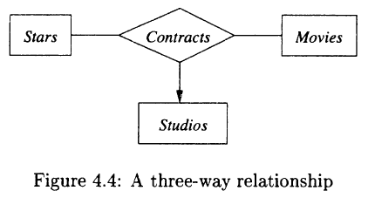
The arrow pointing to entity set Studios indicates that for a particular star and movie, there is only one studio in which the star has contracted for the movie

PAGE 84

