Bee Cha
CSCI 156 (Fall 2015)
Homework 3

P24.

Host A and B are communicating over a TCP connection. Host B received all bytes from host A up through 248 bytes. Host A then sends two segments to host B. First segment contains 40 bytes, second segment contains 60 bytes. First segment has sequence number 249, source port number 503, destination port number 80. Host B sends ACK whenever received segment from host A.

a) In the second segment from host A to host B, what are the sequence number, source port number, and destination port number?

Source port and destination port number stays the same: Source port number: 503, and destination port number: 80. Since the starting sequence number is 249, by sending the first segment, it will increase the number by 40 bytes, then 249 + 40 = 289. Thus the starting sequence number for the second segment is 289.

b) If the first segment arrives before the second segment, in the acknowledgement of the first arriving segment, what is the acknowledgement number, source port number, and destination port number?

Acknowledge number for the first segment will be 249 + 40 = 289. It will then send the acknowledgement back from its source port: 80, to the destination port from where it came from: 503.

c) If the second segment arrives before the first segment, in acknowledgement of the first arriving segment, what is the acknowledgement number?

Well, if it received the second segment before the first segment, it wouldn't know what to do with it. It'll drop the second segment and ask for the sender to resend the segments again. So in this case, the segment number doesn't change as it needs the first segment first. It'll still be acknowledgement number 249.
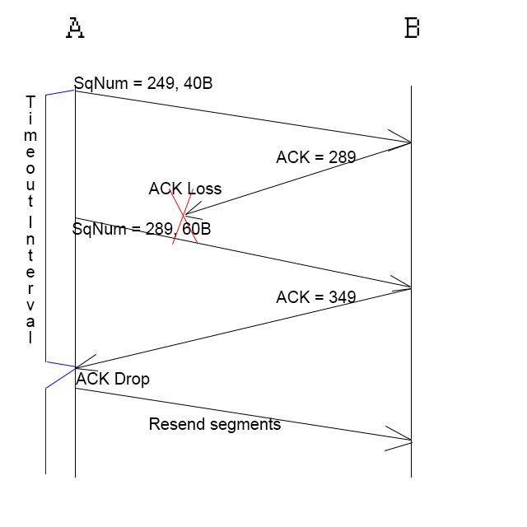
d)

P25.

Host A and B are directly connected with a 200 Mbps link. There is one TCP connection between the two hosts, and Host A is sending to Host B an enormous file over this connection. Host A can send application data into the link at 100 Mbps but Host B can read out of its TCP receive buffer at a maximum rate of 50 Mbps. Describe the effect of TCP flow control.

If we start with host B's buffer being empty, then host A will keep sending packets until the buffer gets full. Host B can only read off from the buffer at 50 Mbps, but host A is sending packets faster than host B can read them off at 100 Mbps. So when the buffer is full, host B will send a signal back to host A telling host A to stop sending packets. When there's room in the buffer, host B will send a signal back to host A to send in more packets.

