- Metodologi
- Study Kelayakan (Feasibility Study)
- Analisa System
- Design System
- Implementasi System
- Dokumentasi
- Maintenance

- Rancangan Anggaran Biaya

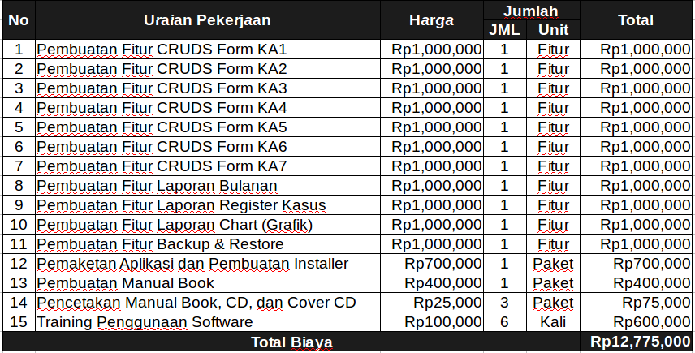
- Jadwal Proyek

