1. **Metodologi**

* **Study Kelayakan (Feasibility Study)**
* **Analisa System**
* **Design System**
* **Implementasi System**
* **Dokumentasi**
* **Maintenance**

1. **Rancangan Anggaran Biaya**

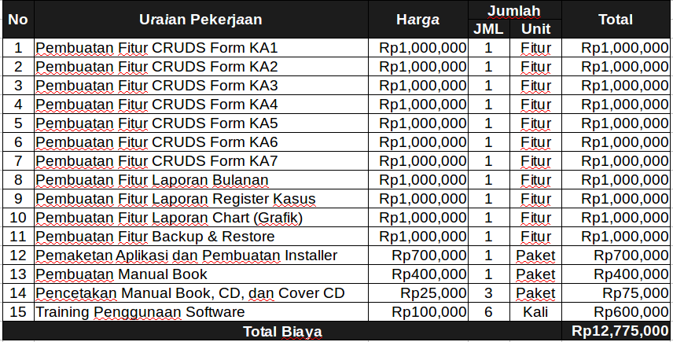

1. **Jadwal Proyek**

