Project 6: Network Monitoring and Alert System
  - SDN (Ryu) + Mininet + UDP telemetry

1. Objective
Build a distributed network-monitoring system in which hosts transmit telemetry over UDP sockets and an SDN controller combines that telemetry with OpenFlow flow/port statistics to detect abnormal conditions and raise alerts.

2. Topology and architecture
h1 (10.0.0.1) --\ /-- h3 (10.0.0.3)
s1 ======10 Mbps====== s2
h2 (10.0.0.2) --/ | \-- h4 (10.0.0.4)
|
root namespace 10.0.0.254
Ryu controller + UDP monitoring server (port 9999)
All links are 10 Mbps (Mininet TCLink), so utilization = bits per second / 10,000,000. Switches are Open vSwitch speaking OpenFlow 1.3 to a Ryu remote controller.
Data paths. (1) Each host agent sends one JSON UDP packet per second (host, sequence number, tx/rx bit rate read from its own NIC counters) to the monitoring server. (2) Every 2 s the controller requests flow and port statistics from both switches. (3) The controller correlates both sources every 2 s.

3. Requirement-to-implementation mapping
Requirement | Implementation
Implement UDP telemetry agents | agent.py (UDP socket, 1 packet/s per host)
Develop a centralized monitoring server | _telemetry_server() in monitor_app.py
Collect SDN flow statistics | _poll_loop(), _flow_reply(), _port_reply() (OFPFlowStats / OFPPortStats)
Calculate traffic utilization | port_util = (byte delta x 8 / interval) / link capacity
Define abnormality thresholds | Constants at the top of monitor_app.py (section 4)
Generate alerts | _alert() prints to console and writes alerts.log
Monitor multiple network nodes | 4 hosts + 2 switches monitored simultaneously
Present monitoring results | Console dashboard, metrics.csv, results.png

4. Thresholds and reasoning
Alert | Condition | Reasoning
HIGH_UTILIZATION | link utilization > 70% | Above ~70% queues build up and latency/loss increase
HOST_SILENT | no telemetry for 6 s | 6 missed 1 s reports means the host or its agent is down, not just jitter
TELEMETRY_LOSS | > 10% sequence-number gaps in last 20 s | Sequence numbers reveal lost UDP packets; 10% separates real loss from noise
HOST_FLOW_MISMATCH | host-reported rate and switch-observed rate differ by > 50% (and above 200 kbps) for 2 consecutive polls | Host says it sends traffic that the switches never see: blackhole or silent drop

5. Test scenarios
Scenario | Action | Expected alert
A | 1 Mbps UDP flow h1 to h4 | none (normal)
B | 9 Mbps UDP flow h1 to h4 | HIGH_UTILIZATION
C | Kill h3’s agent, then restart it | HOST_SILENT, then cleared
D | Drop 80% of h2’s telemetry packets with iptables | TELEMETRY_LOSS, then cleared
E | h1 sends 5 Mbps; drop rule installed on s1 | HOST_FLOW_MISMATCH
Short transient mismatch alerts at the start/end of an iperf run are expected because the host (1 s) and controller (2 s) sampling windows are not aligned.

6. Results

6.1 Graph
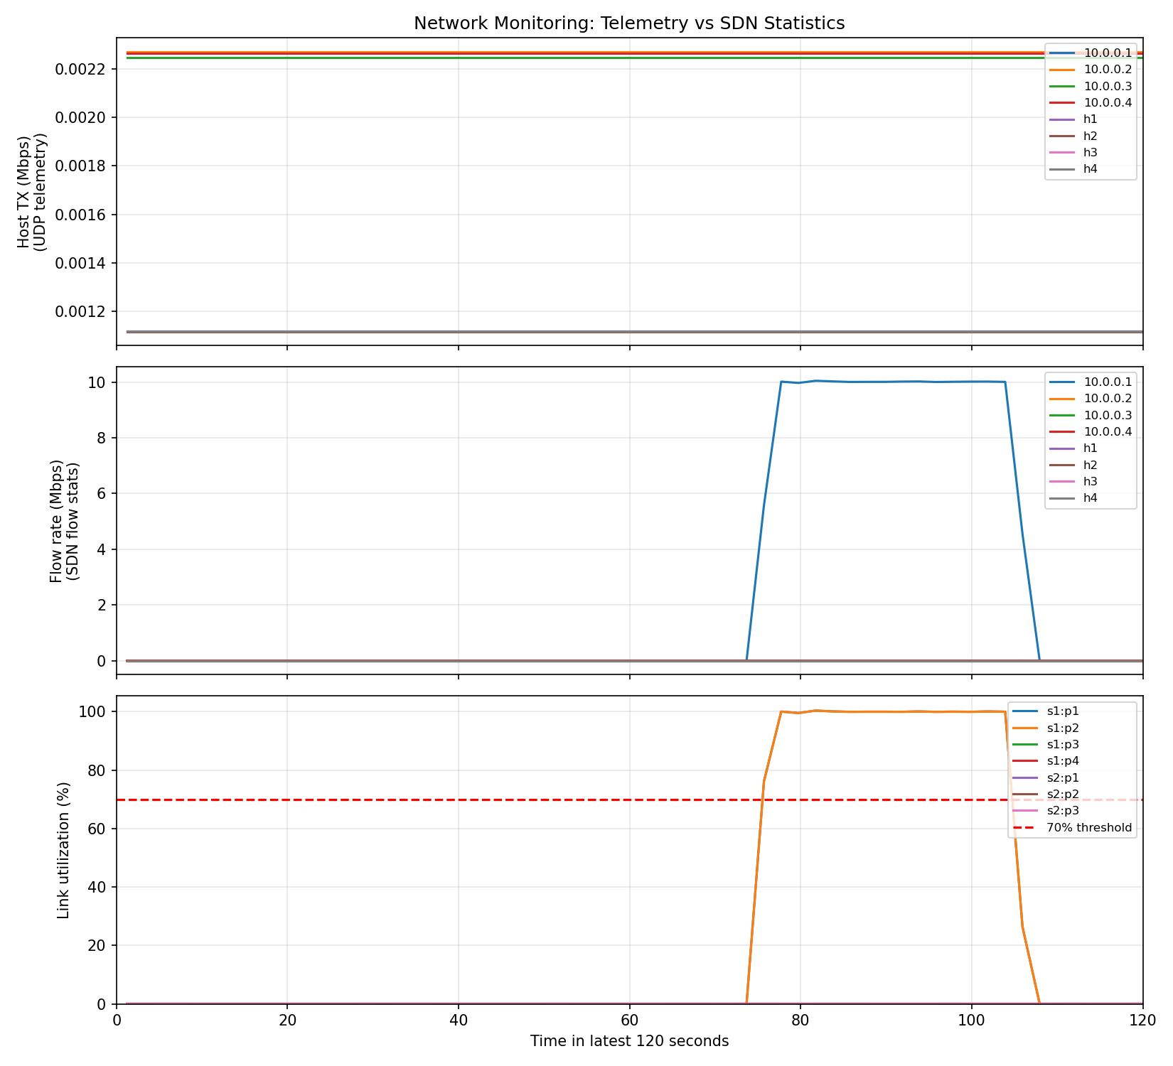
Monitoring results

6.2 Demo timeline (what was triggered, and when)
[DEMO 11:17:49] Agents started; waiting for telemetry to stabilise
[DEMO 11:17:59] SCENARIO A: normal traffic (1 Mbps h1->h4) - expect NO alert
[DEMO 11:18:17] SCENARIO B: congestion (9 Mbps on 10 Mbps links) - expect HIGH_UTILIZATION
[DEMO 11:18:39] SCENARIO C: host h3 agent killed - expect HOST_SILENT after ~6s
[DEMO 11:18:53] SCENARIO C: h3 agent restarted - alert clears
[DEMO 11:19:03] SCENARIO D: 80%% of h2 telemetry dropped - expect TELEMETRY_LOSS
[DEMO 11:19:28] SCENARIO D: telemetry loss removed
[DEMO 11:19:53] SCENARIO E: blackhole h1->h4 at s1 while h1 sends 5 Mbps - expect HOST_FLOW_MISMATCH
[DEMO 11:20:03] SCENARIO E: drop rule installed on s1
[DEMO 11:20:21] SCENARIO E: drop rule removed
[DEMO 11:20:41] DEMO FINISHED

6.3 Alerts generated by the monitor (alerts.log)
[11:18:19] ALERT HIGH_UTILIZATION switch s1 port 1 at 83%
[11:18:19] ALERT HIGH_UTILIZATION switch s1 port 3 at 83%
[11:18:19] ALERT HIGH_UTILIZATION switch s2 port 2 at 83%
[11:18:19] ALERT HIGH_UTILIZATION switch s2 port 3 at 83%
[11:18:34] CLEARED util 1 1
[11:18:34] CLEARED util 1 3
[11:18:34] CLEARED util 2 2
[11:18:34] CLEARED util 2 3
[05:51:17] ALERT HIGH_UTILIZATION switch s1 port 1 at 96%
[05:51:17] ALERT HIGH_UTILIZATION switch s1 port 2 at 96%
[05:51:27] CLEARED util 1 1
[05:51:27] CLEARED util 1 2
[06:27:00] ALERT HIGH_UTILIZATION switch s2 port 1 at 76%
[06:27:00] ALERT HIGH_UTILIZATION switch s2 port 2 at 76%
[06:27:06] CLEARED util 2 1
[06:27:06] CLEARED util 2 2
[06:43:31] ALERT HOST_SILENT h2 sent no telemetry for >6s
[06:43:31] ALERT HOST_SILENT h4 sent no telemetry for >6s
[06:43:31] ALERT HOST_SILENT h1 sent no telemetry for >6s
[06:43:31] ALERT HOST_SILENT h3 sent no telemetry for >6s
[06:47:53] ALERT HOST_SILENT h2 sent no telemetry for >6s
[06:47:53] ALERT HOST_SILENT h4 sent no telemetry for >6s
[06:47:53] ALERT HOST_SILENT h1 sent no telemetry for >6s
[06:47:53] ALERT HOST_SILENT h3 sent no telemetry for >6s
[06:52:48] ALERT HOST_SILENT h2 sent no telemetry for >6s
[06:52:48] ALERT HOST_SILENT h4 sent no telemetry for >6s
[06:52:48] ALERT HOST_SILENT h1 sent no telemetry for >6s
[06:52:48] ALERT HOST_SILENT h3 sent no telemetry for >6s
[06:58:17] ALERT HOST_SILENT h2 sent no telemetry for >6s
[06:58:17] ALERT HOST_SILENT h4 sent no telemetry for >6s
[06:58:17] ALERT HOST_SILENT h1 sent no telemetry for >6s
[06:58:17] ALERT HOST_SILENT h3 sent no telemetry for >6s
[14:43:27] ALERT HOST_SILENT h2 sent no telemetry for >6s
[14:43:27] ALERT HOST_SILENT h4 sent no telemetry for >6s
[14:43:27] ALERT HOST_SILENT h1 sent no telemetry for >6s
[14:43:27] ALERT HOST_SILENT h3 sent no telemetry for >6s
[14:50:32] ALERT HOST_SILENT h2 sent no telemetry for >6s
[14:50:32] ALERT HOST_SILENT h4 sent no telemetry for >6s
[14:50:32] ALERT HOST_SILENT h1 sent no telemetry for >6s
[14:50:32] ALERT HOST_SILENT h3 sent no telemetry for >6s
[14:58:09] ALERT HOST_SILENT h2 sent no telemetry for >6s
[14:58:09] ALERT HOST_SILENT h4 sent no telemetry for >6s
[14:58:09] ALERT HOST_SILENT h1 sent no telemetry for >6s
[14:58:09] ALERT HOST_SILENT h3 sent no telemetry for >6s
[15:36:15] ALERT HOST_SILENT h2 sent no telemetry for >6s
[15:36:15] ALERT HOST_SILENT h4 sent no telemetry for >6s
[15:36:15] ALERT HOST_SILENT h1 sent no telemetry for >6s
[15:36:15] ALERT HOST_SILENT h3 sent no telemetry for >6s
[16:05:11] ALERT HOST_SILENT h2 sent no telemetry for >6s
[16:05:11] ALERT HOST_SILENT h4 sent no telemetry for >6s
[16:05:11] ALERT HOST_SILENT h1 sent no telemetry for >6s
[16:05:11] ALERT HOST_SILENT h3 sent no telemetry for >6s
[16:14:36] ALERT HOST_SILENT h2 sent no telemetry for >6s
[16:14:36] ALERT HOST_SILENT h4 sent no telemetry for >6s
[16:14:36] ALERT HOST_SILENT h1 sent no telemetry for >6s
[16:14:36] ALERT HOST_SILENT h3 sent no telemetry for >6s
[16:18:55] ALERT HOST_SILENT 10.0.0.3 sent no telemetry for >6s
[16:18:55] ALERT HOST_SILENT 10.0.0.4 sent no telemetry for >6s
[16:18:56] ALERT HOST_SILENT 10.0.0.1 sent no telemetry for >6s
[16:18:56] ALERT HOST_SILENT 10.0.0.2 sent no telemetry for >6s
[09:38:18] ALERT HOST_SILENT h2 sent no telemetry for >6s
[09:38:18] ALERT HOST_SILENT h4 sent no telemetry for >6s
[09:38:18] ALERT HOST_SILENT h1 sent no telemetry for >6s
[09:38:18] ALERT HOST_SILENT h3 sent no telemetry for >6s
[09:38:18] ALERT HOST_SILENT 10.0.0.3 sent no telemetry for >6s
[09:38:18] ALERT HOST_SILENT 10.0.0.4 sent no telemetry for >6s
[09:38:18] ALERT HOST_SILENT 10.0.0.1 sent no telemetry for >6s
[09:38:18] ALERT HOST_SILENT 10.0.0.2 sent no telemetry for >6s
[09:46:30] ALERT HOST_SILENT h2 sent no telemetry for >6s
[09:46:30] ALERT HOST_SILENT h4 sent no telemetry for >6s
[09:46:30] ALERT HOST_SILENT h1 sent no telemetry for >6s
[09:46:30] ALERT HOST_SILENT h3 sent no telemetry for >6s
[09:46:30] ALERT HOST_SILENT 10.0.0.3 sent no telemetry for >6s
[09:46:31] ALERT HOST_SILENT 10.0.0.4 sent no telemetry for >6s
[09:46:31] ALERT HOST_SILENT 10.0.0.1 sent no telemetry for >6s
[09:46:31] ALERT HOST_SILENT 10.0.0.2 sent no telemetry for >6s
[09:48:43] CLEARED down 10.0.0.4
[09:48:47] CLEARED down 10.0.0.3
[09:48:53] CLEARED down 10.0.0.2
[09:48:59] CLEARED down 10.0.0.1
[09:50:48] ALERT HIGH_UTILIZATION switch s1 port 1 at 79%
[09:50:48] ALERT HIGH_UTILIZATION switch s1 port 2 at 78%
[09:51:19] CLEARED util 1 1
[09:51:19] CLEARED util 1 2
[09:51:19] ALERT HOST_FLOW_MISMATCH 10.0.0.1 reports 0.00 Mbps but switches see 4.72 Mbps (possible drop/blackhole)
[09:51:21] CLEARED mm 10.0.0.1
[09:52:05] ALERT HIGH_UTILIZATION switch s1 port 1 at 77%
[09:52:05] ALERT HIGH_UTILIZATION switch s1 port 2 at 77%
[09:52:35] CLEARED util 1 1
[09:52:35] CLEARED util 1 2
[09:52:35] ALERT HOST_FLOW_MISMATCH 10.0.0.1 reports 0.00 Mbps but switches see 2.36 Mbps (possible drop/blackhole)
[09:52:37] CLEARED mm 10.0.0.1
[09:54:22] ALERT HOST_SILENT 10.0.0.1 sent no telemetry for >6s
[09:54:24] ALERT HOST_SILENT 10.0.0.3 sent no telemetry for >6s
[09:54:24] ALERT HOST_SILENT 10.0.0.4 sent no telemetry for >6s
[09:54:24] ALERT HOST_SILENT 10.0.0.2 sent no telemetry for >6s
[09:56:41] ALERT HIGH_UTILIZATION switch s1 port 1 at 101%
[09:56:41] ALERT HIGH_UTILIZATION switch s1 port 2 at 101%
[09:58:09] CLEARED util 1 1
[09:58:09] CLEARED util 1 2
[10:32:30] ALERT HOST_SILENT h2 sent no telemetry for >6s
[10:32:30] ALERT HOST_SILENT h4 sent no telemetry for >6s
[10:32:30] ALERT HOST_SILENT h1 sent no telemetry for >6s
[10:32:30] ALERT HOST_SILENT h3 sent no telemetry for >6s
[10:32:30] ALERT HOST_SILENT 10.0.0.3 sent no telemetry for >6s
[10:32:30] ALERT HOST_SILENT 10.0.0.4 sent no telemetry for >6s
[10:32:30] ALERT HOST_SILENT 10.0.0.1 sent no telemetry for >6s
[10:32:30] ALERT HOST_SILENT 10.0.0.2 sent no telemetry for >6s
[10:33:49] ALERT HIGH_UTILIZATION switch s1 port 1 at 76%
[10:33:49] ALERT HIGH_UTILIZATION switch s1 port 2 at 76%
[10:34:19] CLEARED util 1 1
[10:34:19] CLEARED util 1 2

6.4 Sample of the console dashboard (results/ryu_output.txt)
=== 11:17:45 ===
HOST TX Mbps RX Mbps FLOW Mbps LOSS %
=== 11:17:47 ===
HOST TX Mbps RX Mbps FLOW Mbps LOSS %
=== 11:17:49 ===
HOST TX Mbps RX Mbps FLOW Mbps LOSS %
=== 11:17:51 ===
HOST TX Mbps RX Mbps FLOW Mbps LOSS %
=== 11:17:53 ===
HOST TX Mbps RX Mbps FLOW Mbps LOSS %
=== 11:17:55 ===
HOST TX Mbps RX Mbps FLOW Mbps LOSS %
=== 11:17:57 ===
HOST TX Mbps RX Mbps FLOW Mbps LOSS %
=== 11:17:59 ===
HOST TX Mbps RX Mbps FLOW Mbps LOSS %
=== 11:18:01 ===
HOST TX Mbps RX Mbps FLOW Mbps LOSS %
link s1 port 1 utilization: 9.0%
link s1 port 3 utilization: 9.0%
link s2 port 2 utilization: 9.0%
link s2 port 3 utilization: 9.0%
--
=== 11:18:03 ===
HOST TX Mbps RX Mbps FLOW Mbps LOSS %
link s1 port 1 utilization: 10.8%
link s1 port 3 utilization: 10.8%
link s2 port 2 utilization: 10.8%
link s2 port 3 utilization: 10.8%
--
=== 11:18:05 ===
HOST TX Mbps RX Mbps FLOW Mbps LOSS %
link s1 port 1 utilization: 10.8%
link s1 port 3 utilization: 10.9%
link s2 port 2 utilization: 10.8%
link s2 port 3 utilization: 10.9%
--
=== 11:18:07 ===
HOST TX Mbps RX Mbps FLOW Mbps LOSS %
link s1 port 1 utilization: 10.8%
link s1 port 3 utilization: 10.8%

