***Exp-6 Design an obstacle detector and distance measuring device.***

**Circuit diagram**

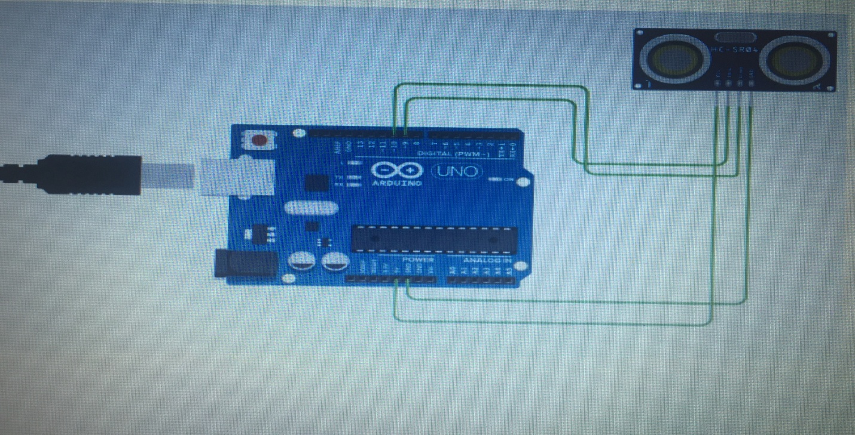

***Concept Used :-*** This experiment shows how does the obstacle detector works. The obstacle detector works on the principle of transmitting and receiving the Ultrasonic signal, and calculating the distance by measuring the time between transmitting and receiving the signal.

***Learning and Observations :-***

1. Connection between the arduino and Ultrasonic signal transmitter IC

2. Concept of calculation of distance on the basis of signal transmission

and receiving.

3. Coding to be done for Arduino.

4. Basic understanding of Electrical Connections.

5. What’s inside the Ultrasonic Signal Transmitter IC.

***Problems & Troubleshooting:-***

* *The circuit was not getting closed as the wires were not connected properly so I made sure that the connections were made properly.*
* *The required pattern was not getting created because of some error in the code so I had to change the code as per requirement.*
* *We have to take at least 4 tries to find the right amount of delay so that one LED glows for the correct time interval .*
* *At first the LED was not working properly so we had to change and put a new LED in its place.*
* *Proper closing of while using loops in the code.*

***Precautions:***

1. Making correct connection

2. Using multimeter to check whether the devices are damaged or not.

3. Correct sets of instructions to be passed to successfully execute the

experiment.

4. Port selection for Arduino.

***Learning Outcomes:-***

1. Setting up correct connection.

2. Connecting Arduino and the Ultrasonic signal Transmitter.

3. Concept of distance measuring using the Ultrasonic Signal. 4. Working & Coding of Arduino.

***Result :-*** The whole Setup executed successfully and is ready to be used.