Quick PT Clinic Application Guide

1. Schedule Appointments – On Patient Profile

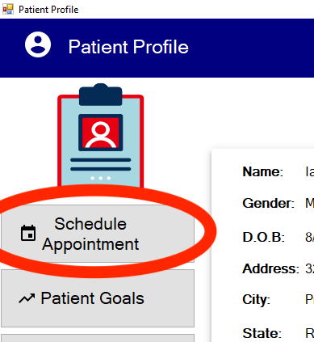

* This part of the application is merely a way for you to print a receipt for the patient for any upcoming appointments. When you schedule an appointment, be aware that this has no bearing as to how the application will work/flow.

2. Saving Partially Completed Visit Information

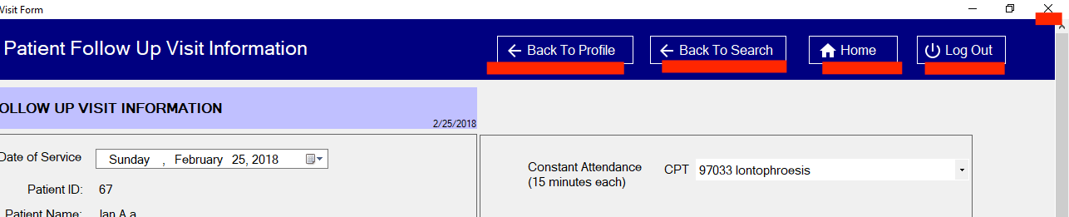

* When you’re filling out the initial or follow up visit forms and would like to save what you’ve entered so far, simply click any of the navigation buttons at the top of the form screen (Depicted above). When you come back to the visit form you’ll be able to pick up where you left off.
* Note that if form is not complete before you see the patient again, there may be issues with how you may expect the program to run. For instance if the initial visit form was never completed, and you “Patient Visit” on the profile page, expecting to fill out the “follow up” visit form, you will be met with an incomplete “Initial” visit form. To rectify this follow the steps below.

2. Completing Initial/Follow-Up Visit Forms

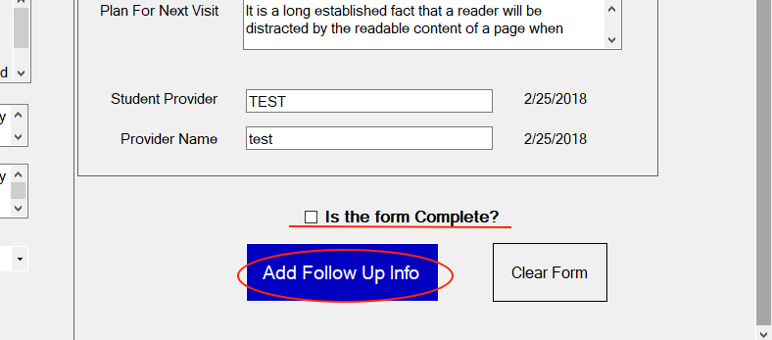

* At the bottom right corner of all visit forms you will see a checkbox stating “Is the form Complete?” Please check this off after you’ve reviewed the page ensuring all the fields have been completed. There are no validations in place to ensure all the form fields are completed, so this is the only way for the program to complete the form and provide new visit forms in the future.

Steps to Complete form

1. Check off “Is the form complete?” checkbox
2. Click the “Add Visit Info” or “Add Follow Up Info” button
3. You should be prompted with a success message in green stating the form was saved
4. Print form if needed (only on Follow Up Form)

2. Printing Follow-Up Visit Information

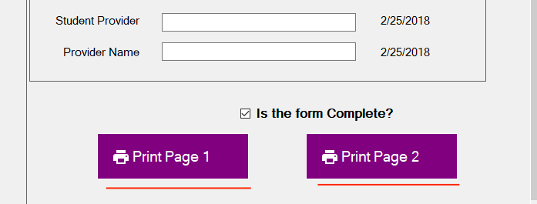

* After you’ve completed the follow up visit record two print buttons will appear at the bottom right hand corner. Unfortunately at this state you will have to print both Page 1 and Page 2 separately due to constraints within the print format of the program. Simply click both buttons and you will be prompted with a print dialog to print all form fields from the page.