AWS – Project management in the Cloud
Learning Outcomes
At the end of this practical lesson, students will be able to:
- Setup VPC Public and Private Network
- Setup AWS EC2 Instances
- Setup Active Directory Domain Controller in Domain Server
- Create different users under the domain
- Allow client to join Domain Server
- Allow non-administrators to use Remote Desktop Services on user logon

Topology Diagram Overview
VPC

d
1b private 10.0.2.0/24

EC2

Domain Server (1bs)

10.0.2.200

EC2

Internal Host (1bh)

10.0.2.42

S
1a public 10.0.3.0/24
NAT

EC2

Bastion Host 2 (1bh2)

10.0.3.104
EC2

Bastion Host 1 (1ah1)

10.0.3.28

- Setup VPC Public and Private Network
Step 1: Search for the "VPC" service in the search box located at the top left corner of the screen.
Step 2: From the left sidebar, select "Your VPCs" to access the VPC management dashboard.
Step 3: Click on "Create VPC" on the right side of the screen.
Step 4: Refer to Figure 1 (provided below) and follow the instructions to create your VPC.
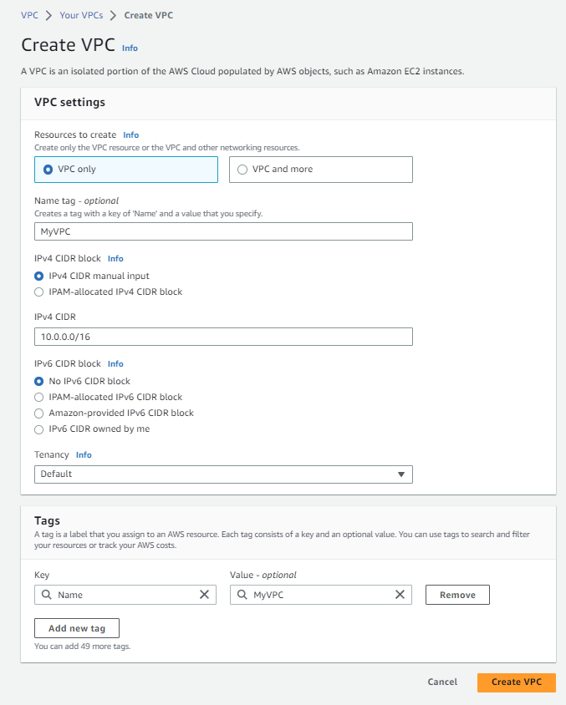 Figure 1
Step 5: To create subnets and associate them with your VPC ("MyVPC"), select "Subnets" from the left sidebar and click on "Create subnet" on the right side of the screen. Follow Figure 2, 3, and 4 (provided below) to create the desired subnets.
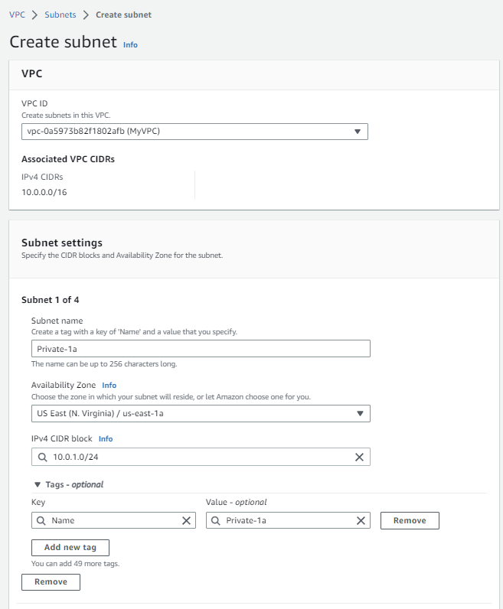 Figure 2 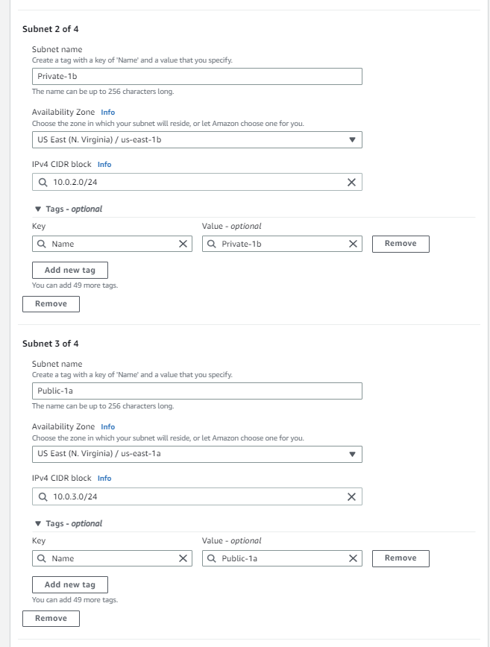 Figure 3
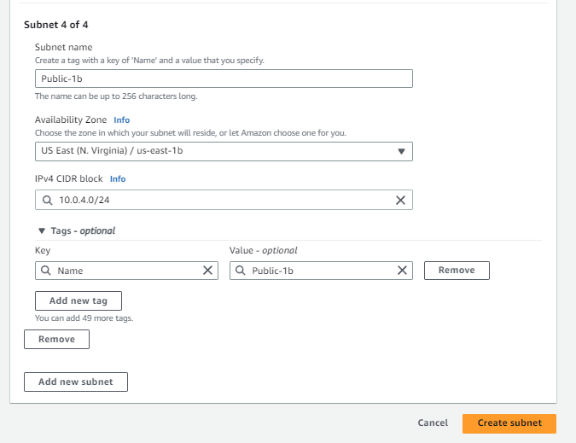 Figure 4

Step 6: Enable "Auto-assign" for public IPv4 addresses in the "Public-1a" and "Public-1b" subnets. Check the box next to "Public-1a" and click on "Create subnet" -> "Edit subnet settings." Check the "Enable auto-assign public IPv4 address" box. Repeat the same process for the "Public-1b" subnet.
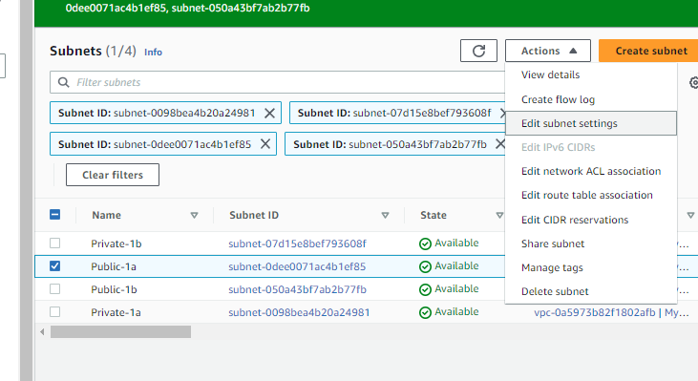
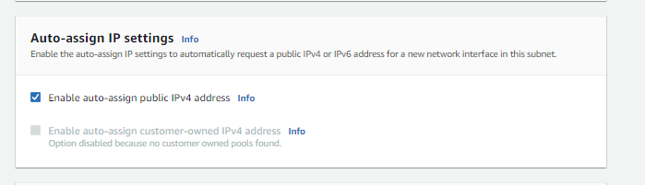
Step 7: Create an internet gateway for your VPC ("MyVPC"). Select "Internet gateways" from the left sidebar and click on "Create internet gateway" on the right side of the screen. Follow Figure 5, 6, and 7 (provided below) to create the internet gateway.
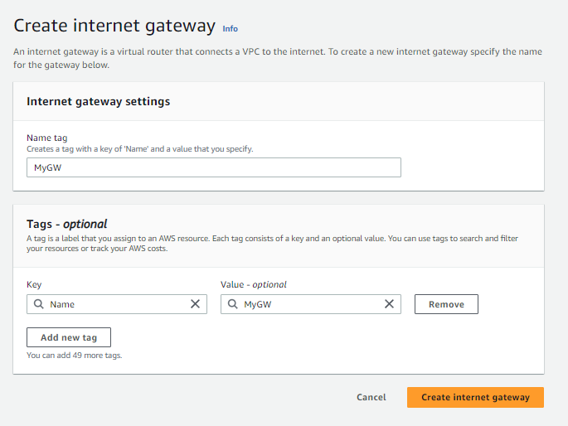 Figure 5 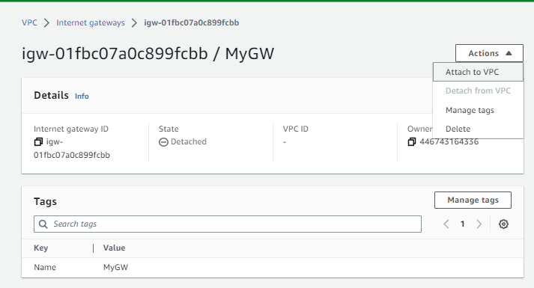 Figure 6
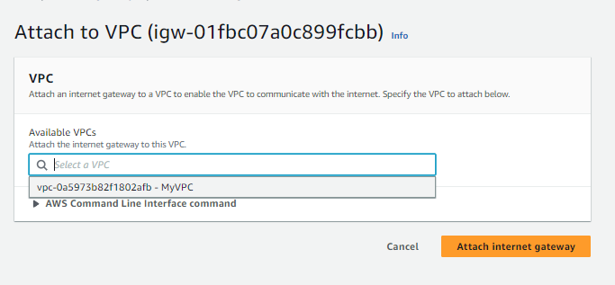 Figure 7

Step 8: To route vpc public subnet to the internet, select “Route tables” at the left sidebar and select the route that is linked with “MyVPC” and select “Edit routes” at the bottom right of the screen Follow Figure8,9 which is provided below to add in an “anywhere” route for IPv4
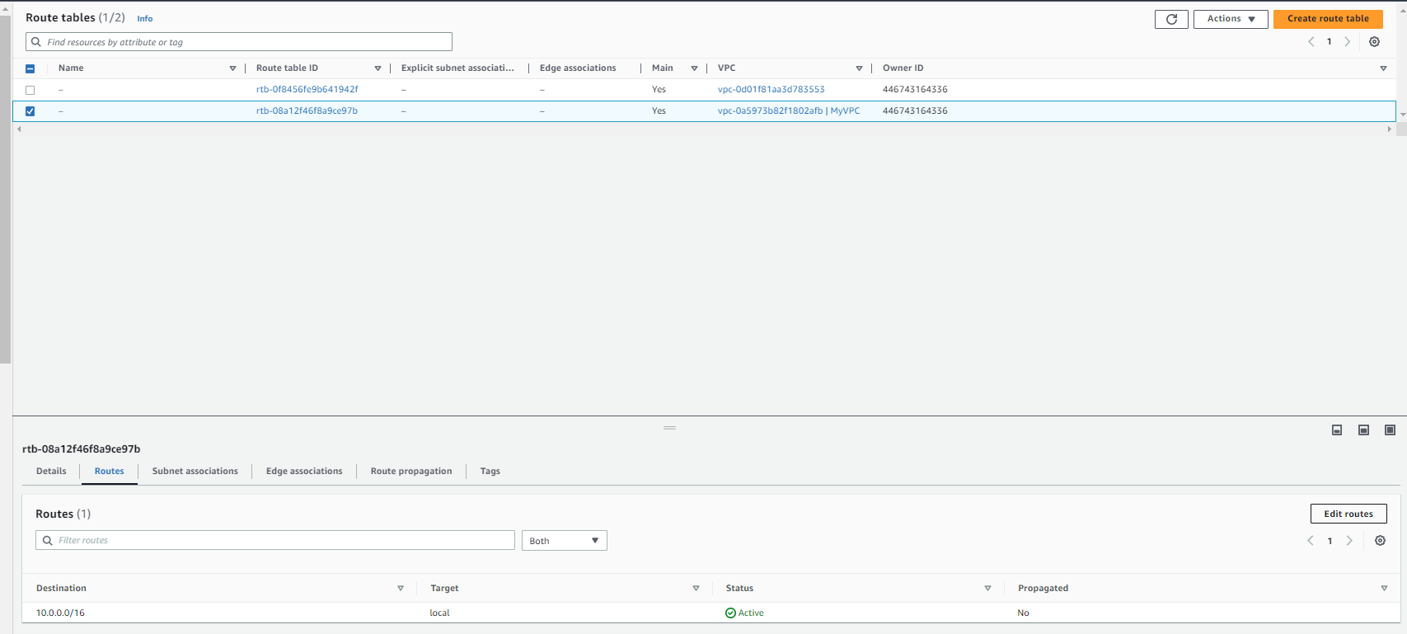
Figure 8
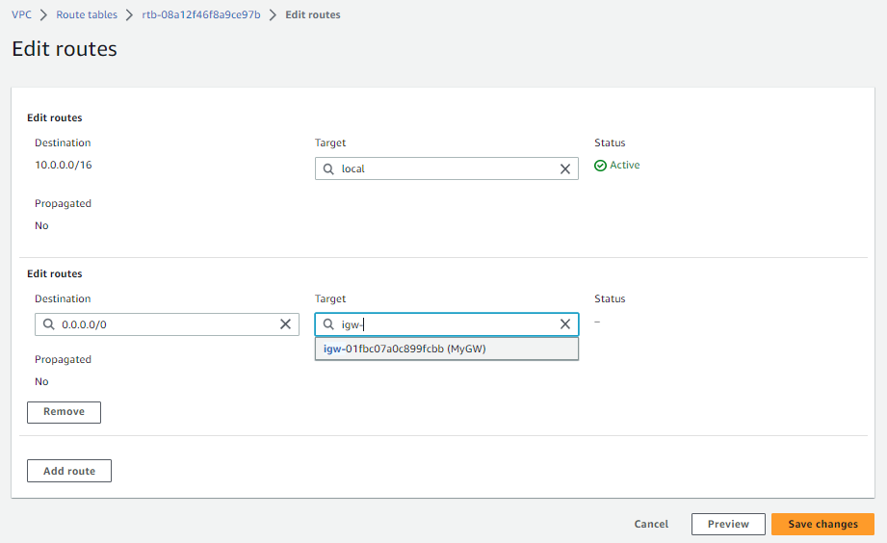
Figure 9

Step 9: To route the vpc private subnet separately, select “Route tables” at the left sidebar and click “Create route table” at the right side of your screen. Follow Figure10, 11 and 12 which is provided below.
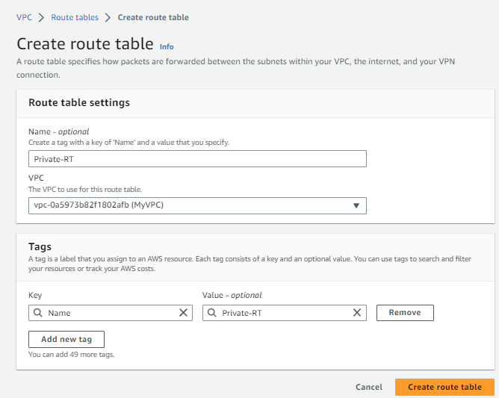 Figure 10
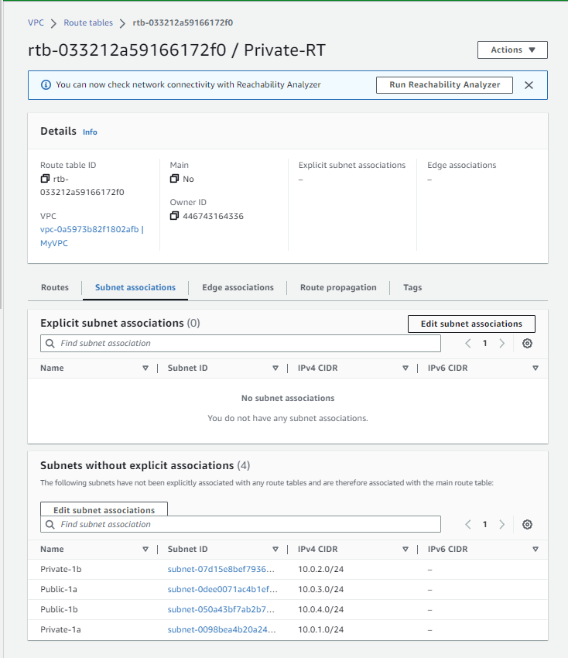 Figure 11
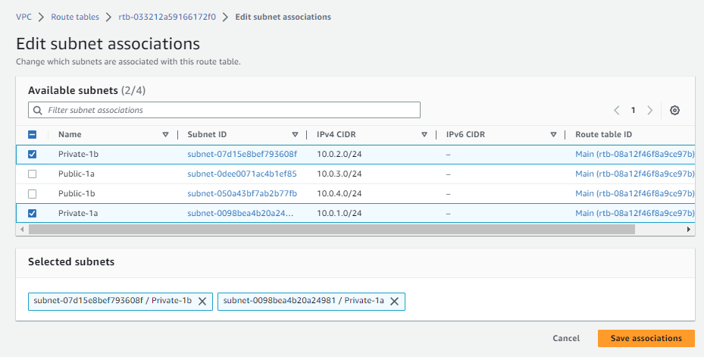 Figure 12

Step 10: to create a NAT gateway for “Public-1a”, select “NAT gateways” at the left sidebar and click “Create NAT gateway” at the right side of your screen. Follow Figure13 which is provided below.
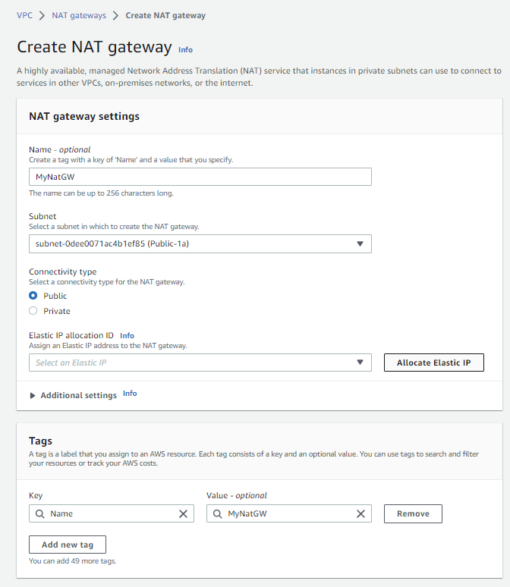 Figure 13 (Follow and click “allocate elastic ip”, wait for a while and the ip for elastic ip allocation will appear in the box. Click “Create NAT gateway” only after an IP is displayed)

Step 11: To allow Private address to be NAT to any destination, select “Edit routes” at the bottom right after selecting “NAT gateways” at the left sidebar and choose “Private-RT”. Follow Figure 14,15 which is provided below.
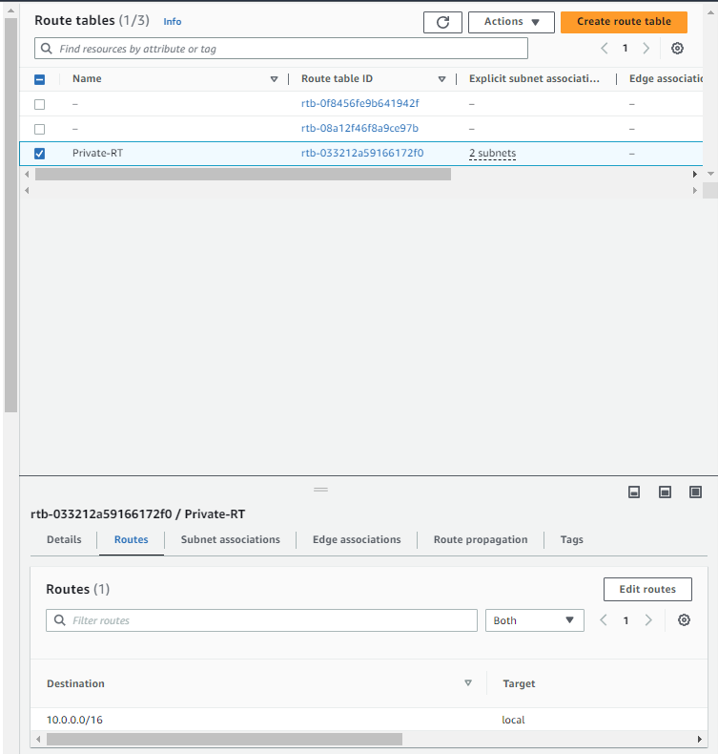 Figure 14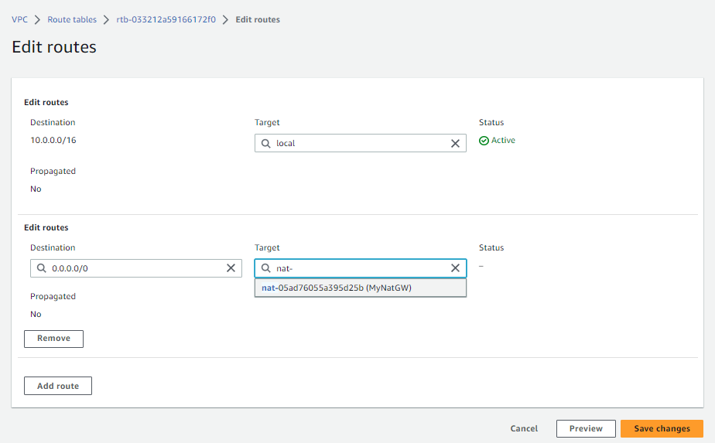 Figure 15

- Setup AWS EC2 Instances
Step 1: in the search bar at the left of your screen search and select “EC2”.

Step 2: at the left sidebar, scroll down and click on “Network & Security” dropdown button. Select “Security Groups” and create 3 Security Groups, name each group as “SecureDomain”, “SecureBastionHost” and “SecureInternalHost” for “MyVPC” network in the VPC box. Set Inbound and outbound rule to allow all traffic.

Step 3: at the left sidebar, click on “Instances” dropdown button and select “Instances” to create 4 instances. Click on “Launch instances” and name the five hosts as “Bastion Host 1”, “Bastion Host 2”, “DomainServer” and “Internal Host”. (Refer to Setup AWS Services documentation on how to create a single instance)

Step 4: Select “Windows Microsoft” as your Amazon Machine Image Operating System

Step 5: Under Key pair (login) select “Create new key pair”. Key pair name as “MyKeyPairs”, file format as ‘.pem’. and click “Create key pair”. You will see that a file has been downloaded.
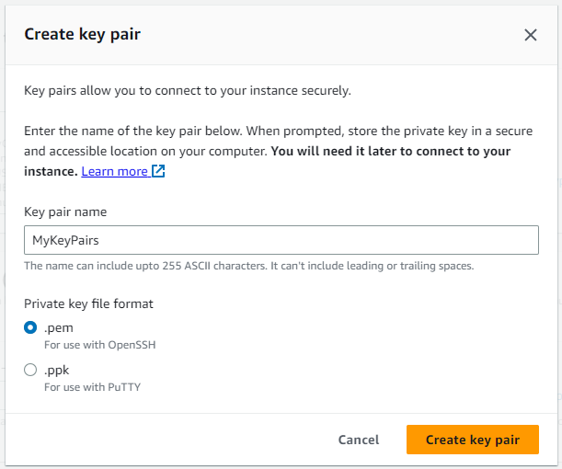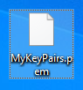

Step 6: click “Edit” beside “Network settings” info dropdown

Step 7: Select “Select existing security group”. Click on the dropdown button and select “SecureDomain”, “SecureBastionHost”, “SecureInternalHost” security groups for each instances respectively. (Take note of the 3 pictures below to edit the network settings for step 5 and 6)
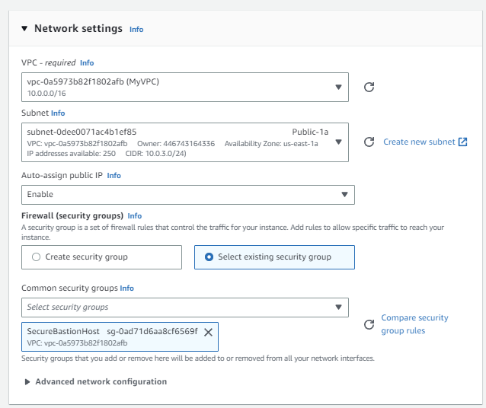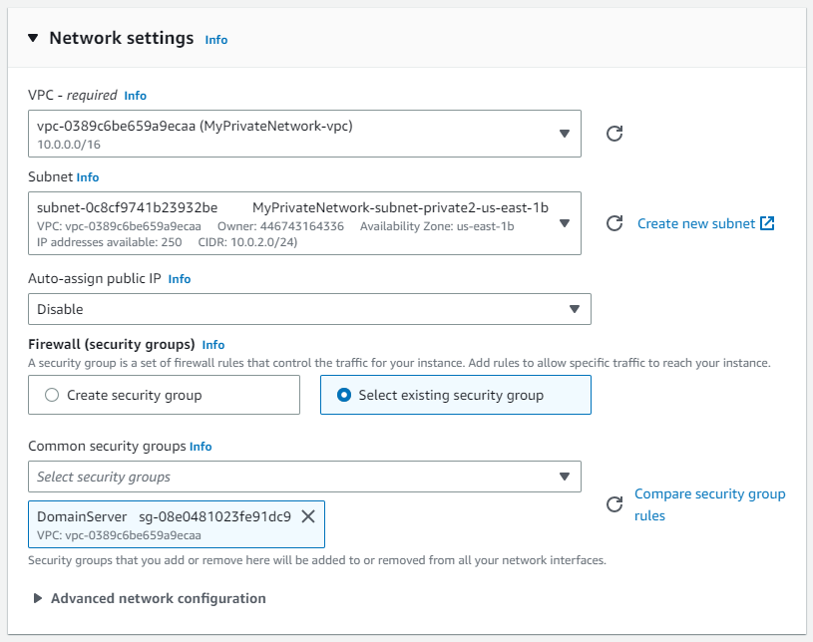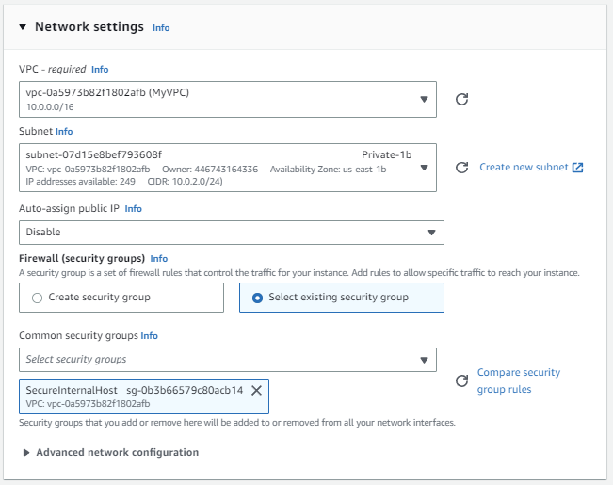
Select “Launch instance” on the right of the screen to initate the instance creation process.
- Setup Active Directory Domain Controller in Domain Server
Step 1: Log in to Bastion Host 1 (1bh1) to access the Domain Server and Bastion Host 2 (1bh2) to access the Internal Host. For Bastion Host 1 (1bh1) EC2 instance, use Remote Desktop Connection(rdp) to connect to the Domain Server (1bs) since the Bastion Host is in the same network as the Domain Server. Copy the private IP address of the Domain Server from the details of the Domain Server EC2 instance in AWS and paste it into the Remote Desktop Connection(rdp) box. Click "Connect" to establish the connection.
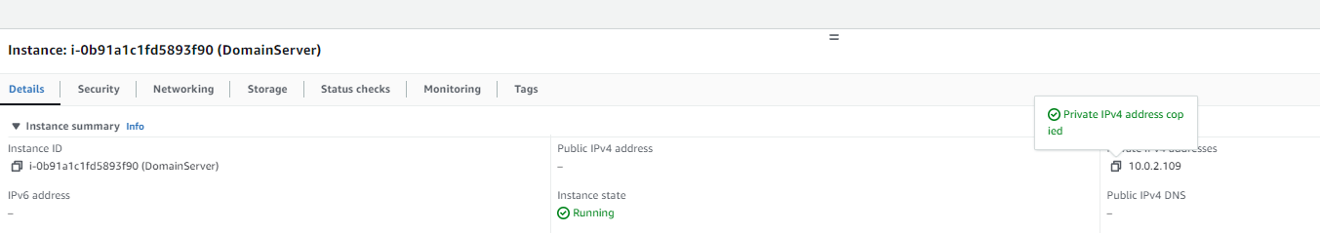

And paste in the box and connect
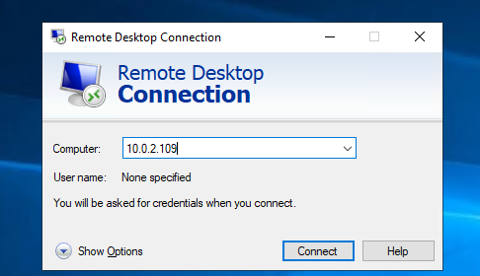

Step 2: use the password that is decrypted from the “.pem” key for domain server ec2 and connect by clicking yes afterwards
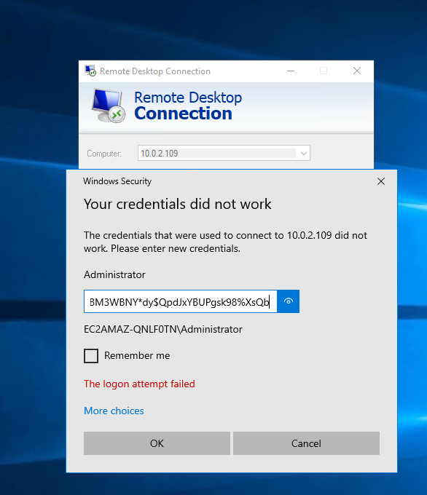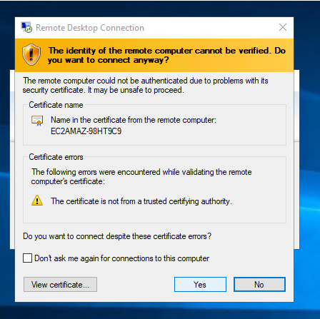

The bastion host is now in the rdp of domain server
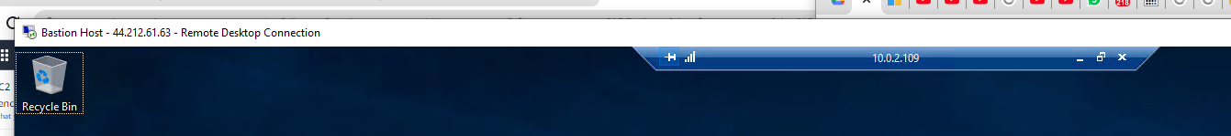

Step 3: open “Server Manager” software install AD Domain service by clicking “Add Roles and Features”. In server role, tick “Active Directory Domain Services”. Follow Figure 16,17,18 which is provided below.
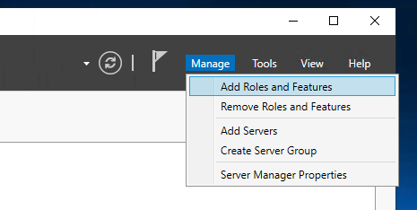 Figure 16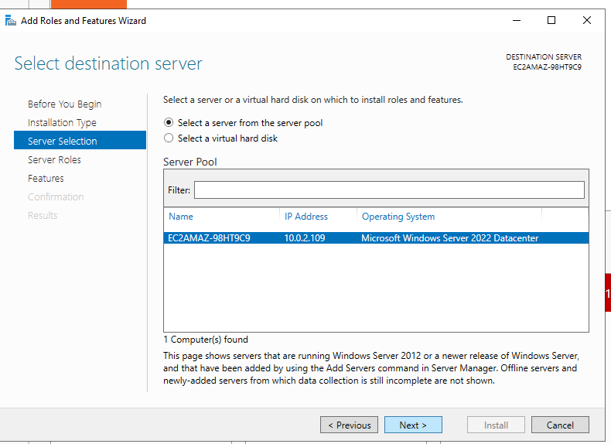Figure 17
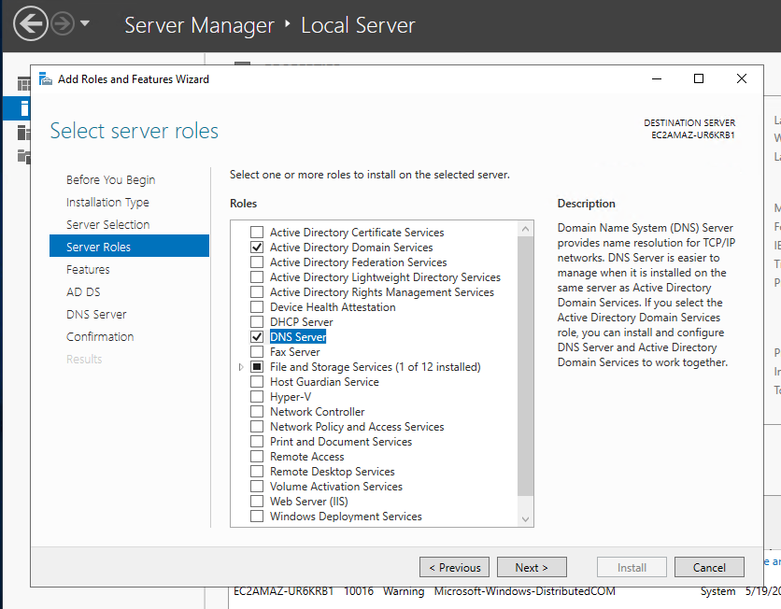 Figure 18
Rest of the configuration follow by default and install.

Step 4: After installation, a warning sign will pop out. Navigate to the “warning” sign and select “Promote this server to a domain controller”
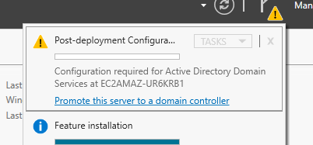

Step 5: For deployment configuration, set the root domain name as “MyDC.local” and click next
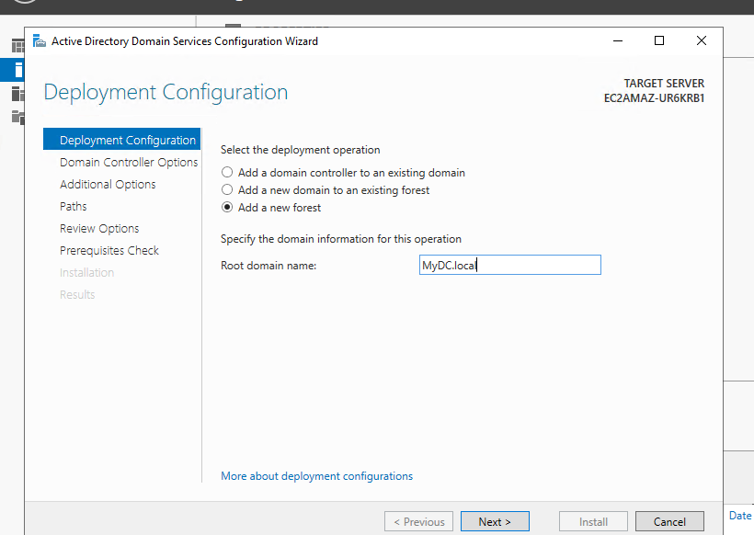

Step 6: Set your preferred password and click next. Set the rest as default setting and install
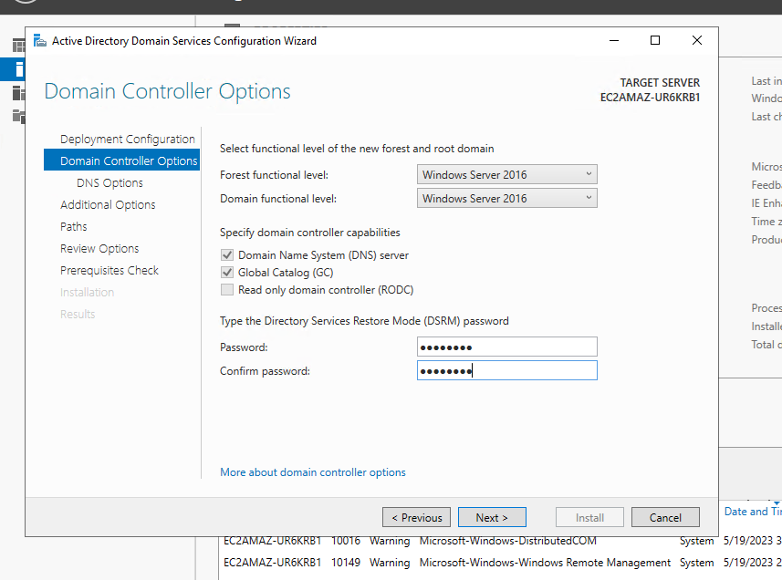
After success installation, the remote desktop connection will log you out automatically. Wait for about 3mins and log back in using rdp again.

- Create different users under the domain
Step 1: now we can create user accounts and test them out. Select “AD Users and Computers” in tools dropdown.
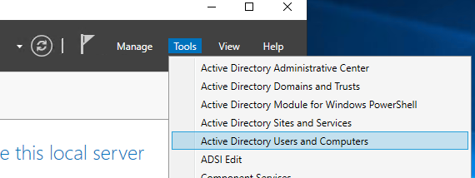

Step 2: right click “Users” “New” “User” to create a user account in “MyDC.local” domain
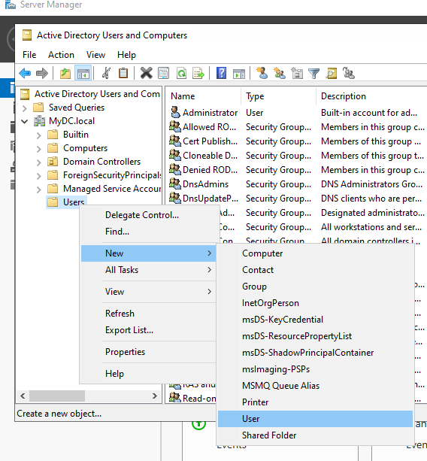

Step 3: create a user name “John”. Follow Figure 19 which is provided below
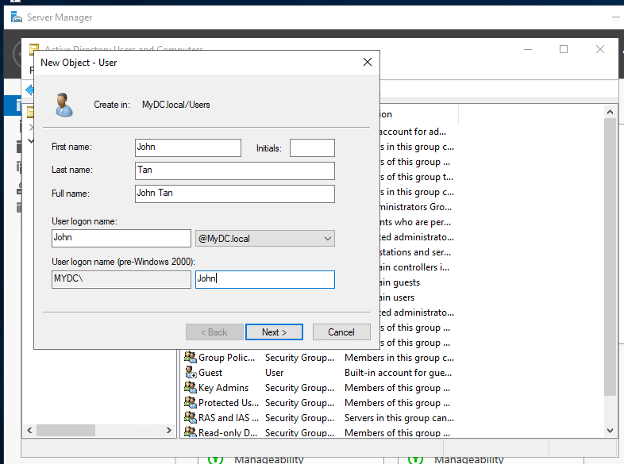 Figure 19

Step 4: Use “Pa$$w0rd” as the password for that user. And check “user cannot change password”.
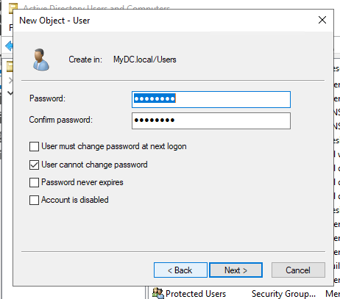

Step 5: Press next and click finish

Step 6: create another user named “James” and set its password.
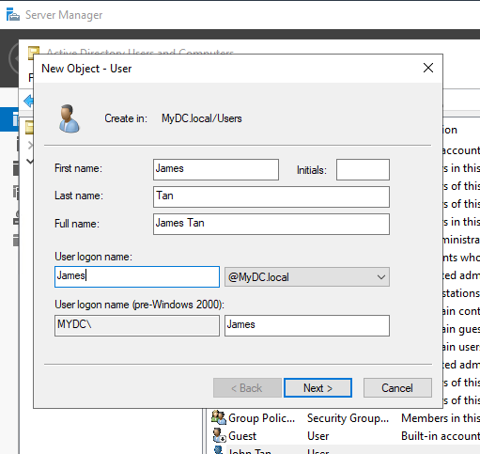

Step 7: Press next and click finish

Step 8: Set User ID “John” as an administrator of Domain Server. Right click on “John Tan” “Properties” “Member Of”. Click “Add…” and add “Administrators”. Click ok and apply and ok. As shown in Figure 20,21,22 below.
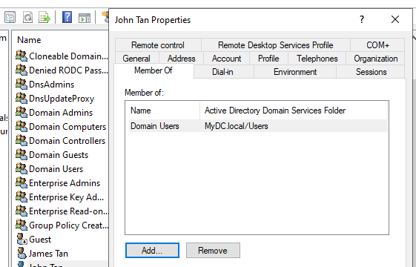 Figure 20 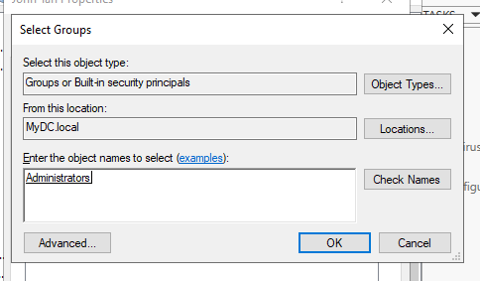 Figure 21
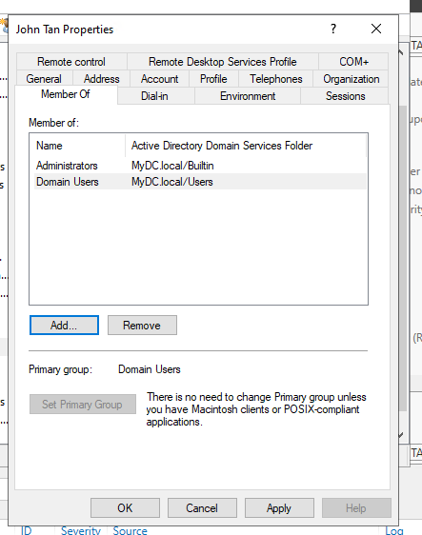 Figure 22

- Allow client to join Domain Server
Step 1: For Internal Host to join “MyDC.local” Domain Server, first use Bastion Host 2 and remote desktop connection into Internal Host EC2. Next in control panel, go to “Network and Internet” “Network Connections” and right click “Ethernet 2” “Properties” find “Internet Protocol Version 4 (TCP/IPv4)” and click properties to edit its DNS Server to the Domain Server ip address “x.x.x.x” and click “ok” two times.
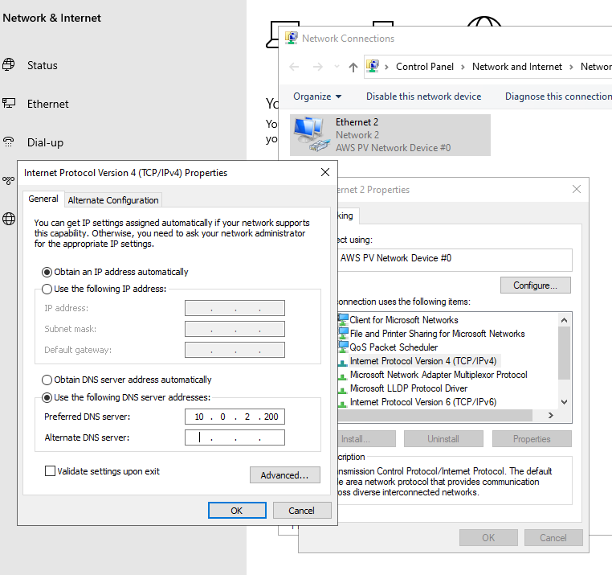
Get Ip Address from AWS EC2 instance
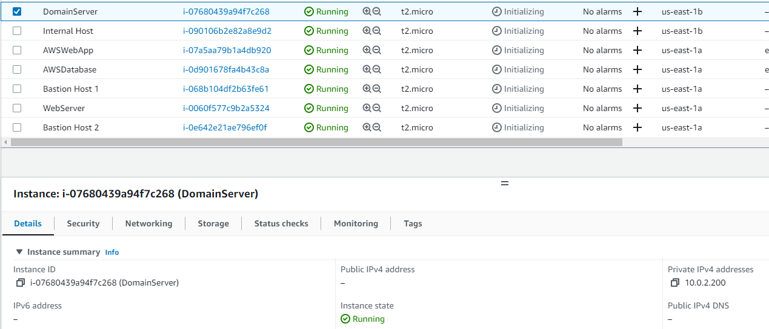
(Domain) DNS Server ip address from the DomainServer EC2 1bs

Step 2: In the windows search, search for “Change workgroup name”. Click “Change…”. Under Member of, select “Domain” and enter “MyDC.local” in the textbox. And click “ok” two times.
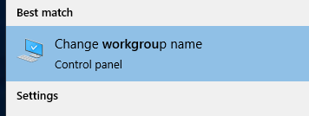
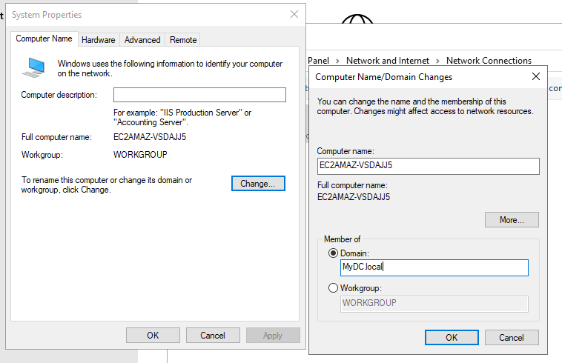
Step 3: a pop up will appear to prompt you to enter one of the domains server’s Administrator’s User ID username and password for confirmation. In this case, we will use User ID “John” which we had set as an Administrator. Click “ok” three times and click “Restart Now”.
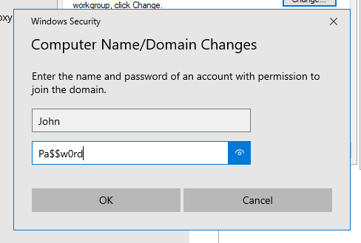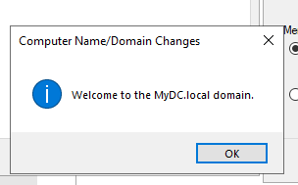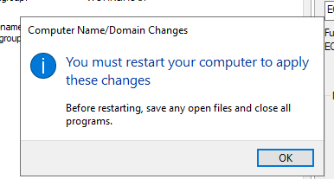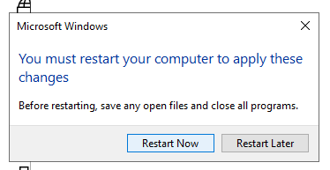
Here, it will close the rdp connection by itself. Wait 3mins and rdp into Internal Host again.

Step 4: Go back to the change workgroup. Notice now that you are in the domain already.
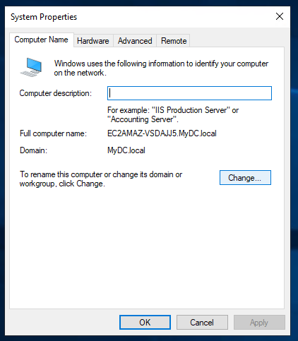

- Allow non-administrators to use Remote Desktop Services on user logon
Step 1: Try to log in from bastion host 2 to domain server using one of the account User ID, e.g “James” by signing in using rdp.
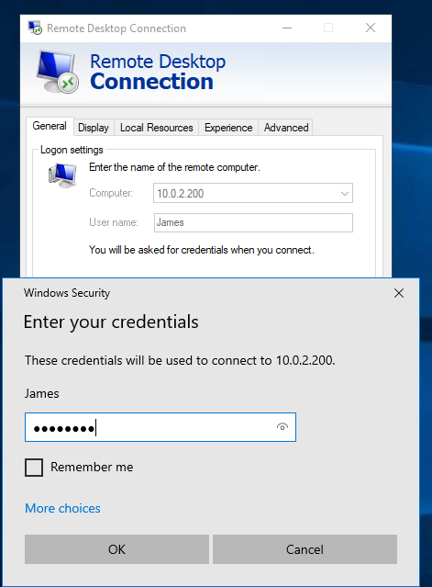 Figure 23
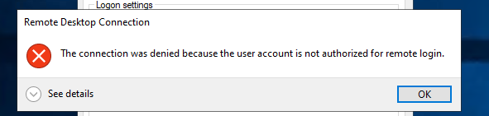
Notice that a pop out appear prompting you that the connection was denied because that account is not authorized.

Step 2: To allow rdp, in Bastion Host 1 in Domain Server EC2, go to “builtin” folder, notice that “Remote Desktop Users” security group is in the folder. We will be using the security group in step 3.
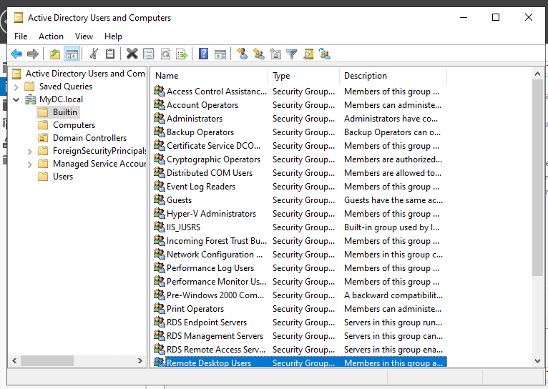
Local admin

Step 3: Go back to “Users” folder “James Tan” “properties” “Member Of” and add in “Remote Desktop User” security group
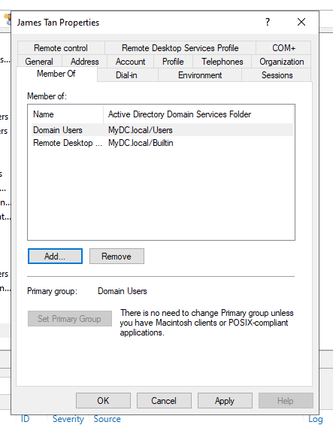

Step 4: Select “Group Policy Management” under “Tools” dropdown
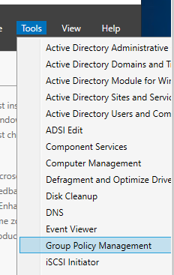

Step 5: select “Forest: MyDC.local” “Domains” “MyDC.local” and right click “Domain Controllers” “Create a GPO in this domain, and link it here…”
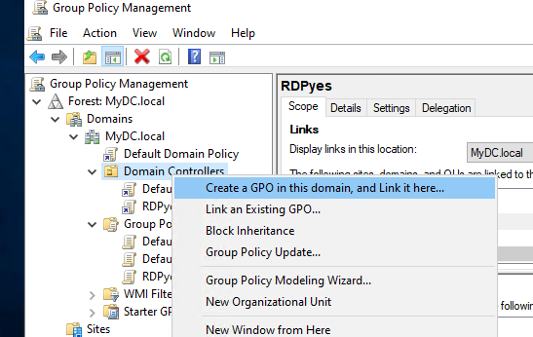

Step 6: to create a group policy, under name input “RDPyes” and click ok
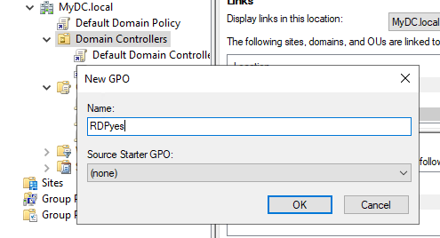

Step 7: right click “RDPyes” “Edit…”
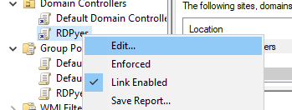

Step 8: a windows appear similar to Figure 24 below. Select “Computer Configuration” “Policies” “Windows Settings” “Security Settings” “Local Policies” “User Rights Assignment”
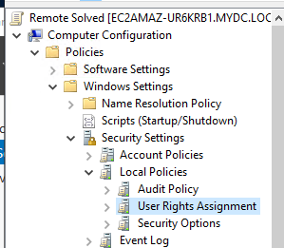 Figure 24

Step 9: find “Allow log on through Remote Desktop Services” right click select “Properties”
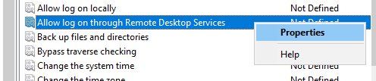

Step 10: to enable “Add User or Group” button, check the “Define these policy settings” checkbox
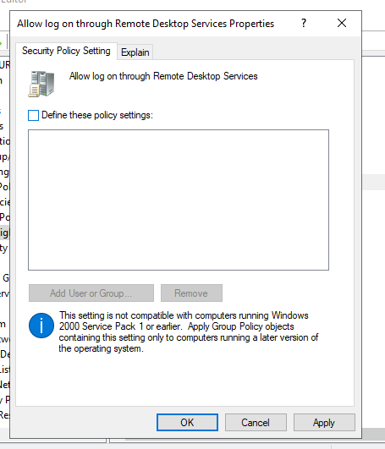
Step 11: after clicking “Add User or Group”, a pop up appears. Select “Browse”
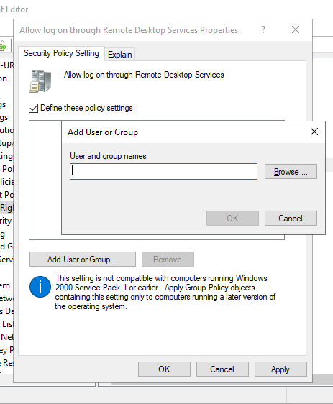

Step 12: find “Authenticated Users”, “Domain Computers” and “Domain Users” and click ok
Browse
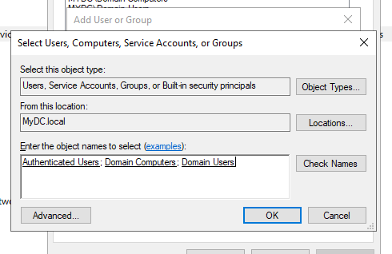

Step 13: click ok after the textbox is filled
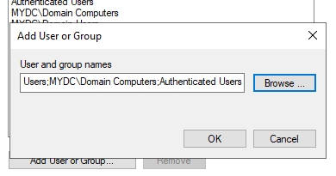

Step 14: click Apply and ok
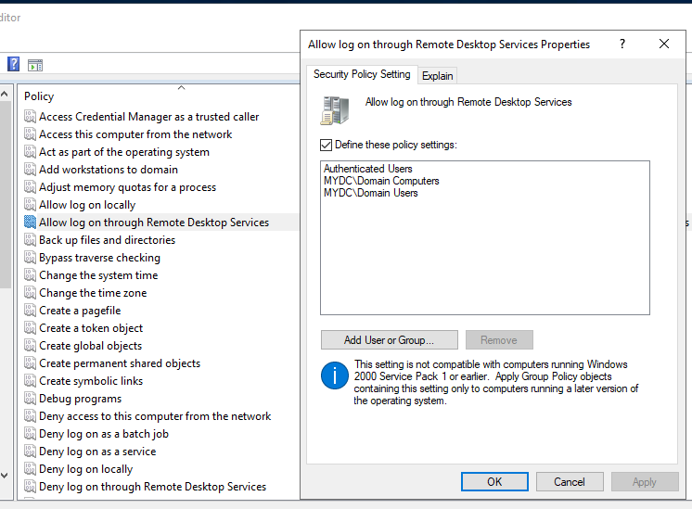

Step 15: open Command Prompt as Administrator and type “gpudate /force” for domain server 1b-s
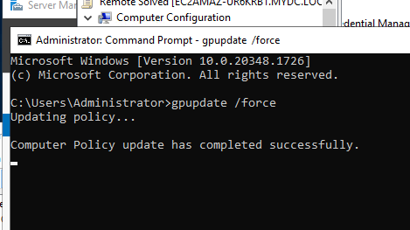
After the message in the command prompt showing that the policy have been updated successfully, now try again to login in from internal host you will see that it is successful

Video References:
- Create a Custom VPC on AWS
- How to Set Up Active Directory in Windows Server 2022 Step by Step Guide #windowsserver2022
- How to create user in active directory and join a domain

