

**CCP6224**

**Object-Oriented Analysis and Design**

**Assignment Report**

**By:** **TT7L Group E**

**Lecturer: Al-Abrar Abdul Wahid**

|  |  |
| --- | --- |
| Group Leader | Ng Jia Huang 011-10770848 1211309530@student.mmu.edu.my |
| Group Members | Hiew Wei Cheng 019-2606683 1211108075@student.mmu.edu.my |
|  | Say Si Ting 017-3728569 1211108625@student.mmu.edu.my |
|  | Tan Jing Yi 010-3671019 1211105905@student.mmu.edu.my |

Table of Contents

UML Diagram 3

Use Case Diagram 4

Sequence Diagram 5

Compile and Run Instructions 8

Kwazam Chess User manual 10

# UML Diagram

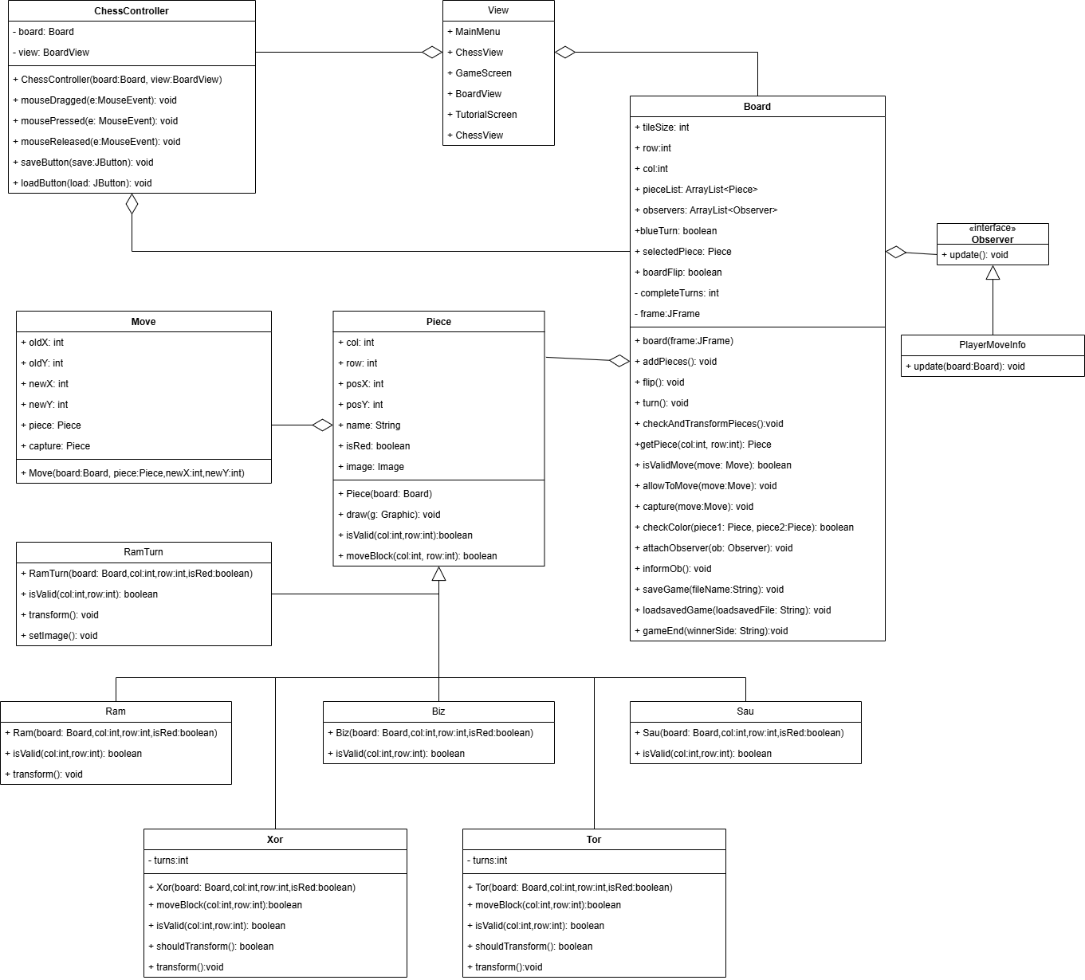

For clearer view:

<https://drive.google.com/file/d/1k7L7FVUp5SEvQMrTCjUflPIRbwnuysQy/view?usp=sharing>

# Use Case Diagram

# Sequence Diagram

1. **Start Game:**

1. **Exit to Main Menu:**

1. **Move Piece:**

1. **Save & Load Game:**

1. **Pause Game:**

1. **View Tutorial:**

1. **Exit Program**

# Compile and Run Instructions

**Step 1:** Open cmd and compile View.java file first.

Type: javac View.java

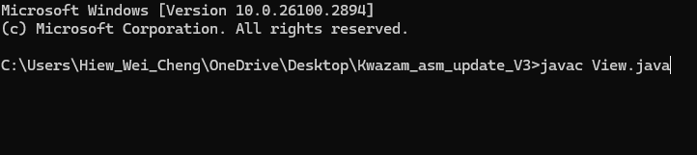

**Step 2:** Next, compile GameLauncher.java file

Type: javac GameLauncher.java

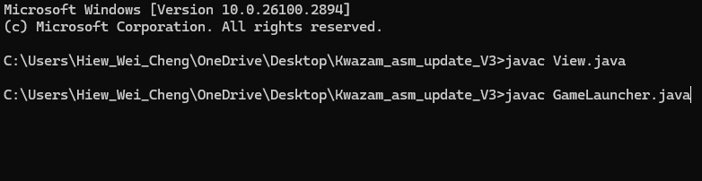

**Step 3:** Last run the GameLauncher

Type: java GameLauncher

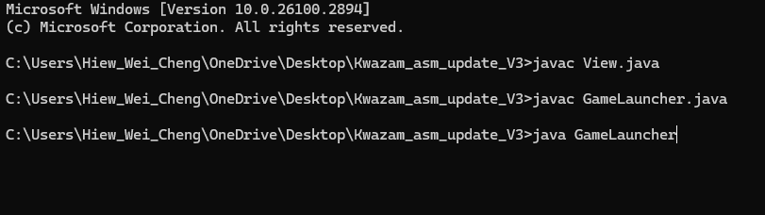

**Step 4:** The output should be like the screenshot below

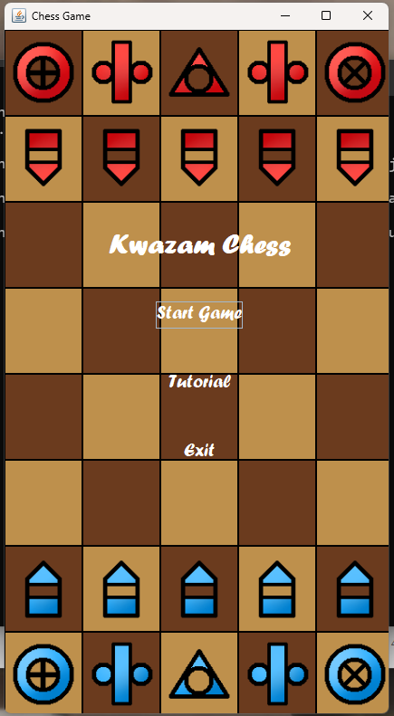

# Kwazam Chess User manual

**Main menu**

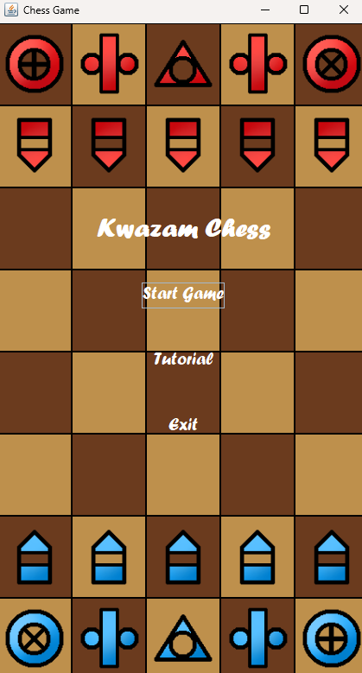

Figure 1.1

This is the main menu of the program, it has 3 buttons which is start game, tutorial and exit. When user press Tutorial, it will navigate the user to tutorial screen (Figure 1.2). When the user presses Start Game, it will send the user to the game screen (Figure 1.3).

**Tutorial Screen**

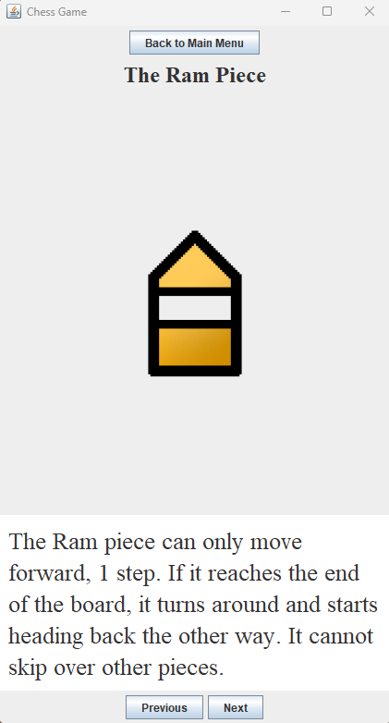

Figure 1.2

This is the Tutorial Screen for the program, in this tutorial screen user can see the moving logic of each chess piece. The user can press the next button to see the next chess piece logic. User can press back to main menu to return to the main menu screen (Figure 1.1).

**Game Screen**

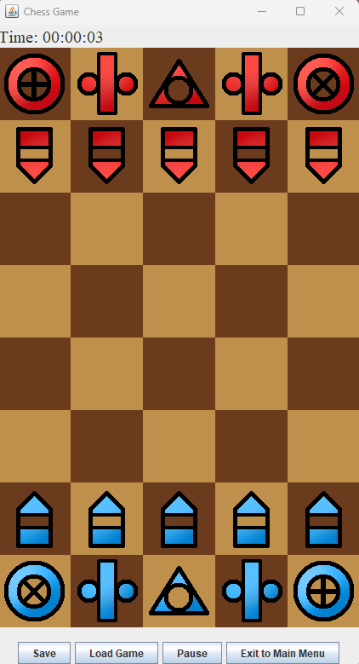

Figure 1.3

This is the Game Screen (Figure 1.3) that allows user to play Chess game. There is a save, load, pause and exit to main menu buttons. When pressing the pause button, the game will pause, and the user can choose to resume the game. The user also can go back to the main menu screen (Figure 1.1) by pressing the exit to main menu button.

**Save file**

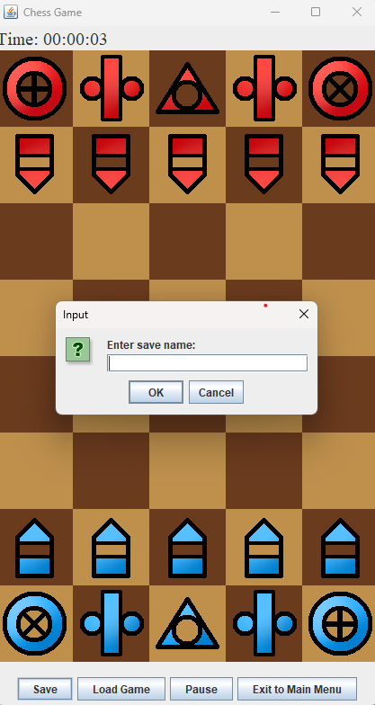

Figure 1.4

When the user presses the save button it will ask the user to type the save file name and it will create a text file based on the user type in name that stores the board state.

**Load Game**

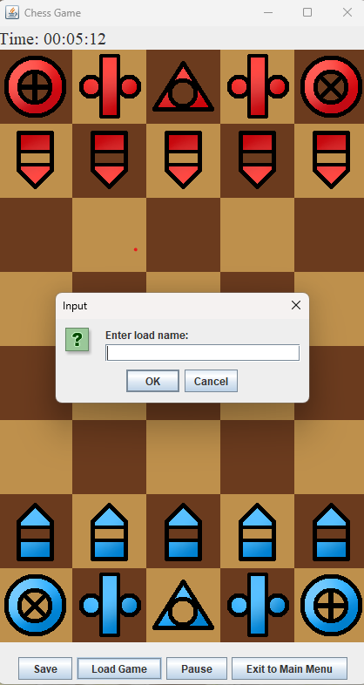

Figure 1.5

If the user decided to load their game, they could type in their saved file name, and it will load the board state for them so that they can continue.

**In game**

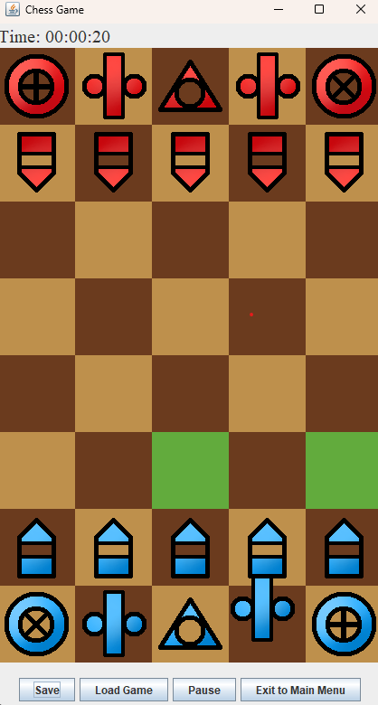

Figure 1.6

When the user drags the chess piece, the highlighted tile will be shown. The highlighted tile is the location that is valid for the chess piece to move.

**Win Page**

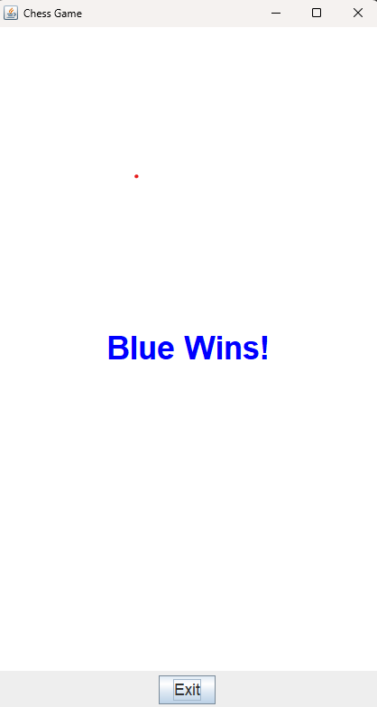

Figure 1.7

When the opponent Sau piece is captured, it will show a Win Page (Figure 1.7) and show which side (Red or Blue) wins. After that the user can choose to exit the game.