# 安装SVN

* SVN安装包

<http://gidea.ihaiu.com/Download/TortoiseSVN-1.8.7.25475-x64-svn-1.8.9.msi>

* SVN安装 中文补丁

<http://gidea.ihaiu.com/Download/TortoiseSVN%20LanguagePack_1.8.1.24570-x64-zh_CN.msi>

注意安装时候选上命令行 Command line

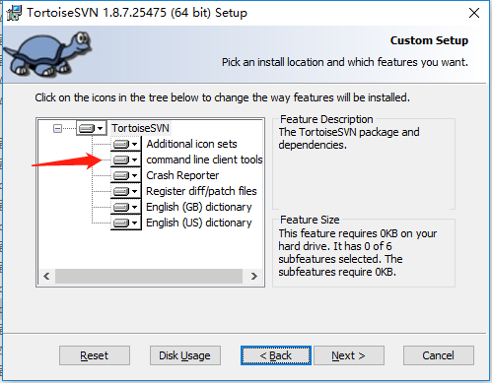

# 安装Net Core

* dotnet runting: dotnet-hosting-2.2.0-win.exe

<http://gidea.ihaiu.com/Download/dotnet-hosting-2.2.0-win.exe>

* dotnet sdk: dotnet-sdk-2.2.101-win-x64.exe

<http://gidea.ihaiu.com/Download/dotnet-sdk-2.2.101-win-x64.exe>