### RAK12019 Matters Needing Attention

RAK12019 has two working modes (measuring light intensity in normal environment and measuring ultraviolet intensity). The following code is modified to switch the working mode.

Ltr. setMode(LTR_MODE_ALS) Sets the working mode to measure the normal ambient light intensity.The unit of ambient light intensity is lux.

Ltr.setmode (LTR_MODE_UVS) Sets the working mode to measure uv intensity.The unit of uv intensity is UW /cm2.

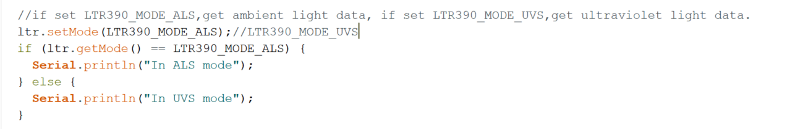

LUX and UVI sent via LoRaWan and Ble have been expanded tenfold (the original value is float, have two decimal places).