**Five-pin soil multi-parameter sensor**

**(Type 485)**

**SN -300 2-TR - * -N01**

**Ver 2 .0**



Table of contents

Chapter 1​ Product Introduction  3

1.1 Product Overview  3

1.2 Features  3

1.3 Main parameters  3

1.4 System Framework Figure  5

1.5 Product Selection  6

Chapter 2​ Hardware Connection  6

2.1 Equipment pre-installation inspection  6

2.2 Interface Description  6

2.2.1 Sensor Wiring  6

Chapter 3​ Usage  6

3.1 Rapid test  method 7

3.2 Buried measurement  method 7

3.3​ Note  8

No. 4 chapter Configuration software installation and use  8

4.1 Sensor connection to computer  8

4.2 Use of sensor monitoring software  8

No. 5 chapter Communication Protocol  9

5.1 Basic communication parameters  9

5.2 Data frame format definition  9

5.3 Register Address  10

5.4 Communication protocol examples and explanations  11

No. Chapter 6 Common problems and solutions  13

6.1 Note No Output or Output Error  13

# Chapter 1 Product Introduction

## 1.1 Product Overview

**This product has stable performance, high sensitivity,** fast response, stable output, and is suitable for all kinds of soil . **It is an important tool for observing and studying the occurrence, evolution, improvement, and water-salt dynamics of saline soil. By measuring the dielectric constant of the soil, it can directly and stably reflect the true moisture content of various soils. It can measure the volume percentage of soil moisture, which is a soil moisture measurement method that meets the current international standards.** It can be buried in the soil for a long time, is resistant to long-term electrolysis, corrosion, vacuum potting, and is completely waterproof.

**It is suitable for temperature, humidity, conductivity and pH value testing in soil moisture monitoring, scientific experiments, water-saving irrigation, greenhouses, flowers and vegetables, grasslands, rapid soil testing, plant cultivation, sewage treatment, precision agriculture and other occasions.**

## 1.2 Features

■ Low threshold, few steps, fast measurement, no reagents required, and no limit on the number of tests.

■ The electrodes are made of specially treated alloy material, which can withstand strong external impact and is not easily damaged.

■ Completely sealed, resistant to acid and alkali corrosion, can be buried in the soil or directly put into water for long-term dynamic detection.

■ High precision, fast response, good interchangeability, and the probe insertion design ensures accurate measurement and reliable performance.

■ It can also be used for the conductivity of water-fertilizer solution, other nutrient solutions and substrates.

## 1.3 Main parameters

|  |  |  |
| --- | --- | --- |
| **DC power supply (default)** | **DC 4.5-30V** | |
| **Maximum power consumption** | **0.5W** (24V DC power supply) | |
| **Operating temperature** | -20℃~+60℃ | |
| **Core chip temperature resistance** | 85℃ | |
| **Stabilization time** | **≤5min** | |
| **Conductivity parameters** | **Range** | **0-20000** μS/cm |
| **Resolution** | **1** μS/cm |
| **Typical accuracy** | **±3%FS in the range of 0-10000** μS/cm ; **±5%FS in the range of 10000-20000** μS/cm ;  **(Brown soil, 60%, 25℃ )** |
| **Soil moisture parameters** | **Range** | **0-100%** |
| **Resolution** | **0.1%** |
| **Accuracy** | **0-50% within ±2%, @** (brown soil, 3 0%, 25℃)  **50-100% within ±3%, @** (brown soil, 60%, 25℃) |
| **Soil temperature parameters** | **Range** | **-40~80℃** |
| **Resolution** | **Resolution: 0.1℃** |
| **Accuracy** | **±0.5℃（25℃）** |
| **Soil pH parameters** | **Range** | **3~9PH** |
| **Resolution** | **0.1** |
| **NPK parameters**  **(Input after measurement by national standard instrument)** | **Range** | 0-2999 **mg/kg(mg/L)** |
| **Resolution** | **1 mg/kg(mg/L)** |
| **Typical accuracy** | **≤5% (subject to the actual measuring instrument)** |
| **Conductivity temperature compensation** | **Built-in temperature compensation sensor, compensation range 0-50℃** | |
| **Protection level** | **IP68** | |
| **Pin material** | **Anti-corrosion special electrode** | |
| **Sealing material** | **Black flame retardant epoxy resin** | |
| **Default cable length** | **2m, cable length can be customized as required** | |
| **Dimensions** | **45*15*123mm** | |
| **Output signal** | **RS485 (ModBus protocol)** | |

Note: The performance data stated above was obtained under test conditions using our test system and software. In order to continuously improve our products, our company reserves the right to change design features and specifications without prior notice.

**Shell size**

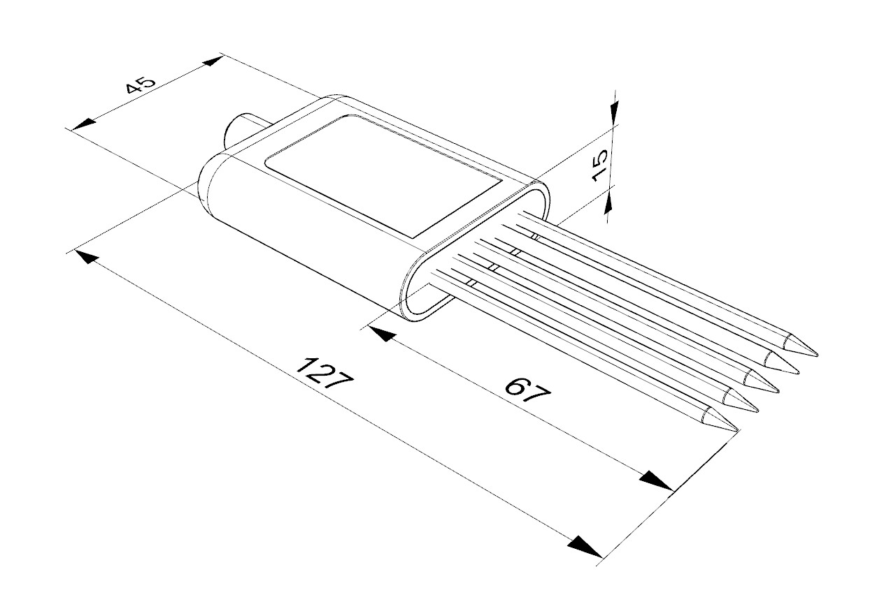

Equipment dimensions (unit: mm)

## 1.4 System Framework Diagram

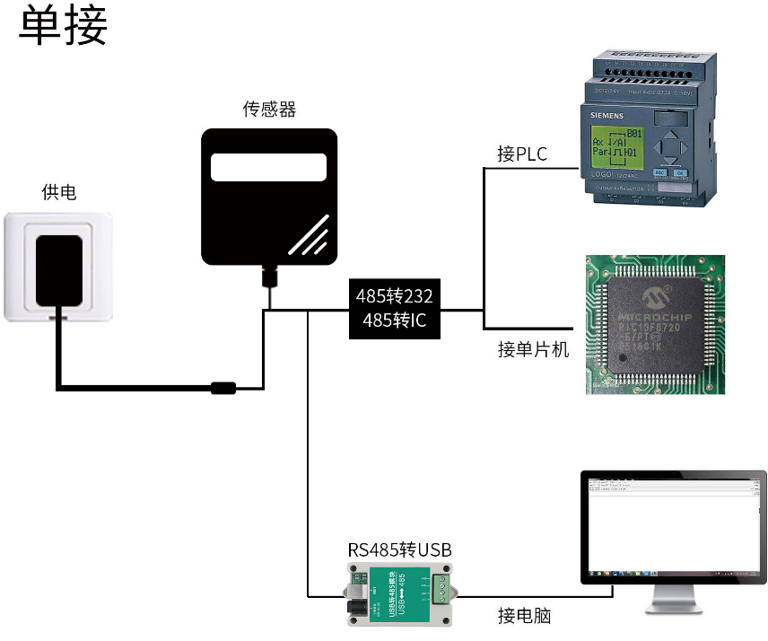

This product can also be used by combining multiple sensors on a 485 bus . Theoretically, one bus can have 254 485 sensors. The other end can be connected to a PLC with a 485 interface , a single-chip microcomputer through a 485 interface chip, or a computer using a USB to 485 converter . Use the sensor configuration tool provided by our company for configuration and testing ( only one device can be connected when using this configuration software) .

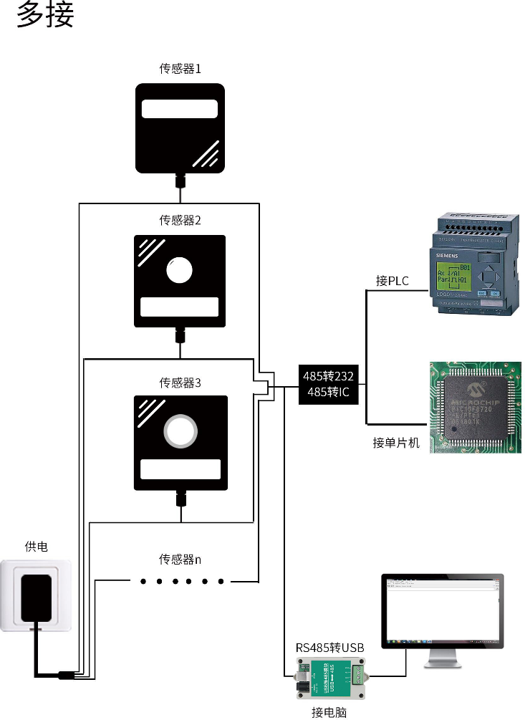

## 1.5 Product Selection

|  |  |  |  |  |  |
| --- | --- | --- | --- | --- | --- |
| SN- |  | | | | Company Code |
|  | 3002- |  | | |  |
|  | TR- |  | | Soil testing enclosure |
|  | NPKPH- |  | NPK PH |
| TH NPK PH - |  | Temperature, moisture, nitrogen, phosphorus, potassium, PH |
| ECNPKPH- |  | Conductivity NPK PH |
| ECTHNPKPH- |  | Conductivity Temperature Moisture NPK PH |
|  | N01 | RS485 (ModBus-RTU protocol) |

# Chapter 2 Hardware Connection

## 2.1 Equipment inspection before installation

Equipment List:

■1 device

■Certificate of conformity, wiring instructions, etc.

■USB to 485 (optional)

## 2.2 Interface Description

The wide voltage power input is 4.5~30V. When wiring the 485 signal line, please note that the A/B lines cannot be connected in reverse, and the addresses of multiple devices on the bus cannot conflict.

### 2.2.1 Sensor wiring

|  |  |  |
| --- | --- | --- |
| Line Color | illustrate | Remark |
| brown | Power positive | 4.5~30V DC |
| black | Power Ground | GND |
| yellow | 485-A | 485-A |
| blue | 485-B | 485-B |

# Chapter 3 How to use

Since the electrode directly measures the conductivity of soluble salt ions in the soil, the soluble ions in the soil can correctly reflect the conductivity of the soil only when the soil volume moisture content is higher than about 20%. In long-term observation, the measured value after irrigation or rainfall is closer to the actual level. If a quick test is performed, water the soil to be tested first, and then measure after the water has fully penetrated.

If measuring on a harder surface, you should first drill a hole (the hole diameter should be smaller than the probe diameter), then insert it into the soil and compact the soil before measuring; the transmitter should be protected from severe vibration and impact, and should not be hit with hard objects. Since the transmitter is packaged in black, it will heat up rapidly (up to 50°C or more) under strong sunlight . In order to prevent excessive temperature from affecting the temperature measurement of the transmitter, please pay attention to sunshade and protection when using it in the field or outdoors.

## 3.1 Rapid test method

Select a suitable measuring location, avoid stones, ensure that the steel needle does not hit hard objects, discard the topsoil according to the required measuring depth, maintain the original tightness of the soil below, hold the sensor firmly and insert it vertically into the soil. Do not shake it left or right during insertion. It is recommended to measure multiple times within a small range of a measuring point to obtain the average value.

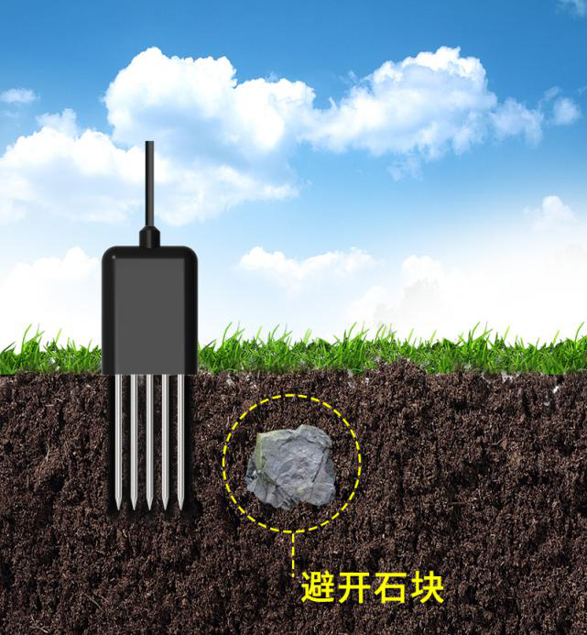

## 3.2 Buried measurement method

Dig a pit vertically with a diameter of >20cm, insert the transmitter steel needle horizontally into the pit wall at a predetermined depth, fill the pit tightly, and after a period of stability, you can perform measurements and records for days, months or even longer.

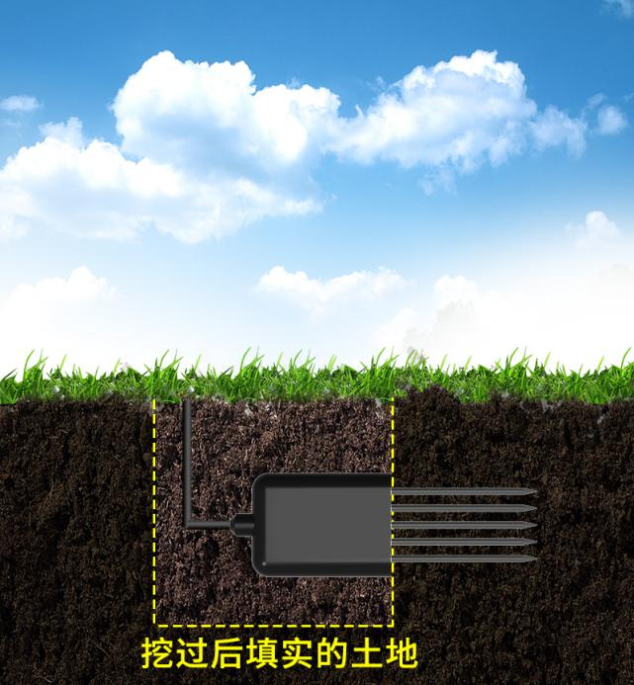

## 3.3 Notes​

1. When measuring, the steel needle must be completely inserted into the soil.

2. Avoid strong sunlight directly shining on the transmitter to avoid overheating. Be careful to prevent lightning strikes when using it outdoors.

3. Do not bend the steel needle violently, do not pull the transmitter lead wire hard, and do not drop or hit the transmitter violently.

4. The protection level of the transmitter is IP68, and the entire transmitter can be immersed in water.

5. Due to the presence of radio frequency electromagnetic radiation in the air, it is not advisable to keep the device powered on in the air for a long time.

# Chapter 4 Configuration Software Installation and Usage

Our company provides the matching "485 parameter configuration software" , which can conveniently use the computer to read the parameters of the sensor and flexibly modify the device ID and address of the sensor.

Note that when using software to automatically acquire, it is necessary to ensure that there is only one sensor on the 485 bus.

## 4.1 Sensor connected to computer

After the sensor is correctly connected to the computer via USB to 485 and powered, the correct COM port can be seen on the computer (check the COM port in "My Computer - Properties - Device Manager - Port").

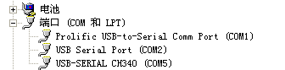

Open the data package, select "debugging software"---"485 parameter configuration software", find it and open it.

If the COM port is not found in the device manager, it means that you have not installed the USB to 485 driver (in the data package) or the driver is not installed correctly. Please contact the technician for help.

## 4.2 Use of sensor monitoring software

①. The configuration interface is as shown in the figure. First, obtain the serial port number according to the method in Section 3.1 and select the correct serial port .

②. Click the test baud rate of the software, and the software will test the baud rate and address of the current device. The default baud rate is 4800bit/s and the default address is 0x01.

③. Modify the address and baud rate according to the needs, and query the current functional status of the device.

④. If the test fails, please recheck the device wiring and 485 driver installation.

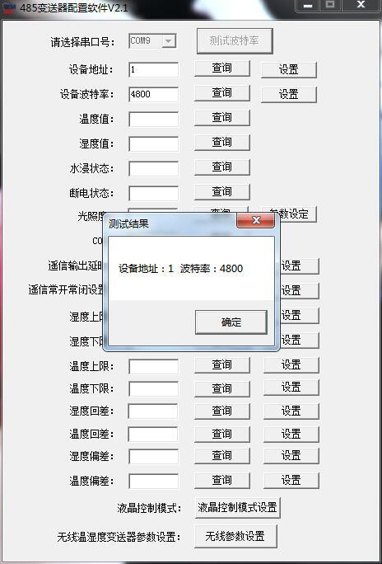

# Chapter 5 Communication Protocol

## 5.1 Basic communication parameters

|  |  |
| --- | --- |
| Edit code | 8 -bit binary |
| Data bits | 8 -bit |
| Parity bit | none |
| Stop bits | 1st​ |
| Error checking | CRC (Redundant Cyclic Code) |
| Baud rate | 2400 bit/s , 4800 bit/s , 9600 bit/s can be set, the factory default is 4800 bit/s |

## 5.2 Data frame format definition

Using ModBus-RTU communication protocol, the format is as follows:

Time when initial structure ≥ 4 bytes

Address code = 1 byte

Function code = 1 byte

Data area = N bytes

Error checking = 16-bit CRC code

End structure ≥ 4 bytes

Address code: The address of the transmitter, which is unique in the communication network (factory default 0x01).

Function code: This product uses function codes 0x03, 0x06, 0x10, etc.

Data area: The data area is the specific communication data. Note that the high byte of the 16-bit data comes first!

CRC code: a two-byte check code.

Host inquiry frame structure:

|  |  |  |  |  |  |
| --- | --- | --- | --- | --- | --- |
| Address code | Function code | Register start address | Register length | Check code low | Check code high digit |
| 1 byte | 1 byte | 2 bytes | 2 bytes | 1 byte | 1 byte |

Slave response frame structure:

|  |  |  |  |  |  |  |
| --- | --- | --- | --- | --- | --- | --- |
| Address code | Function code | Number of valid bytes | Data Zone 1 | Second data area | Nth data area | Check code |
| 1 byte | 1 byte | 1 byte | 2 bytes | 2 bytes | 2 bytes | 2 bytes |

## 

## 5.3 Register Address

|  |  |  |  |  |
| --- | --- | --- | --- | --- |
| Register Address | PLC PLC or configuration address | Content | Operation | Definition |
| 0000 H | 40001 (dec) | Moisture content | Read-only | Real-time value of moisture content (expanded 10 times) |
| 0001 H | 40002 (dec) | Temperature value | Read-only | Real-time temperature value (expanded 10 times) |
| 0002 H | 40003 (dec) | Conductivity | Read-only | Conductivity real-time value |
| 0003 H | 40004 (dec) | pH​ | Read-only | PH real-time value (expanded ten times) |
| 0004H | 40005(dec) | Nitrogen content temporary value | Read and Write | The nitrogen content value or test value to be written 1 |
| 0005H | 40006(dec) | Phosphorus content temporary value | Read and Write | Phosphorus content value or test value to be written 2 |
| 0006H | 40007(dec) | Potassium content temporary value | Read and Write | Potassium content value or test value to be written 3 |
| 0007 H | 40008 (dec) | Salinity | Read-only | Salinity real-time value (for reference only) |
| 0008 H | 40009 (dec) | Total dissolved solids TDS | Read-only | TDS real-time value (for reference only) |
| 0022 H | 40035 (dec) | Temperature coefficient of conductivity | Read and Write | 0-100 corresponds to 0.0%-10.0%  Default 0.0% |
| 0023 H | 40036 (dec) | Salinity coefficient | Read and Write | 0-100 corresponds to 0.00-1.00 Default is 55 (0.55) |
| 0024 H | 40037 (dec) | TDS coefficient | Read and Write | 0-100 corresponds to 0.00-1.00 Default is 50 (0.5) |
| 0050 H | 40081 (dec) | Temperature calibration value | Read and Write | Integer (expanded by 10 times) |
| 0051 H | 40082 (dec) | Moisture content calibration value | Read and Write | Integer (expanded by 10 times) |
| 0052 H | 40083 (dec) | Conductivity calibration value | Read and Write | Integer |
| 0053 H | 40084 (dec) | PH Calibration value | Read and Write | Integer |
| 0 4 E8 H | 41257 (dec) | Nitrogen content temporary value coefficient high sixteen digits | Read and Write | Floating point number (IEEE754 standard floating point type) |
| 0 4 E 9 H | 41258 (dec) | Nitrogen content temporary value coefficient low sixteen digits | Read and Write |
| 0 4 E AH | 41259 (dec) | Deviation of temporary nitrogen content value | Read and Write | Integer |
| 0 4F2 H | 41267 (dec) | Phosphorus content temporary value coefficient high sixteen digits | Read and Write | Floating point number (IEEE754 standard floating point type) |
| 0 4F3 H | 41268 (dec) | Phosphorus content temporary value coefficient low sixteen digits | Read and Write |
| 0 4F4 H | 41269 (dec) | Deviation of temporary phosphorus content value | Read and Write | Integer |
| 0 4FC H | 41277 (dec) | Potassium content temporary value coefficient high sixteen digits | Read and Write | Floating point number (IEEE754 standard floating point type) |
| 0 4FD H | 41278 (dec) | Potassium content temporary value coefficient low sixteen digits | Read and Write |
| 0 4FEH | 41279 (dec) | Deviation of temporary potassium content value | Read and Write | Integer |
| 07D0H | 42001 (dec) | Device Address | Read and Write | 1~254 (factory default 1) |
| 07D1 H | 42002 (dec) | Device baud rate | Read and Write | 0 represents 2400 1 represents 4800 2 represents 9600 |

## 1: When the 0004H register is not written, the value in the register is f1 (conductivity measurement value). After the 0004H register is written, the register stores the written value.

## 2: When the 0005H register is not written, the value in the register is f2 (conductivity measurement value). After the 0005H register is written, the register stores the written value.

## 3: When the 0006H register is not written, the value in the register is f3 (conductivity measurement value). After the 0006H register is written, the register stores the written value.

## 5.4 Communication protocol examples and explanations

**Example: Read the parameter values of the conductivity, temperature, moisture and pH four-in-one device (address 0x01)**

Inquiry frame

|  |  |  |  |  |  |
| --- | --- | --- | --- | --- | --- |
| Address code | Function code | Starting address | Data length | Check code low byte | Checksum high byte |
| 0x 01 | 0x0 3 | 0x00 0x0 0 | 0x00 0x0 4 | 0x 44 | 0x 09 |

Response frame

|  |  |  |  |  |  |  |  |  |
| --- | --- | --- | --- | --- | --- | --- | --- | --- |
| Address code | Function code | Return valid  Number of bytes | Moisture value | Temperature value | Conductivity value | pH | Check code  Low Byte | Check code  High Byte |
| 0x 01 | 0x0 3 | 0x0 8 | 0x02 0x92 | 0xFF 0x9B | 0x03 0xE8 | 0x00 0x38 | 0x57 | 0xB6 |

Temperature calculation:

When the temperature is below 0 ℃ The temperature data is uploaded in the form of complement code.

Temperature: FF9B H ( hexadecimal ) = - 101 => Temperature = -10.1 ℃

Moisture calculation:

Water content: 292 H ( hexadecimal ) = 658 => Humidity = 65.8% , that is, the volume moisture content of the soil is 65.8% .

Conductivity calculation:

Conductivity : 3E8 H ( hexadecimal ) = 1000 conductivity = 1000 μS/cm

PH value calculation:

PH value: 38H (hexadecimal) = 56 => PH value = 5.6

# No. Chapter 6 Common Problems and Solutions

## 6.1 Note No Output or Output Error

Possible causes:

①. The computer has a COM port, but the selected port is incorrect.

②. The baud rate is wrong.

③. The 485 bus is disconnected, or the A and B lines are connected reversely.

④. If there are too many devices or the wiring is too long, power supply should be provided nearby, a 48 5 amplifier should be added, and a 120Ω terminal resistor should be added.

⑤. The USB to 485 driver is not installed or is damaged.

⑥. Equipment damage.