1.How to recover you deleted data from pc Using EASEUS Recovery tool ?

Ans. Following are the steps to install ease us tool to recover data

Step 1 :- First download the setup from getintopc.com

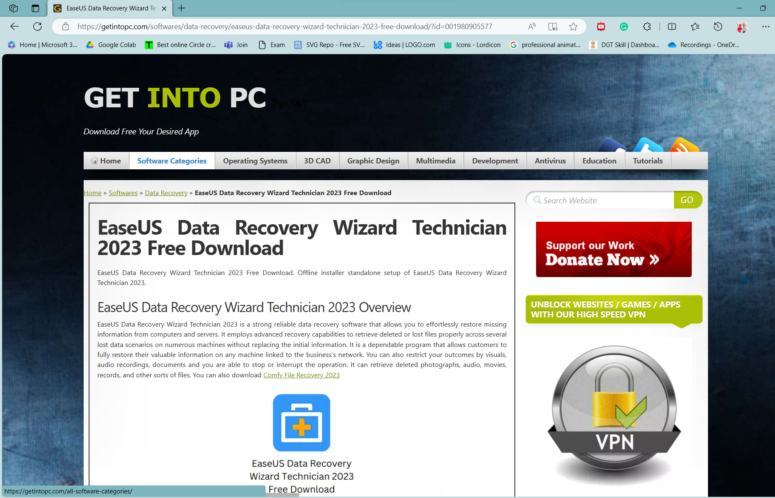

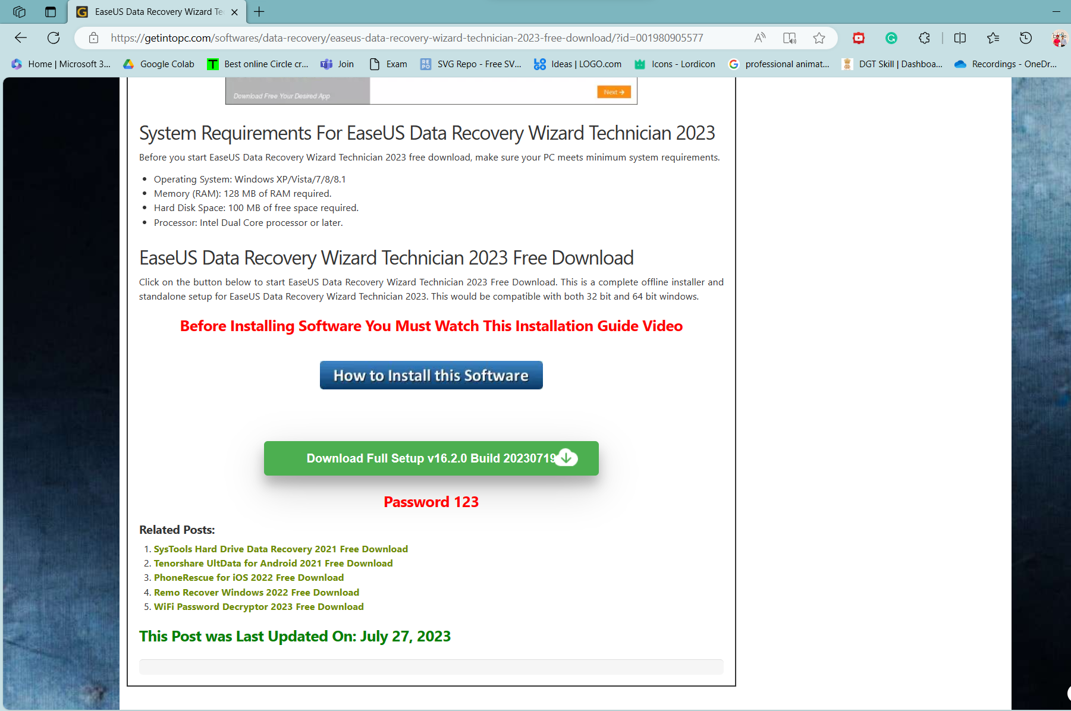

Step 2:- Extract the files to your decided drive

Precautions :- Windows security and network disable first

Password :- use 123 to open or extract file



Step 3:- open folder and install setup.exe file by run as administrator

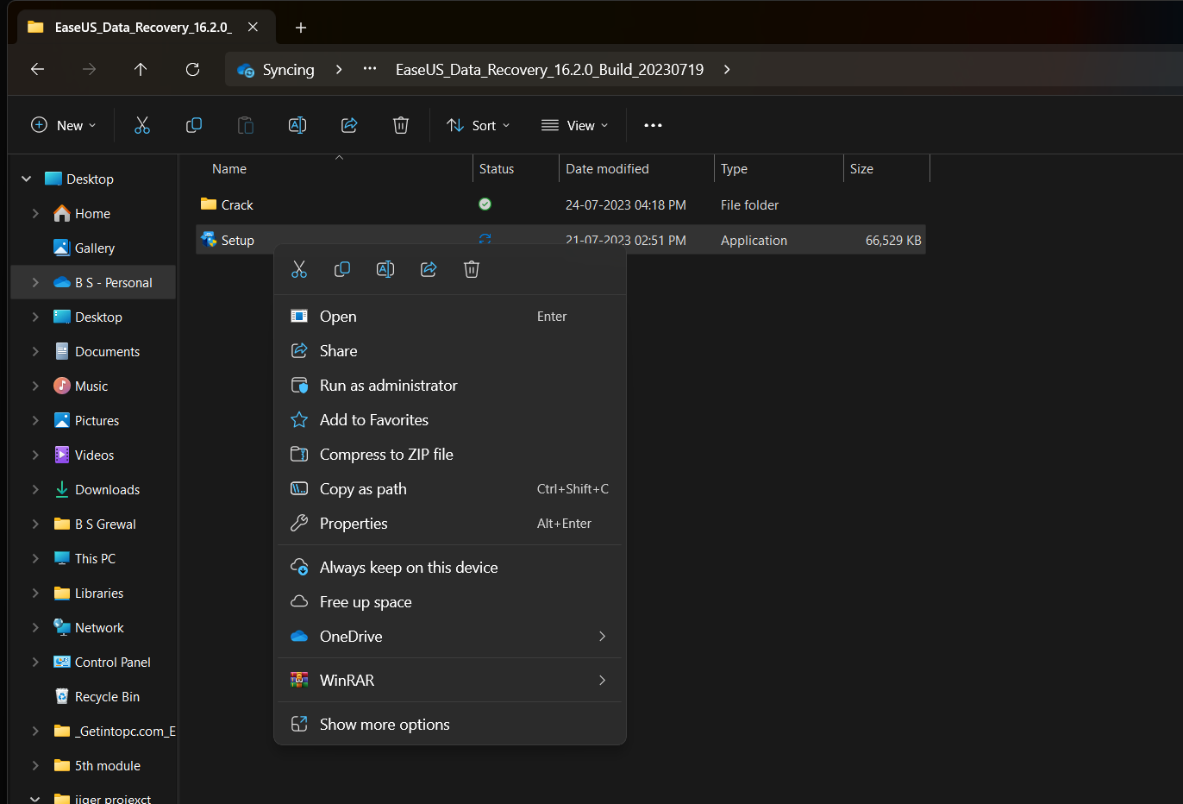

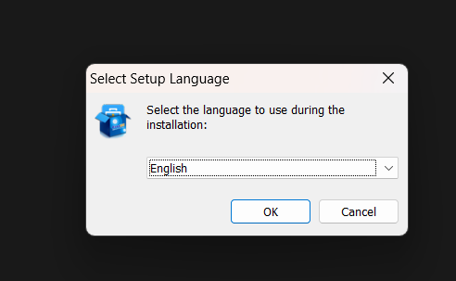

Step 4:- follow the navigation to install setup

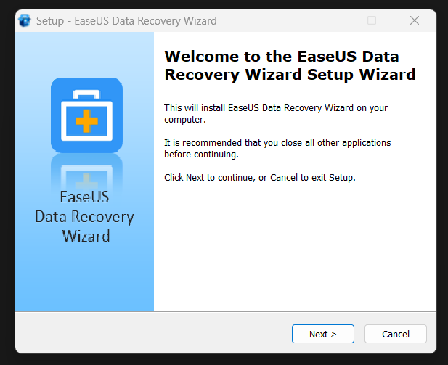

Step 5:- select folder and install

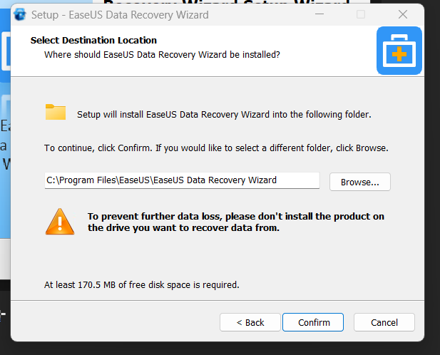

Step 6:- untick the options shown in pic

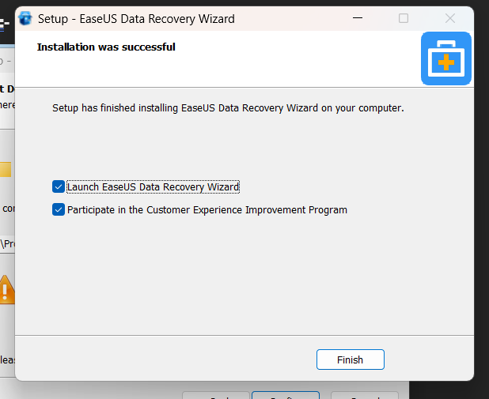

Note :- Finish with no blue tick

Crack the file to use for data recovery

Step 1:- open the folder to use crack section from it

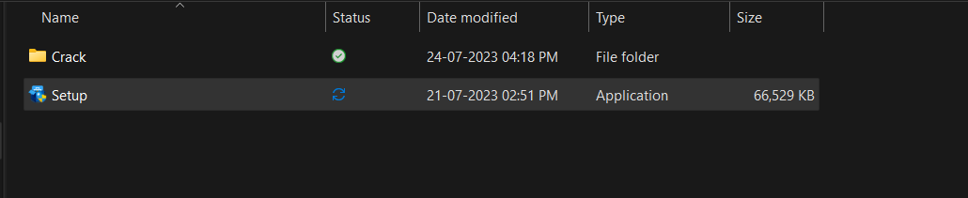

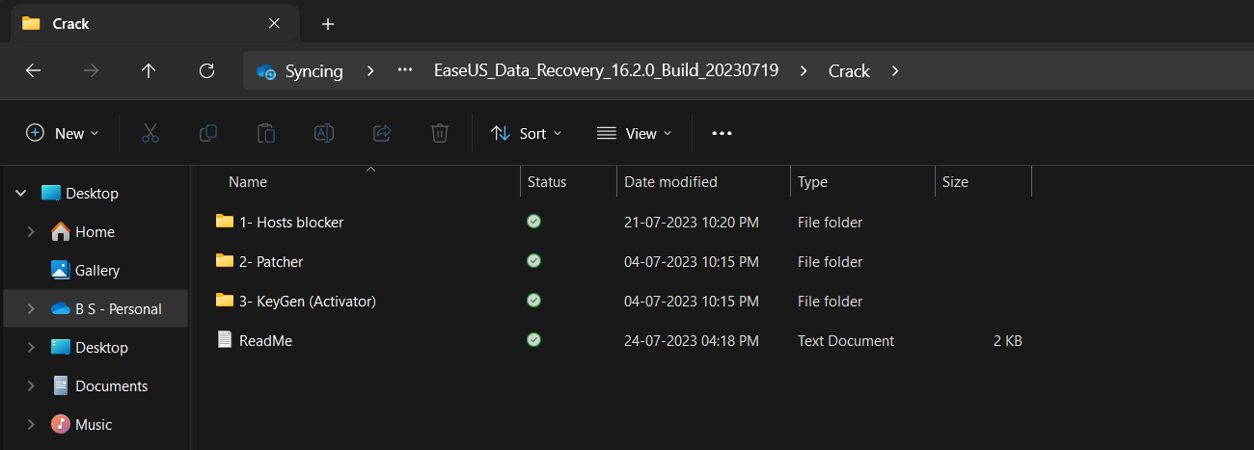

Step 2 :- open patch folder and copy x64 file from it

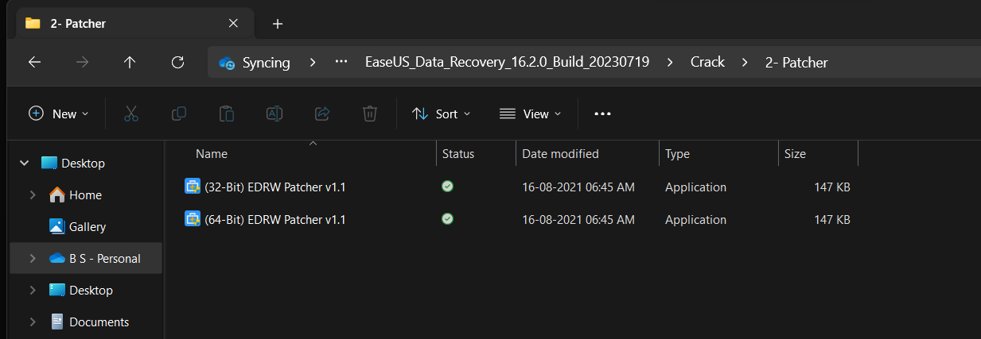

Step 3 :- copy the file and paste to where application is installed

:- C:\Program Files\EaseUS\EaseUS Data Recovery Wizard

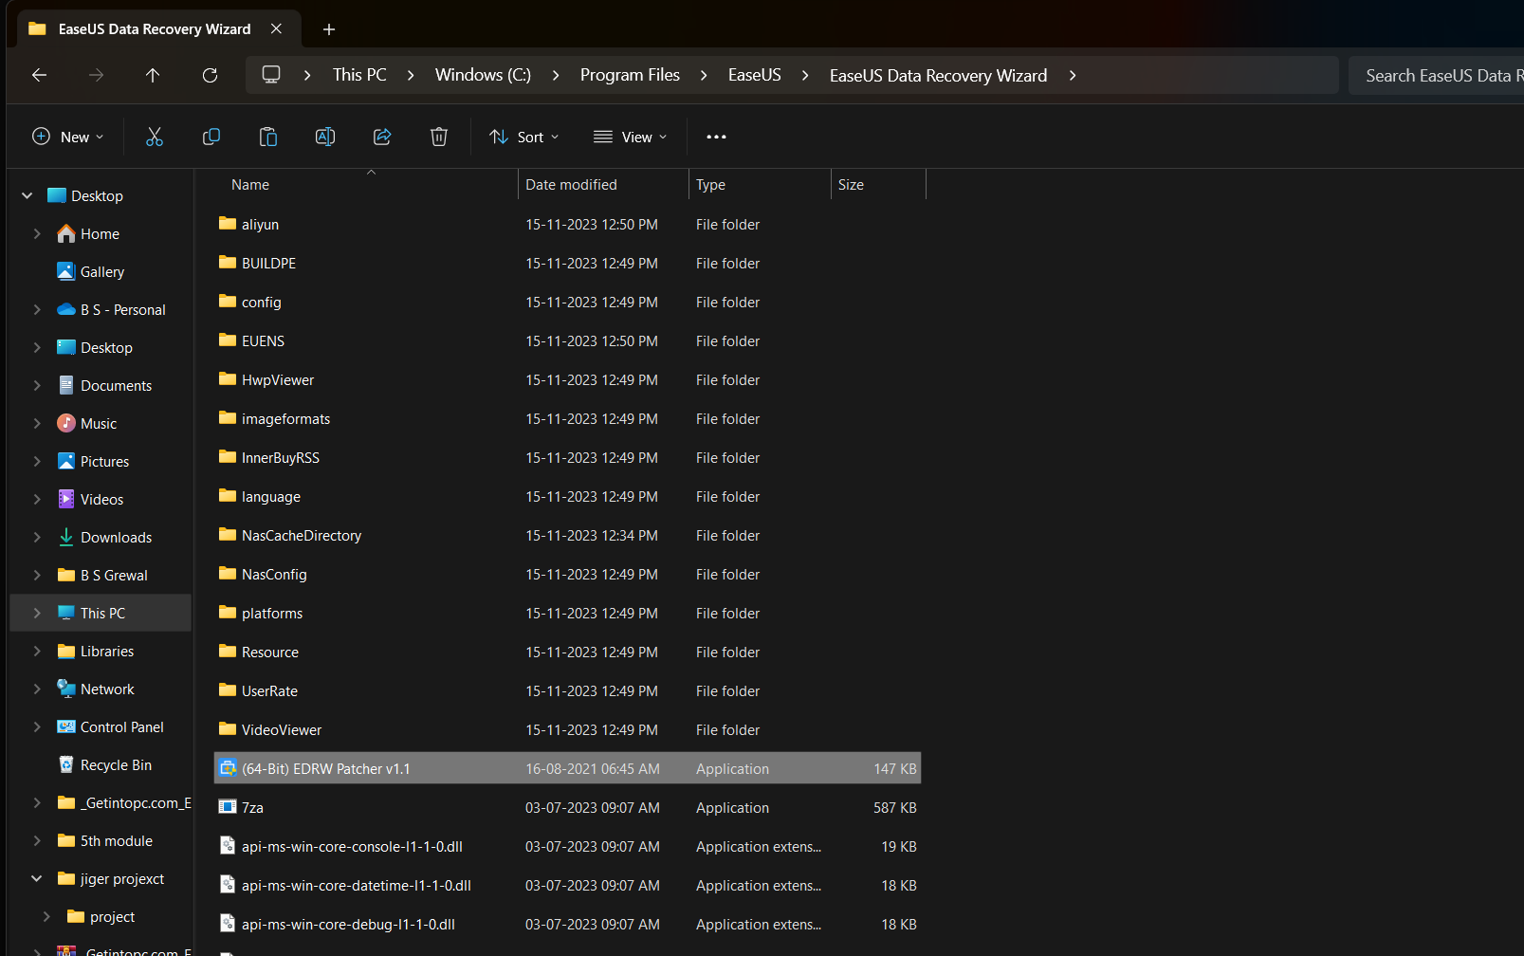

Step 4 :- run patch file from there and select patch

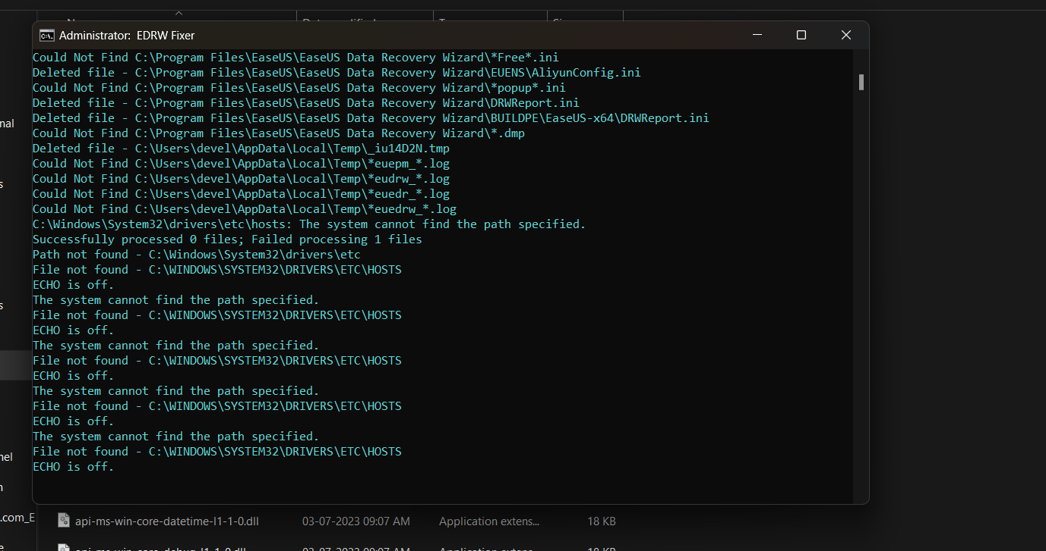

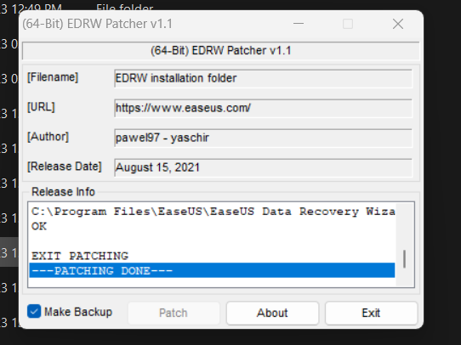

Step 5:- now run keygen activator from the folder

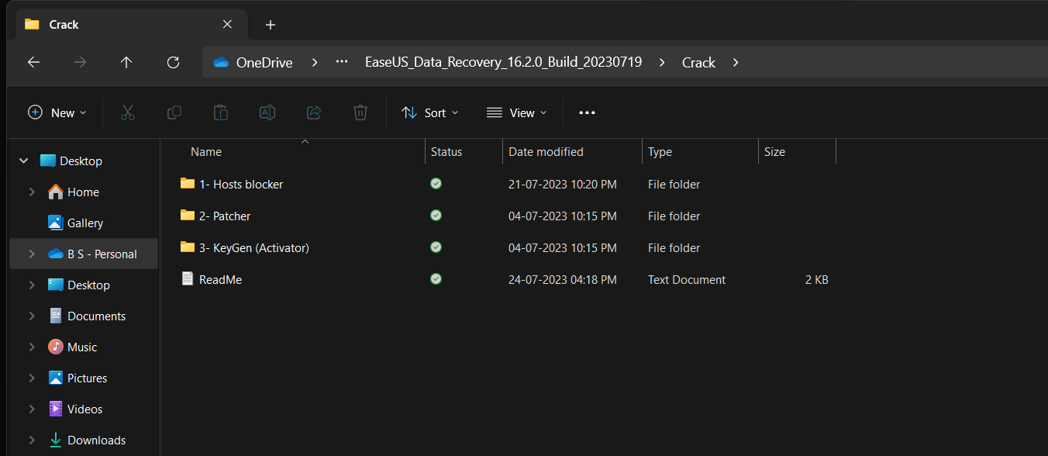

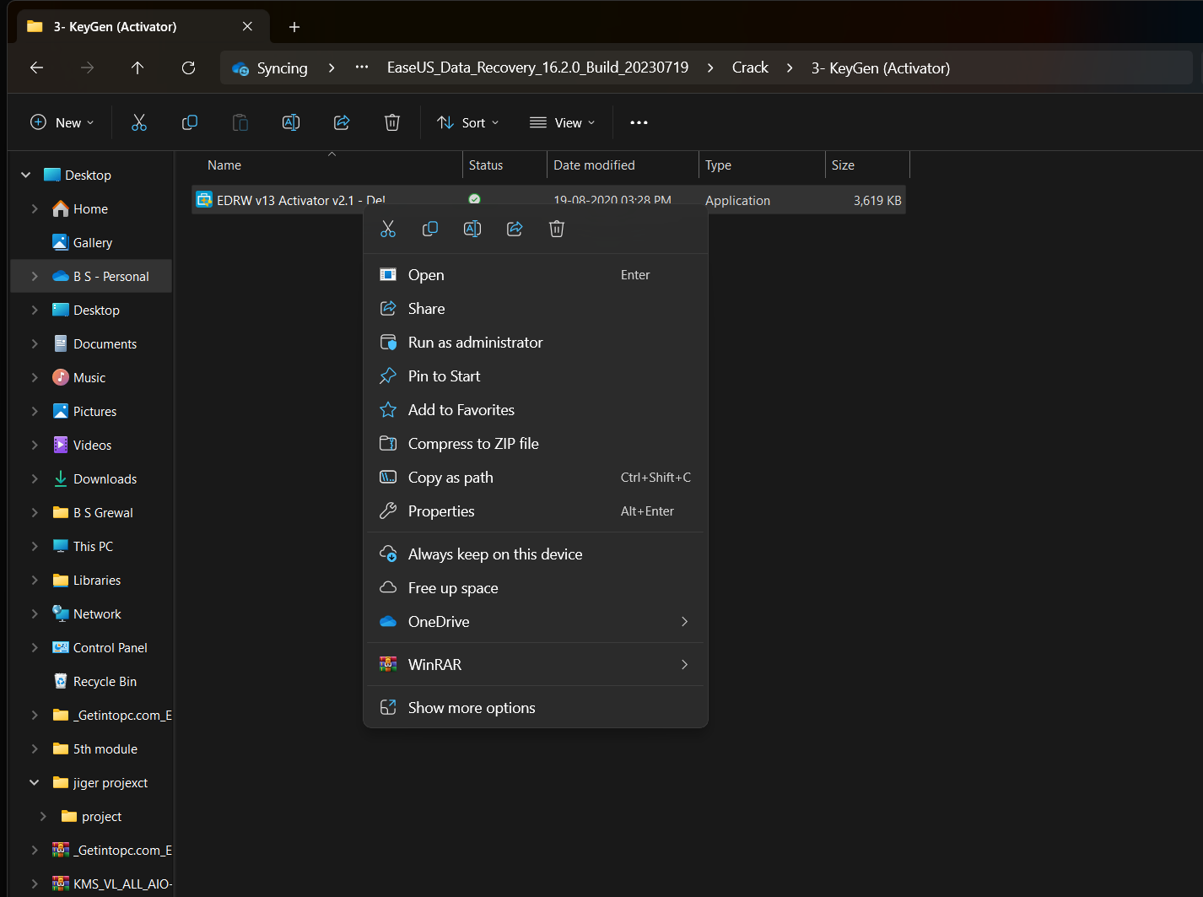

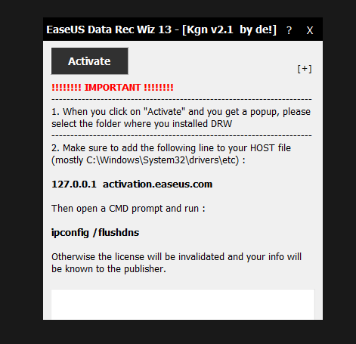

Step 6 :- Click activate and choose path where your software tool is installed

Path :- C:\Program Files\EaseUS\EaseUS Data Recovery Wizard

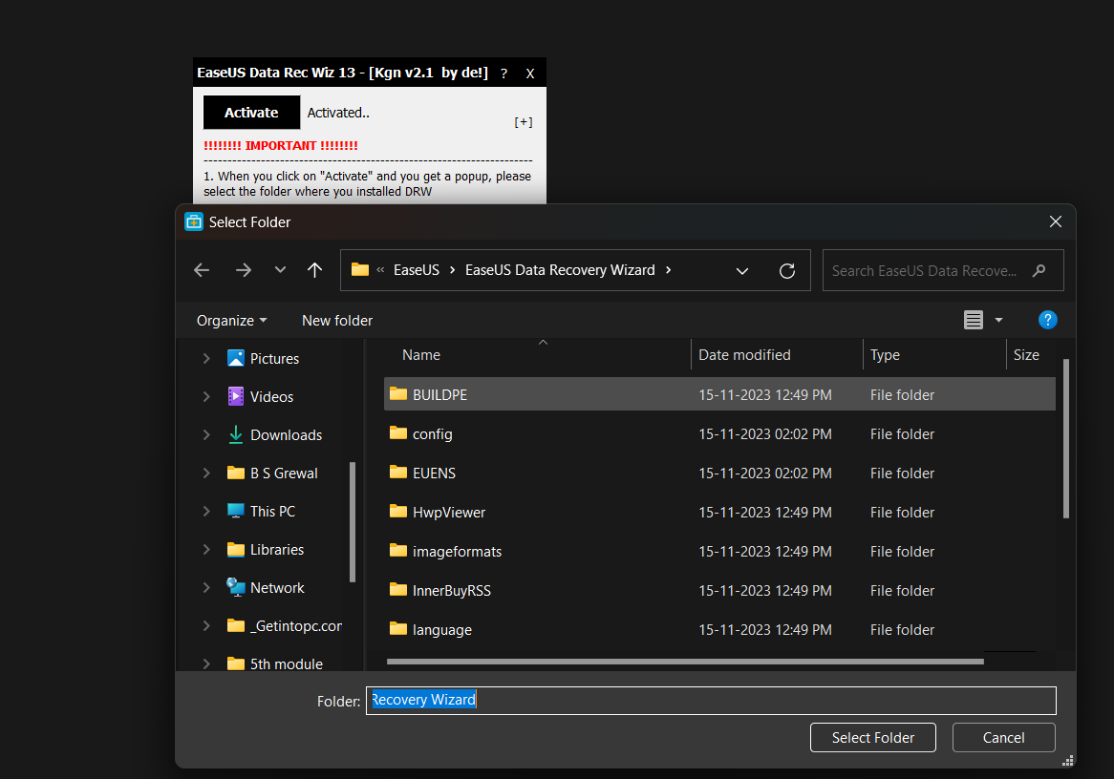

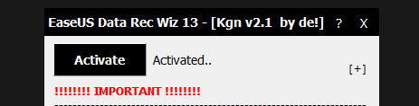

Step 7 :- your software is activated now you can use it to recover your lost data



