

**Project Report**

**On**

**“PHARMACY MANAGEMENT SYSTEM"**

**Submitted in Partial Fulfillment of**

**Bachelor of Business Administration ( BBA-CA Semester VI)**

**Faculty of Management (UG)**

**MIT WORLD PEACE UNIVERSITY**

**Submitted**

**By**

**VAIBHAV DIXIT ADITYA DAND**

**Roll No: 46 Roll No: 3**

**Faculty of Management (UG)**

**Department of Bachelor of Business Administration (Computer Application) BBA(CA)**

**CERTIFICATE**

This is to certify that Mr. Vaibhav G. Dixit has successfully completed Trimester VIII project work, titled Restaurant Management System in partial fulfillment of requirement, for the completion of BBA (CA) Programme, prescribed by MIT WPU. This project report is the record of authentic work carried out by him/her during the period from February 2019 to April 2019.

Date:

Signature Signature

Project Guide (Internal) External Examiner

Signature

Prof. Gautam Bapat

Program Head – BBA(CA)

**ACKNOWLEDGEMENT**

We are very glad to take this opportunity to acknowledge all those who helped us in developing and in successful execution of our Project on

“RESTAURANT MANAGEMENT SYSTEM”.

We would like to extend our thanks and gratitude to our Project guide Prof. Kalyani Belsare and for her valuable guidance and timely assistance throughout the development of the project.

We would also like to extend our thanks and gratitude to the Course In-charge Prof. Shalaka Ghodke without whose help and support this project would not have been possible.

Thanking you in anticipation.

|  |  |  |
| --- | --- | --- |
| **S.No** | **Title** | **Page No** |
|  | Certificate |  |
|  | Introduction of the system |  |
|  | Scope of the system |  |
|  | Objectives of the system |  |
|  | Hardware and Software Requirement |  |
|  | Functional and Non-functional Requirement |  |
|  | Requirement Gathering |  |
|  | System Design – DFD, ERD,CLD |  |
|  | Data Dictionary |  |
| 10. | Form Designing with input values |  |
| 11. | Advantage and Limitations |  |
| 12. | Future Enhancement |  |
| 13. | Bibliography |  |

**INDEX**

**INTRODUCTION OF THE SYSTEM**

A fully functional restaurant Management Unit involves many different processes like Bill Generation, Order Generation, Maintaining Customer relationships etc. This system is targeted to reduce introduction of errors, low reliability, no statistical data that we often find prevailing in manual work.

Having to have a look at the manual work every single time becomes too complex and time consuming. This Restaurant management system is being developed to override the current prevailing hardships faced in manual work.

The aim of this document is to gather information and analyze and give an in-depth insight of the complete Restaurant Management System. This system will help to automate the work and make it easier for the activities mentioned above with perfection, accuracy and not to mention, with ease!

**PROBLEM STATEMENT**

Main objective of this project is to show how automation of different systems in restaurant can be done; there are systems available in market that show maintain their chronicle, Dynamic database, customer details, etc.

With this system when we have customer sales, order details, etc. we can give information about functioning of the restaurant and how good or bad is it performing. With some minor tweaks system can perform much better and in more efficient manner. System available now have just a ability of bill generation and does not take total control of the system.

This system is to make software better and to relate and logically upgrade the current systems and increase restaurant and customer satisfaction.

**SCOPE OF THE STUDY**

The system will be a Stand-alone System for better efficient restaurant Management. It aims to maximize the productivity and provide improved and a managed system which would also be easy to understand and use.

This system will be designed to minimize the manual work in maintaining records, better management and all other activities as well.

More specifically, this system is designed to allow an admin to manage the records of orders, Maintaining Customer, bill generation, keep records of events taken place in any restaurant.

.

**OBJECTIVE OF THE STUDY**

The main objective of our project (Restaurant Management System) is to reduce the current prevailing hardships faced and provide flawless automation and management tool for the restaurant for all that the restaurant works like does like generating bill, keeping records, etc.

This is the system built at admin end. The main purpose of this system is to reduce manual work and to build a smooth Functioning system.

**HARDWARE AND SOFTWARE REQUIREMENTS**

* **System Requirement:**

OS Required: Microsoft Windows Vista, Microsoft Windows XP SP2 or later

OS Family: Windows

Additional Requirements: 5400 RPM or faster hard drive.

* **Details:**

Min Operating System: Microsoft Windows Vista, Microsoft Windows XP SP2 or later

Processor Speed: 1.6 Hz

Min RAM Size: 384 MB, 768 MB

Min Hard Drive Space: 2.2 GB

**REQUIREMENT GATHERING**

To study any system the analyst needs to collect facts and all relevant information. The facts when expressed in quantitative form are termed as data.

The success of any project depends upon the accuracy of available data. Accurate information can be collected with help of certain methods/ techniques. These specific methods for Gathering information of the system are termed as **fact finding techniques**.

Interview, Questionnaire, Record Review and Observations are the different fact finding techniques used by the analyst. The analyst may use more than one technique for investigation.

To make the system effective, we have followed following fact finding techniques to collect the detailed information about each and every aspect depending upon the nature of work and information needed.

**2.1.1 Interview:**

Pharmacy store authorities stationed in vicinity of Kothrud were interviewed to understand the system more openly and clearly.

Question 1 : Do you use any system for store management?

Ans: 30% yes, 30% only for bill, 40% No

Question 2 : Do you make orders manually?

Ans: 95% Yes

Question 3 : Do you maintain records?

Ans: 97% No

**2.1.2 Record:**

Observation of activities, their functionalities, records etc., thus providing with a thorough perspective.

**2.1.3 Observations:**

This technique helped in understanding the actual processes like buying goods, scheduling stock entry, maintaining the records, generating bills, creating Reports, etc. thus giving a physical overview.

**SYSTEM DESIGN**

**ENTITY RELATIONSHIP DIAGRAMS**

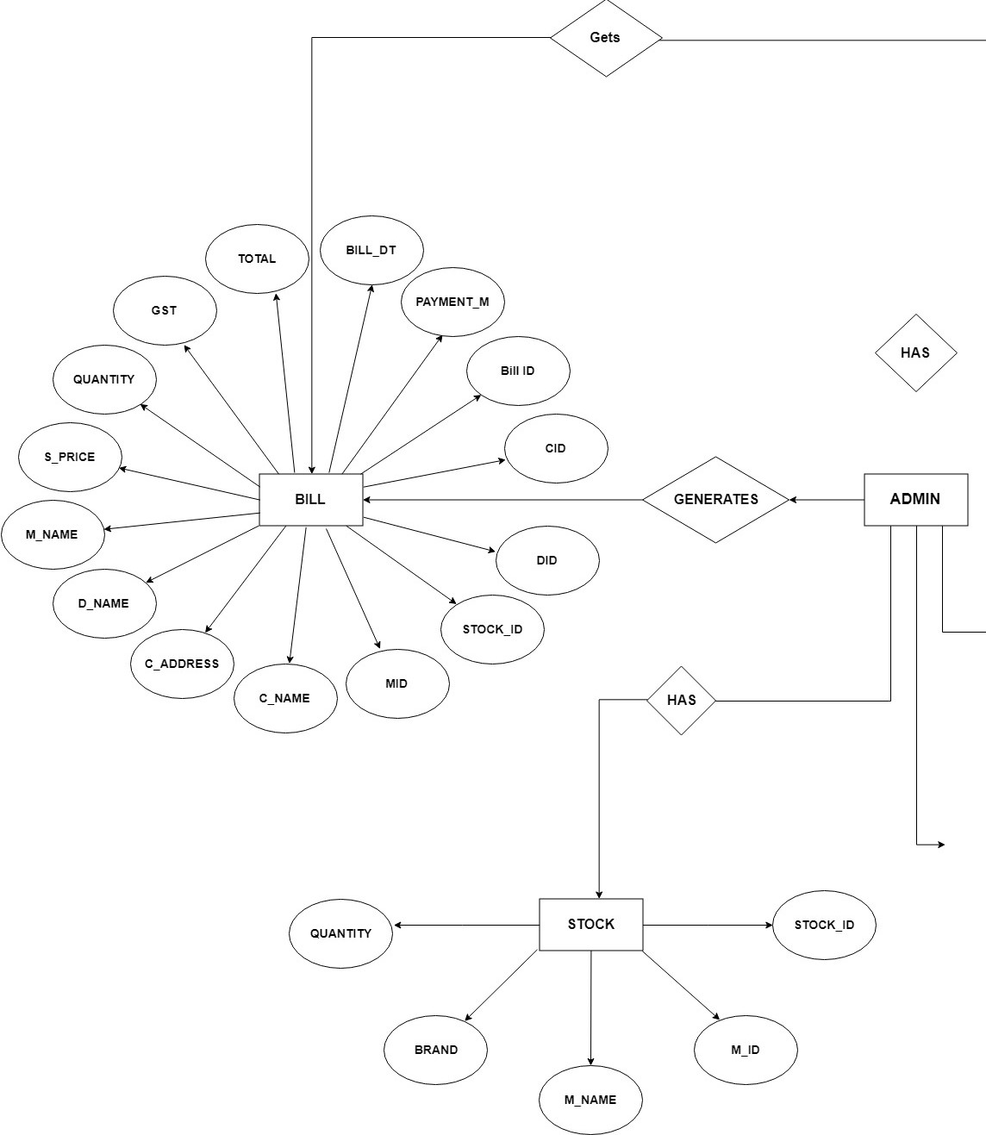

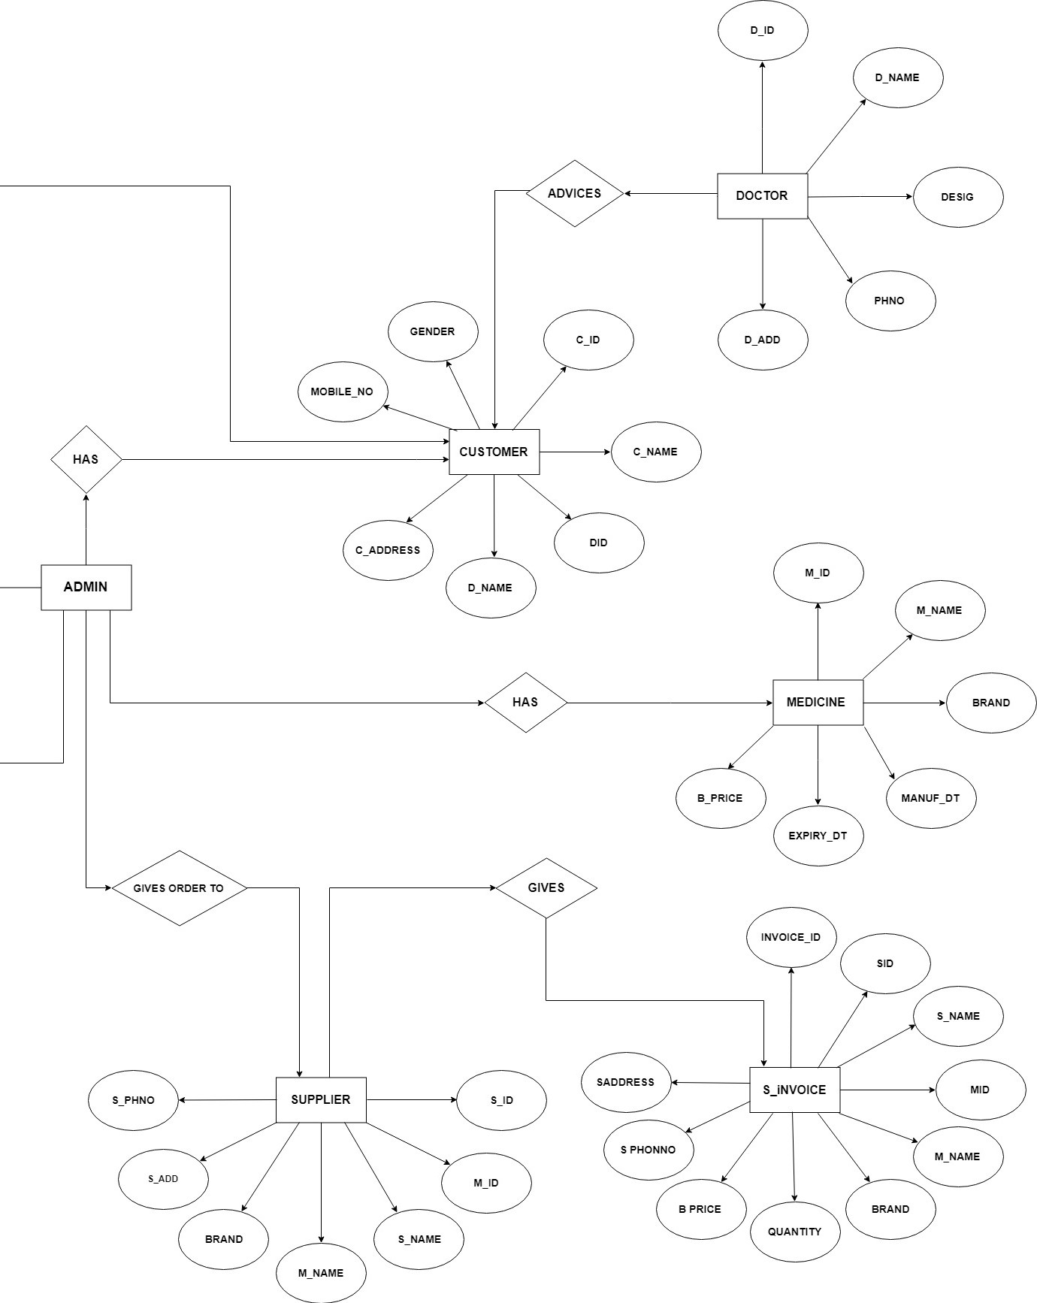

**CONTEXT LEVEL DIAGRAM**

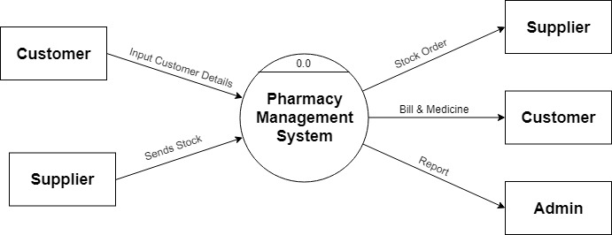

**DATA FLOW DIAGRAM**

**1ST LEVEL DFD**

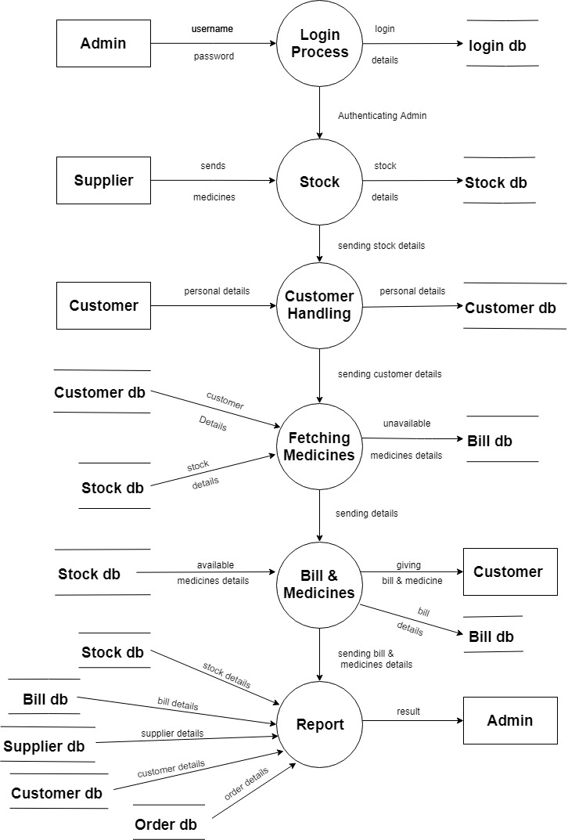

**2ND LEVEL DFD**

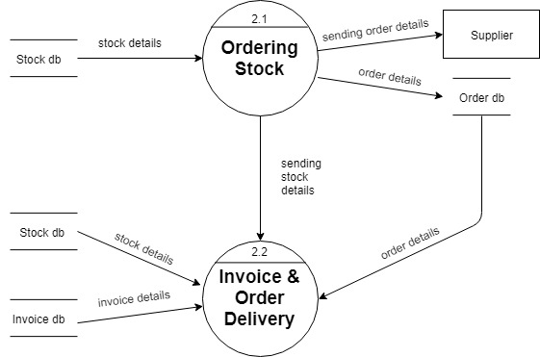

**DATA DICTIONARY**

**TABLE: CUSTOMER DETAILS**

|  |  |  |  |
| --- | --- | --- | --- |
| FIELD NAME | DATA TYPE | CONSTRAINTS | DESCRIPTION |
| CID | Number | Primary key | Unique (non – editable) |
| CNAME | Short text | Not null | Name (text only) |
| DID | Number | Foreign key | Did no same as Doctor master table |
| DNAME | Short text | Not null | Name (text only) |
| MOBILE_NO | Number | Not null | 10 digits only |
| CADDRESS | Short text | Not null | Address( text only) |
| GENDER | Short text | Not null | Male/Female |

**TABLE: DOCTOR DETAILS**

|  |  |  |  |
| --- | --- | --- | --- |
| FIELD NAME | DATA TYPE | CONSTRAINTS | DESCRIPTION |
| DID | Number | Primary key | Unique (non – editable) |
| DNAME | Short text | Not null | Name (text only) |
| DESIGNATION | Short text | Not null | Name (text only) |
| DADDRES | Short text | Not null | Address(text) |
| PHNO | Number | Not null | 10 digits only |

**TABLE: ORDER DETAILS**

|  |  |  |  |
| --- | --- | --- | --- |
| FIELD NAME | DATA TYPE | CONSTRAINTS | DESCRIPTION |
| ORDERID | Number | Primary key | Unique (non – editable) |
| SID | Number | Foreign key | Sid no same as Supplier master table |
| SNAME | Short text | Not null | Name (text only) |
| MID | Number | Foreign key | Mid no same as Medicines master table |
| MNAME | Short text | Not null | Name (text only) |
| BRAND | Short text | Not null | Name (text only) |

**TABLE: SINVOICE DETAILS**

|  |  |  |  |
| --- | --- | --- | --- |
| FIELD NAME | DATA TYPE | CONSTRAINTS | DESCRIPTION |
| INVOICEID | Number | Primary key | Unique (non – editable) |
| SID | Number | Foreign key | Sid no same as Supplier master table |
| SNAME | Short text | Not null | Name (text only) |
| MID | Number | Foreign key | Mid no same as Medicines master table |
| MNAME | Short text | Not null | Name (text only) |
| BRAND | Short text | Not null | Name (text only) |
| QUANTITY | Number | Not null | In (numbers only) |
| BPRICE | Number | Not null | In (numbers only) |
| SPHNO | Number | Not null | 10 digits only |
| SADD | Short text | Not null | Address(text) |

**TABLE: STOCK DETAILS**

|  |  |  |  |
| --- | --- | --- | --- |
| FIELD NAME | DATA TYPE | CONSTRAINTS | DESCRIPTION |
| STOCKID | Number | Primary key | Unique (non – editable) |
| MID | Number | Foreign key | Mid no same as Medicines master table |
| MNAME | Short text | Not null | Name (text only) |
| BRAND | Short text | Not null | Name (text only) |
| QUANTITY | Number | Not null | In (numbers only) |

**TABLE: SUPPLIER DETAILS**

|  |  |  |  |
| --- | --- | --- | --- |
| FIELD NAME | DATA TYPE | CONSTRAINTS | DESCRIPTION |
| SID | Number | Primary key | Unique (non – editable) |
| MID | Number | Foreign key | Mid no same as Medicines master table |
| SNAME | Short text | Not null | Name (text only) |
| MNAME | Short text | Not null | Name (text only) |
| BRAND | Short text | Not null | Name (text only) |
| SADD | Short text | Not null | Address(text) |
| SPHNO | Number | Not null | 10 digits only |

**TABLE: MEDICINE DETAILS**

|  |  |  |  |
| --- | --- | --- | --- |
| FIELD NAME | DATA TYPE | CONSTRAINTS | DESCRIPTION |
| MID | Number | Primary key | Unique (non – editable) |
| MNAME | Short text | Not null | Name (text only) |
| BRAND | Short text | Not null | Name (text only) |
| MANUF_DT | date/time | Not null | Date (MM/DD/YYYY) |
| EXPIRY_DT | date/time | Not null | Date (MM/DD/YYYY) |
| B_PRICE | Number | Not null | Rate in (RS) |
| S_PRICE | Number | Not null | Rate in (RS) |

**TABLE: BILL DETAILS**

|  |  |  |  |
| --- | --- | --- | --- |
| FIELD NAME | DATA TYPE | CONSTRAINTS | DESCRIPTION |
| BILL_ID | Number | Primary key | Unique (non – editable) |
| CID | Number | Foreign key | Cid no same as Customer master table |
| DID | Number | Foreign key | Did no same as Doctor master table |
| STOCKID | Number | Foreign key | StockId no same as Stock master table |
| MID | Number | Foreign key | Mid no same as Medicines master table |
| CNAME | Short text | Not null | Name (text only) |
| CADDRESS | Short text | Not null | Address(text) |
| DNAME | Short text | Not null | Name (text only) |
| MNAME | Short text | Not null | Name (text only) |
| SPRICE | Number | Not null | Rate in (RS) |
| QUANTITY | Number | Not null | In (numbers only) |
| GST | Number | Not null | In (numbers only) |
| TOTAL | Number | Not null | In (numbers only) |
| BILL_DT | date/time | Not null | Date (MM/DD/YYYY) |
| PAYMENT_M | Short text | Not null | Method (numbers only) |

**LIST OF TABLES**

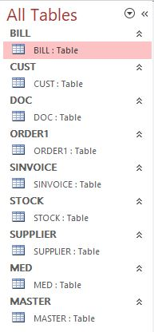

**RELATIONSHIPS**

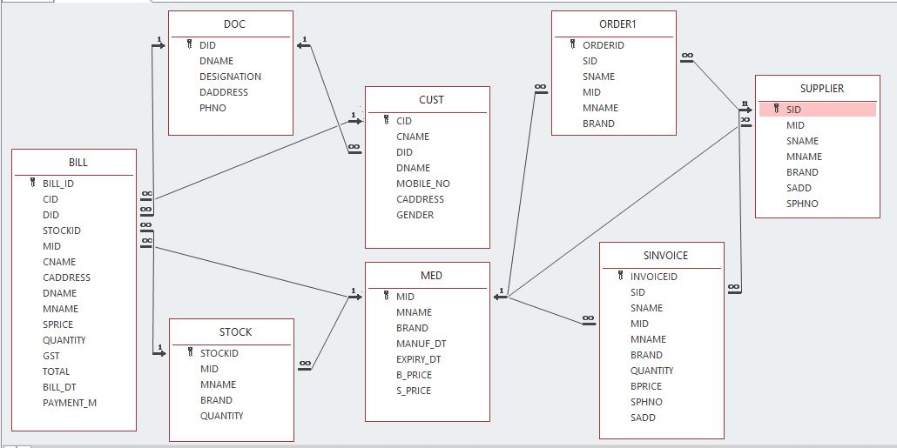

**FORM SCREEN**

**LOGIN FORM**

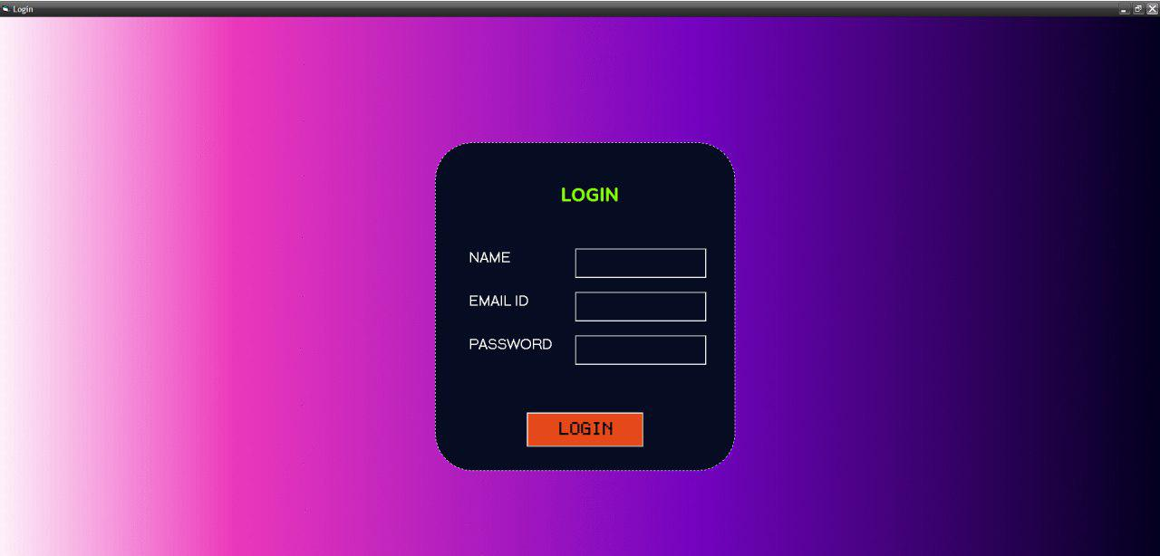

**START PAGE**



**CUSTOMER**

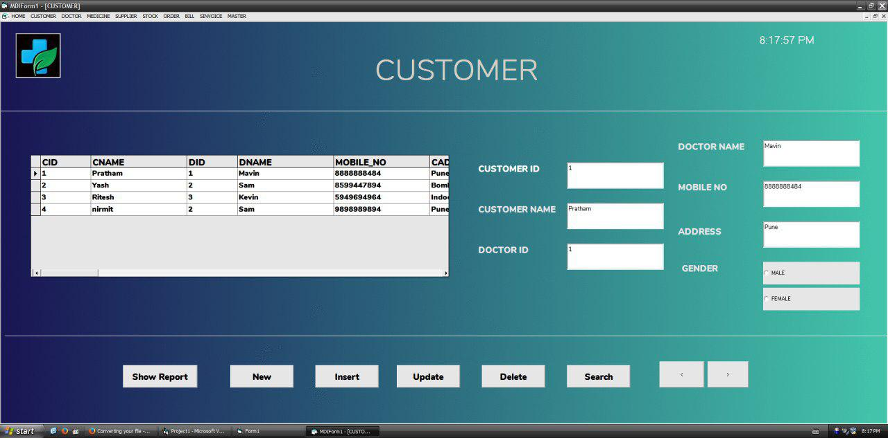

**DOCTOR**

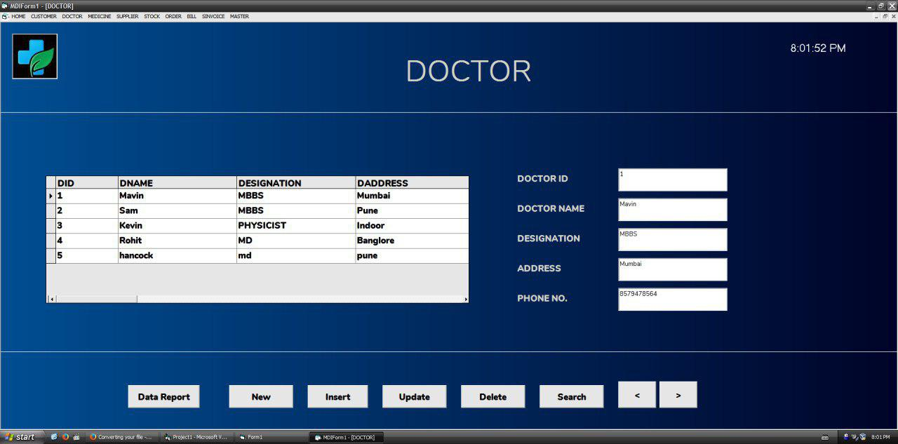

**MEDICINE**

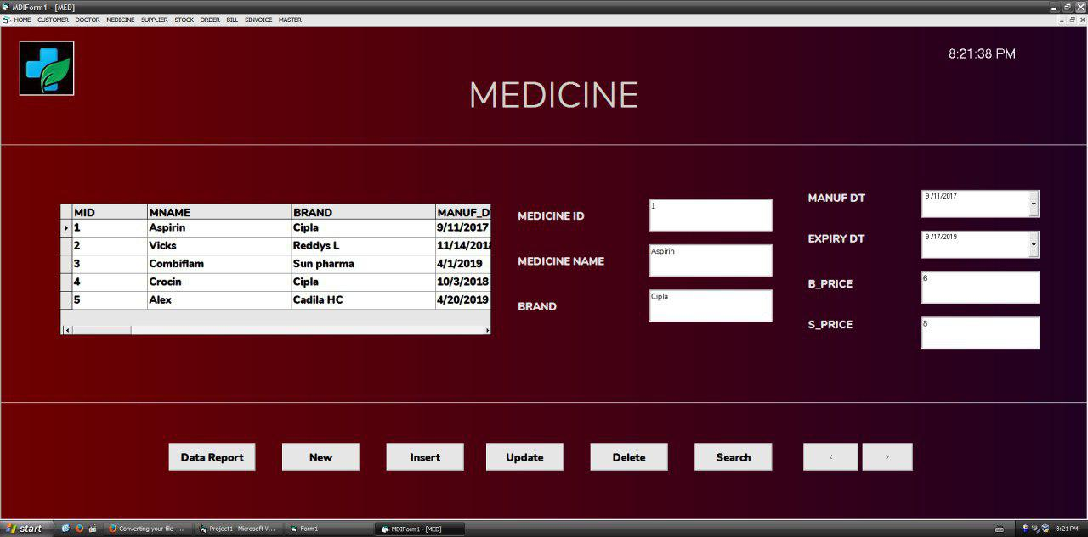

**SUPPLIER**

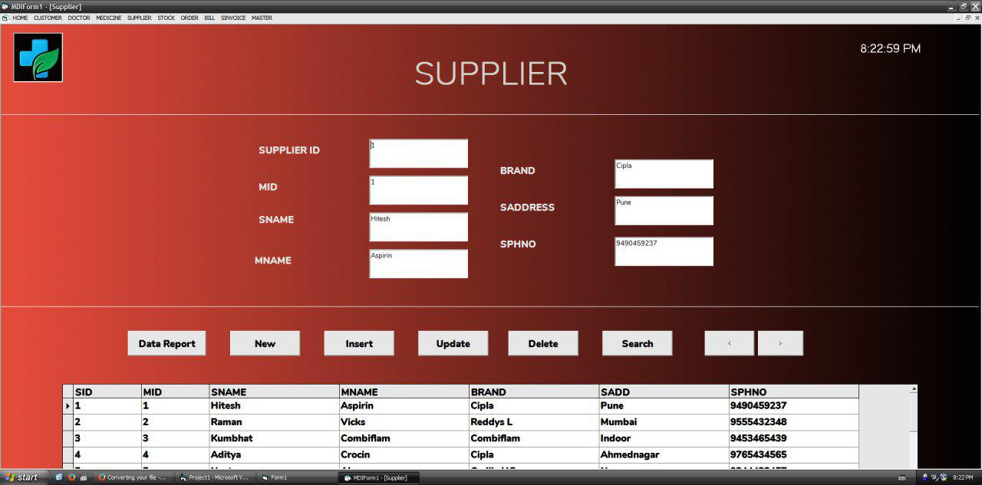

**STOCK**

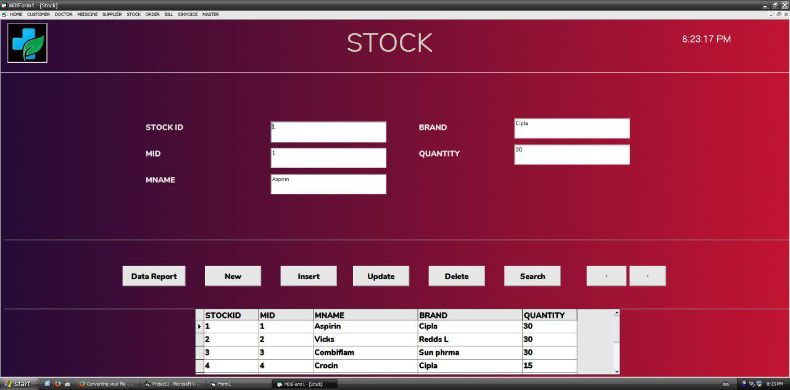

**ORDER**

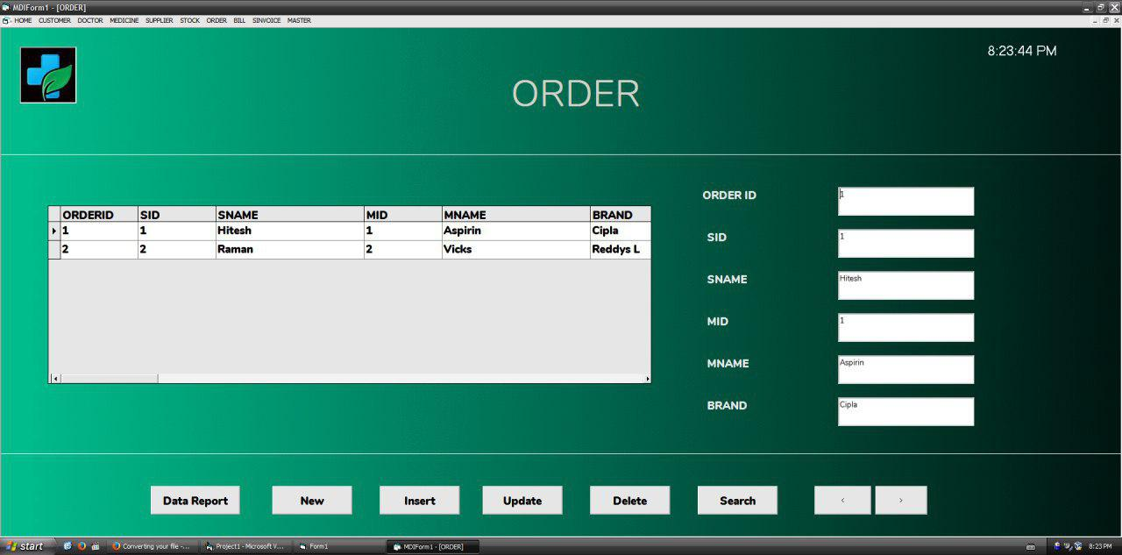

**BILL**

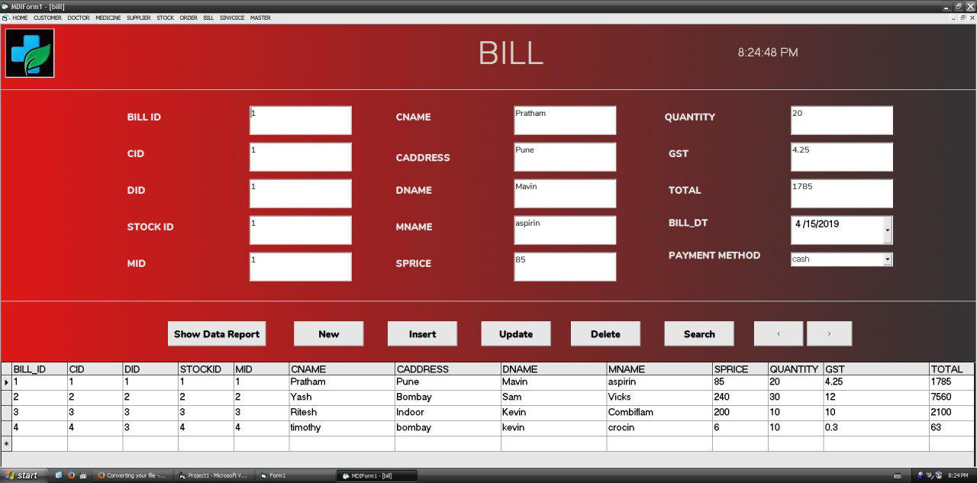

**SINVOICE**

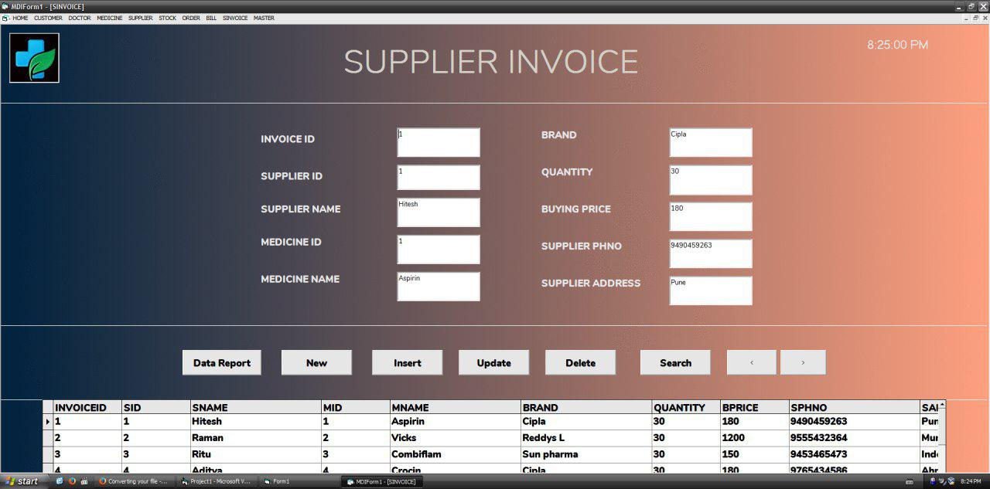

**REPORT**

**CUSTOMER**

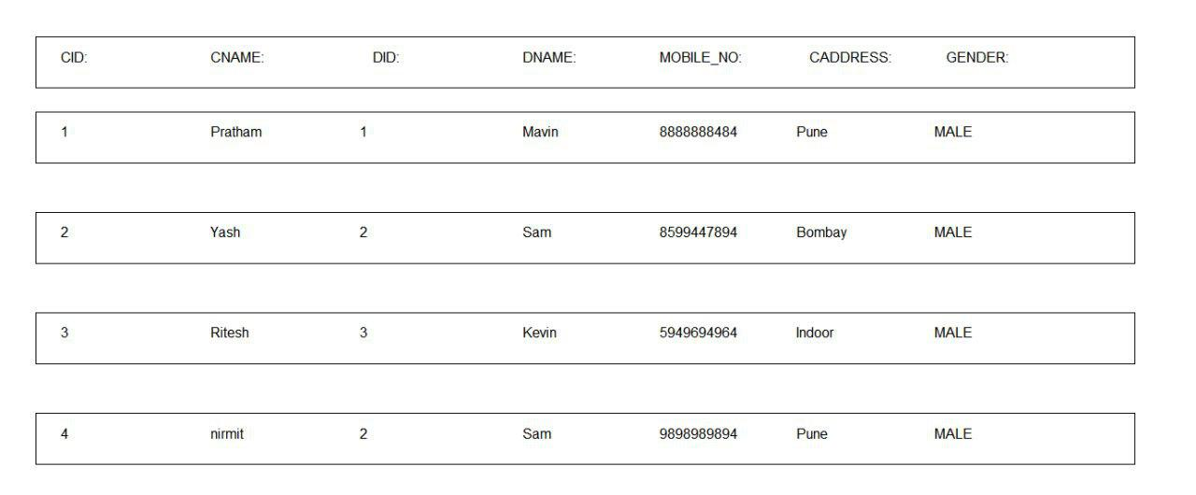

**DOCTOR**

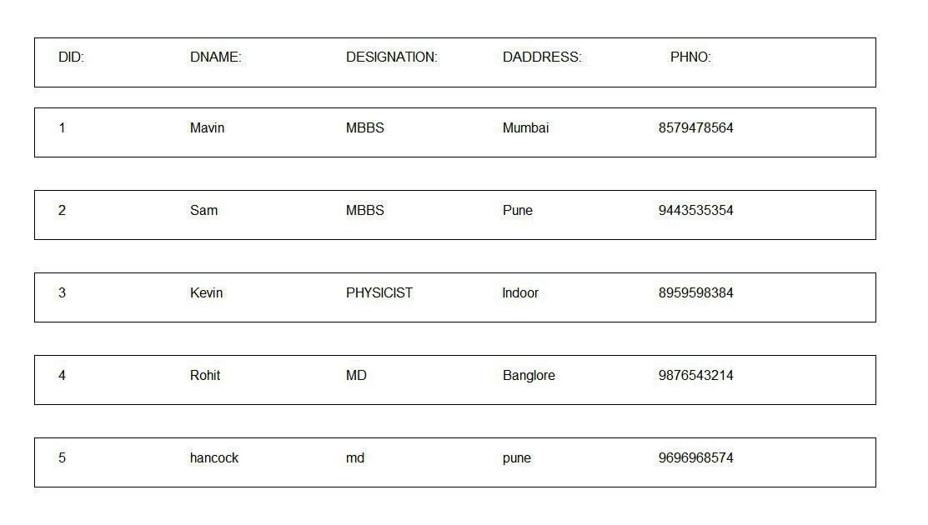

**MEDICINE**

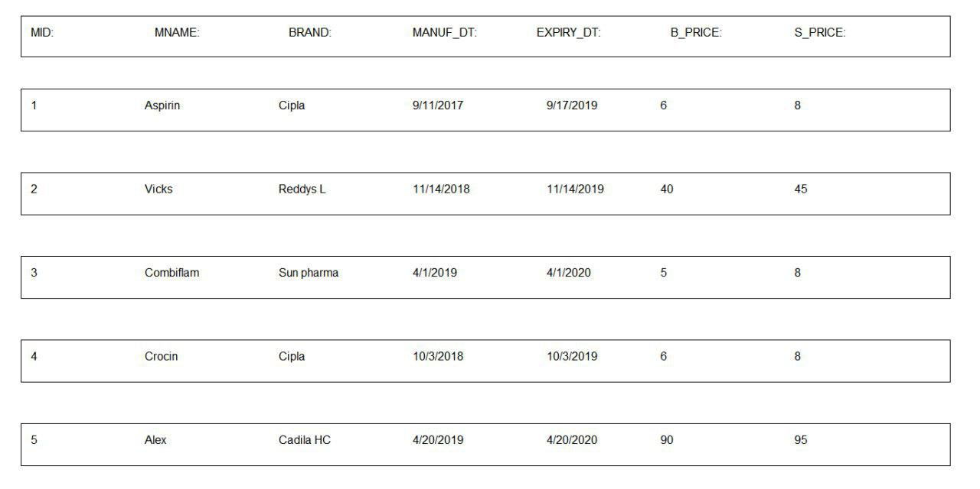

**SUPPLIER**

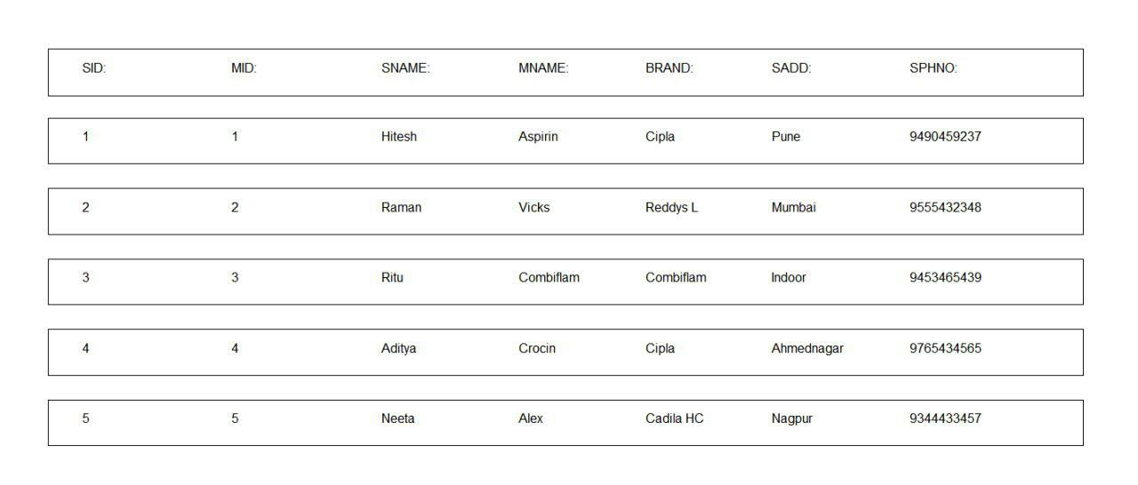

**STOCK**

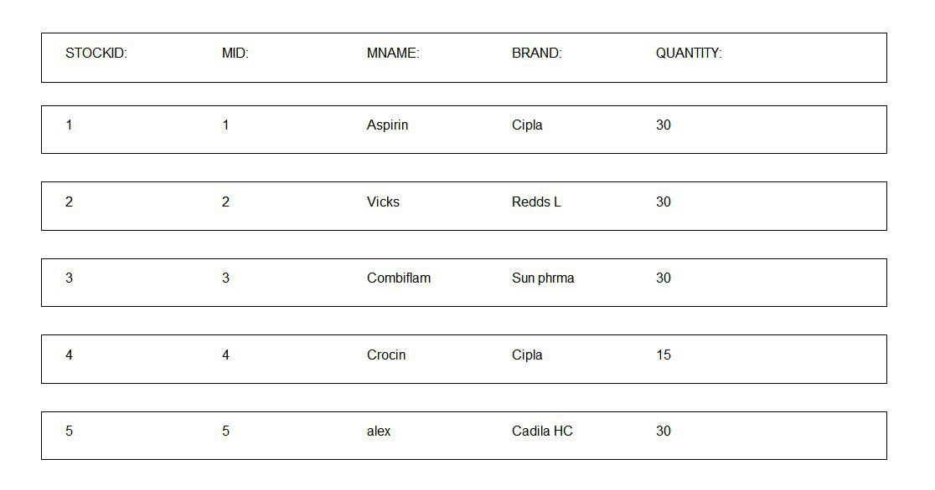

**ORDER**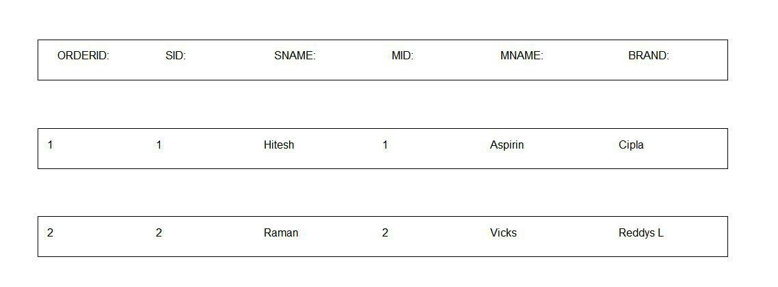

**BILL**

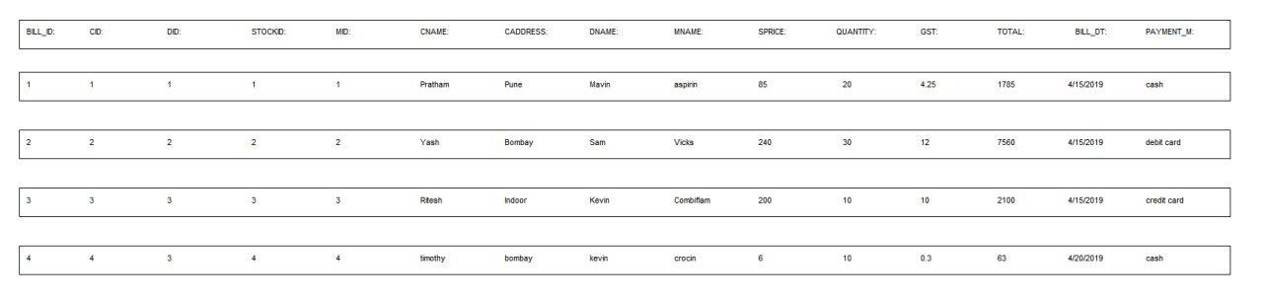

**SINVOICE**



**­­**

**ADVANTAGES AND LIMITATIONS**

* **Advantages:**

The system is very simple in design and to implement.

It requires very low system resources and will work in almost all configurations.

It has got following advantages:

* Admin controlled system.
* Easy data updating.
* Less error prone.
* Accurate analysis.
* User friendly application.
* System reduces manual workload.
* Well maintained database.
* Redundancy of data is dissolved.
* Hassel-free updating.
* Data reports are provided.
* Pretty flexible working.
* Records’ retrieved as and when required.
* Fast processing.
* Graphical explanation present.
* R-to-R approach i.e. from registration to the reports’ generation.
* **Limitations:**

Every system has some limitations or drawbacks.

Some of the limitations are:

* Despite of taking adequate measures, large amount of data can sometime result into system overload.
* Applied measures/ strategy may not be always effective in fulfilling customer expectations.
* Prerequisites needed could be critical at times.

**FUTURE ENHANCEMENTS**

* With the help of internet online prescription can be uploaded and delivery can be made.
* Detailed analysis of sales, stocks and progress of store in more enhance manner.
* Cognizance regarding the overcrowding of data.
* Enhancing data storing and representation of data in dynamic form.
* Efficient balancing of both stock and sales.

**BIBLIOGRAPHY**

* **BOOKS REFERRED**
* Learn VB in 72 Hours
* Microsoft Visual Basic 2008 Express Edition: Build a Program Now!
* **WEBSITE REFERRED**
* [www.vbtutor.com](http://www.vbtutor.com)
* [www.guru99.com](http://www.guru99.com)
* [www.vb.nettutorials.com](http://www.vb.nettutorials.com)
* [www.VisualStudioHints.com](http://www.VisualStudioHints.com)
* [www.youtube.com](http://www.youtube.com)
* www.draw.io