Assignment 4 Q1

Barbara Rose Hoover

11/8/2018

### 1. Lobster abundance and fishing pressure (2012 - 2017)

Describe trends in *lobster abundance (counts)* and *fishing pressure (trap buoys)* at the five locations from 2012 - 2017. Ignore transect information - we are only interested in evaluating abundance and pressure on the order of SITE. Note: you are not expected to use regression here - just think of ways to clearly describe annual totals visually and in text, noting important trends, events and differences.

lobster_traps <- read_csv("lobster_traps.csv")

## Parsed with column specification:  
## cols(  
## YEAR = col_integer(),  
## MONTH = col_integer(),  
## DATE = col_character(),  
## FISHING_SEASON = col_character(),  
## SITE = col_character(),  
## SWATH_START = col_character(),  
## SWATH_END = col_character(),  
## TRAPS = col_integer(),  
## OBSERVER = col_integer(),  
## NOTES = col_character()  
## )

lobster_size_abundance <- read_csv("lobster_size_abundance.csv")

## Parsed with column specification:  
## cols(  
## YEAR = col_integer(),  
## MONTH = col_integer(),  
## DATE = col_character(),  
## SITE = col_character(),  
## SBC_LTER_TRANSECT = col_integer(),  
## LOBSTER_TRANSECT = col_character(),  
## SIZE = col_integer(),  
## COUNT = col_integer()  
## )

# 1.Describe Lobster Abundance and Fishing Pressure (2012-2017)

## Lobster Abundance

##library(plyr)  
lb_count_month_year<- lobster_size_abundance %>%  
 filter(SITE == "AQUE" | SITE == "CARP" | SITE == "IVEE" | SITE == "MOHK" | SITE == "NAPL") %>%  
 group_by(SITE, YEAR) %>%  
 select(YEAR,SITE,COUNT)   
  
lb_count_month_year<- aggregate(COUNT~SITE+YEAR, data=lb_count_month_year, sum)  
lb_count_month_year<- mutate(lb_count_month_year, MPA = ifelse(grepl("IVEE", SITE), "Yes",  
 ifelse(grepl("NAPL", SITE), "Yes", "No")))   
   
  
lb_count_month_year

## SITE YEAR COUNT MPA  
## 1 AQUE 2012 38 No  
## 2 CARP 2012 78 No  
## 3 IVEE 2012 26 Yes  
## 4 MOHK 2012 83 No  
## 5 NAPL 2012 6 Yes  
## 6 AQUE 2013 32 No  
## 7 CARP 2013 93 No  
## 8 IVEE 2013 40 Yes  
## 9 MOHK 2013 15 No  
## 10 NAPL 2013 63 Yes  
## 11 AQUE 2014 100 No  
## 12 CARP 2014 78 No  
## 13 IVEE 2014 132 Yes  
## 14 MOHK 2014 34 No  
## 15 NAPL 2014 159 Yes  
## 16 AQUE 2015 83 No  
## 17 CARP 2015 90 No  
## 18 IVEE 2015 361 Yes  
## 19 MOHK 2015 296 No  
## 20 NAPL 2015 270 Yes  
## 21 AQUE 2016 48 No  
## 22 CARP 2016 231 No  
## 23 IVEE 2016 193 Yes  
## 24 MOHK 2016 210 No  
## 25 NAPL 2016 127 Yes  
## 26 AQUE 2017 67 No  
## 27 CARP 2017 705 No  
## 28 IVEE 2017 606 Yes  
## 29 MOHK 2017 178 No  
## 30 NAPL 2017 112 Yes

lb_trends_plot<-ggplot(lb_count_month_year, aes(factor(YEAR), COUNT, group = SITE,   
 color = SITE)) +   
 geom_line(size = 1, alpha = 0.8, aes(linetype = MPA)) +  
 geom_point() +  
 scale_color_brewer(name = "Location", palette = "Set1")+  
 xlab("Year") +   
 ylab("Lobster Count")+  
 labs(title = "Lobster Abundance")  
lb_trends_plot

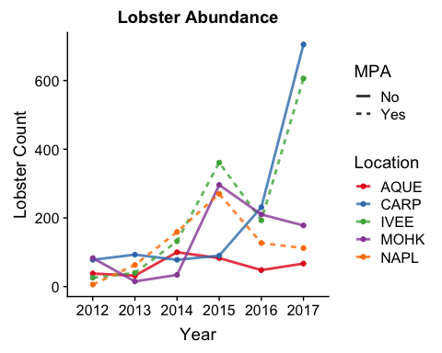

## Fishing Pressure

fishing_pressure_month_year<- lobster_traps %>%  
 filter(SITE == "AQUE" | SITE == "CARP" | SITE == "IVEE" | SITE == "MOHK" | SITE == "NAPL") %>%  
 group_by(SITE, YEAR, MONTH) %>%  
 select(YEAR,SITE,TRAPS)

## Adding missing grouping variables: `MONTH`

fishing_pressure_month_year

## # A tibble: 3,704 x 4  
## # Groups: SITE, YEAR, MONTH [150]  
## MONTH YEAR SITE TRAPS  
## <int> <int> <chr> <int>  
## 1 10 2012 CARP 4  
## 2 10 2012 CARP 14  
## 3 10 2012 CARP 10  
## 4 10 2012 CARP 7  
## 5 10 2012 CARP 11  
## 6 10 2012 CARP 12  
## 7 10 2012 CARP 12  
## 8 10 2012 CARP 2  
## 9 10 2012 CARP 13  
## 10 10 2012 CARP 5  
## # ... with 3,694 more rows

fishing_pressure_month_year<- aggregate(TRAPS~SITE+YEAR, data=fishing_pressure_month_year, sum)  
fishing_pressure_year<- mutate(fishing_pressure_month_year, MPA = ifelse(grepl("IVEE", SITE), "Yes",  
 ifelse(grepl("NAPL", SITE), "Yes", "No")))   
   
  
fishing_pressure_year

## SITE YEAR TRAPS MPA  
## 1 AQUE 2012 509 No  
## 2 CARP 2012 788 No  
## 3 IVEE 2012 0 Yes  
## 4 MOHK 2012 567 No  
## 5 NAPL 2012 0 Yes  
## 6 AQUE 2013 813 No  
## 7 CARP 2013 1039 No  
## 8 IVEE 2013 0 Yes  
## 9 MOHK 2013 448 No  
## 10 NAPL 2013 0 Yes  
## 11 AQUE 2014 685 No  
## 12 CARP 2014 1164 No  
## 13 IVEE 2014 0 Yes  
## 14 MOHK 2014 518 No  
## 15 NAPL 2014 0 Yes  
## 16 AQUE 2015 676 No  
## 17 CARP 2015 568 No  
## 18 IVEE 2015 0 Yes  
## 19 MOHK 2015 357 No  
## 20 NAPL 2015 0 Yes  
## 21 AQUE 2016 816 No  
## 22 CARP 2016 1176 No  
## 23 IVEE 2016 0 Yes  
## 24 MOHK 2016 345 No  
## 25 NAPL 2016 0 Yes  
## 26 AQUE 2017 179 No  
## 27 CARP 2017 108 No  
## 28 IVEE 2017 0 Yes  
## 29 MOHK 2017 40 No  
## 30 NAPL 2017 0 Yes

fishing_pressure_plot<-ggplot(fishing_pressure_year, aes(factor(YEAR), TRAPS, group = SITE, color = SITE)) +   
 geom_line(size = 1, alpha = 0.8, aes(linetype = MPA)) +  
 geom_point() +  
 scale_color_brewer(name = "Location", palette = "Set1")+  
 xlab("Year") +   
 ylab("Trap Count")+  
 labs(title = "Lobster Fishing Pressure")  
fishing_pressure_plot

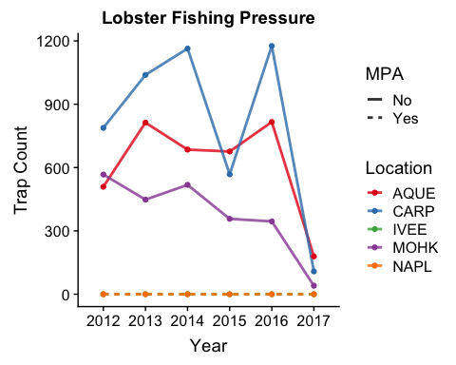

quartz(fishing_pressure_plot)

## Warning: 'mode(title)' differs between new and previous  
## ==> NOT changing 'title'

## Warning: 'length(title)' differs between new and previous  
## ==> NOT changing 'title'