**Real World Object-Capture in a Mixed-Reality Environment**

**Week 9 Report, SOC10101 Honours Project**

**Beej Persson, 40183743**

1. **Aims and Objectives**

This project aims to evaluate the effectiveness of capturing real world objects using Vuforia on the Microsoft HoloLens. Initially, a method to capture simple objects will be developed, before attempts to manipulate the objects in real-time will be implemented. The project aims to explore the extent to which this can be done.

1. **Project Progress**

To start the project an Initial Project Overview was written detailing some of the key milestones, the work to be undertaken and the challenges to be overcome, as well as highlighting the importance of the project and its potential target audience. After this a Project Plan was written up with preferred deadlines for the preliminary objectives of the project.

Following the plan, the first task was to research the required software to determine a sensible way to proceed as there were a few options available going forward (ref [1]). At the start consideration was put into working with the HoloLens Emulator but there was an issue with this: the main device being used to undertake the project ran on an operating system that didn’t support Hyper-V, software required to run the emulator. Another possible option was to start the project by attempting some simple object capture on Android using Vuforia, however it was decided that the required time investment would be too high given that it was slightly out of scope of the projects key goals. As a result of this preliminary research it was decided to proceed by working with the HoloLens itself.

Therefore, the next task was to build a basic application on a development PC that runs on the Microsoft HoloLens. The application would be a built in Visual Studio 2017 as a Universal Windows Application. This was more complicated than it had seemed beforehand and extra time was needed to complete this step, pushing back other tasks. Simply linking the HoloLens to the development PC took some time. Due to the work being undertaken in the university’s Games Lab, there were connectivity issues when trying to link the devices over the Wi-Fi (which was the recommended method of connection according the HoloLens development website). Instead, the devices were linked by enabling Developer Mode on the PC and connecting them using a USB cable, which required pairing the devices using a PIN. At this point an application could be deployed from Visual Studio over USB to the HoloLens. A simple application consisting of a button that played audio when pressed was built and operated correctly on the HoloLens.

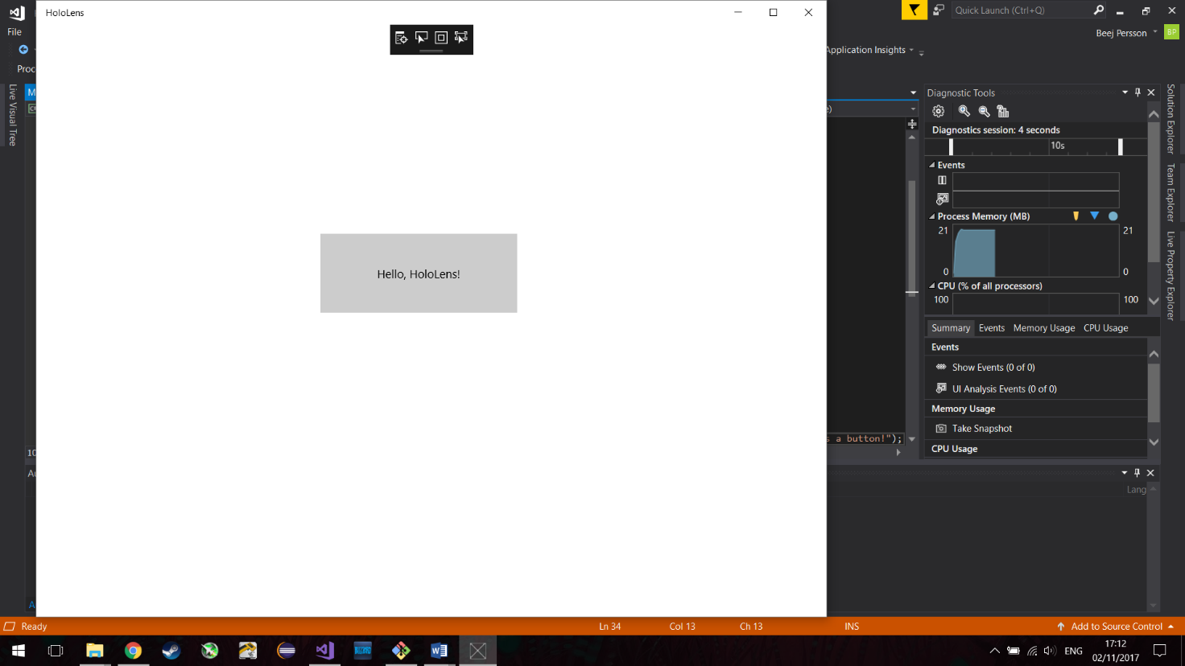

Fig. 1. A screenshot of the basic Universal Application when run on Visual Studio 2017 on the development PC.

This is the stage the project is at now. The next task is to begin working Unity to build a 3D application that runs on the HoloLens, before working with Vuforia to capture simple objects.

1. **Plan of Work**

*Date to be completed* Task

*X 29th September:* Write Initial Project Overview and Project Plan.

*X 13th October:* Research similar attempts at mixed-reality object manipulation.

Research required software and decide on preferred way to proceed.

*X 20th October:* Start with a HoloLens, get a basic app running.

*X 3rd November:* Report back on findings, writing Interim Report.

*(Evidence of attending meetings, aims and objectives, having a plan of work, how I am going evaluate.)*

*~~~~~~~~~~~~~~~~~~Below subject to change based on progress~~~~~~~~~~~~~~~~~~*

*17th November:* Get running with Vuforia in Unity.

Attempt to capture simple objects.

*1st December:* Explore manipulation of objects.

*~~~~~~~~~~~~~~~~~~~~~~~~Below to be done next year~~~~~~~~~~~~~~~~~~~~~~~~*

Explore and evaluate the extent to which the objects can be manipulated in real-time.

Document and report findings, writing dissertation.

Design and create poster.

1. **Evaluation**

This project looks to evaluate the effectiveness of capturing real world objects using Vuforia on the Microsoft HoloLens and exploring the extent to which these object manipulations can be performed in real-time. Real-time will be defined as providing the necessary feedback to the user after specific inputs within a time-frame small enough that it feels instant, roughly less than 100 milliseconds. The project could benefit from a survey ran where participants are asked whether they felt the software performed in real-time. Evaluation will be performed by measuring the performance of the object manipulations and determining whether it is realistic to have such software operating in real-time in a mixed-reality environment and thereby helping to determine the project’s significance. If the outcome of the project is software that can perform simple manipulations of multiple real-world objects in a mixed-reality environment, then the project can be deemed a worthwhile endeavour.

**References**

[1] https://developer.microsoft.com/en-us/windows/mixed-reality/development

✔ Define real-time

✔ Reference research done on software

✔ Possible surveys: are you convinced this has been manipulated in front of them?