

School of Future Tech

Case Study Report

on

Course Registration System

by

Bhaumikk Keer

150096725030

Index
- Introduction to the Case Study.
- Problem Statement / Case Background (Abstract).
- Problem Statement / Case Study Design.
- Methods & Algorithms Technology Applied in the Problem Statement / Case Study.
- Problem Statement / Case Study Implementation Details and Snapshots.
- Problem Statement / Case Study Results and Conclusion.
- References

1. Introduction to the Case Study
Managing course registrations is a fundamental challenge faced by educational institutions. When students must manually track available seats, prevent duplicate enrolments, and drop courses efficiently, the process requires careful coordination between data management and user interaction. This case study presents the design and implementation of a Console-Based Course Registration System written in C++, which simulates the core registration workflow found in real-world academic environments.
The system is built as a menu-driven application that allows a student to view available courses, register for courses of their choice, drop previously registered courses, and view their current enrolment list at any time during a session. Structurally, the application uses arrays and the C++ struct mechanism to organise course information, demonstrating fundamental techniques in data management with statically allocated memory.
By working through this case study, learners gain hands-on exposure to applying arrays and structures for data organisation, writing conditional logic for input validation, and using loops to sustain interactive program flow. The case study also reinforces good software design habits.

2. Problem Statement / Case Background (Abstract)

Background
Universities and colleges routinely face the challenge of coordinating course registrations across large student populations. Traditional paper-based or manual systems are prone to errors such as exceeding class capacity, duplicate registrations, and difficulty tracking enrolment in real time. Software-based registration systems address these shortcomings by enforcing business rules automatically and providing instant feedback to the user.
This case study simulates a simplified version of such a system. It focuses specifically on the core operations that a student-facing registration interface must support: browsing the catalogue, claiming a seat in a course, releasing a seat when a course is no longer required, and reviewing one's own registration list. Although simplified, the design mirrors the logic used in production academic management systems.

Abstract
This case study presents the design and implementation of a Course Registration System using C++. A pre-loaded catalogue of five courses, each with a course code, title, maximum seat capacity, and current enrolment count, is managed through a menu-driven console interface. Students can register for up to five courses per session. The system validates each registration attempt against three constraints: duplicate enrolment prevention, capacity enforcement, and the per-student registration limit. Courses can be dropped at any time, freeing the seat for other students. The implementation demonstrates the practical use of C++ structs, parallel arrays, linear search, and array compaction for deletion, providing a foundation for understanding how larger-scale registration platforms manage dynamic enrolment data.

3. Case Study Design
The Course Registration System is structured as a modular single-file C++ application with five logical components:
- Data Model — A Course struct holds the course code, course name, seat capacity, and current enrolment count. A global array of five Course objects forms the course catalogue. A parallel string array tracks the codes of courses registered by the student, managed alongside an integer counter.
- View Courses Module — Iterates over the catalogue array and prints each course's code, name, and remaining seats (capacity minus enrolled) in a formatted list.
- Registration Module — Accepts a serial number from the user, maps it to a catalogue index, and performs three sequential checks: (a) whether the student is already enrolled, (b) whether any seats remain, and (c) whether the student has reached the five-course limit. On success, the enrolment counter is incremented and the code is appended to the registration array.
- Drop Module — Displays the student's current registrations, accepts a choice, and removes the selected entry using left-shift array compaction. The corresponding catalogue enrolment counter is decremented simultaneously.
- Menu Loop — A while(true) loop in main() repeatedly displays the menu and dispatches to the appropriate function using a switch statement, exiting cleanly when the user selects option 5.

The data flow for a registration operation is:
- User selects "Register Course" from the menu.
- System calls viewcourse() to display available courses.
- User enters a serial number; system validates range.
- System checks for duplicate registration via linear search on the registration array.
- System checks seat availability in the catalogue.
- On success: catalogue enrolled++ and code appended to registration array.
- On failure: appropriate error message displayed; state unchanged.

4. Methods & Algorithms Technology Applied in the Problem Statement / Case Study
Key methods and algorithms used in the implementation:
- Struct-based Data Modelling — The Course struct groups related fields (code, name, capacity, enrolled) into a single named type, enabling the array of courses to be treated as a table of records. This mirrors the concept of a database row in a simplified in-memory form.
- Linear Search — Before registering a course, the system scans the registration array from index 0 to regcount-1 comparing each stored code with the requested code. This O(n) search ensures duplicate entries are prevented without requiring sorted data.
- Array Compaction for Deletion — When a course is dropped, the system shifts all elements to the right of the removed index one position to the left and decrements regcount. This in-place deletion keeps the registration array contiguous without requiring dynamic memory allocation.
- Boundary Validation — All user-supplied indices are checked against valid bounds before use, preventing out-of-range array access. Registration also checks the per-student limit and per-course capacity before modifying any state, ensuring the data remains consistent at all times.
- Menu-Driven Control Flow — A while(true) loop combined with a switch statement provides an interactive, persistent interface. The loop exits only on explicit user request (choice 5), making the program robust for multiple sequential operations in a single session.

Technology Stack Used for the Case
- Programming Language: C++ (Standard: C++11 or later).
- Core Language Features: struct, arrays, string (std::string), cin/cout, switch, while loop, for loop.
- Standard Libraries: iostream for console I/O; string for std::string type.
- Build Environment: Any standard C++ compiler such as g++ (GCC), MSVC, or Clang. Compilable with: g++ -o course_reg course_registration.cpp -std=c++11
- IDE / Editor: VS Code, Code::Blocks, Dev-C++, or any text editor with a terminal.
- Data Storage: Entirely in-memory using stack-allocated arrays; no file I/O or database required.

5. Problem Statement / Case Study Implementation Details and Snapshots
The implementation is contained in a single file, course_registeration_system.cpp, organised into the following functional blocks:
- Data Definitions — Top of the file declares the Course struct, the global catalogue array (5 courses), the registration string array (size 5), and the regcount integer.
- viewcourse() — Iterates the catalogue and prints each course with its serial number, code, name, and remaining seats. Called both from the menu and from within registerCourse() for convenience.
- registerCourse() — Implements the three-gate validation pattern described in Section 3. Appends the course code to registercourse[] and increments courses[c].enrolled on success.
- viewRegistered() — Iterates registercourse[0..regcount-1] and prints each registered code, guarding against an empty list.
- dropCourse() — Displays the registered list, accepts a serial number, performs bounds checking, decrements the catalogue enrolment, and applies array compaction to remove the entry.
- main() — Contains the menu loop. Reads an integer choice and dispatches to the corresponding function. Handles invalid choices via the default case.

Sample Code Snapshot
Course struct and catalogue initialisation:
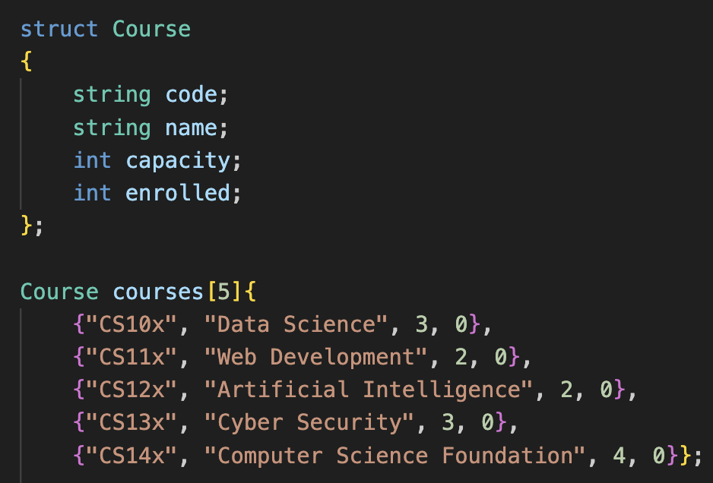

Viewing available courses:
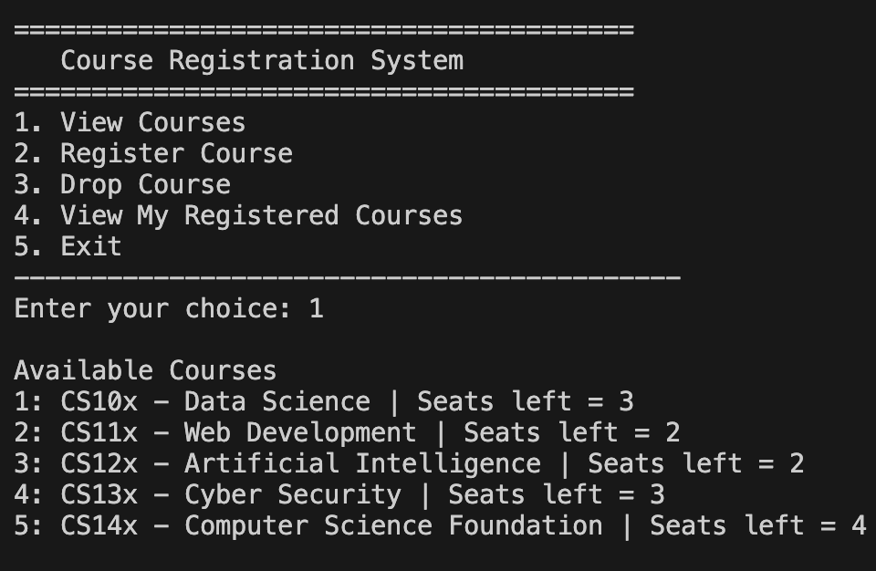

Successful registration:
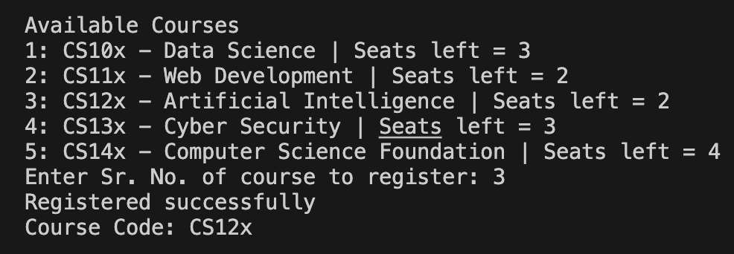

Duplicate registration attempt:
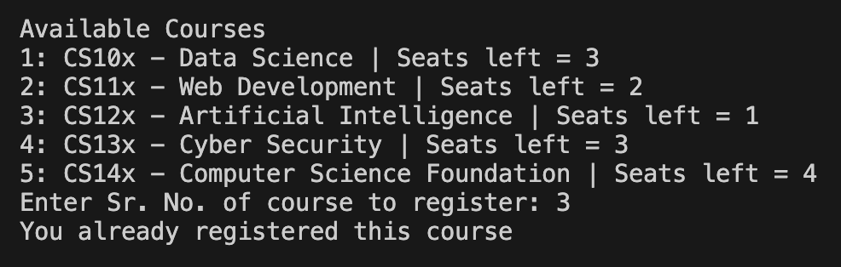

Dropping a course:

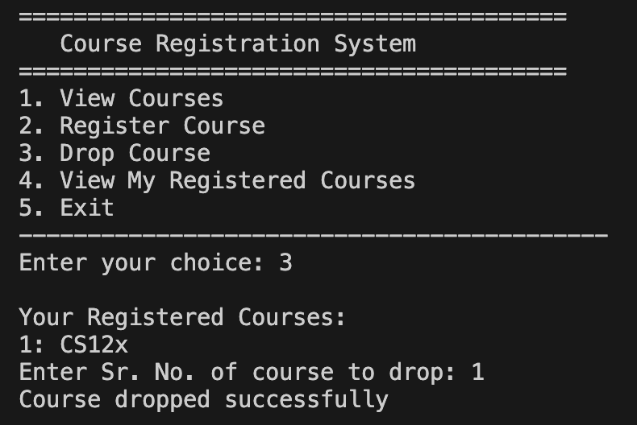

6. Problem Statement / Case Study Results and Conclusion

Findings
- The menu-driven interface supports all three core registration operations — view, register, and drop — within a single continuous session without data loss between operations.
- All three validation gates (duplicate check, capacity check, registration limit) function correctly: each returns an appropriate message and leaves the data state unchanged on failure.
- Array compaction correctly maintains a contiguous, ordered registration list after any number of drop operations, with accurate seat counts reflected back in the course catalogue.
- The program handles invalid menu choices and out-of-range serial numbers gracefully, preventing crashes due to bad user input.
- The data model cleanly separates catalogue information (stored in the Course struct array) from student enrolment information (stored in the registration string array), keeping responsibilities distinct.

Conclusion
This case study demonstrates a complete implementation of a console-based Course Registration System in C++. It integrates structured data modelling with a Course struct, array-based state management, and a suite of validation routines into a coherent, interactive application. The system reliably enforces academic registration constraints including capacity limits, duplicate prevention, and per-student enrolment caps while providing clear feedback to the user.
The project provides practical experience with fundamental C++ concepts including structs, parallel arrays, linear search, and in-place array modification. These techniques form the algorithmic foundation of larger-scale registration platforms, making this case study a valuable stepping stone toward understanding real-world academic management systems. Future enhancements could include persistent storage using file I/O, support for multiple students, dynamic memory allocation using vectors, and a graphical or web-based user interface.

7. References
- Official C++ reference documentation (cppreference.com) for language syntax, standard library containers, and I/O streams.
- Stroustrup, B. (2013). The C++ Programming Language (4th ed.). Addison-Wesley. — For struct design and array management patterns.
- Lippman, S. B., Lajoie, J., & Moo, B. E. (2012). C++ Primer (5th ed.). Addison-Wesley. — For foundational control-flow and function design.
- GeeksforGeeks C++ tutorials on arrays, structures, and menu-driven programs (geeksforgeeks.org).
- Case Study 115: Course Registration System problem statement and evaluation criteria provided by School of Future Tech.

