Project Report

Promise-Based Recruitment Evaluation System

Name: Bhaumikk Keer
Roll No: 150096725030
Cohort: Larry Page

1. Introduction
This project implements a simulated recruitment evaluation workflow using JavaScript Promises. The system models a three-stage hiring process, Coding Assessment, Technical Interview, and Final Selection Review where a candidate must clear the cutoff score of each stage before advancing to the next. The project demonstrates the practical use of asynchronous JavaScript concepts, including Promise, setTimeout, .then(), and .catch().

2. Objective
The objective of this assignment is to:
- Implement asynchronous evaluation logic using JavaScript Promises.
- Simulate real-world delays using setTimeout.
- Chain multiple asynchronous stages using .then().
- Handle failures gracefully using .catch().
- Calculate averages and apply cutoff-based decision logic.

3. Problem Statement
A software company conducts recruitment in three stages: Coding Assessment, Technical Interview, and Final Selection Review. Each stage evaluates a candidate's average score against a defined cutoff. A candidate must pass a stage to proceed to the next one. The task was to model each stage as a Promise that resolves or rejects after a 2-second delay, and to chain the stages together using proper asynchronous control flow.

4. System Design

4.1 Functions Implemented
Function | Parameters | Purpose
codingScoreCheck | marks (array), cutoff (number) | Evaluate coding assessment
technicalInterviewCheck | marks (array), cutoff (number) | Evaluate technical interview
finalSelectionCheck | codingAverage, technicalAverage, cutoff | Final selection decision

4.2 Workflow
- Candidate's coding marks are submitted to codingScoreCheck().
- After a 2-second delay, the average is calculated and compared to the cutoff.
- If passed, technicalInterviewCheck() runs next; otherwise the chain rejects and .catch() displays the failure message.
- If the technical interview is passed, finalSelectionCheck() combines both averages and applies the final cutoff.
- The final result (selected or rejected) is displayed via .then() / .catch().

5. Implementation Details
Each function returns a new Promise. Inside the Promise executor, setTimeout() delays execution by 2000 milliseconds to simulate real evaluation time. The average of the marks array is computed, then compared against the cutoff: resolve() is called with the average on success, and reject() is called with a descriptive error message on failure. The three functions are chained using nested .then() calls, and each stage has its own .catch() to handle rejection.

5.1 Code Screenshots

codingScoreCheck()
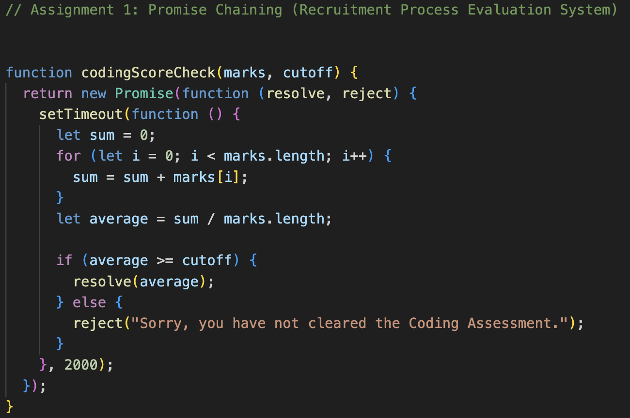

technicalInterviewCheck()
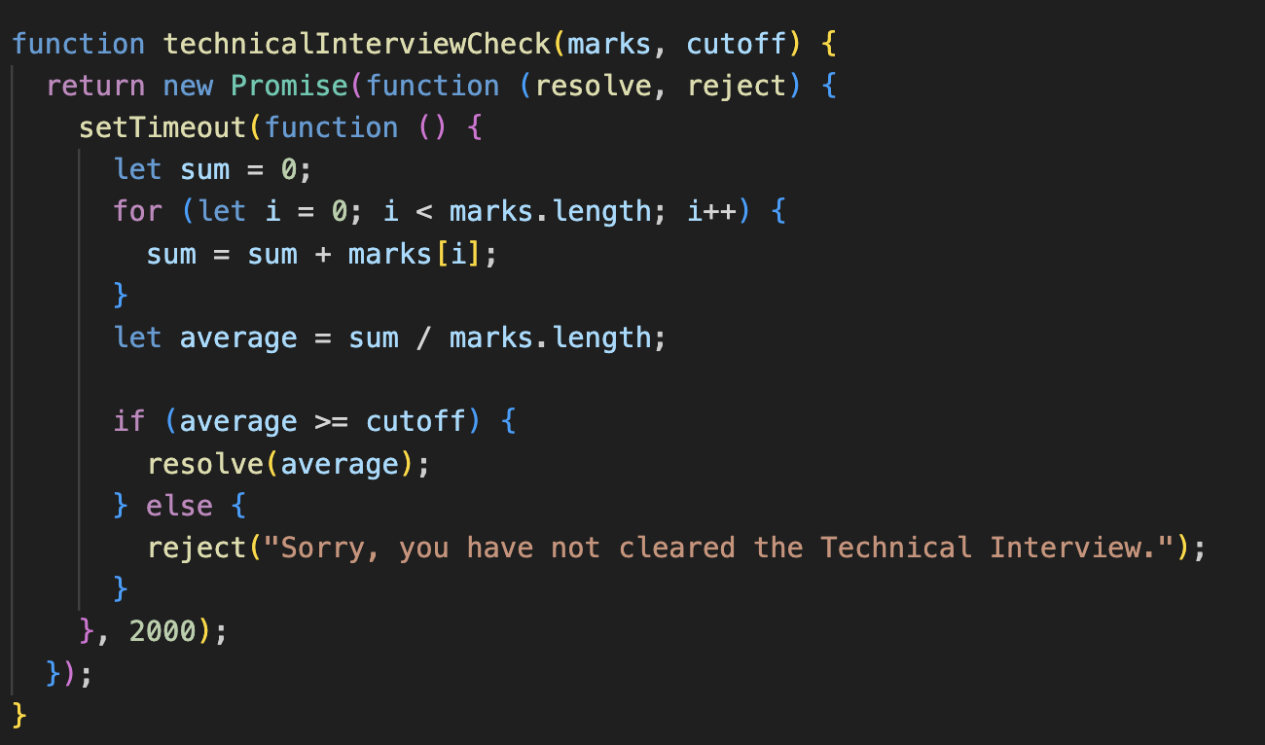

finalSelectionCheck()
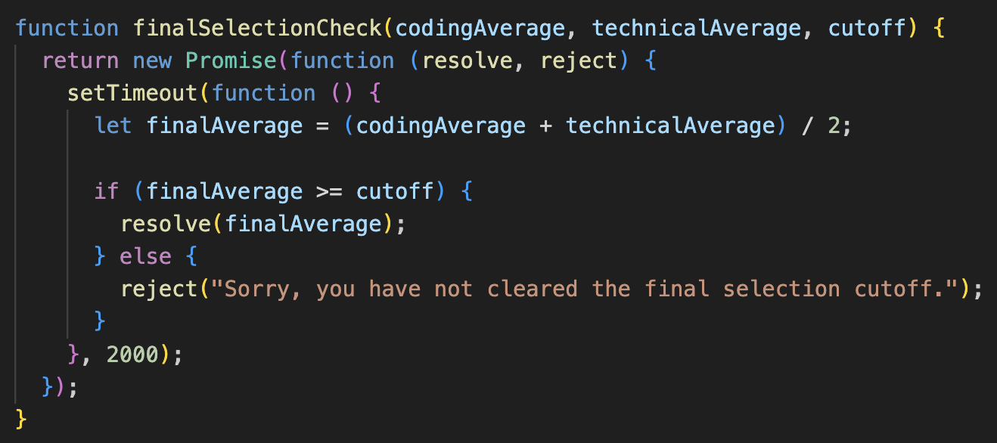

Chaining the three stages with .then() and .catch()
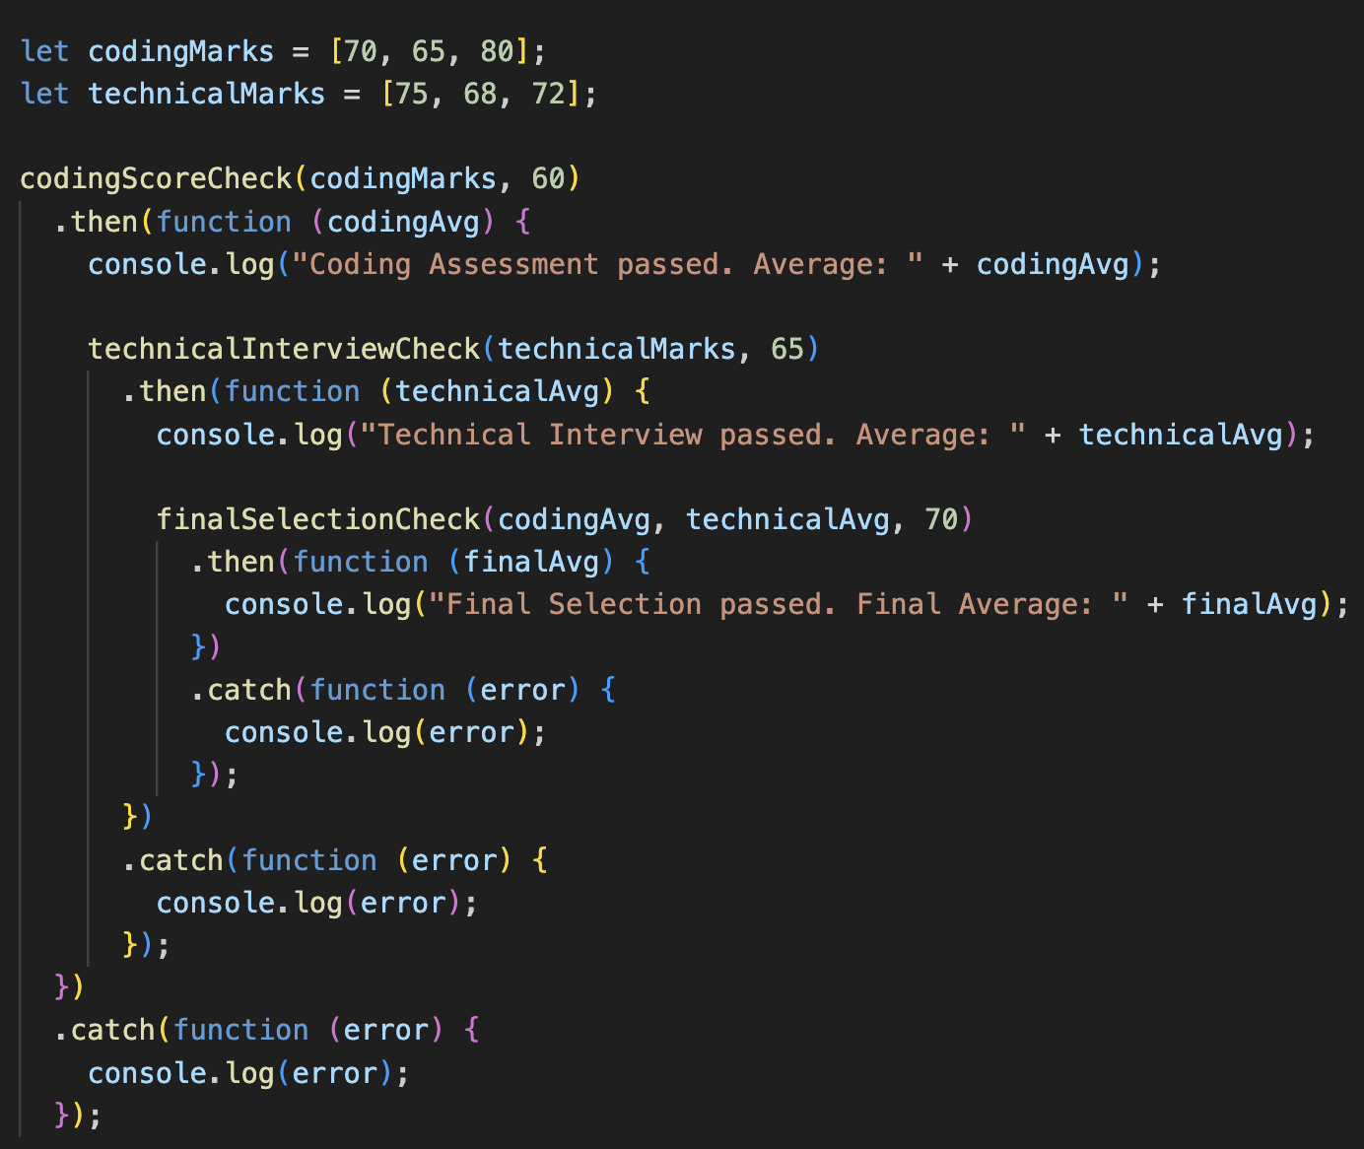

6. Test Results

6.1 Successful Run (all stages cleared)
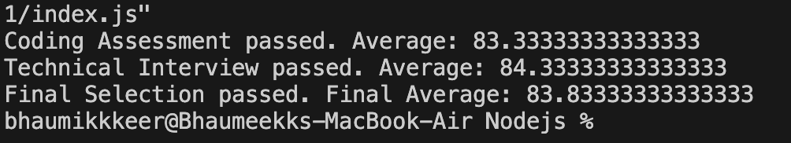

6.2 Failure Cases (cutoff not cleared)
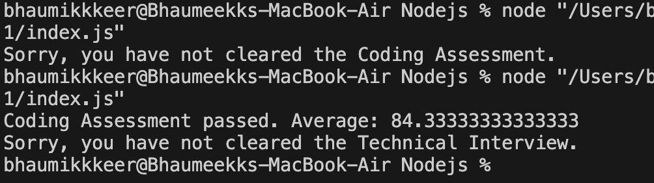
The output confirms that each stage correctly resolves with the calculated average when the cutoff is met, and rejects with the corresponding error message when it is not. When a stage is rejected, the chain stops immediately and later stages are not executed, as seen in the failure runs above.

7. Conclusion
This project successfully demonstrates asynchronous programming in JavaScript using Promises. It shows how multiple dependent asynchronous tasks can be organized into a clean, readable sequence using .then() chaining, and how errors at any stage can be gracefully handled using .catch(). The recruitment evaluation system is a practical example of real-world use cases for Promises, such as multi-step approval processes or sequential API calls.

