Trading Plan
Having a trading plan and sticking to it is an indispensable requisite before risking any money in the markets. In short, a plan describes what to do, why, when, and how to do it. Not having a plan is one of the top reasons traders fail. A good trading plan should describe your overall goals, what markets and timeframes to trade, how to keep records to review your performance and how to apply risk management. Other parts of a good trading plan are how to find trade candidates, how to manage trades, what techniques or methods to employ and what rules to use for entry and exit. You should also consider what pre and post market activities to perform, what checklists to use, how to educate yourself and how to act in case of a calamity.
A plan defines your trading activities in detail, helps you control your emotions and keeps you focussed on executing your strategy with rock solid discipline to avoid trading errors. There is no fixed blueprint for the optimal plan, it can be as simple or as complex as you want and tailored to your needs and trading personality. Plan your trade and trade your plan!
Trading Psychology
Trading psychology refers to the state of mind of traders when they are active in the financial markets and how this affects their trading decisions. This psychological side of trading is often overlooked. A sound state of mind means a trader executes his plan consistently, is mindful of the risks involved, is not hindered by emotions, takes equal responsibility for wins and losses and is realistic about trading in general. Bad trading psychology is one of the top reasons traders fail.
Signs of good psychology include not being emotionally attached to individual trades, not being affected by performance anxiety, focussing on results over a larger number of trades and not putting up positions that are too big to handle. Good psychological traders do not engage in revenge trading, do not second guess trades, and focus on self-improvement without sabotaging their results. They are honest about wins and losses, hold themselves accountable and understand how to deal with fear and greed. Both can be destructive emotions and several techniques exist to control them.
Risk Management
Risk management is the management of risk inherent in trading by identifying these risks, assessing them and knowing how to control them. You can't control how much you may profit on each trade, but you can control how much you may lose. Poor risk management is one of the top reasons traders fail. Managing your risk exposure, by knowing what to do and what not to do, helps to prevent deep drawdowns or losing your trading capital. There is a variety of potential risks to take into account.
Good risk management is key to capital preservation and involves thinking about how much capital to employ, how much to risk on each trade, how many trades to make daily, weekly and monthly and what stop levels to use for each type of set-up. Also included in good risk management are what reward / risk requirements to enforce, how to employ money management, how to use a balanced portfolio and how to deal with correlations between open trades. Traders employing good risk management also consider what loss limits to set daily, weekly and monthly, how to calculate the overall expectancy of your trading strategy and how to avoid the risk of ruin.

Trading Tools
Regardless of what type of market analysis a trader uses, there is a set of tools needed in order to do the job effectively. Traders can not do everything themselves and need certain tools to carry out particular functions to get them through the day. Not having them could mean failure. Obvious basic tools are a computer, phone or tablet, additional monitors, internet access, a charting package, technical analysis tools and an execution platform.
Less obvious perhaps are a checklist, a cheat sheet, a trading journal, a stock screener, a calendar, a currency correlation tool, specific reports, a market hours timetable, a news squawk, a handy tool to calculate pivot points or an optimal position size calculator. Whether they are charting tools, or news gathering tools, whether they are high-tech tools or low-tech tools, whether you find them online or offline, serious traders rely on various must-have tools to support them. Selecting the right ones is crucial for smooth and efficient trading.
Fundamental Analysis
Fundamental analysis is one of the true cornerstones of investing and it can be applied to all asset classes. It looks at what causes price to move up or down and uses this to anticipate and profit from future price moves. It can be used to analyse a national economy by examining areas like gross domestic product, employment, inflation and the monetary policy of a central bank. It can be used to analyse an individual company by examining its financial statements like assets, liabilities and earnings as well as its management and competition.
Fundamental analysis can also be applied to whole industries by examining the drivers of supply and demand. There are many different fundamental trading and investment strategies and most of them try to determine the fair value of an instrument by analysing the underlying drivers of price. If the current market price of an instrument differs significantly from this fair value, it will eventually gravitate towards it, as long as none of the fundamental drivers change.

Supply and Demand
Supply and Demand is one of the core strategies used in trading. It focusses on the ancient laws of supply and demand and how price moves in a free-flowing market. The foundation of this strategy is that the amount of an instrument that is available and the desire of buyers for it, drive the price. It identifies zones on the chart where demand overwhelms supply (the demand zone), driving the price up or where supply overwhelms demand (the supply zone), driving the price down. Most supply and demand traders wait for the price to enter these zones, where major activities of buying or selling have taken place, before entering a long or short position themselves.
It makes sense to buy at a demand zone and to sell at a supply zone, but keep in mind that fresh zones are more effective than retested ones. They can be used as entry zones for a continuing trend or as reversal zones for a changing trend. Trades can be made aggressively or conservatively, each with their own rules of entry and exit
The Laws of Supply and Demand
The principle that within a competitive market, price for a particular asset will fluctuate until it reaches a value where the amount demanded by consumers is equal to the amount supplied by producers. This is known as an economic equilibrium.
There are four laws of supply and demand:
If demand increases and supply remains unchanged, a shortage occurs, leading to a higher equilibrium price.
If demand decreases and supply remains unchanged, a surplus occurs, leading to a lower equilibrium price.
If demand remains unchanged and supply increases, a surplus occurs, leading to a lower equilibrium price.
If demand remains unchanged and supply decreases, a shortage occurs, leading to a higher equilibrium price.

Candlestick Analysis
Candlestick analysis focuses on individual candles, pairs or at most triplets, to read signs on where the market is going. The underlying assumption is that all known information is already reflected in the price. The technique is usually combined with support & resistance. Each candle contains information about 4 prices: the high, the low, the open and the close. A candle body reflects the net price movement between open and close while the wicks show reversals that occurred within the timeframe of the candle.
Each candlestick, therefore, provides an easy-to-decipher picture of the price action. The length of the wicks versus the length of the body in combination with whether a candle is bullish or bearish, can be used to determine a signal for the price action to come. Common candlesticks that are used in this analysis are dojis, spinning tops, hammers, engulfing candles, pinbars and inside bars.
Support and Resistance
Support and Resistance is one of the most used techniques in technical analysis based on a concept that's easy to understand but difficult to master. It identifies price levels where historically the price reacted either by reversing or at least by slowing down and prior price behaviour at these levels can leave clues for future price behaviour. There are many ways to identify these levels and to apply them in trading. Support and Resistance levels can be identifiable turning points, areas of congestion or psychological levels (round numbers that traders attach significance to). The higher the timeframe, the more relevant the levels become.
Finding the most important ones can take many hours of practice. They exist due to an influx of buyers or sellers at key junctures. The fact that these levels flip roles between support and resistance can be used to determine the range of a market, trade reversals, bounces or breakouts. Each of these trades will have their own rules for entry and exit.

Support and Resistance are price levels that can help to find trading ranges. Support and Resistance levels, at their core are defined by supply and demand. When demand goes up, buying pressure is up and so is price. When supply goes up, selling pressure is up and price goes down.

Support
In a Bearish Market, a price point where demand is so high that price will not continue to fall past that point would be considered a support level. Support levels are typically below the current price. Keep in mind that a support level is not necessarily set in stone. It is common for a price to briefly break through (or test) the level without making a major decline afterwards. Because of this, some technical analysts use a support zone rather than a specific price level.
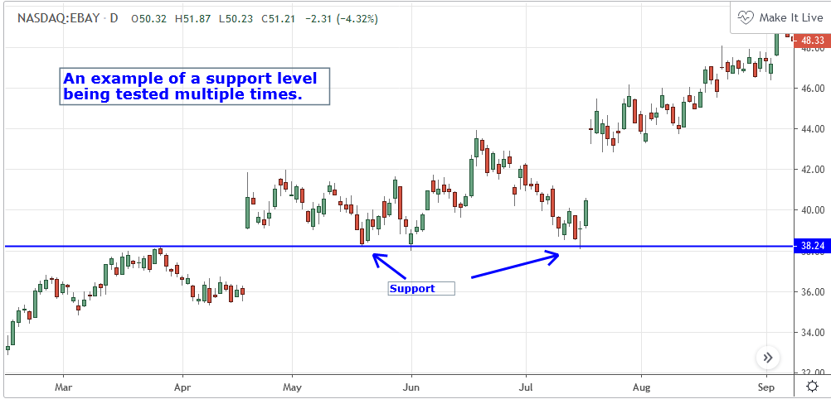
Resistance
In a Bullish Market, a price point where supply is so high that price will not break through that point would be considered a resistance level. Resistance levels are typically above the current price. Keep in mind that a resistance level is not necessarily set in stone. It is common for a price to briefly break through (or test) the level without making a major advance afterwards. Because of this, some technical analysts use a support zone rather than a specific price level.
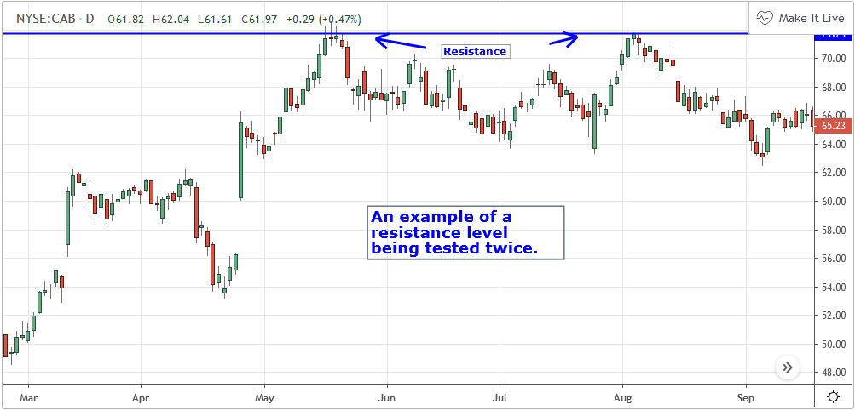
Support/Resistance Switching
It is not uncommon for a support level to eventually become a resistance level, or vice-versa. Once price breaks above a resistance or falls below a support, that level typically reverses its role. In the following example, we clearly see a resistance being broken, and subsequently becoming a support.
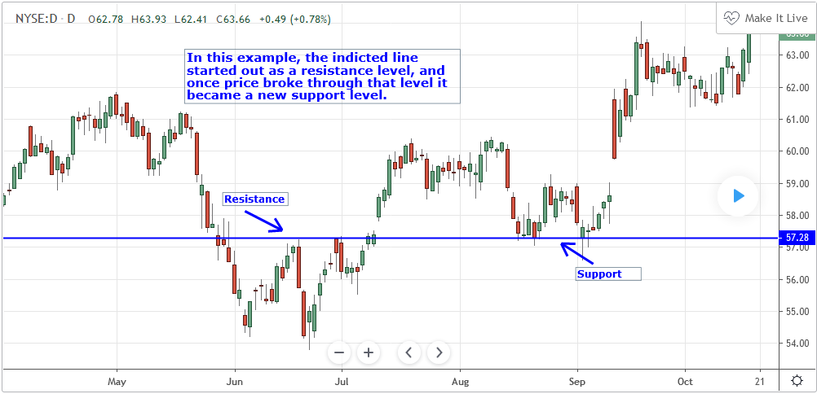

Breakout
A breakout is when price moves outside of defined levels of support and resistance. They are significant because they can precede major price swings as well as increased volatility.
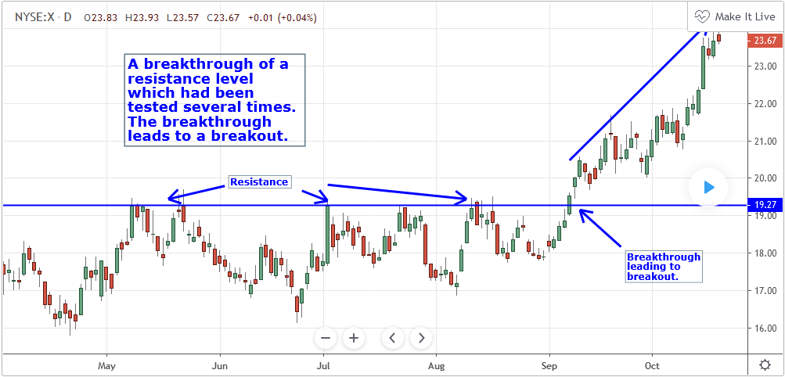
Volatility
A measurement of price variations for a security or other financial instrument over a specified period of time. The wider the range in prices, the higher the volatility. The narrower the range in prices, the lower the volatility.
Trading Range
A trading range is a price range in which a market is currently trading. Frequently, trading ranges are characterized by areas of support and resistance, with the support being at the low end of the range, and the resistance being at the high end.
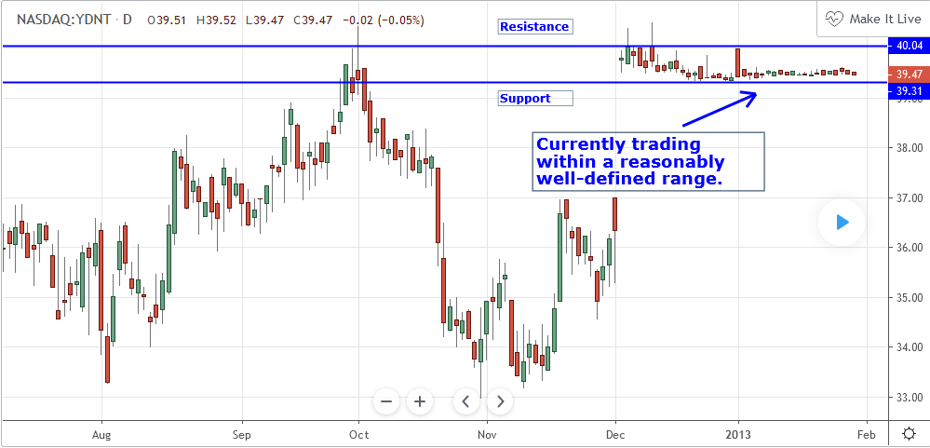
Market Trend
Bearish
A market that is characterized by increased buying pressure and is moving upwards.
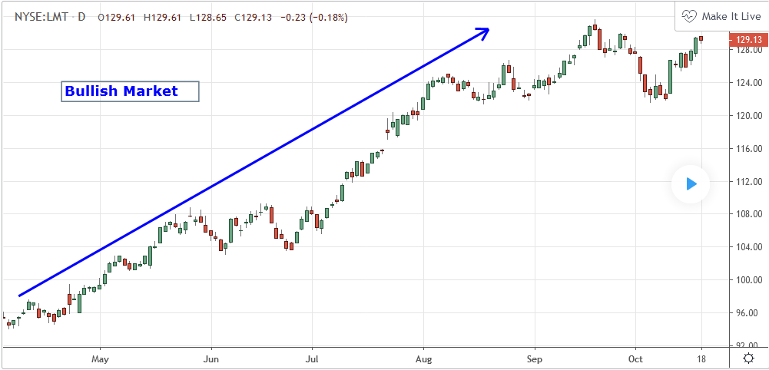
Bullish
A market that is characterized by increased selling pressure and is moving downwards.
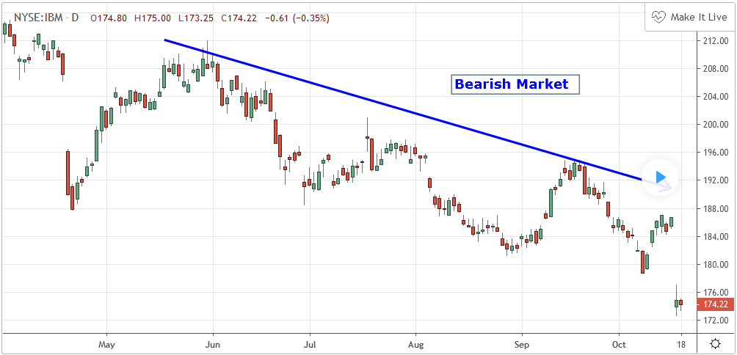
Sideways
A market that is trading sideways with no discernible directional trend. Trading usually takes place between areas of support and resistance.
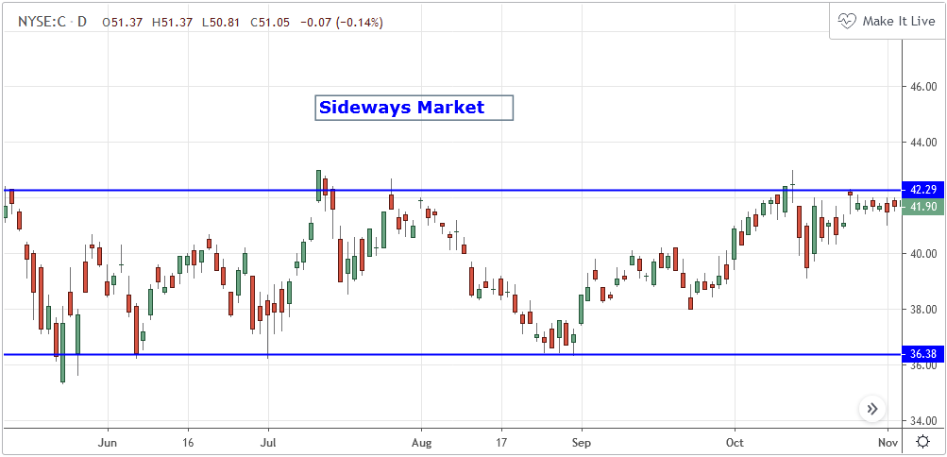
Reversal
When a market is clearly trending in one direction and then changes to move in the opposite direction.
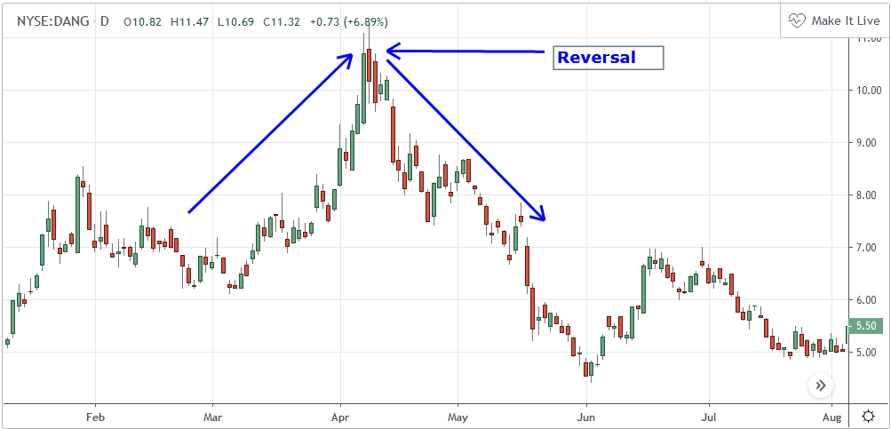
Trend Lines
Trend lines can be used to identify and confirm trends. A trend line connects at least 2 price points on a chart and is usually extended forward to identify sloped areas of support and resistance. Lines with a positive slope that support price action show that net-demand is increasing. As long as the price action stays above this line, we have a bullish trend. Lines with a negative slope that act as resistance to the price action show that net-supply is increasing. As long as the price action stays under this line, we have a bearish trend.
Price usually retests a sloped trend line several times, until it breaks at which point we may have a trend reversal. The more points there are to connect, the stronger a trend line becomes. Different strategies have different rules on how far apart connected price points can be and whether to connect wicks or candle bodies, but all trend lines break eventually.
Moving Averages
Moving Averages are price based, lagging (or reactive) indicators that display the average price of a security over a set period of time. A Moving Average is a good way to gauge momentum as well as to confirm trends, and define areas of support and resistance. Essentially, Moving Averages smooth out the “noise” when trying to interpret charts. Noise is made up of fluctuations of both price and volume. Because a Moving Average is a lagging indicator and reacts to events that have already happened, it is not used as a predictive indicator but as an interpretive one for confirmations and analysis.
In fact, Moving Averages form the basis of several other well-known technical analysis tools such as the Bollinger Bands and the MACD. There are different types of Moving Averages which all take the same basic premise and add a variation. Most notable are the Simple Moving Average (SMA), the Exponential Moving Average (EMA), the Weighted Moving Average (WMA) and the Hull Moving Average (HMA).
Moving Average
Definition
Moving Average (MA) is a price based, lagging (or reactive) indicator that displays the average price of a security over a set period of time. A Moving Average is a good way to gauge momentum as well as to confirm trends, and define areas of support and resistance. Essentially, Moving Averages smooth out the “noise” when trying to interpret charts. Noise is made up of fluctuations of both price and volume. Because a Moving Average is a lagging indicator and reacts to events that have already happened, it is not used as a predictive indicator but rather an interpretive one, used for confirmations and analysis. In fact, Moving Averages form the basis of several other well-known technical analysis tools such as Bollinger Bands and the MACD. There are a few different types of Moving Averages which all take the same basic premise and add a variation. Most notable are the Simple Moving Average (SMA), the Exponential Moving Average (EMA) and the Weighted Moving Average (WMA)

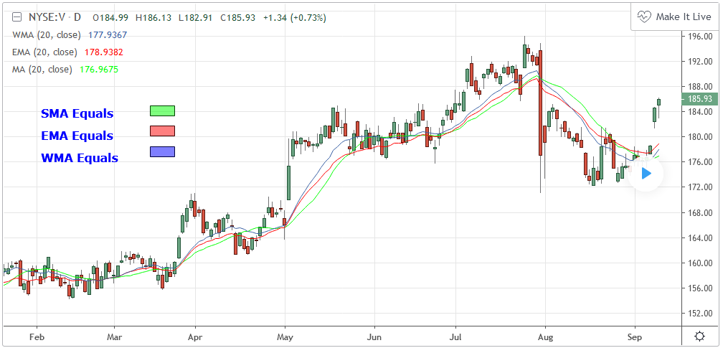
Types
Moving Averages visualize the average price of a financial instrument over a specified period of time. However, there are a few different types of moving averages. They typically differ in the way that different data points are weighted or given significance.
Simple Moving Average ( SMA )
Simple Moving Average is an unweighted Moving Average. This means that each day in the data set has equal importance and is weighted equally. As each new day ends, the oldest data point is dropped and the newest one is added to the beginning.
Calculation
An example of a 3 period SMA:
Sum of Period Values / Number of Periods
Closing Prices to be used: 5, 6, 7, 8, 9
First Day of 3 Period SMA: (5 + 6 + 7) / 3 = 6
Second Day of 3 Period SMA: (6 + 7 + 8) / 3 = 7
Third Day of 3 Period SMA: (7 + 8 + 9) /3 = 8
Weighted Moving Average (WMA)
Weighted Moving Average is similar to the SMA, except the WMA adds significance to more recent data points. Each point within the period is assigned a multiplier (largest multiplier for the newest data point and then descends in order) which changes the weight or significance of that particular data point. Then, just like the SMA, once a new data point is added to the beginning, the oldest data point is thrown out.
CALCULATION
This Is similar to the SMA except it adds a weight (multiplier) to each period.
The most recent period has the most weight)
An example of a 5 period WMA
Sum of Period Values / Number of Periods
Closing Prices to be used: 5, 6, 7, 8, 9
Period | Weight |  | Price | Weighted Average
1 | 1 | * | 5 | 5
2 | 2 | * | 6 | 12
3 | 3 | * | 7 | 21
4 | 4 | * | 8 | 32
5 | 5 | * | 9 | 45
TOTAL = 15 X 35 = 525
WMA = (Sum of Weighted Averages) / (Sum of Weight)
WMA 115 / 15 = 7.6667
Exponential Moving Average (EMA)
Exponential Moving Average is very similar to (and is a type of) WMA. The major difference with the EMA is that old data points never leave the average. To clarify, old data points retain a multiplier (albeit declining to almost nothing) even if they are outside of the selected data series length.
Calculation
There are three steps to calculate the EMA. Here is the formula for a 5 Period EMA
1. Calculate the SMA - (Period Values / Number of Periods)
2. Calculate the Multiplier - (2 / (Number of Periods + 1) therefore (2 / (5+1) = 33.333%
3. Calculate the EMA
For the first EMA, we use the SMA(previous day) instead of EMA(previous day).
EMA = {Close - EMA(previous day)} x multiplier + EMA(previous day)
Double Exponential Moving Average
Calculation
Double EMA = 2*EMA – EMA (EMA)
Triple Exponential Moving Average
Calculation
Triple EMA = (3*EMA – 3*EMA(EMA)) + EMA(EMA(EMA))
The Basics
Moving Averages takes a set of data (closing prices over a specified time period) and outputs their average price. Now, unlike an oscillator, Moving Averages are not restricted to a number within a band or a set range of numbers. The MA can move right along with price.
The timeframes or periods used can vary quite significantly depending on the type of technical analysis being done. One fact that most always be remembered however, is that Moving Averages have lag inherently built into them. What this means is actually pretty simple. The longer the timeframe being used, the more lag there will be. Likewise, the shorter the timeframe, the less lag there will be. Basically, Moving averages with shorter timeframes tend to stay close to prices and will move right after prices move. Longer timeframes have much more cumbersome data and their moves lag behind the market’s move much more significantly. As for what time frames should be used, it really is up to the trader’s discretion. Typically any period under 20 days would be considered short term, anything between 20 and 60 would be medium term and of course anything longer than 60 days would be viewed as long term.
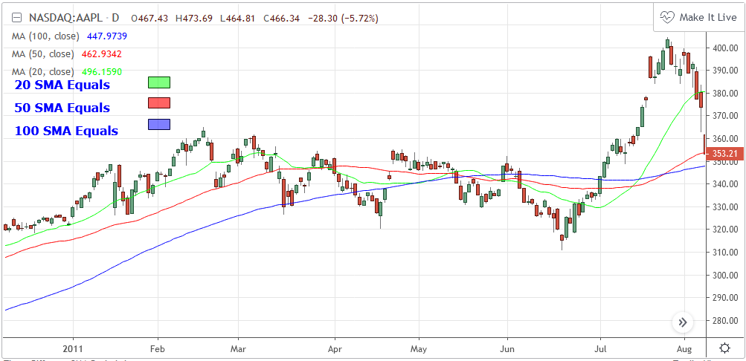Another option which boils down to the trader’s preference is which type of Moving Average to use. While all the different types of Moving Averages are rather similar, they do have some differences that the trader should be aware of. For example, the EMA has much less lag than the SMA (because it puts a greater importance on more recent prices) and therefore turns quicker than the SMA. However, since the SMA gives an equal weighting to all data points, no matter how recent, the SMA has a much closer relationship to areas of significance such as traditional Support and Resistance.
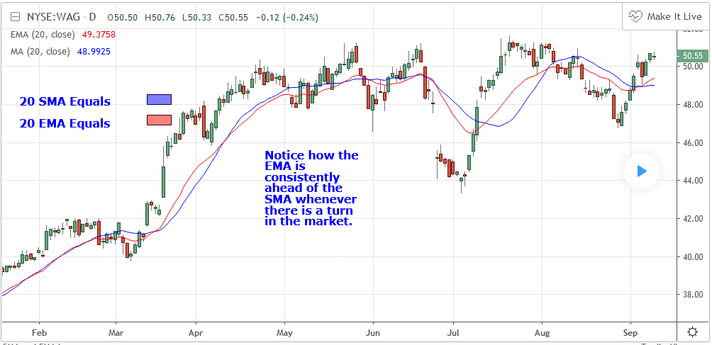
What To Look For
When examining some of these common uses for Moving Averages, keep in mind that that it is the trader’s discretion which Moving Average in particular they wish to use. In the following examples, there will be written instances of; Moving Averages (MA), Simple Moving Averages (SMA), Exponential Moving Averages (EMA) and Weighted Moving Averages (WMA). Unless otherwise specified, these indicators can be considered interchangeable in terms of the governing principles behind their basic uses.
Basic Trend Identification
Using a Moving Average to confirm a trend in price is really one of the most basic, yet effecting ways of using the indicator. Consider that by design, Moving Averages “report” on what has already happened and that they also take into consideration a whole range of past events when calculating their formula. This is what makes a Moving Average such a good technical analysis tool for trend confirmations.
The general rules of thumb are as follows:
A Long-Term Moving Average that is clearly on the upswing is confirmation of a Bullish Trend.
A Long-Term Moving Average that is clearly on the downswing is confirmation of a Bearish Trend.
Because of the large amounts of data considered when calculating a Long-Term Moving Average, it takes a considerable amount of movement in the market to cause the MA to change its course. A Long-Term MA is not very susceptible to rapid price changes regarding the overall trend.
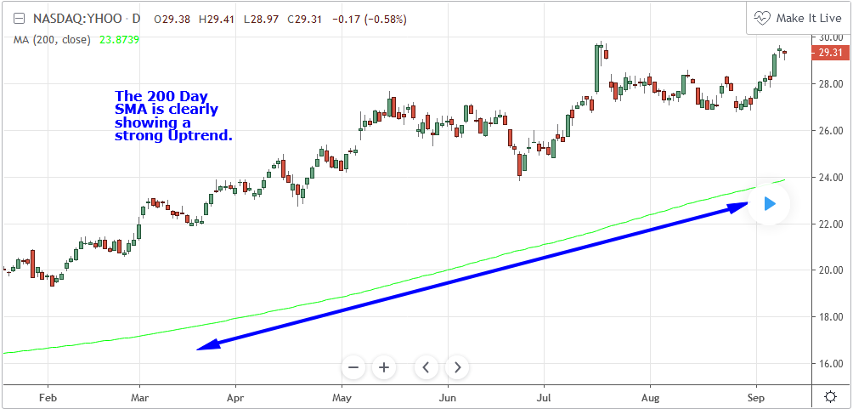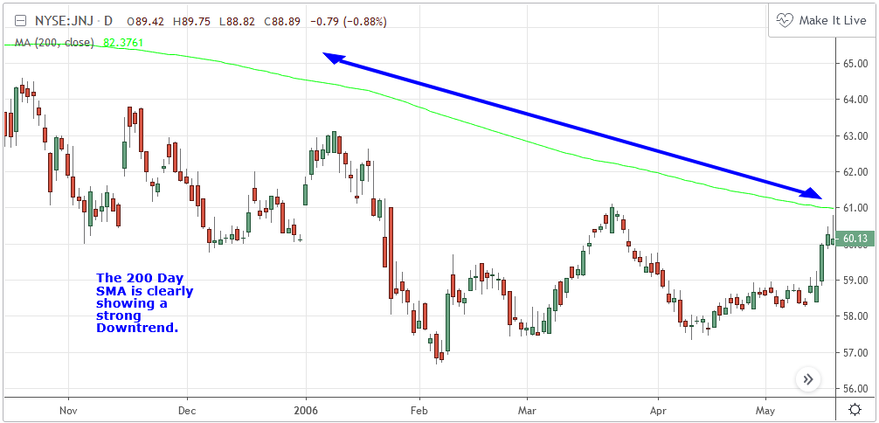

Support and Resistance
Another fairly basic use for Moving Averages is identifying areas of support and resistance. Generally speaking, Moving averages can provide support in an uptrend and also they can provide resistance in a downtrend. While this can work for shorter term periods (20 days or less), the support and resistance provided by Moving Averages, can become even more readily apparent in longer term situations.
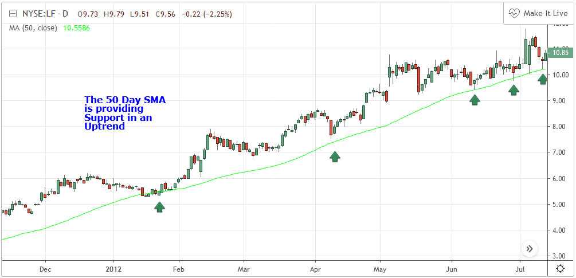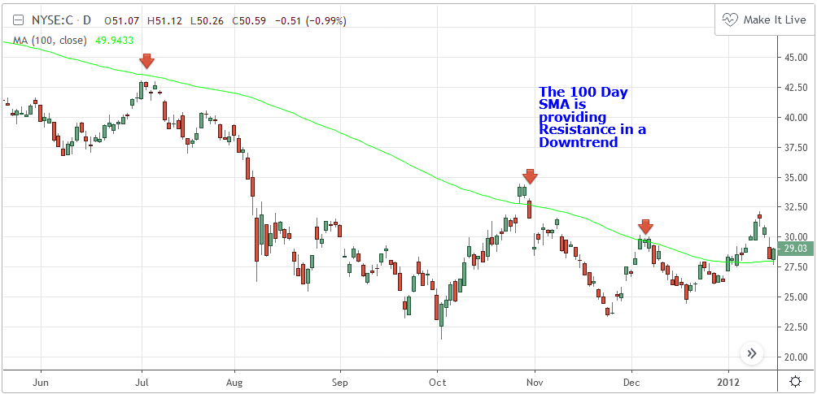

Crossovers
Crossovers require the use of two Moving Averages of varying length on the same chart. The two Moving averages should be of two different term lengths. For example a 50 Day Simple Moving Average (medium-term) and a 200 Day Simple Moving Average (long-term) The signals or potential trading opportunities occur when the shorter term SMA crosses above or below the longer term SMA.
Bullish Crossover – Occurs when the shorter term SMA crosses above the longer term SMA. Also known as a “Golden Cross”.

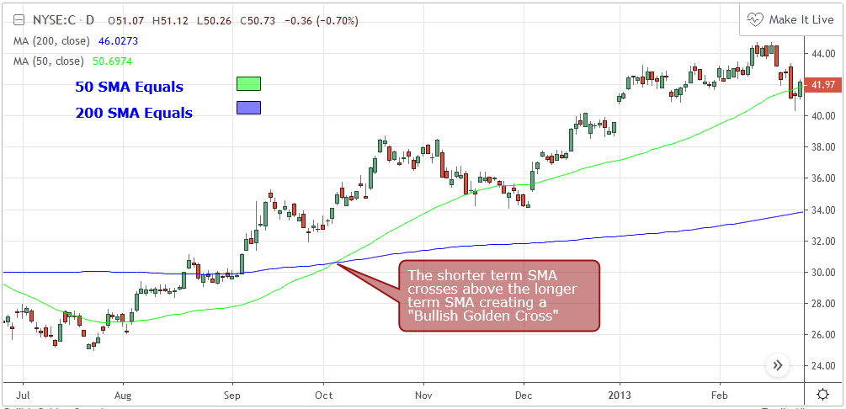

Bearish Crossover – Occurs when the shorter term SMA crosses below the longer term SMA. Also known as a “Dead Cross”.

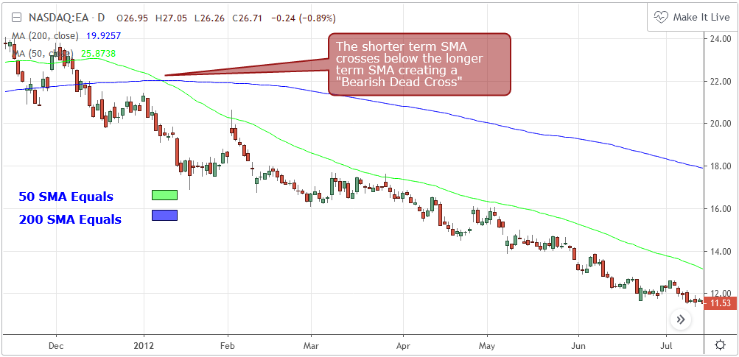
- It is imperative however, that the trader realizes the inherent shortcomings in these signals. This is a system that is created by combining not just one but two lagging indicators. Both of these indicators react only to what has already happened and are not designed to make “predictions”. A system like this one definitely works best in a very strong trend. While in a strong trend, this system or a similar one can actually be quite valuable.

Price Crossovers
If you take the two Moving Averages setup that was discussed in the previous section and add in the third element of price, there is another type of setup called a Price Crossover. With a Price Crossover you start with two Moving Averages of different term lengths (just like with the previously mentioned Crossover). You basically use the longer term Moving Average to confirm long term trend. The signals then occur when Price crosses above or below the shorter term Moving Average going in the same direction of the main, longer term trend. Just like in the previous example, let’s use a 50 Day Simple Moving Average and a 200 Day Simple Moving Average.
Bullish Price Crossover – Price crosses above the 50 SMA while the 50 SMA is above the 200 SMA. The 200 SMA is confirming the trend. Price and short term SMA are generating signals in the same direction as the trend.
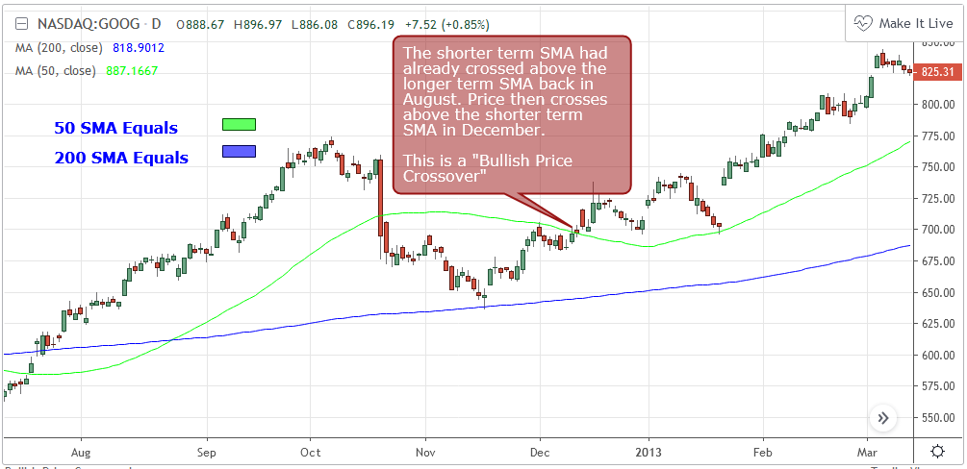
Bearish Price Crossover - Price crosses below the 50 SMA while the 50 SMA is below the 200 SMA. The 200 SMA is confirming the trend. Price and short term SMA are generating signals in the same direction as the trend.

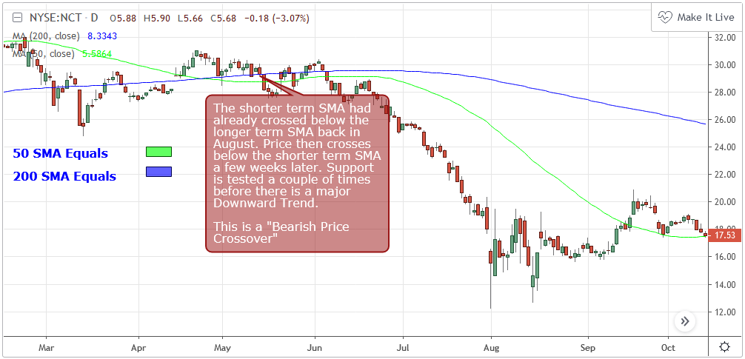

SUMMARY
An experienced technical analyst will know that they should be careful when using Moving Averages (Just like with any indicator). There is no doubt about the fact that they are trend identifiers. That can be quite a valuable bit of information. However, it is important to always be aware that they are lagging or reactive indicators. Moving Averages will never be on the cutting edge when it comes to predicting market moves. What they can do though, is just like many other indicators that have withstood the test of time, provide an added level of confidence to a trading strategy or system. When used in conjunction with more active indicators, you can at least be sure that in regards to the long term trend, you are looking to trade in the correct direction.

HOW TO USE IN TRADINGVIEW
- Navigate to https://www.tradingview.com/
- On the landing page, enter a symbol and click "Launch Chart"
- Within the Toolbar along the top of the chart select "Indicators" and choose the one you would like to add to your chart.
- To make changes to your Indicator you will need to access the Formatting Window.
- You can access the Formatting Window by either clicking on the Blue "Format" button in the Chart Header next to the Indicator name, or by right clicking on the Indicator in the chart itself and selecting "Format".

INPUTS
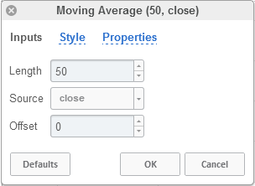

Length
The time period to be used in calculating the Moving Average. 9 days is the default.

Source
Determines what data from each bar will be used in calculations. Close is the default.

Offset
Changing this number will move the Moving Average either Forwards or Backwards relative to the current market. 0 is the default.

STYLE
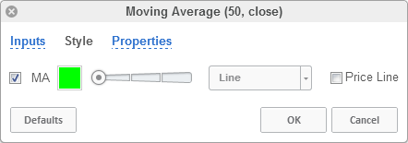

MA
Can toggle the visibility of the MA as well as the visibility of a price line showing the actual current value of the MA. Can also select the MA's color, line thickness and line style.

PROPERTIES
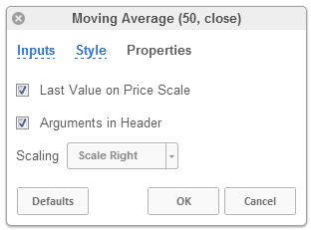

Last Value on Price Scale
Toggles the visibility of Last Values for the Moving Average on the Price Scale.

Arguments in Header
Toggles the visibility of the indicator's name and settings in the upper left hand corner of the chart.

Scaling
Scales the indicator to either the Right or to the Left.

Simple Moving Average (SMA)
Moving averages visualize the average price of a financial instrument over a specified period of time. However, there are a few different types of moving averages. They typically differ in the way that different data points are weighted or given significance. A Simple Moving Average (SMA) is an unweighted moving average. This means that each period in the data set has equal importance and is weighted equally. As each period ends, the oldest data point is dropped and the newest one is added to the beginning. Please note that of all the moving averages the SMA lags price the most.
Read more about Simple Moving Average in TradingView wiki.

Exponential Moving Average (EMA)
Moving averages visualize the average price of a financial instrument over a specified period of time. However, there are a few different types of moving averages. They typically differ in the way that different data points are weighted or given significance. An Exponential Moving Average (EMA) is very similar to (and is a type of) a weighted moving average. The major difference with the EMA is that old data points never leave the average. To clarify, old data points retain a multiplier (albeit declining to almost nothing) even if they are outside of the selected data series length.

Weighted Moving Average (WMA)
Moving averages visualize the average price of a financial instrument over a specified period of time. However, there are a few different types of moving averages. They typically differ in the way that different data points are weighted or given significance. A Weighted Moving Average (WMA) is similar to the simple moving average (SMA), except the WMA adds significance to more recent data points. Each point within the period is assigned a multiplier (largest multiplier for the newest data point and then descends in order) which changes the weight or significance of that particular data point. Then, just like the SMA, once a new data point is added to the beginning, the oldest data point is thrown out.

Hull Moving Average (HMA)
The Hull Moving Average (HMA) was developed by Alan Hull for the purpose of reducing lag, increasing responsiveness while at the same time eliminating noise. Its calculation is elaborate and makes use of the Weighted Moving Average (WMA). It emphasizes recent prices over older ones, resulting in a fast-acting yet smooth moving average that can be used to identify the prevailing market trend. It can also be used for entry and exit signals. The indicator is mostly used by swing traders and by long term traders in combination with other signals and analysis techniques.

Relative Strength Index (RSI)
The Relative Strength Index (RSI) is a well versed momentum based oscillator which is used to measure the speed (velocity) as well as the change (magnitude) of directional price movements. Essentially the RSI, when graphed, provides a visual mean to monitor both the current, as well as historical, strength and weakness of a particular market. The strength or weakness is based on closing prices over the duration of a specified trading period creating a reliable metric of price and momentum changes. Given the popularity of cash settled instruments (stock indexes) and leveraged financial products (the entire field of derivatives); RSI has proven to be a viable indicator of price movements.
Definition
The Relative Strength Index (RSI) is a well versed momentum based oscillator which is used to measure the speed (velocity) as well as the change (magnitude) of directional price movements. Essentially RSI, when graphed, provides a visual mean to monitor both the current, as well as historical, strength and weakness of a particular market. The strength or weakness is based on closing prices over the duration of a specified trading period creating a reliable metric of price and momentum changes. Given the popularity of cash settled instruments (stock indexes) and leveraged financial products (the entire field of derivatives); RSI has proven to be a viable indicator of price movements.
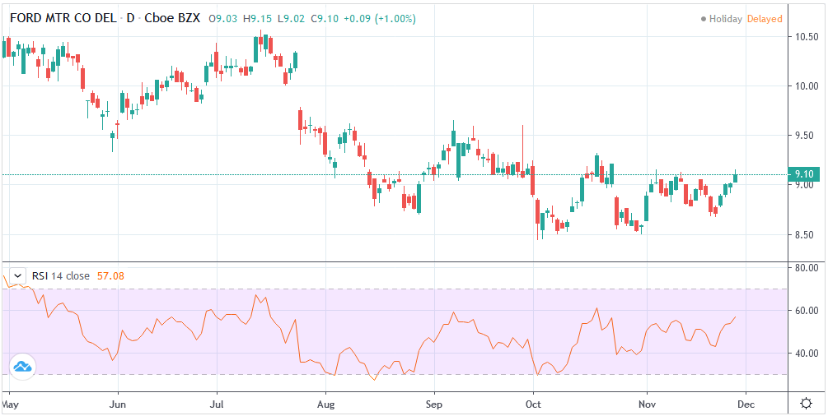

HISTORY
J.Welles Wilder Jr. is the creator of the Relative Strength Index. A former Navy mechanic, Wilder would later go on to a career as a mechanical engineer. After a few years of trading commodities, Wilder focused his efforts on the study of technical analysis. In 1978 he published New Concepts in Technical Trading Systems. This work featured the debut of his new momentum oscillator, the Relative Strength Index, better known as RSI.
Over the years, RSI has remained quite popular and is now seen as one of the core, essential tools used by technical analysts the world over. Some practitioners of RSI have gone on to further build upon the work of Wilder. One rather notable example is James Cardwell who used RSI for trend confirmation.

CALCULATION
RSI = 100 – 100/ (1 + RS)
RS = Average Gain of n days UP / Average Loss of n days DOWN
For a practical example, the built-in Pine Script function rsi(), could be replicated in long form as follows.
change = change(close)
gain = change >= 0 ? change : 0.0
loss = change < 0 ? (-1) * change : 0.0
avgGain = rma(gain, 14)
avgLoss = rma(loss, 14)
rs = avgGain / avgLoss
rsi = 100 - (100 / (1 + rs))
"rsi", above, is exactly equal to rsi(close, 14).

THE BASICS
As previously mentioned, RSI is a momentum based oscillator. What this means is that as an oscillator, this indicator operates within a band or a set range of numbers or parameters. Specifically, RSI operates between a scale of 0 and 100. The closer RSI is to 0, the weaker the momentum is for price movements. The opposite is also true. An RSI closer to 100 indicates a period of stronger momentum.
- 14 days is likely the most popular period, however traders have been known to use a wide variety of numbers of days.

WHAT TO LOOK FOR

Overbought/Oversold
Wilder believed that when prices rose very rapidly and therefore momentum was high enough, that the underlying financial instrument/commodity would have to eventually be considered overbought and a selling opportunity was possibly at hand. Likewise, when prices dropped rapidly and therefore momentum was low enough, the financial instrument would at some point be considered oversold presenting a possible buying opportunity.
There are set number ranges within RSI that Wilder consider useful and noteworthy in this regard. According to Wilder, any number above 70 should be considered overbought and any number below 30 should be considered oversold.
An RSI between 30 and 70 was to be considered neutral and an RSI around 50 signified “no trend”.
- Some traders believe that Wilder’s overbought/oversold ranges are too wide and choose to alter those ranges. For example, someone might consider any number above 80 as overbought and anything below 20 as oversold. This is entirely at the trader’s discretion.
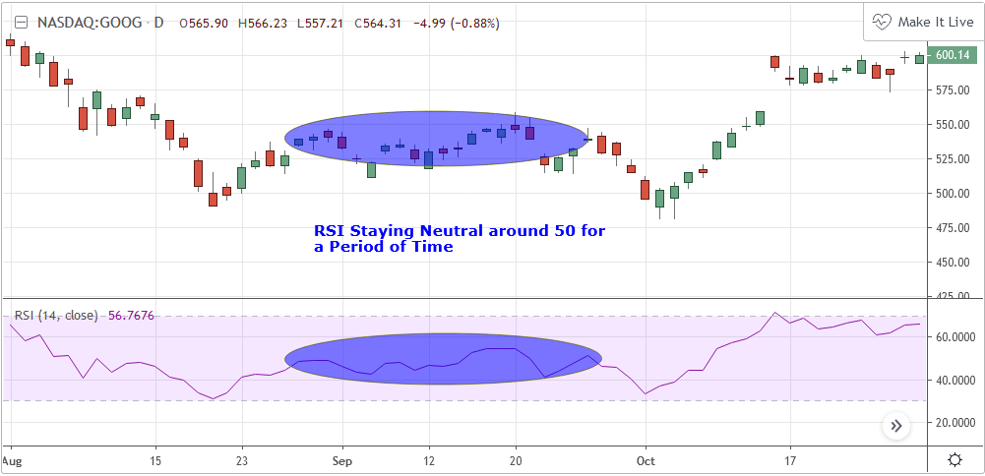

Divergence
RSI Divergence occurs when there is a difference between what the price action is indicating and what RSI is indicating. These differences can be interpreted as an impending reversal. Specifically there are two types of divergences, bearish and bullish.
Bullish RSI Divergence – When price makes a new low but RSI makes a higher low.
Bearish RSI Divergence – When price makes a new high but RSI makes a lower high.
- Wilder believed that Bearish Divergence creates a selling opportunity while Bullish Divergence creates a buying opportunity.

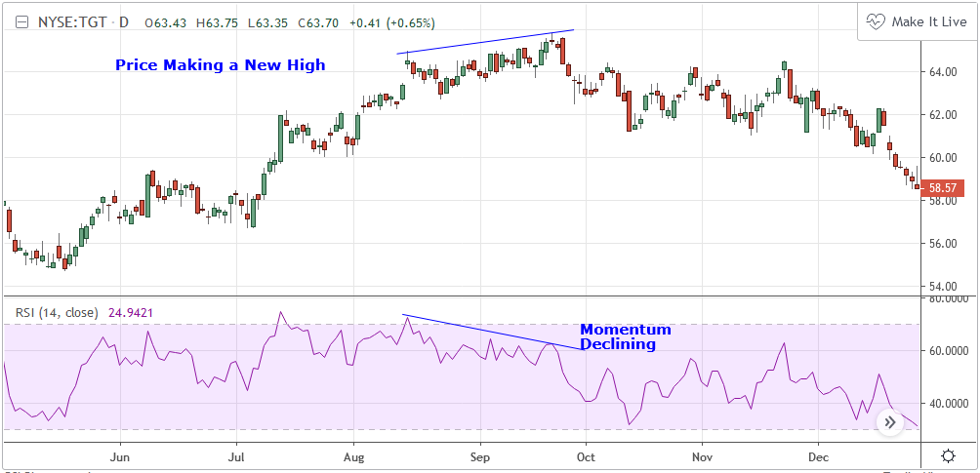Failure Swings
Failure swings are another occurrence which Wilder believed increased the likelihood of a price reversal. One thing to keep in mind about failure swings is that they are completely independent of price and rely solely on RSI. Failure swings consist of four “steps” and are considered to be either Bullish (buying opportunity) or Bearish (selling opportunity).
Bullish Failure Swing
- RSI drops below 30 (considered oversold).
- RSI bounces back above 30.
- RSI pulls back but remains above 30 (remains above oversold)
- RSI breaks out above its previous high.
Bearish Failure Swing
- RSI rises above 70 (considered overbought)
- RSI drops back below 70
- RSI rises slightly but remains below 70 (remains below overbought)
- RSI drops lower than its previous low.

- 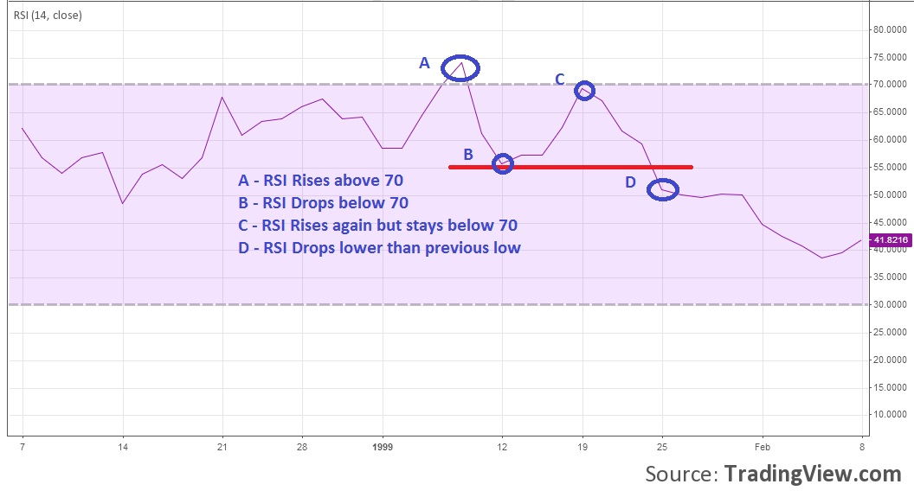

CARDWELL’S TREND CONFIRMATIONS
Of course no one indicator is a magic bullet and almost nothing can be taken simply at face value. Andrew Cardwell, who was mentioned earlier, was one of those students who took Wilder’s RSI interpretations and built upon them. Cardwell’s work with RSI led to RSI being a great tool not just for anticipating reversals but also for confirming trends.

Uptrends/Downtrends
Cardwell made keen observations while studying Wilder’s ideas of divergence. Cardwell believed that:
- Bullish Divergence only occurs in a Bearish Trend.
- Bearish Divergence only occurs in an Bullish Trend.
- Both Bullish and Bearish Divergence usually cause a brief price correction and not an actual trend reversal.
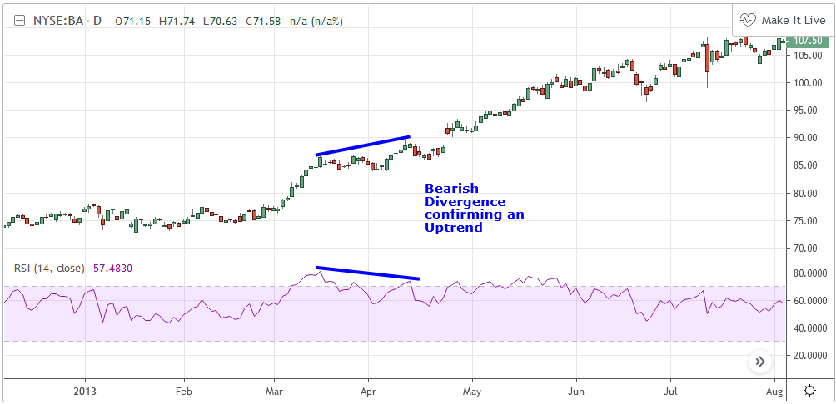
What this means is that essentially Divergence should be used as a way to confirm trends and not necessarily anticipate reversals.

Reversals
Cardwell also discovered what are referred to as Positive and Negative Reversals. Positive and Negative Reversals are basically the opposite of Divergence.
- Positive Reversal occurs when price makes a higher low while RSI makes a lower low. Price proceeds to rise. Positive Reversals only occur in Bullish Trends.
- Negative Reversal occurs when price makes a lower high while RSI makes a higher high. Price proceeds to fall. Negative Reversals only occur in Bearish Trends.
Positive and Negative Reversals can be boiled down to cases where price outperformed momentum. And because Positive and Negative Reversals only occur in their specified trends, they can be used as yet another tool for trend confirmation.

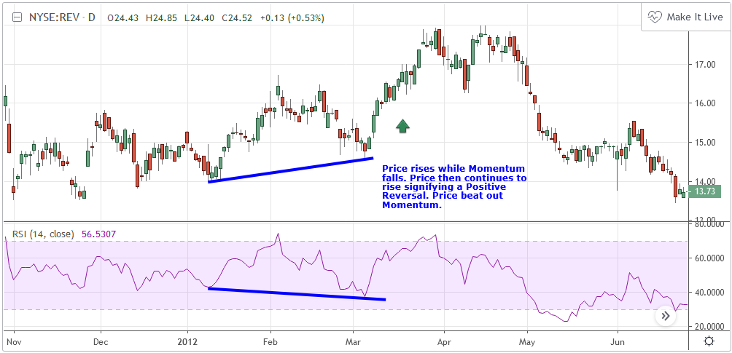

SUMMARY
For more than four decades the Relative Strength Index (RSI) has been an extremely valuable tool for almost any serious technical analyst. Wilder’s work with momentum laid the groundwork for future chartists and analysts to dive in deeper to further explore the implications of his RSI modeling and its correlation with underlying price movements. As such, RSI is simply one of the best tools or indicators in a trader’s arsenal of market metrics to develop most any trading methodology. Only the novice will take one look at RSI and assume which direction the market will be heading next based off of one number. Wilder believed that a bullish divergence was a sign that the market would soon be on the rise, while Cardwell believed that such a divergence was merely a slight price correction on the continued road of a downward trend. As with any indicator, a trader should take the time to research and experiment with the indicator before relying on it as a sole source of information for any trading decision. When used in proper its perspective, RSI has proven to be a core indicator and reliable metric of price, velocity and depth of market.

HOW TO USE WITH TRADINGVIEW
- Navigate to https://www.tradingview.com/
- On the landing page, enter a symbol and click "Launch Chart"
- Within the Toolbar along the top of the chart select "Indicators" and choose the one you would like to add to your chart.
- To make changes to your Indicator you will need to access the Formatting Window.
- You can access the Formatting Window by either clicking on the Blue "Format" button in the Chart Header next to the Indicator name, or by right clicking on the Indicator in the chart itself and selecting "Format".

INPUTS
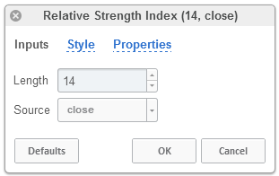

Length
The time period to be used in calculating the RSI. 14 days is the default.

Source
Determines what data from each bar will be used in calculations. Close is the default.

STYLE
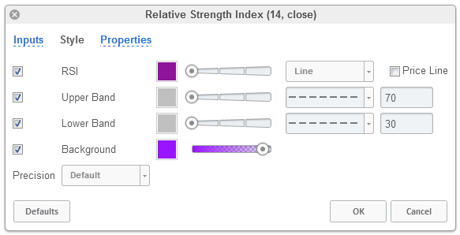

RSI
Can toggle the visibility of the RSI as well as the visibility of a price line showing the actual current price of the RSI. Can also select the RSI's color, line thickness and line style.

Upper Band
Can toggle the visibility of the Upper Band as well as sets the boundary, on the scale of 1-100, for the Upper Band (70 is the default). the Upper Band's color, line thickness and line style can also be determined.

Lower Band
Can toggle the visibility of the Lower Band as well as sets the boundary, on the scale of 1-100, for the Lower Band (30 is the default). the Lower Band's color, line thickness and line style can also be determined.

Background
Toggles the visibility of a Background color within the RSI's boundaries. Can also change the Color itself as well as the opacity.

Precision
Sets the number of decimal places to be left on the indicator's value before rounding up. The higher this number, the more decimal points will be on the indicator's value.

PROPERTIES
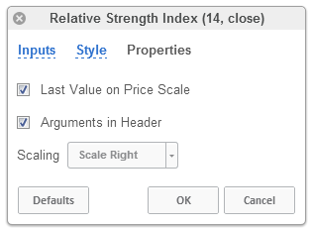

Last Value on Price Scale
Toggles the visibility of the Indicator Value on the vertical axis.

Arguments in Header
Toggles the visibility of the indicator's name and settings in the upper left hand corner of the chart.

Scaling
Scales the indicator to either the Right or to the Left.

