CMPG 325 PHASE 3
TECHNICAL REPORT
Mothusi Bed & Breakfast
Potchefstroom, South Africa
Project ID: CMPG325-2026-053
Client ID: CL-053
Student name: MASHISHI BOIKANYO
Student number: 43267734
Module: CMPG 325

Summary
This document outlines the Phase 3 network deployment for Mothusi Bed & Breakfast located in Potchefstroom, South Africa. The architecture incorporates three routers and several IPv4 subnets, utilizing static routes for inter-network communication. Access control lists (ACLs) limit the public self-service kiosk and contractor network from accessing specific internal networks. A virtual Internet server is employed to evaluate accessibility. Results are derived from the Packet Tracer command output provided during implementation; unverified elements are indicated.

Client Requirements and Objectives
The network divides administrative, staff, contractor wireless, and public kiosk traffic while maintaining necessary communication. The public kiosk (CR13) must solely use the Internet and must not connect to internal client networks. Access for contractors is limited from the evaluated Admin and Staff subnets. The designated technical task involves multi-router static routing.
• Set up the designed topology with three routers positioned in a triangular formation.
• Implement subnetting on 192.168.31.0/24 to divide operational groups.
• Set up static routes to ensure connectivity among necessary networks.
• Implement ACLs to restrict kiosk and contractor access to specific internal networks.
• Confirm connectivity and limitations through ping tests and router command results.

3. Network Design and Topology
The logical design includes three routers (R1, R2, and R3). R1 links the admin subnet with the public kiosk subnet. R2 links the wireless subnets of staff and contractors. R3 links to the simulated Internet/server subnet. Links between routers create a triangular shape.
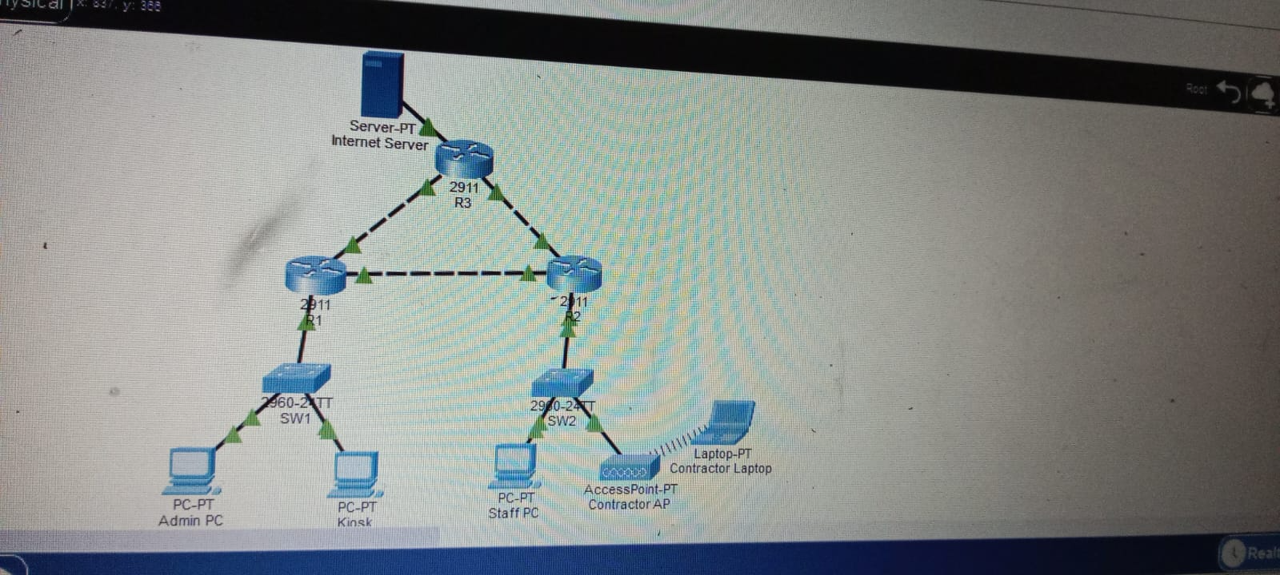

4. IPv4 Addressing Plan
Network / Link | Subnet | Gateway / Interface | Example host / peer
Admin | 192.168.31.0/27 | 192.168.31.1 (R1) | Admin PC: 192.168.31.10
Staff | 192.168.31.64/27 | 192.168.31.65 (R2) | Staff PC: 192.168.31.70
Contractor Wi-Fi | 192.168.31.96/27 | 192.168.31.97 (R2) | Contractor laptop: 192.168.31.100
Public kiosk | 192.168.31.128/27 | 192.168.31.129 (R1) | Kiosk: 192.168.31.130
R1–R2 link | 192.168.31.160/30 | R1: .161; R2: .162 | Point-to-point
R2–R3 link | 192.168.31.164/30 | R2: .165; R3: .166 | Point-to-point
R1–R3 link | 192.168.31.168/30 | R1: .169; R3: .170 | Point-to-point
Simulated server subnet | 192.168.31.172/30 | R3: 192.168.31.173 | Server: 192.168.31.174
The /27 client subnets provide 30 usable host addresses each. The /30 point-to-point and server subnets provide two usable host addresses each.

5. Implementation Summary
5.1 Interfaces of routers and static routing
The provided show-command output verifies that the pertinent, routed interfaces R1, R2, and R3 are in an up/up state. R1 has linked paths for Admin and kiosk, featuring fixed routes to Staff, Contractor Wi-Fi, and the server subnet. R2 features sub interfaces for Staff and Contractor Wi-Fi, connections to R1 and R3, and static routes to Admin, kiosk, and server. R3 features linked routes for inter-router connections as well as the server subnet, along with static routes to the four client subnets.
5.2 Access Control List for Public Kiosk
R1 implements access-list 101 on the inbound for the kiosk sub interface GigabitEthernet0/0.20. It blocks traffic from 192.168.31.128/27 to Admin (192.168.31.0/27), Staff (192.168.31.64/27), and Contractor (192.168.31.96/27), while allowing other IP traffic.
The kiosk obtained 3 out of 4 responses from server 192.168.31.174 (25% loss). Pings to 192.168.31.10 and 192.168.31.70 both got four 'Destination host unreachable' replies from 192.168.31.129. These findings align with the intended isolation policy for the destinations that were tested.
5.3 ACL of the Contractor
R2 has an expanded ACL called CONTRACTOR_RESTRICT enforced inbound on GigabitEthernet0/0.40. It restricts contractor subnet traffic (192.168.31.96/27) for Admin and Staff while allowing access to other IP destinations. Provided ACL counters indicate matches on both deny and permit entries. The contractor's laptop arrived at its gateway and emulated the server, while entry to the evaluated Admin and Staff hosts was restricted.

6. Assigned Technical Challenge: Multi-Router Static Routing
Static routes on R1, R2, and R3 specify destination subnets and next-hop router addresses. R3 routes 192.168.31.0/27 via 192.168.31.169, 192.168.31.64/27 and 192.168.31.96/27 via 192.168.31.165, and 192.168.31.128/27 via 192.168.31.169. R3 has connected interfaces on 192.168.31.168/30, 192.168.31.164/30, and 192.168.31.172/30.
A direct test from R3 to 192.168.31.174 succeeded with 5/5 replies (100% success; minimum/average/maximum round-trip 0/0/1 ms). The kiosk test received 3/4 replies, demonstrating server reachability despite an initial timeout.

7. Testing and Results
Source | Destination | Observed result | Interpretation
R3 | Server 192.168.31.174 | 5/5 replies; 0% loss | Server reachable from R3
Kiosk | Server 192.168.31.174 | 3/4 replies; 25% loss | Reachable; first packet timed out
Kiosk | Admin PC 192.168.31.10 | 0/4; 100% loss; gateway reports unreachable | Consistent with ACL isolation
Kiosk | Staff PC 192.168.31.70 | 0/4; 100% loss; gateway reports unreachable | Consistent with ACL isolation
Admin PC | Staff PC 192.168.31.70 | Repeat test: 4/4 replies | Inter-subnet connectivity verified
Contractor laptop | Gateway 192.168.31.97 | 4/4 replies | Gateway reachable
Contractor laptop | Admin PC 192.168.31.10 | 0/4 after ACL | Tested host blocked
Contractor laptop | Staff PC 192.168.31.70 | 0/4 after ACL | Tested host blocked
Contractor laptop | Server 192.168.31.174 | Initial 2/4; repeat 4/4 replies | Server reachable on repeat

8. Security Considerations and Limitations
• The public kiosk operates on a distinct subnet, and an inbound ACL blocks traffic to the Admin, Staff, and Contractor subnets.
• The contractor subnet features an inbound ACL that blocks traffic to Admin and Staff subnets.
• The ACLs allow additional IP traffic, so stricter rules might be necessary if the client requires kiosk or contractor access restricted to specific Internet services.
• The provided R3 routing table lacks a default route and contains a connected route to the subnet of the simulated server. Wider Internet accessibility has not been proven.
• Server ping verifies the accessibility of the IP address. HTTP, DNS, or other services must only be taken if individually set up and verified.

9. Conclusion
The provided Packet Tracer evidence shows a network of three routers implementing subnetting, static routing, and ACLs to distinguish client groups. The test from R3 to the server was entirely successful. Kiosk and contractor evaluations confirm the desired limitations for the internal hosts assessed.

10. Evidence Checklist