📑 HomeMatch Model Report

🔹 Regression Results
Best Model: XGB

Metrics
Model | RMSE | MAE | R²
Linear | 33294.8541 | 27378.7872 | 0.0619
RF | 25059.3431 | 20034.1408 | 0.4686
XGB | 25049.6220 | 20055.0808 | 0.4690
Ensemble | 25987.2455 | 20576.5749 | 0.4285

Plots
Residuals vs Predicted
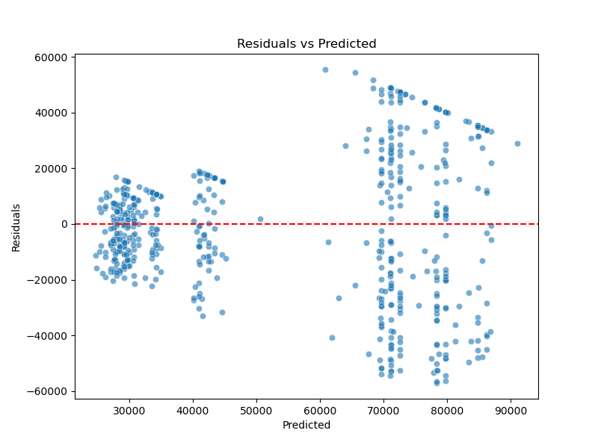
Error Distribution
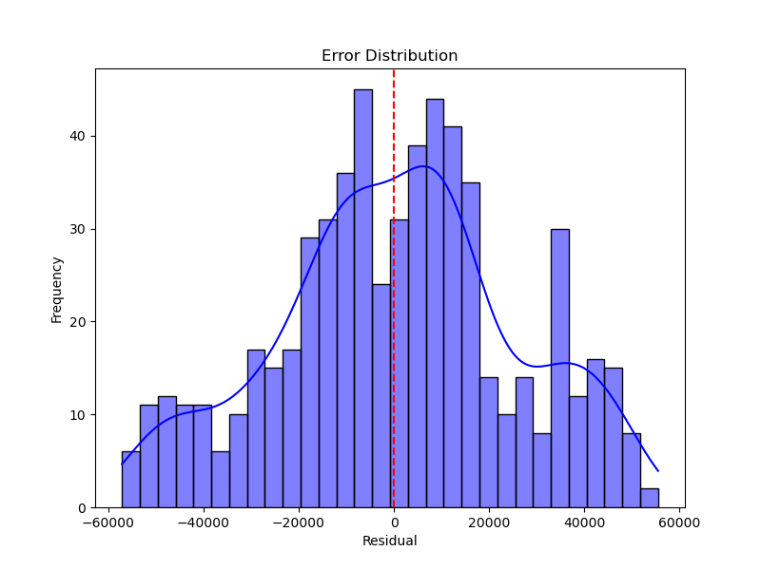

🔹 Classification Results
Best Model: RFC

Metrics
Model | F1 Score
Logistic | 0.8417
RFC | 0.8425
XGB | 0.8417
Voting | 0.8417

Plots
Confusion Matrix
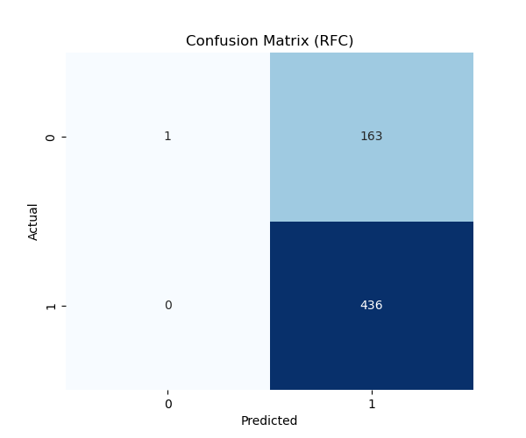
ROC Curve
