**WHISH : Personal Travel Blog on IBM Cloud Static Web**

**Apps**

**Objective:**

This project aims to create a personal travel blog hosted on IBM Cloud Static Web Apps. The blog aims to share travel experiences, stories, photos, and travel tips with readers. The project combines design thinking principles with technical implementation to create an engaging and informative travel blog.

**Design Thinking Process:**

1. **Empathise:**

The first stage involves understanding the problem or challenge from the perspective of the end-users. Design thinking involves engaging with the people experience the problem to gain deep insights and empathy. This often involves interviews, surveys, and observations to uncover their needs, motivations, and pain points.

1. **Define:**

In this stage, the insights gained from empathizing are synthesized to define the core problem or challenge. We distill the information into a clear and actionable problem statement that serves as a guide throughout the process. This step ensures that the problem is well understood and is framed in a way that can lead to innovative solutions.

1. **Ideate:**

Ideation is a creative brainstorming phase where team members generate a wide range of ideas, solutions, and possibilities without judgment. The goal is to encourage divergent thinking and explore as many potential solutions as possible. Techniques such as mind mapping, and brainstorming sessions are used here.

1. **Prototype:**

In this phase, we create rough, low-cost, and scaled-down versions of the potential solutions. These prototypes can be physical or digital and are designed to be quick and inexpensive. The purpose is to test and refine the concepts and learn from the hands-on experience of trying out ideas in a tangible form.

1. **Test:**

Prototypes are put in front of users or stakeholders to gather feedback and evaluate the ideas. This testing phase involves observing how users interact with the prototypes, collecting their feedback, and understanding what works and what doesn't. Iterative feedback loops are common as design thinkers refine and improve the solutions based on user input.

1. **Implement:**

Once a solution has been refined and validated through testing, it's ready for implementation. This phase involves scaling up the solution and making it a

reality. It might involve collaboration with engineers, developers, marketers, and other professionals to ensure a successful launch.

1. **Iterate:**

The design thinking process is often cyclical, with the understanding that the first solution might not be the best one. Continuous refinement and improvement based on feedback and real-world usage are key principles of design thinking. The team revisits earlier stages, making adjustments as needed to create a better solution.

**Development Phases:**

1. **Planning Phase**
   * Define Objectives and Scope:

In the planning phase, the project's objectives are clearly defined. This includes establishing the overarching goal of creating a personal travel blog, understanding the target audience, and defining the scope of the project.

* + Content Strategy:

Content planning is a critical part of the planning phase. Decide on the types of content to be created, such as travel articles, destination guides, travel tips, and personal stories. Consider the frequency of content updates and the editorial calendar.

* + Technical Stack Selection:

The choice of technologies and tools is also part of the planning phase. This project involves selecting the programming languages (HTML, CSS, JavaScript), hosting platform (IBM Cloud Static Web Apps), and any third-party services or libraries to be used.

1. **Design Phase:**
   * Wireframing and Prototyping:

The design phase involves creating wireframes and prototypes that provide a visual representation of the blog's layout, user interface, and visual style. This step helps in defining the structure of the website and the placement of various elements.

* + User Experience (UX) Design:

It ensures that the blog is easy to navigate, visually appealing, and user-friendly. This includes designing a logical information architecture, creating intuitive navigation menus, and optimizing the site.

* + Visual Design:

The visual design phase focuses on the aesthetics of the blog, including color schemes, typography, imagery, and branding elements. The goal is to create a visually engaging and cohesive design that aligns with the blog's theme and content.

1. **Content Creation Phase:**

Writing and Editing:

Content creation involves researching and writing travel articles, personal stories, and other types of content. Attention to detail is crucial, and content should be engaging, informative, and error-free. Proofreading and editing are essential to maintain quality.

1. **Technical Implementation Phase:**
   * Front-End Development:

This is where the technical implementation begins. Front-end developers use HTML, CSS, and JavaScript to build the website's structure, layout, and interactivity. They transform the design and content into a functional web interface.

* + Hosting Setup:

During this phase, the blog is set up on the selected hosting platform, in this case, IBM Cloud Static Web Apps. The domain and server configuration are established, and necessary security measures are put in place.

1. **Testing Phase:**
   * Quality Assurance :

Thorough testing is crucial to ensure the website functions correctly. QA involves checking for broken links, responsive design across various devices and browsers, and testing the user interface for smooth navigation.

* + User Testing:

Actual users may be involved in testing to gather feedback on the site's usability, speed, and overall user experience. Feedback is used to identify and resolve any issues.

1. **Launch Phase:**
   * Deployment: Once the testing phase is completed, the blog is ready for launch. It is made accessible to the public, and the custom domain is linked.
   * Promotion: The launch phase also involves promoting the blog through various channels, including social media, email newsletters, and other marketing efforts to attract an initial readership.
   * Security and Performance: Regularly monitor the website's security and performance, applying updates and optimizations as needed.

**Website structure:**

1. **Home Page:**

* Introduces visitors to the blog.
* Highlights the latest posts and featured content.
* Offers an engaging visual and navigational entry point.

2. **Blog Posts:**

* Contains a collection of articles, travel experiences, and destination guides.
* Organized into categories and searchable by keywords. - Includes a comments section for reader engagement.

3. **Destinations:**

* Focuses on specific travel destinations.
* Provides detailed guides, itineraries, and multimedia content. - Features interactive maps and photo galleries.

4. **About Me:**

* Introduces the blog's author.
* Shares the author's travel journey and motivations. - Offers contact information and recommendations.

5. **Contact:**

* Allows readers to get in touch with the author.
* Includes a contact form and links to the author's social media. - Encourages newsletter signups for updates.

6. **Search and Categories:**

* Enhances navigation and content discovery.
* Includes a search bar and categorizes content. - May provide travel planner tools if relevant.

7. **Interactive Map:**

- Allows users to explore destinations and related content. - Features marked locations and filtering options.

8. **User Profiles:**

* Enables readers to personalize their experience.
* Offers saved articles, travel wishlists, and travel journey tracking.

9. **Newsletter Signup:**

* Encourages readers to subscribe for updates.
* Provides subscription forms and access to newsletter archives.

1. **Social Media Integration:**
   * Incorporates social sharing buttons and live social media feeds.
   * Promotes social engagement and real-time updates.
2. **Comments Section:**
   * Encourages reader interaction and feedback.
   * May include user profiles for commenters.
3. **User Ratings and Reviews:**
   * Allows users to rate and review destinations and services.
   * Highlights top-rated destinations and user-generated content.
4. **Guest Blogging:**
   * Offers a platform for guest bloggers to contribute.
   * Includes submission guidelines and author profiles.

**Content Creation:**

* 1. **Content Strategy:** Defining the blog's objectives, target audience, and types of content to be created.
  2. **Research**: Conducting in-depth research to gather accurate and valuable information about travel destinations, culture, and relevant topics.
  3. **Ideation:** Brainstorming and generating creative ideas for blog content that will engage and resonate with the audience.
  4. **Writing:** Composing engaging and informative blog articles, personal travel stories, and destination guides.
  5. **Media Production:** Creating high-quality images, photos, and multimedia elements to enrich the content.

**SCREENSHOTS:**

* 1. Login Page:

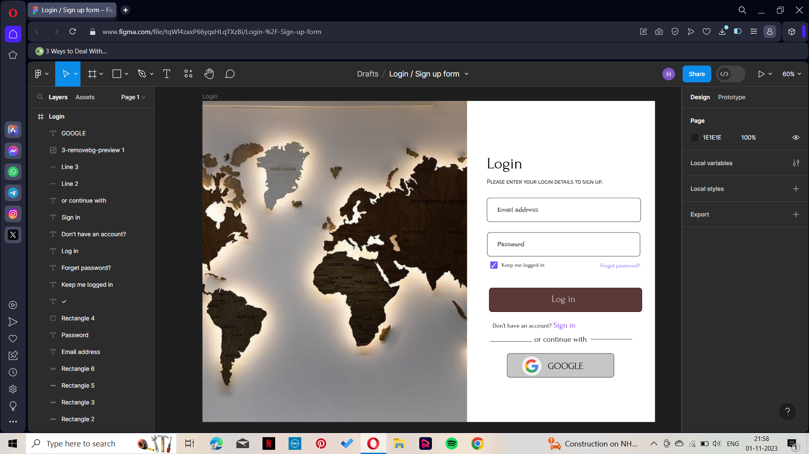

2.Home page:

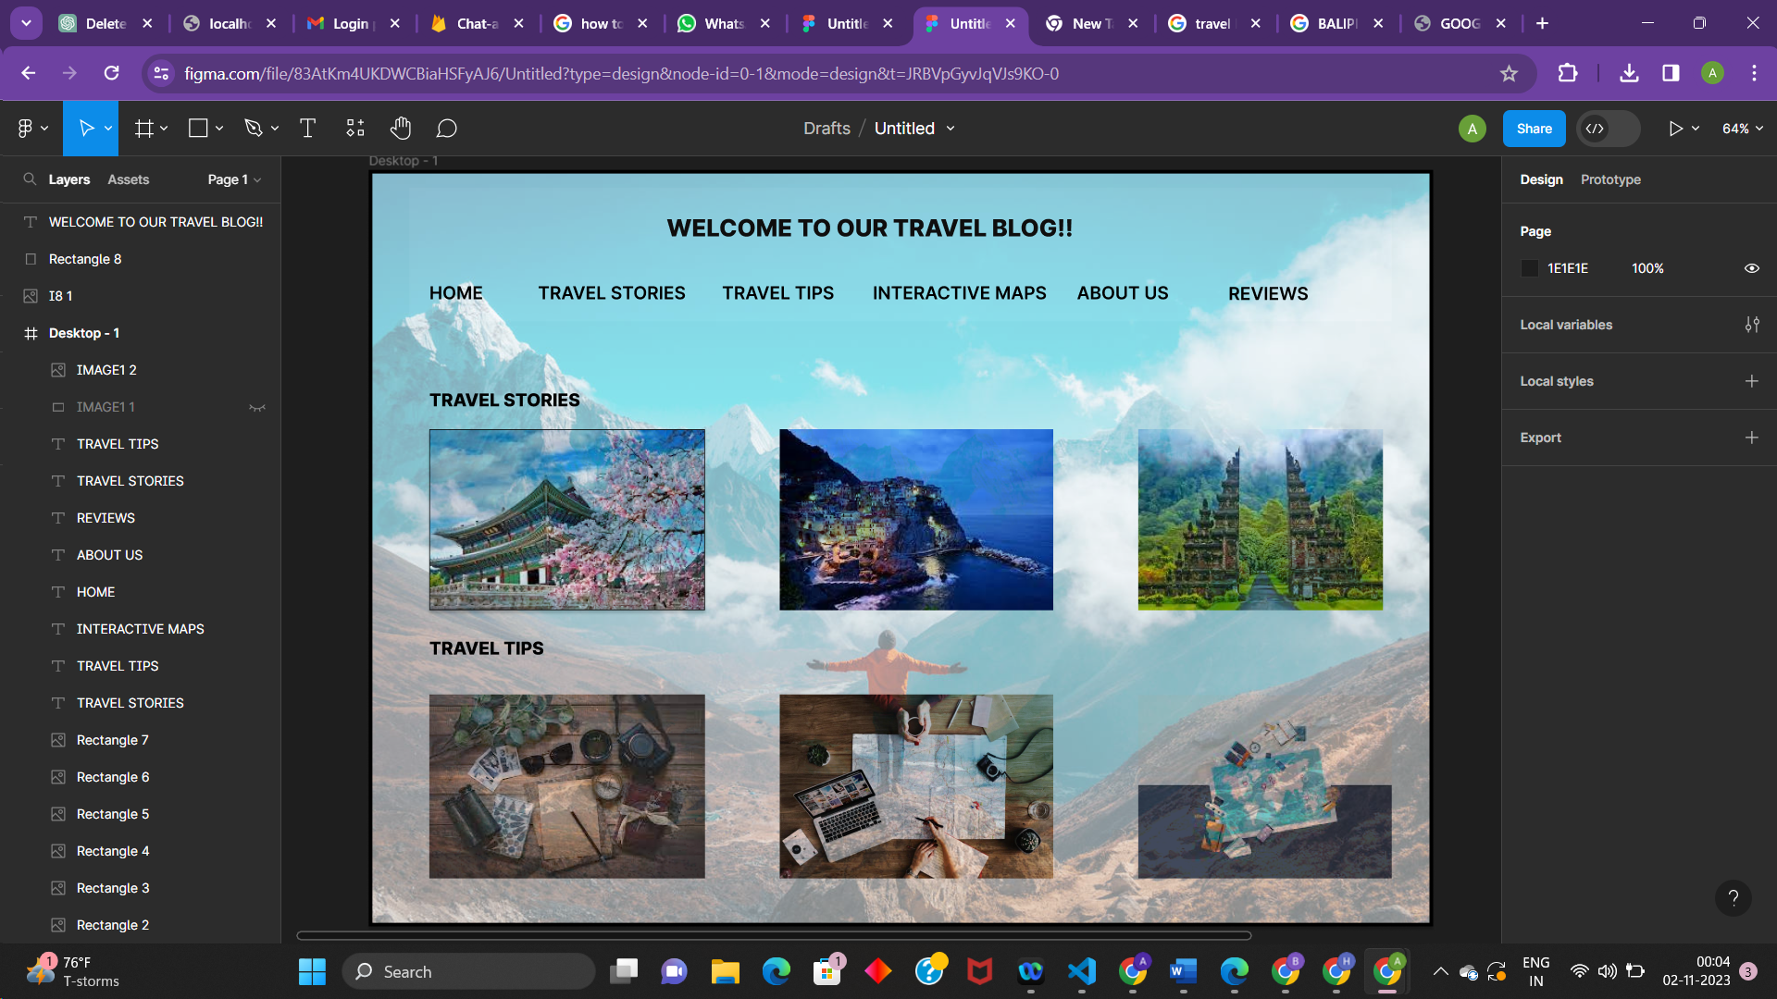

3.Blog creation:

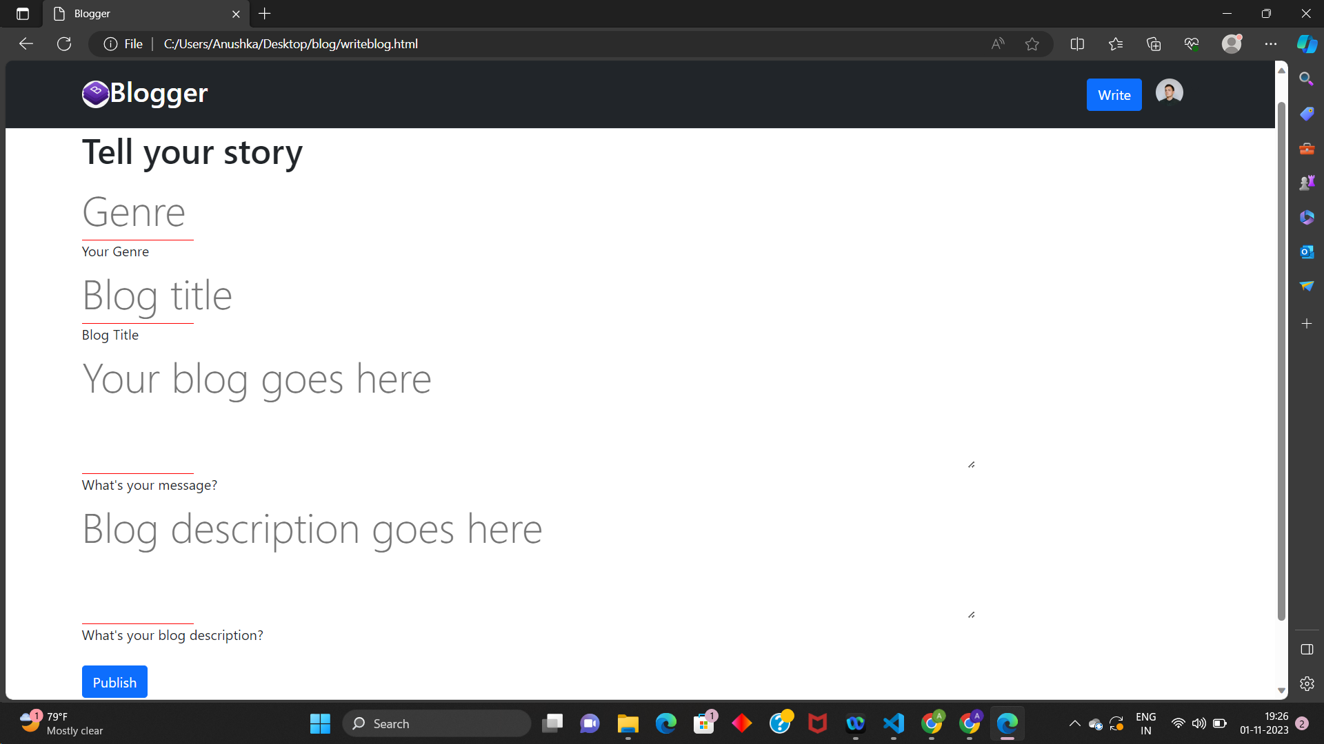

4.Blog post:

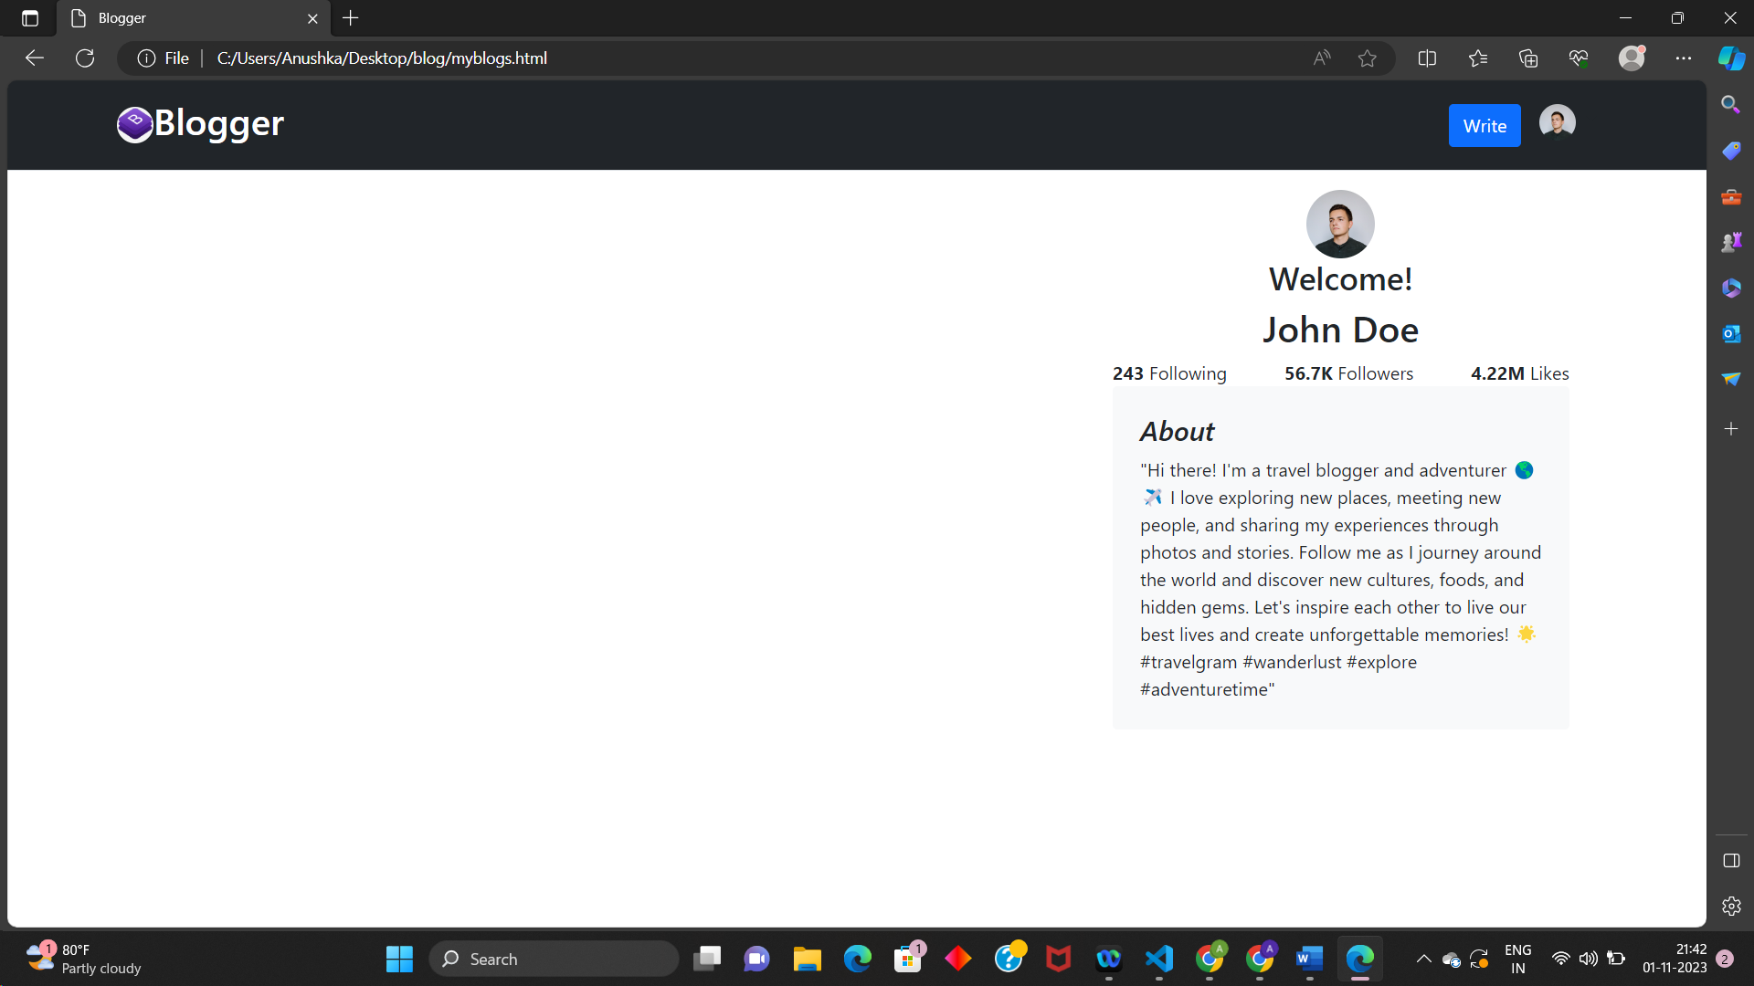

**CONCLUSION:**

The personal travel blog on IBM Cloud Static Web Apps is ready. It has been designed and developed to offer an engaging and informative experience for readers interested in travel content. The project follows a user-centered approach, providing valuable information and inspiring wanderlust.