Aerial Power: 4.5th Generation Fighters in Modern Warfare”

Introduction

WHAT ARE 4.5TH GENERATIONS FIGHTER JETS?

4.5th Generation fighter jets are upgraded 4th generation aircraft that integrate some 5th generation technologies without being fully stealth. They offer better radar, avionics, weapons, and maneuverability, making them more cost-effective than 5th generation fighters while still highly capable in modern warfare.
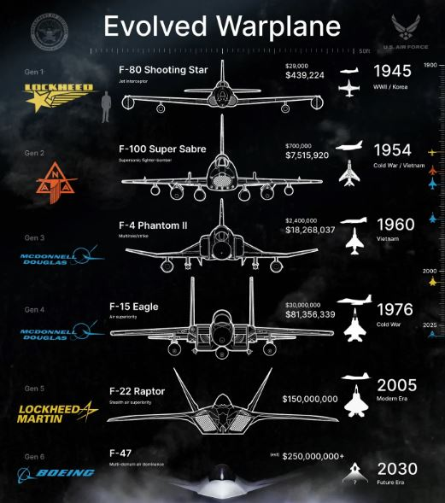
Figure 1: EVOLVED WARPLANE

GLOBAL ADOPTION

WHO OPERATED 4.5TH GENERATION JETS

44.5th Generation fighter jets are upgraded 4th generation aircraft that integrate some 5th generation technologies without being fully stealth. They offer better radar, avionics, weapons, and maneuverability, making them more cost-effective than 5th generation fighters while still highly capable in modern warfare.
Figure 2: DATA TO VISUALIZE

Fighter Jet Showcase below:
These advanced multirole jets combine enhanced maneuverability, partial stealth, and cutting-edge avionics—bridging the gap between legacy 4th generation and expensive 5th generation aircraft. They represent a critical step for many nations, delivering powerful capabilities at a more accessible cost, ensuring air superiority and flexibility in modern warfare.

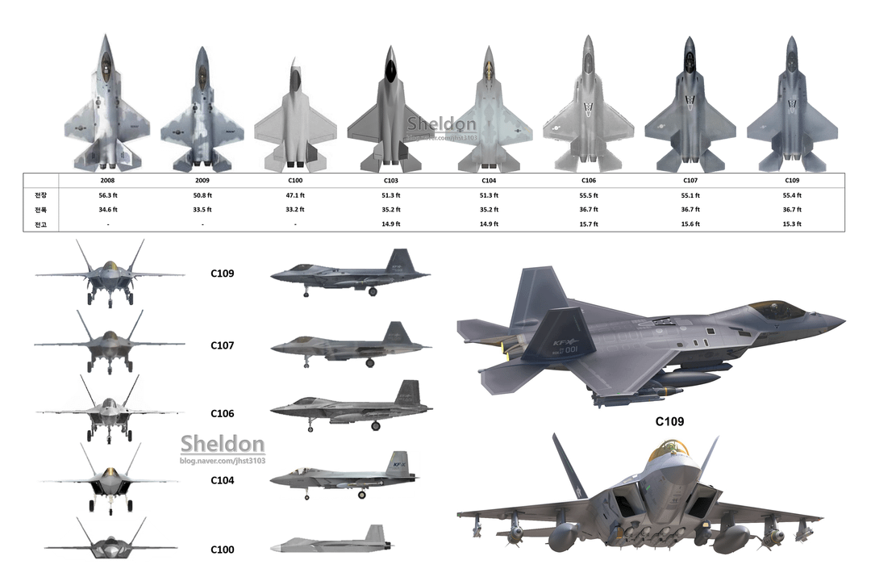
Figure 3: ADVANCEMENTS

