Hexadecimal to decimal

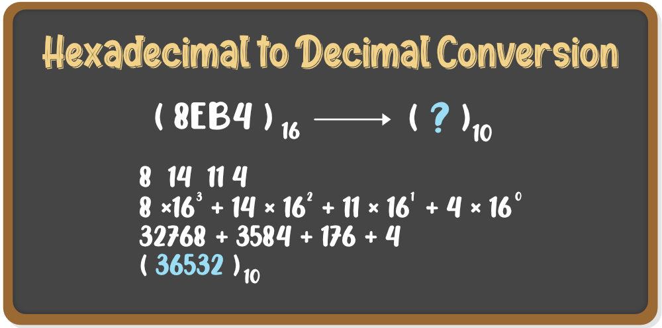

Hexadecimal to binary

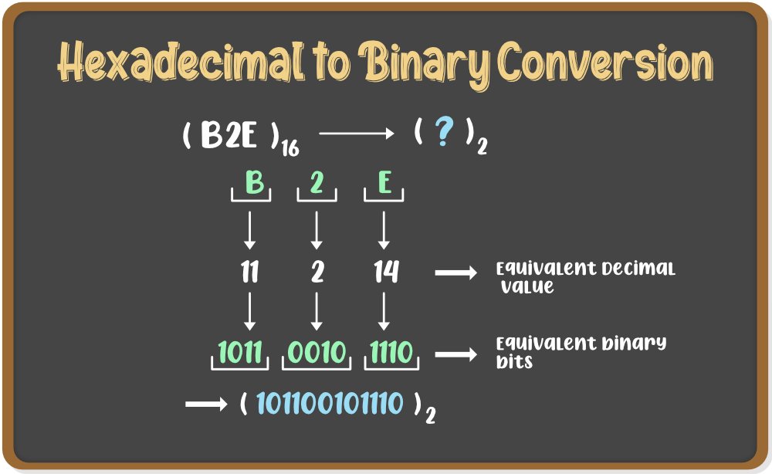

Hexadecimal to octal  
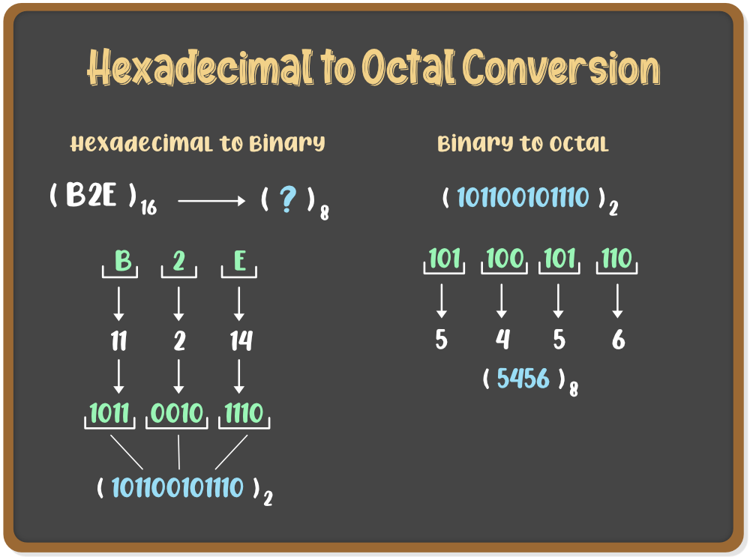1 decimal to binary   
2 decimal to octal   
3 decimal to hexadecimal  
4 binary to decimal  
5 binary to octal  
6 binary to hexadecimal  
7 octal to decimal   
8 octal to binary   
9 octal to hexadecimal  
10 hexadecimal to decimal   
11 hexadecimal to binary  
12 hexadecimal to octal

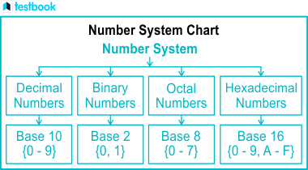

**Decimal to binary** 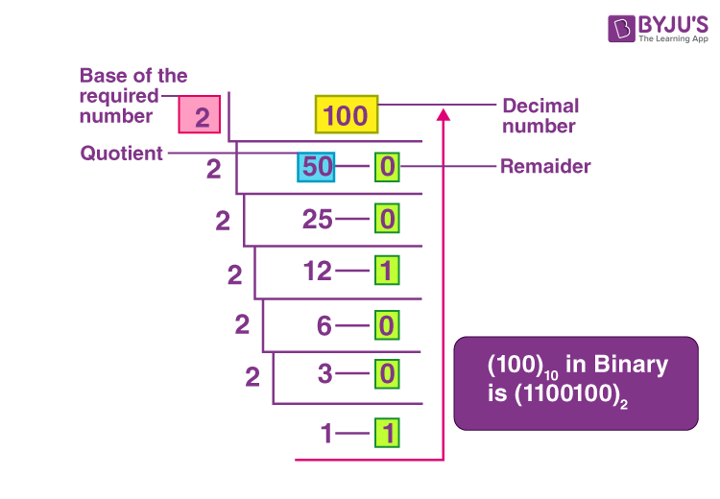

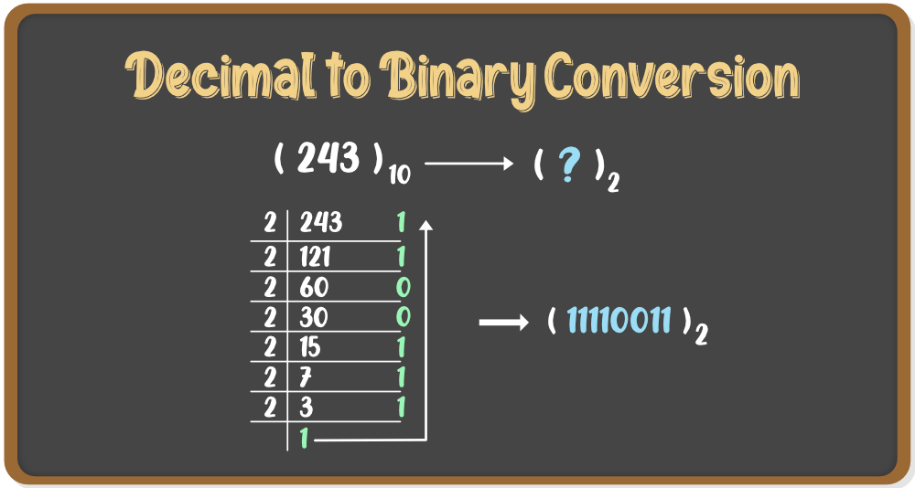

**Decimal to octal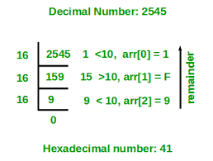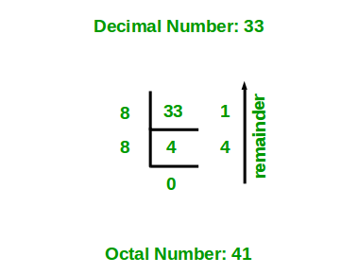decimal to hexadecimal  
  
binary to decimal**

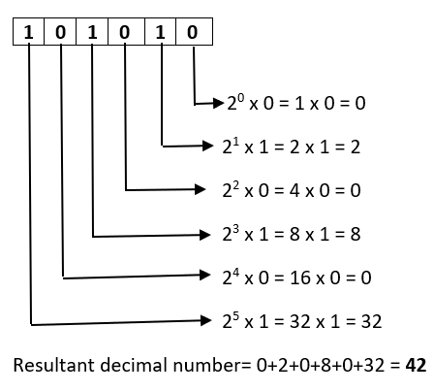

**Binary to octal**

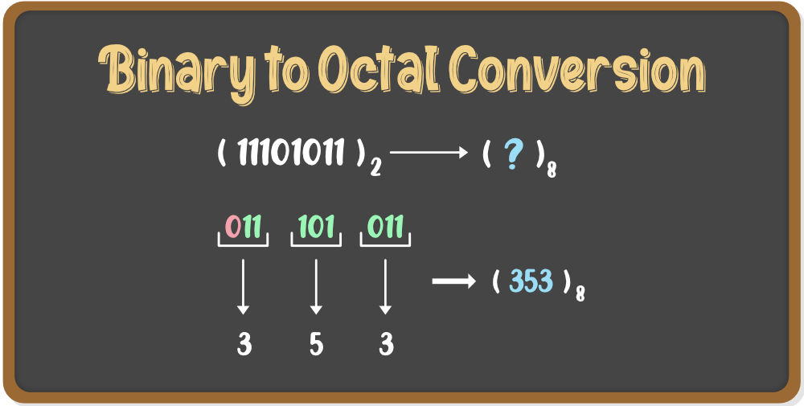

**Binary to hexadecimal**

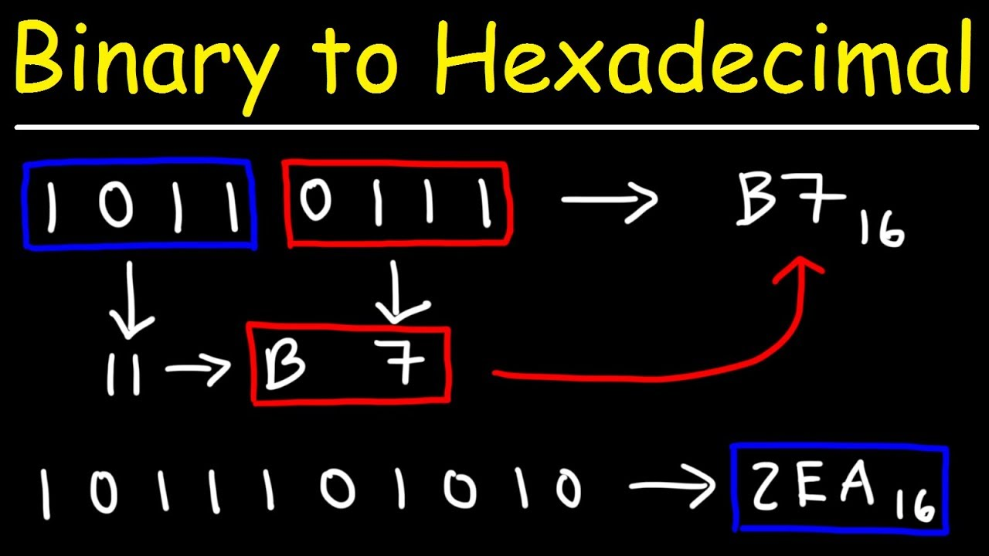

**Octal to decimal**

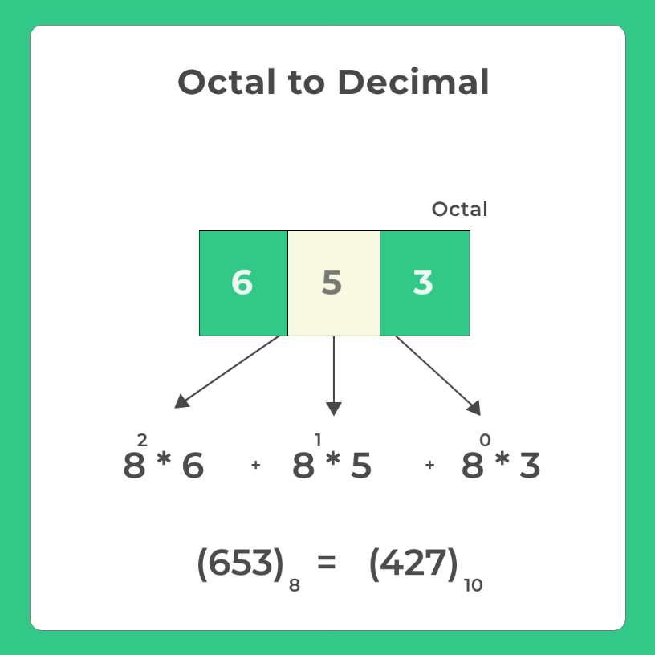

**Octal to binary**

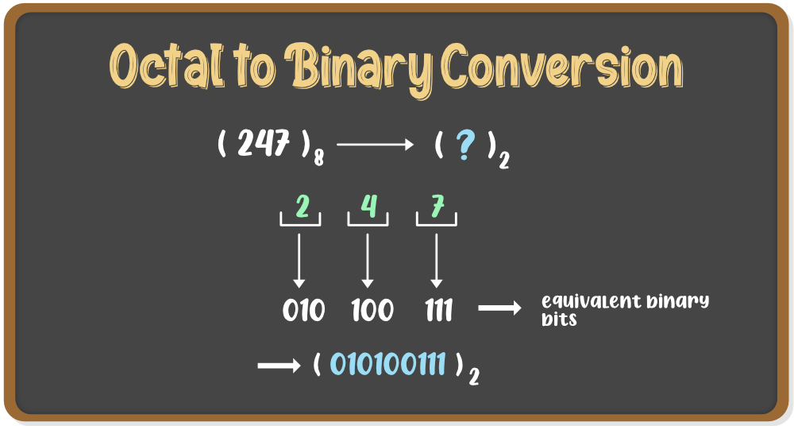

**Octal to hexadecimal**

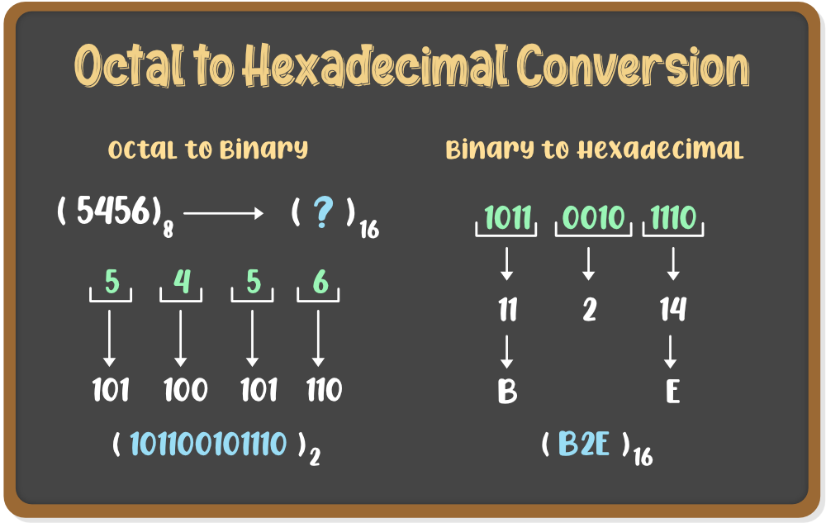

**Tables of binary ,octal, hexadecimal**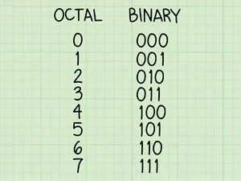

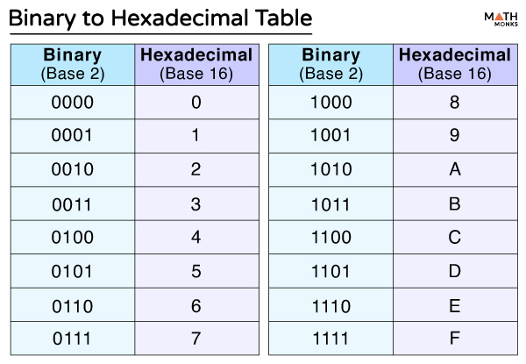

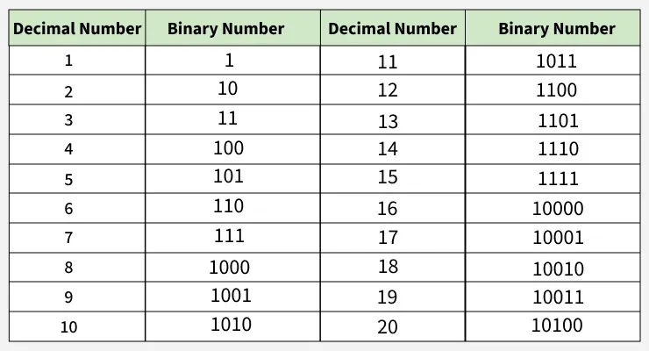

**Rules   
0+0=0 1+0=1 0+1=1 1+1=10 10+1=11**