X/Twitter Report
Sr.No | Screenshot | Post URL | Handler ID
1 | 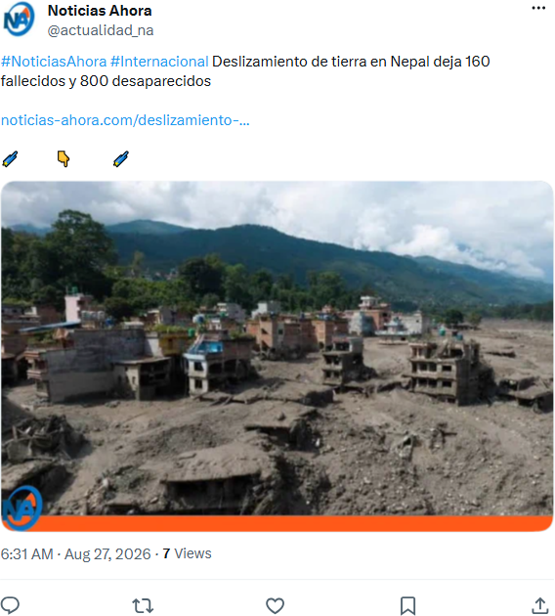 | https://x.com/actualidad_na/status/2092787156750114894 | @actualidad_na
2 |  | https://x.com/sarwara__/status/2092787149431283952 | @sarwara__
3 | 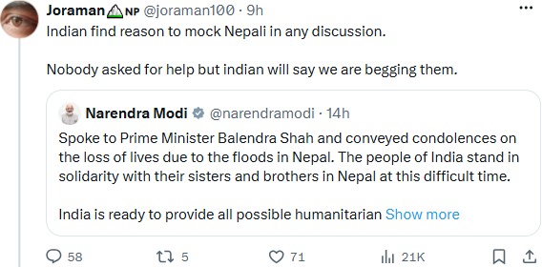 | https://x.com/SachinDhinwa/status/2092787149376745736 | @SachinDhinwa

