X/Twitter Report
Sr.No | Screenshot | Post URL | Handler ID
1 | 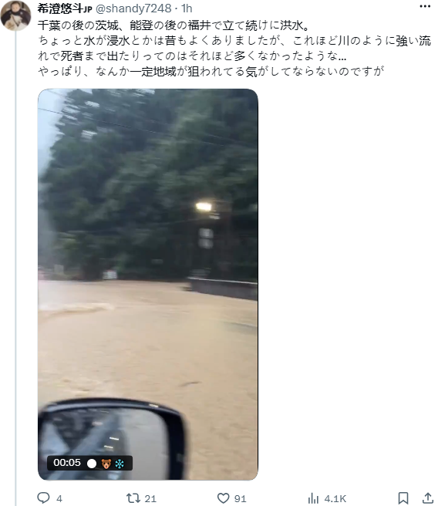 | https://x.com/ecoenep/status/2093896310814654944 | @ecoenep

