Unit # 1 Introduction to Problem Solving

Problem solving is the process of finding solutions to difficult or complex issues. Problem solving requires two distinct types of mental skill, analytical and creative. Analytical or logical thinking includes skills such as ordering, comparing, contrasting, evaluating and selecting. Creative thinking uses the imagination to create a large range of ideas for solutions.

**Learning Objectives**

After completing this unit, students will be able to

* Communicate and collaborate with classmates in order to solve a problem
* Iteratively improve a solution to a problem
* Identify different strategies used to solve a problem
* Identify the four steps of the problem solving process
* Given a problem, identify individual actions that would fall within each step of the problem solving process
* Identify useful strategies within each step of the problem solving process
* Apply the problem solving process to approach a variety of problems
* Assess how well-defined a problem is and use strategies to define the problem more precisely

# Introduction

**Problem solving** refers to tasks that have the potential to provide intellectual challenges for enhancing understanding and mental development. It is the application of a variety of tools, strategies and knowledge to a wide range of problems related to mathematics, computer science or even daily life routine. Problem solving

* Is a life skill
* Creates a purpose for learning skills and concepts
* Motivates students by developing a sense of inquiry
* Allows students to demonstrate their understanding of mathematical concepts and skills in meaningful contexts
* Teaches perseverance

## Communicate and Collaborate with Classmates

Communicate and collaborate with your classmates to try and solve some simple daily life problems. Let’s consider a basic daily life problem:

“*There are 300 people in a line. How many people are behind the 7th person?*”

Discuss with your classmates and find out what makes this problem hard? Some might say that 300 is a lot of people. Some might say that 7 and 300 are far apart. Ask around and make a list of difficulties that your classmates see in this problem.

## Iterative Solution

One of the simpler strategies to solve this problem is to try and solve a simpler version of this problem and then iteratively improve the solution for the harder version. Let’s consider the following problem statement

“*There are 8 people in line. How many people are behind the 7th person?*”

***Act It Out***

* Ask your teacher to pick out 8 students from your class randomly and make them stand in a line.
* Ask the student standing at 7th position to raise his hand.
* Now ask all those students who are standing behind the student at 7th position to raise their hands
* How many students are raising their hands?

***Draw a Diagram***

Draw 8 people on board or a paper

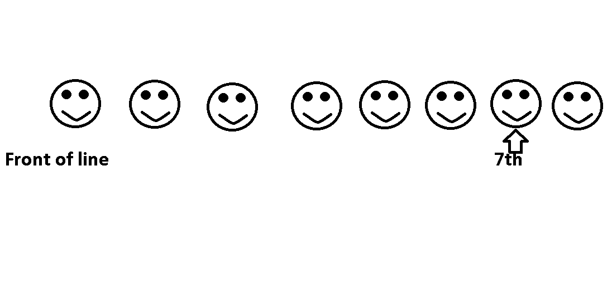

How many people are behind the 7th person?

*Answer: 1*

Now consider another similar problem

“*There are 5 people in a line. How many people are behind the 3rd person*?”

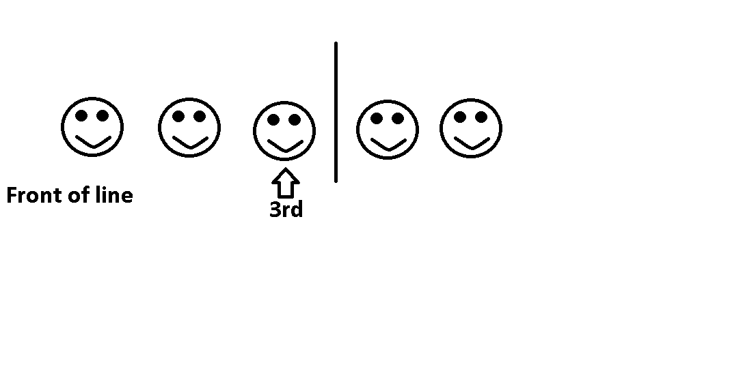

There are 2 people behind the 3rd person.

Consider another similar problem

“*There are 9 people in a line. How many people are behind the 4th person*?”

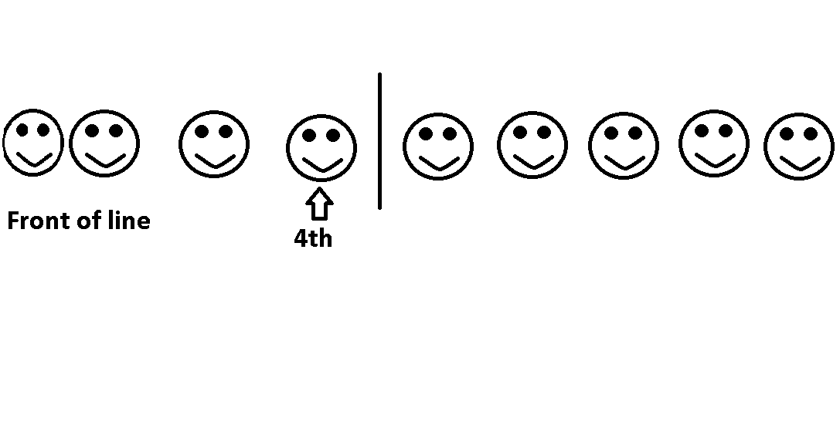

There are 5 people behind the 4th person.

Observe all above examples and note what is similar in all these examples? How can you get the answer from the two numbers given?

*Answer:* through subtraction!

Let’s consider another similar example

“*There are 8 people in a line. How many people are behind the 5th person*?”

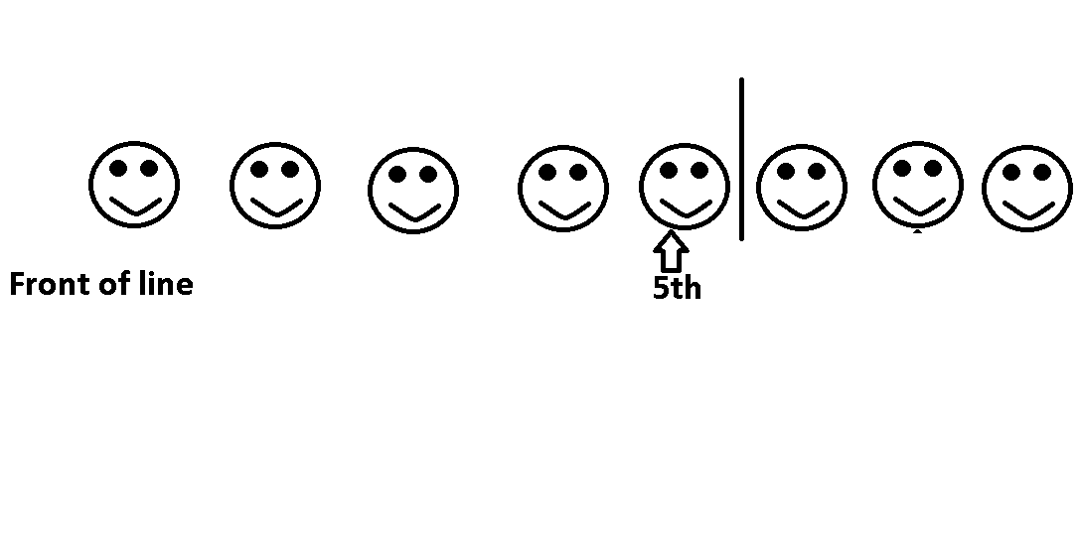

We can see there are 3 happy faces after the 5th happy face. And also, *8-5 =3.* We can get our answer by subtracting all the people before the line from the total number of people in the line.

Now, we come back to our original problem

“*There are 300 people in a line. How many people are behind the 7th person?*”

*Answer:* 300-7 = 293

Note that solving easier problems make it easier to solve the harder problems. Solving easier problems led us to the conclusion that the right approach to solve this problem is to *subtract: number of people in line – position of the person in line*

**

Try It Yourself!

Create and decorate a medium-sized box with a slot in

the top. Label the box “The Problem-Solving Box.” Invite

students to anonymously write down and submit any

problem or issue they might be having at school or at

home, ones that they can’t seem to figure out on their

own. Once or twice a week, have a student draw one of

the items from the box and read it aloud. Then have the class as a group figure out the ideal way the student can address the issue and hopefully solve it.

## Strategies to Solve a Problem

Many strategies are available to solve a problem effectively and easily. Listed below are some of the most commonly used strategies to solve problems:

1. **Working Backwards**

**Working backwards is to start with the final solution and work back one step at a time to get to the beginning. For example, in maths, these are called inverse operations. When using the work backwards strategy, each operation must be reversed to get back to the beginning. So if working forwards requires addition, working backwards requires subtraction. And if you multiply working forwards, then you must divide when working backwards.**

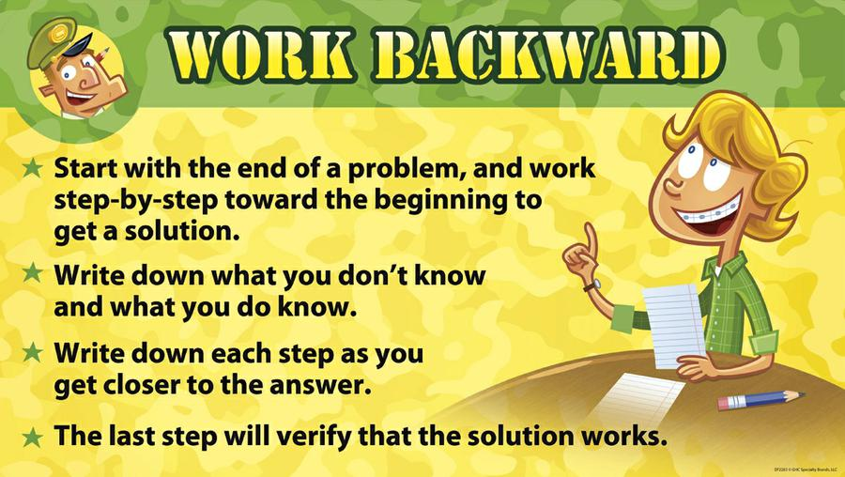

1. **Look for a Pattern**

**When using this strategy you look for a pattern from the information that has been given. Once the pattern has been identified, you can predict what will happen next and then continue the pattern to find the correct solution.**

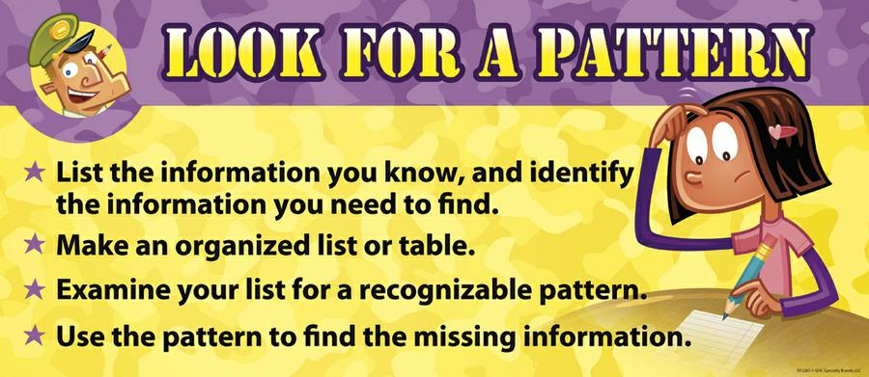

1. **Solving a Simpler Problem**

Sometimes the problem is too difficult to solve in one step. When this happens you can make the problem more simpler by dividing it into smaller and easiest steps, such as rephrasing the problem using smaller numbers. These strategies are really useful in helping to solve maths problems.

DO YOU KNOW?

Famous mathematician George Polya said

*“If you can't solve a problem, then there is an easier problem you can solve: find it.”*



.

1. **Make a Drawing / Act It Out**

In this strategy you can draw pictures, have people play roles or use manipulative to act the problem out. Creating a diagram can help you to picture the problem and find the solution. To create a diagram, the problem must be read carefully and the information that has been given to you in the question drawn into the diagram. You can then work out the solution from the diagram that has been drawn.

1. **Guess and Check**

The guess and check strategy can be helpful for many types of problems. When using this strategy, you will make a reasonable guess, based on the information that you have been given and then check to see if your guess is correct. The guesses should get closer and closer to the answer, until the correct answer is found.

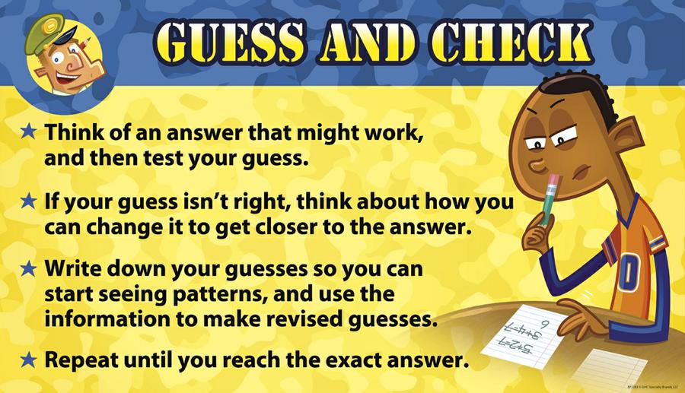

1. **Organizing Data**

Using a table is a good way to sort out and organize the information that has been given in the question. The information that has been set out in the table will hopefully lead you to the correct solution.

Making a list is also a strategy that will help you sort out the information that has been given in the problem. Once you can see all of the possibilities for the solution, you can then attempt to solve the problem more easily.

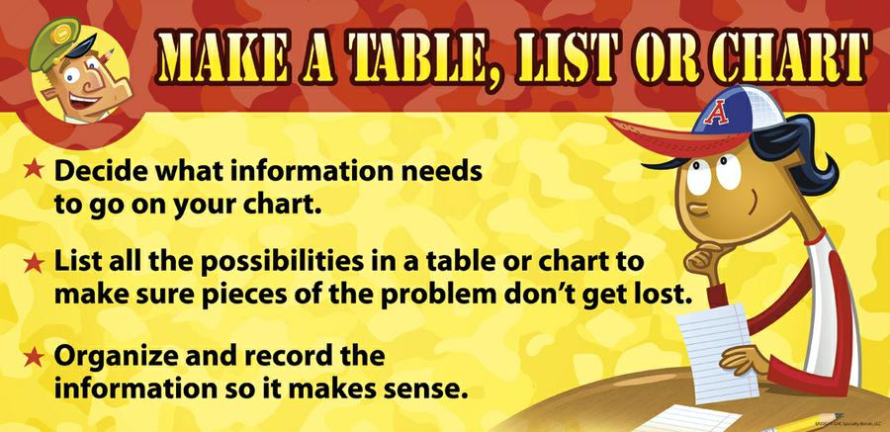

1. **Considering Alternatives**

This strategy requires looking at your problems in different ways; find a new perspective that you haven't thought of before.  
Brainstorming, or rapid noting of alternatives, is an excellent discovery process. Once you have listed or mapped alternatives, be open to their possibilities. Make notes on those that:

* need more information
* are new solutions
* can be combined or eliminated
* seem promising

After listing possible alternatives, evaluate them by considering all criteria and select the best alternative.

1. **Logical Reasoning**

This strategy requires using the information that has been given in the question to eliminate possible solutions to finally discover the correct solution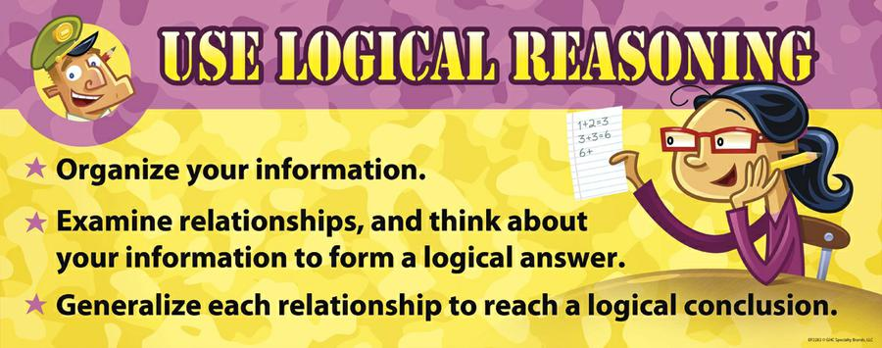

Try It Yourself!

**Clue me in:** This fun detective game encourages

problem-solving, critical thinking and cognitive

development. Collect a number of items (e.g

pictures) that are associated with a specific

profession, social trend, place, public figure,

historical event, animal, etc. Place them all in a bag

(5-10 clues should be sufficient.) Then have a friend reach into the bag and one by one pull out clues. Choose a minimum number of clues they must draw out before making their first guess (2- 3). After this, your friend must venture a guess after each clue pulled until they guess correctly. See how quickly they are able to solve the riddle.



# The Problem Solving Process

# The problem solving process consists of a sequence of sections that fit together depending on the type of problem to be solved. It is the process of working through details of a problem to reach a solution.  The process is only a guide for problem solving. It is useful to have a structure to follow to make sure that nothing is overlooked.

**George Pólya** was a Hungarian mathematician. In 1945 he published the book “How To Solve It” which quickly became his most prized publication. In this book he identifies four basic principles of problem solving.

DO YOU KNOW?

[George Polya](http://www.mathgym.com.au/htdocs/polyab.htm), known as the father of modern problem solving, did extensive studies and wrote numerous mathematical papers and three books about problem solving.



.

**1. UNDERSTAND THE PROBLEM**

First you have to understand the problem. Try to find out the answers to following questions:

* What are you asked to find or show?
* Can you restate the problem in your own words?
* Can you think of a picture or a diagram that might help you understand the problem?
* Is there enough information to enable you to find a solution?
* Do you understand all the words used in stating the problem?
* Do you need to ask a question to get the answer?

**2. DEVISING A PLAN**

There are many reasonable ways to solve problems. The skill at choosing an appropriate strategy is best learned by solving many problems. You will find choosing a strategy increasingly easy with practice. Consider all the strategies discussed in the previous section and pick one that seems most suitable. Eventually you will have a plan to solve your problem.

**3. Carry out the Plan**

This step is usually easier than devising the plan. In general, all you need is care and patience, given that you have the necessary skills. Persist with the plan that you have chosen. If it continues not to work, discard it and choose another.

**4. Look Back**

Examine the solution obtained. Check to see if you used all your information and that the answer makes sense. Much can be gained by taking the time to reflect and look back at what you have done, what worked and what didn't. Doing this will enable you to predict what strategy should be used to solve future problems, if these relate to the original problem.

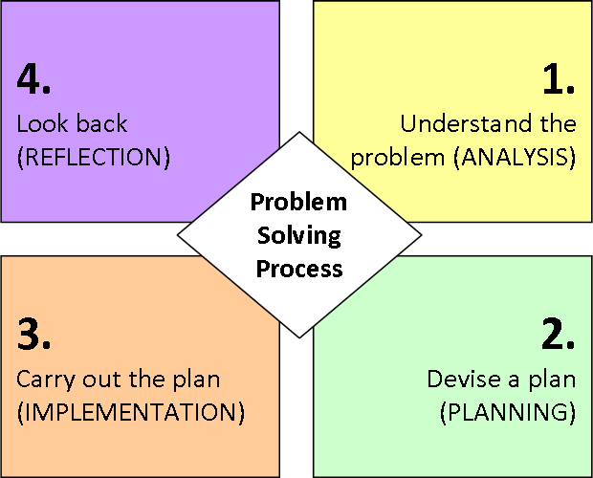

Example of Problem Solving Process

Let us solve a problem known as “*Number Stumper*” using Polya’s four step problem solving process.

Ahmed has given his class mates some clues to help them guess his number.

* There is a 1 in the number
* The digit in the hundreds place is 3 times the digit in the thousands place
* The digit in the ones place is 4 times the digit in the tens place
* The digit in the millions place is 1/2 the digit in the hundreds place
* The digit in the hundred-thousands place is 1 less than the digit in the ones place
* There is a 9 in the ten-thousands place

What is Ahmed’s number?

1. **Understand the Problem**

In this problem we are asked to find out the number given by Ahmed. The number is a seven digit number. Ahmed has given clues about number at each place value and provided us with information about all digits.

1. **Devise a Plan**

Here we have to decide about a strategy that we will use to solve our problem. For this problem we will use the strategy “*Organize the data*”. In this strategy we will organize the given information in the form of a place value chart.

1. **Carry out the Plan**

Here we will implement our plan

|  |  |
| --- | --- |
| Millions | 3 |
| Hundred Thousand | 3 |
| Ten Thousand | 9 |
| Thousand | 2 |
| Hundred | 6 |
| Tens | 1 |
| Ones | 4 |

The number is 3392614

1. **Look Back**

Now we will check to see if our answer is correct or not.

* There is a 1 in the number (tens place)
* The digit in the hundreds place is 3 times the digit in the thousands place (6=2 x 3)
* The digit in the ones place is 4 times the digit in the tens place (4=1 x 4)
* The digit in the millions place is 1/2 the digit in the hundreds place (3 = 6/2)
* The digit in the hundred-thousands place is 1 less than the digit in the ones place (3 = 4-1)
* There is a 9 in the ten-thousands place

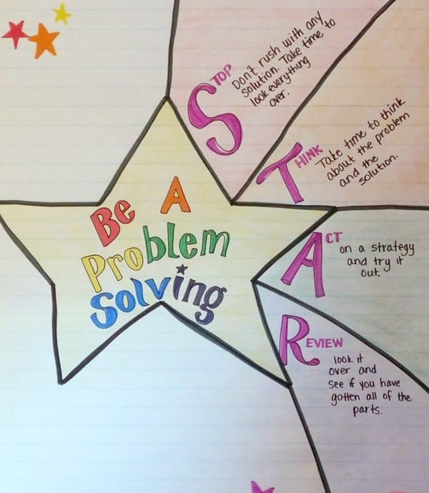

Uses of Strategies

Different strategies have different uses. We will illustrate this by means of a problem:

***The Farmyard Problem****: In the farmyard there are some cows and some chickens. In fact there are 87 animals and 266 legs. How many cows are there in the farmyard?*

1. **Understand the Problem**

Some strategies help you to understand a problem for example *Guess and check*. Let’s guess that there are 80 cows. If there are they will account for 320 legs (80 x 4 = 320). Clearly we have over-guessed the number of cows. So maybe there are only 60 cows. Now 60 cows would have 240 legs (60 x 2 = 240). That would leave us with 16 legs to be found from the chickens. It takes 8 chickens to produce 16 legs (8 x 2 = 16). But 60 cows plus 8 chickens is only 68 animals so we are nearly 20 animals short.

Obviously we haven’t solved the problem yet but we have now understood some of the important aspects of the problem. We know that there are 87 animals and so the number of cows plus the number of chickens must add up to 87. We also know that we have to use the fact that cows have four legs and chickens two, and that there have to be 266 legs altogether.

1. **Devise a Plan**

Some strategies can give you an idea of how you might tackle a problem and plan accordingly. *Making a Table* illustrates this point. We’ll put a few values in and see what happens.

|  |  |  |  |  |  |
| --- | --- | --- | --- | --- | --- |
| Cows | chickens | cows legs | chickens’ legs | total | difference |
| 60 | 27 | 240 | 54 | 294 | 28 |
| 50 | 37 | 200 | 74 | 274 | 8 |
| 40 | 47 | 160 | 94 | 254 | -12 |
| 41 | 46 | 164 | 92 | 256 | -10 |

From the table we can see that every time we change the number of cows by one, we change the number of legs by two. This means that in our last guess in the table, we are five cows away from the right answer. Then there have to be 46 cows.

1. **Carry out the Plan**

Some strategies are methods of solution in themselves. For instance, take *Guess and Improve*. Supposed we guessed 60 cows for a total of 240 legs. Now 60 cows imply 27 chickens, and that gives another 54 legs. Altogether then we’d have 294 legs at this point.

Unfortunately we know that there are only 266 legs. So we’ve guessed too high. As cows have more legs than hens, we need to reduce the guess of 60 cows. How about reducing the number of cows to 50? That means 37 chickens and so 200 + 74 = 274 legs.

We’re still too high. Now 40 cows and 47 hens gives 160 + 94 = 254 legs. We’ve now got too few legs so we need to guess more cows.

You should be able to see now how to oscillate backwards and forwards until you hit on the right number of cows. So guess and improve is a method of solution that you can use on a number of problems.

1. **Look Back**

From drawing table we concluded that there are 46 cows. *Working Backwards* is the best suited strategy for this final step as in this strategy we start from final solution and move towards the start of the problem.

46 cows imply that 87 total animals – 46 cows = 41 chickens

46 cows also imply that 46 x 4 = 184 legs

41 chickens imply that 41 x 2 = 82 legs

184 + 82 = 266 total legs.

Which is correct according to the initial given information.

# Exploring Problem Solving

Example 1

*Three darts hit this dart board and each scores a 1, 5, or 10. The total score is the sum of the scores for the three darts. There could be three 1’s, two 1’s and 5, one 5 and two 10’s, and so on. How many different possible total scores could a person get with three darts?*

1. **Understand the Problem**

In this problem we are asked to find all the possible total sum of scores for a dart game. We have been given the information that a player can score either a 1, a 5 or a 10 while throwing each dart and each player gets 3 turns. So each player can score a possible combination of 1, 5 and 10.

1. **Devise a Plan**

To get an idea about all the possible combinations of scores it is a good idea to make a list using *Organize the Data* strategy.

1. **Carry out the Plan**

Here we will carry out our plan by organizing our data and forming a list of all possible sums of scores. Here we see that there are 10 possible total sum of scores.

|  |  |  |  |
| --- | --- | --- | --- |
| **First dart** | **Second dart** | **Third dart** | **total** |
| **1** | **1** | **1** | **3** |
| **1** | **1** | **10** | **12** |
| **1** | **1** | **5** | **7** |
| **10** | **10** | **10** | **30** |
| **10** | **10** | **1** | **21** |
| **10** | **10** | **5** | **25** |
| **5** | **5** | **5** | **15** |
| **5** | **5** | **1** | **11** |
| **5** | **5** | **10** | **20** |
| **1** | **10** | **5** | **17** |

1. **Look Back**

Here we recheck our list to see if we have missed any possible combination. Note that there are many other possibilities of ordering and listing scores.

Example 2

*Maira has four boxes. She puts 9 model cars in each box. What is the total number of model cars she put in the boxes?*

1. **Understand the Problem**

In this problem we have to arrange some cars in boxes. We have total 4 boxes and we have been told that the number of cars in each box have to be exactly 9. We have been given sufficient information to solve this problem.

1. **Devise a Plan**

For this problem we are going to use the strategy of *Making a Drawing.*

1. **Carry Out the Plan**

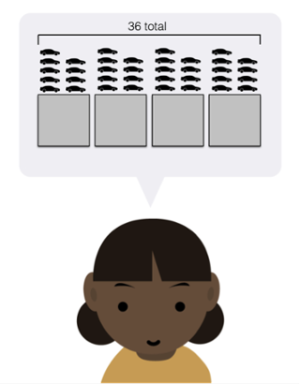

Here we have drawn a picture depicting 4 boxes and 9 cars placed in each of them. This visual representation makes it very easy to count the total number of cars that will be placed in 4 boxes.

1. **Look Back**

Here we recheck our answer and look for additional knowledge we gained from solving this problem. The answer to our problem came out to be 36. We can see that these types of problems can also be solved using multiplication (9 x 4 = 36).

Example 3

*The number of lilies in a lake was found to be increasing according to following table.*

|  |  |  |  |  |  |
| --- | --- | --- | --- | --- | --- |
|  | ***Week 1*** | ***Week 2*** | ***Week 3*** | ***Week 4*** | ***Week 5*** |
| ***Number of Lilies*** | *4* | *8* | *16* | *32* | *64* |

*a) How many lilies will there be in week 7?   
b) How many lilies will there be in week 9?*

*c) If half of the lake was covered with lilies in Week 16, then in which week was a quarter of the lake covered with lilies?*

1. **Understand the Problem**

In this problem we have to calculate the number of lilies in week 7 and 9. The table given in the problem statement tells us about the number of lilies that are found in the lake after each week. If we observe the table and given values carefully we can predict the number of lilies in future weeks.

1. **Devise a Plan**

The values given in the problem statement are increasing in a pattern. Observe carefully and try to find a pattern. For problems like these we can use the strategy *Look for a pattern.*

1. **Carry out the Plan**

The pattern is: Number of lilies doubles each week. So if there are 64 lilies in week 5, there will be 128 lilies in week 6 and *256 lilies in week 7 (128 x 2)*. In week 8 there will be 512 lilies and *1024 lilies in week 9*.  A quarter of the lake covered with lilies in week 15.

1. **Look Back**

Here we check our answer which is correct according to the given information. With this problem we have learned that we can solve similar problems by observing and looking for patterns in the given information.

## Well-defined and Ill-defined Problems

Problems can be categorized into two types: ill-defined or well-defined. A **well-defined problem** is one that has a clear goal or solution, and problem solving strategies are easily developed. In contrast, an **ill-defined problem** is the opposite. It is one that is unclear, abstract, or confusing, and that does not have a clear problem solving strategy.

|  |  |
| --- | --- |
| **Ill–Defined Problem** | **Well-Defined Problem** |
| 1. Given state is not clearly specified | Given state is clearly specified |
| 1. unclear goal state | there are clearly specified goals |
| 1. unclear set of allowable procedures and multiple solutions | clearly specified set of allowable procedures and one clear solution |
| 1. For example: “*You and your friends will be going on a trip. You’ve got the entire school day to travel, and you need to get back to school by the end of the trip, but otherwise how your trip goes it up to you. Plan the best trip that you can!*”   **Understand the problem**: This problem was not well-defined. We need to decide for ourselves what a "good" itinerary looks like, and this definition could even shift throughout the process. | For example: “*list the first ten Pakistani Presidents in order and name one important historical fact about each*”.  **Understand the problem:** This problem is very well-defined and has a clear goal. |

For solving ill-defined problems we should first try to define these problems more precisely. Defining a problem well often makes the rest of the process much easier. To define an ill-defined problem more clearly we should try to consider following questions:

* Who in particular the problem affects. What specifically do they need? In what kind of situations?
* Why the problem exists? Keep asking to get to the heart of the problem.
* How could I be able to tell the problem had been solved? What could I observe or measure?

SUMMARY

* **Problem solving** refers to tasks that have the potential to provide intellectual challenges for enhancing students’ understanding and mental development.
* **Working backwards** is to start with the final solution and work back one step at a time to get to the beginning.
* When using **Look for a pattern** strategy you look for a pattern from the information that has been given. Once the pattern has been identified, you can predict what will happen next and then continue the pattern to find the correct solution.
* Sometimes the problem is too difficult to solve in one step. When this happens you can make the problem more simpler by dividing it into smaller and easiest steps. This strategy is known as **solving a simpler problem.**
* In the strategy known as **make a drawing/act it out** you can draw pictures, have people play roles or use manipulative to act the problem out.
* In **guess and check** strategy you will make a reasonable guess, based on the information that you have been given and then check to see if your guess is correct. The guesses should get closer and closer to the answer, until the correct answer is found.
* **Using a table** is a good way to sort out and organize the information that has been given in the question. The information that has been set out in the table will hopefully lead you to the correct solution.
* **Making a list** is also a strategy that will help you sort out the information that has been given in the problem.
* **Considering alternatives** strategy requires looking at your problems in different ways; find a new perspective that you haven't thought of before.
* **Logical reasoning** strategy requires using the information that has been given in the question to eliminate possible solutions to finally discover the correct solution.
* The **problem solving process** consists of a sequence of sections that fit together depending on the type of problem to be solved.
* First you have to understand the problem.
* There are many reasonable ways to solve problems. The skill at choosing an appropriate strategy is best learned by solving many problems. You will find choosing a strategy increasingly easy with practice.
* Persist with the plan that you have chosen. If it continues not to work, discard it and choose another.
* Examine the solution obtained. Check to see if you used all your information and that the answer makes sense.
* Some strategies help you to understand a problem for example *Guess and check.*
* Some strategies can give you an idea of how you might tackle a problem and plan accordingly for example *making a table.*
* Some strategies are methods of solution in themselves. For instance, take *Guess and Improve.*
* Problems can be categorized into two types: ill-defined or well-defined.
* A **well-defined problem** is one that has a clear goal or solution, and problem solving strategies are easily developed.
* An **ill-defined problem** is the one that is unclear, abstract, or confusing, and that does not have a clear problem solving strategy.

EXERCISE

**Q.1 Tick the right choice**

1. Problem solving is a _____________

a) life skill b)game c)mathematical concept d) framework

1. Use of *working backwards* strategy in maths is known as _____________

a) fractions b) subtraction c)division d)inverse operations

1. In ______________ strategy, you examine your list for a recognizable pattern

a) Organizing data b) guess and check c) look for a pattern d) logical reasoning

1. Sometimes the problem is too difficult to solve in one step. When this happens you can make the problem more simpler by dividing it into ____________ steps

a) two b) simpler c) many d) three

1. ______________ can help you to picture the problem and find the solution

a) logical reasoning b)organizing the data c) making a drawing d) looking for a pattern

1. When using ______________ strategy, you will make a reasonable guess, based on the information that you have been given and then check to see if your guess is correct

a) look for a pattern b) organizing the data c) guess and check d) make a drawing

1. _______________, or rapid noting of alternatives, is an excellent discovery process

a) brain storming b)group discussion c) creative thinking

d) making a llist

1. _______________ requires using the information that has been given in the question to eliminate possible solutions to finally discover the correct solution

a) organizing the data b) acting it out c) logical reasoning d) look for a pattern

1. ____________ is the process of working through details of a problem to reach a solution

a) investigation b) critical analysis c) problem solving d) devising the plan

1. George Polya has identified __________ basic principles of problem solving in his book *How to solve it*

a) three b)four c)five d) six

1. To ______________ all you need is care and patience, given that you have the necessary skills.

a) carry out the plan b) devise the plan c)revise the plan d)change the plan

1. _______________ will enable you to predict what strategy should be used to solve future problems, if these relate to the original problem.

a) devising the plan b) understanding the problem c) carrying out the plan d)looking back

1. Given state is not clearly specified in ____________ problem

a) well-defined b)mathematical c)ill-defined d)routine

1. _______________ strategy can help you to understand a problem

a) solving a simpler problem b) guess and check c) logical reasoning d) making a drawing

1. Using a ___________ is a good way to sort out and organize the information that has been given in the question

a) drawing b) formula c) table d) tool

**Q.2 Fill in the blanks**

1. **______________** refers to tasks that have the potential to provide intellectual challenges for enhancing understanding and mental development.
2. **_________________** is to start with the final solution and work back one step at a time to get to the beginning.
3. In *look for a pattern*strategy, use the pattern to find the __________ information
4. If you can’t solve a problem, then there is an __________ problem you can solve: find it.
5. Creating a _________ can help you to picture the problem and find the solution.
6. Making a _________ is also a strategy that will help you sort out the information that has been given in the problem.
7. ___________________ strategy requires looking at your problems in different ways
8. Some strategies are methods of solution in themselves. For example *_________________*
9. A well-defined problemis one that has a clear ______ or __________
10. An ill-defined problem has unclear set of ___________ procedures.

**Q.3 Define the following**

1) problem solving 2) working backwards 3)guess and check

4) logical reasoning 5) well-defined problem 6) ill-defined problem

**Q.4 Differentiate between the following**

1) well-defined and ill-defined problem 2)organizing data strategy and look for a pattern strategy 3) devise a plan and carry out the plan

**Q.5 Give short answers to the following questions**

1) Define and explain problem solving.

2) What is working backwards strategy?

3) What is looking for a pattern strategy?

4) What is guess and check strategy?

5) What is organizing data strategy?

6) What is considering alternatives strategy?

7) What is problem solving process? Name its steps

8) What is well-defined problem?

9) what is ill-defined problem?

10) what are 3 strategies to define an ill-defined problem more clearly?

**Q.6 Solve the following problem**

Miss Ayesha’s class is playing a math game known as Number Stumper.

Anam gives her classmates some clues to help them guess her number:

* There is a 1 in the number
* The digit in the hundreds place is 3 times the digit in the thousands place
* The digit in the ones place 4 times the digit in the tens place
* The digit in the hundred-thousand place is one more than the digit in ones place
* There is a 9 in the ten-thousand place

Apply the problem solving process to find out Anam’s number.

**Q.7 Solve the following problem using problem solving process**

In a car race, the first five finishers in some order were a Ford, a Corolla, a Peugeot, a Barina, and a Daihatsu. The Ford finished seven seconds before the Corolla. The Peugeot finished six seconds after the Barina. The Daihatsu finished eight seconds after the Barina. The Corolla finished two seconds before the Peugeot. In what order did the cars finish the race? What strategy did you use? (Hint: you can use strategy *draw a diagram*)

**Q.8 Solve the following problem using problem solving process**

The diagram below shows a series of squares formed by small square tiles. Complete the table below.

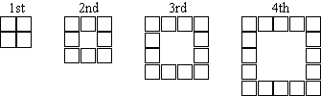

|  |  |  |  |  |  |  |  |  |
| --- | --- | --- | --- | --- | --- | --- | --- | --- |
|  | **1st** | **2nd** | **3rd** | **4th** | **5th** | **6th** | **10th** | **15th** |
| **Number of tiles** | 4 | 8 | 12 | 16 |  |  |  |  |

**Q.9 Solve the following problem using problem solving process**

Which of the numbers 4, 5, or 6 is a solution to (n + 3)(n - 2) = 36?

(**Hint 1**: Substitute each number for “n” in the equation.)

(**Hint 2:** Use “*Guess and check*” strategy)

**Q.10 Solve the following problem using problem solving process**

John is four years younger than Carmel but Jane is 24 years older than Carmel. If Jane is 35, how old is John? (**Hint:** Use *working backwards* strategy)