Damien Baca
Professor Sandra Clark
Art Appreciation
10 July 2016
ASCII Dollar Signs
For most people I assume it was obvious to pick a piece of art before picking a project, however, I tried to approach it in a different way. I knew I wanted to incorporate my background in computer science in some way. I thought back to my freshman year in college where a professor of mine showed me a contest where the objective was to write as obscure and illogical code as possible. Many of the contestants would mold the characters of their submissions into common shapes like a dog or a moon. I thought it would be a good idea to recreate a simpler work of art in this way for my project, and that is exactly what I did.

The piece of art that I eventually choose was a screen print by Andy Warhol titled Dollar Sign.
It is a simple enough piece that I assumed would give me no trouble to replicate in my ASCII media.
The artwork as I said is a screen print on white canvas and due to the fact that it is a screen print, there are many copies of this work with more or less signs. I thought four was a decent enough number for the sake of this project. I did however choose this piece for more than just its simplicity; there are many things that I admire about this piece. I think the biggest thing that I love about this piece is the symbolism involved. Everybody likes money. It doesn't matter if you're rich or poor. It is a symbol that everybody (in the USA at least) can understand and appreciate. The second thing I really enjoy about this piece is the color. I love how these 4 identical screen prints all come together, each bringing their own colors to the mix. The last thing I really like about this piece is the partial re-prints over the solid print. It not only gives them color, but gives them an almost weathered feel that I really like.


The artist, Andy Warhol, was born in Pittsburgh, Pennsylvania on August 6, 1928. Originally Andrew Warhola in his early years, Andy would go on to not only become a successful magazine and ad illustrator, but also become the leading artist of the 1960's Pop art movements. However, Warhol's life had its dark side as well. At the age of 8, Warhol was diagnosed with Chorea, a rare and possibly fatal disease of the nervous system that would devastate his life.

“Dollar Signs” is fantastic but in my opinion a lot of these screen prints are, I'm glad I could take the time to delve into where they come from. I made an attempt to make a unique project and I think I have accomplished that. Also, if you were dyeing wondering if the code in my project actually does anything, then I suppose I can explain. The code does execute as I have submitted to you. The program is actually a solution to an Indian mathematical puzzle called the Towers of Hanoi. In the game you have three pegs spaced spaced out next to each other on a board. Then you have wooden discs of increasing size toward the bottom on the first peg. The goal is to move the whole tower to another peg while following a set of rules.

1. Only one disk can be moved at a time.
2. Each move consists of taking the upper disk i.e a disk can only be moved if it is the uppermost disk on a stack.
3. No disk may be placed on top of a smaller disk.

This game can be played with any number of disks, as long as there are only three pegs. My project, when executed, will give you a step by step solution to this puzzle for any number of disks.

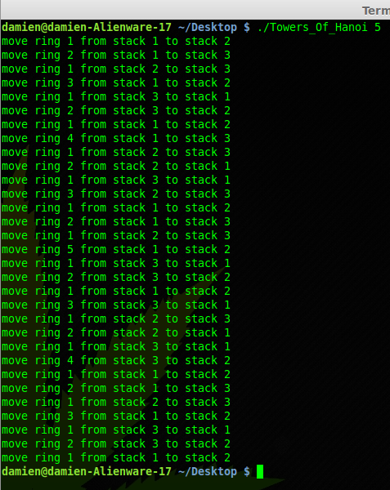
Here you can see me executing the code. I give the program a 5 indicating that it should give me a solution for a 5 disk solution. It then proceeds to print out and tell you exactly what ring to move and where to move it too.
Like I said, it can give you the solution for any number of disks. Yes, even 1000 >, it will just take it forever to print out the solution. I hope you enjoyed my project and got a kick out of the techie stuff. I'm glad I was able to incorporate my passion.

Bibliography

Biography.com Editors. "Andy Warhol Biography." Bio.com. Accessed July 10, 2016. http://www.biography.com/people/andy-warhol-9523875#synopsis.

Koestenbaum, Wayne. Andy Warhol: A Biography.

"Andy Warhol Biography." The Andy Warhol Foundation for the Visual Arts -. Accessed July 11, 2016. http://warholfoundation.org/legacy/biography.html.

