# Task 2

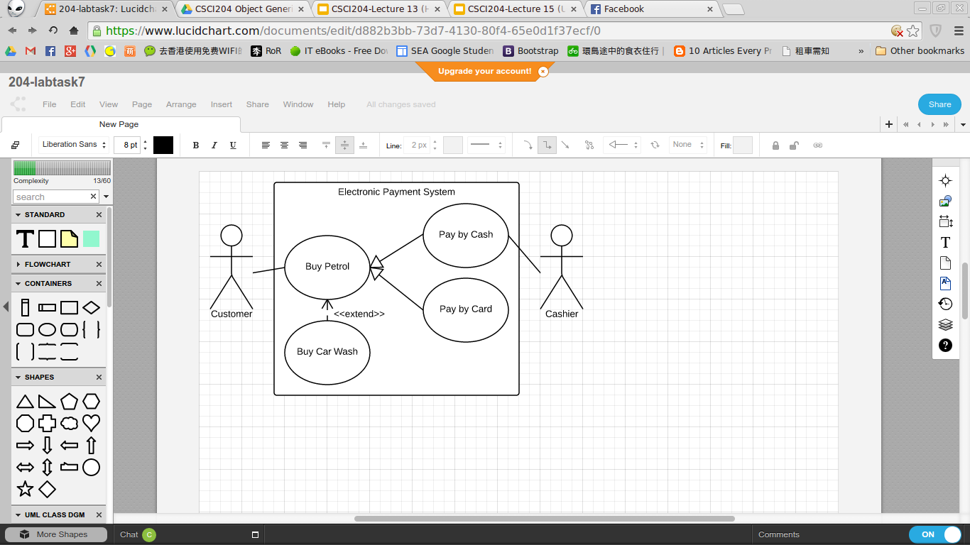

Actor Activity:

1. Customer : Buy Petrol at Petrol System with an option to purchase car wash services, the Customer can choose to pay by cash or pay by credit card.
2. Cashier : Received cash from Customer.

Use cases Behaviour:

1. Buy Petrol : for Customer to purchase petrol。
2. Buy Car Wash : an <<extend>> option of Buy Petrol, which allow Customer to opt-in for car wash services.
3. Pay by Cash : a selection of Buy Petrol, which have to handle by Cashier.
4. Pay by Card : a selection of Buy Petrol.

# Task 3

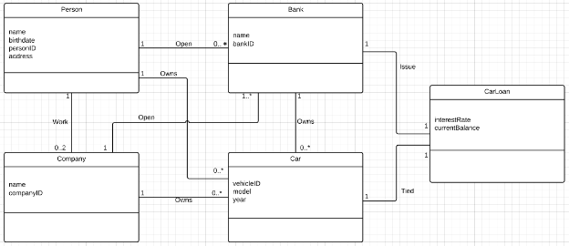

Class interaction with other classes

Person: A **Person** can work at 0 to 2 **Company** as an employers at the same time, also open 0 or many **Bank** account and can own 0 or more **Car** at a same time

Bank: **Bank** account can be owned by a **Person** or a **Company**. Bank can own 0 or more **Car** at the same time, and **Bank** can handle each **CarLoan** for each **Car**.

Company: **Company** is owned by **Person**, a **Company** must have at least one **Bank** account. a **Company** can also owns one or more **Car** at same time.

Car: a **Car** can be owned by **Person**, **Company** or **Bank**. Each purchase of **Car** might tied with a **CarLoan** to pay the bill.

CarLoan: when the potential owner of **Car** doesn’t have enough money to purchase a **Car**, they will buy a **Car** tied with **CarLoan**, which allow the potential owner to borrow money from **Bank** to solve their financial issue in buying a **Car**.