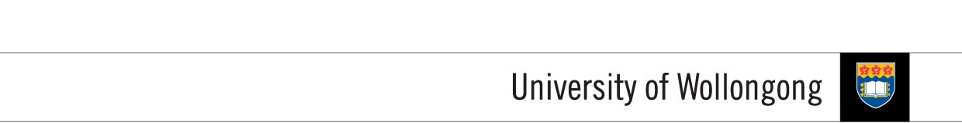

**FACULTY OF INFORMATICS**

**COURSEWORK COVERSHEET**

|  |  |  |  |
| --- | --- | --- | --- |
| **SUBJECT’S INFORMATION:** | | | |
| Subject: | CSCI262: System Security | | |
| Session: | July 2014 | | |
| Programme / Section: |  | | |
| Lecturer: | **S. Shanmuga** | | |
| Coursework Type  *(tick appropriate box)* | ( Individual Assignment ( Group Assignment ( Project  ( Lab Exercise / Journal ( Seminar / Tutorial Paper ( Others | | |
| Coursework Title: | Implémentation of a Simple File System | Coursework Percentage: | 10% |
| Hand-out Date: | Aug 19th, 2014 | Received By :  (signature) |  |
| Due Date: | 9/9/2014 | Received Date : |  |
| **STUDENT’S INFORMATION:** | | | |
| Student’s Name & ID: | **Lim Chee Yeong**  J14016414 4933643 |  |  |
| Contact Number / Email: | **0124043226**  me@cylim.info |  |  |
| **STUDENT’S DECLARATION** | | | |
| By signing this, I / We declare that:   1. This assignment meets all the requirements for the subject as detailed in the relevant Subject Outline, which I/ we have read. 2. It is my / our own work and I / we did not collaborate with or copy from others. 3. I / we have read and understand my responsibilities under the University of Wollongong’s policy on plagiarism. 4. I / we have not plagiarised from published work (including the internet). Where I have used the work from others, I / we have referenced it in the text and provided a reference list at the end of the assignment.   I am / we are aware that late submission without an authorised extension from the subject co-ordinator may incur a penalty. *(See your subject outline for further information).* | | | |
| Name & Signature: | Lim Chee Yeong |  |  |

------------( -------------------( ------------------( -------------------( --------------------( ---------------------( --

|  |  |  |  |
| --- | --- | --- | --- |
| **Assessment Criteria** | | **Total Marks** | **Given Marks** |
|  | Authentication (hash, salt, MD5) | 40 |  |
|  | Security Clearance (0,1,2) | 20 |  |
|  | Options (Create, Read, Write, List, Save, Exit) | 40 |  |
|  |  |  |  |
|  | | **100** |  |
|  | | **Penalty** |  |
| Marked by: _____________________ Date: _____________ | | **Final Mark (%)** |  |
| **Lecturer’s Comments** | | | |
|  | | | |
| **Penalty for late submission:** | | | |
| 1 day – minus 20% of total mark awarded  2 days – minus 50% of total mark awarded  3 days – 0 mark for this piece of coursework | | | |