CSCI212 Interacting Systems

Assignment 2 : Simple ‘Query’ Search & Retrieval Services

Done By:

|  |  |
| --- | --- |
| Lindi Lamduan Wong | 4872721 |

TABLE OF CONTENTS

1 Requirements 5

1.1 Basic Requirements 5

1.2 Addition Self-Requirements 5

2 Diagram of Program Design 6

3 Summary of Implementation 7

3.1 CountryData 7

3.2 Server 7

3.3 Client 7

4 Output 8

5 Reflection on Program Development 11

# Requirements

## Basic Requirements

1. Have a Server
   * This server will be ran as background process. Through this, it will act as a database for the client side whenever he/she is doing a country search. The server has to be connected to a port.
2. Have a Client
   * This client side will do most of the interactions whereby the user has to key in what country he/she wants to find, and from there the data packet sent from server to client will tell if the country exist or not. Not to mention that client has to be connected to the Server side.
3. Country Data
   * Country Data has to be only accessed by only the server and not the client side.

## Addition Self-Requirements

1. Display Country Data
   * This function will enable users to see the country’s details that they have searched for.

# Diagram of Program Design

Countries.txt

Find port,

Connect

Bind

Listen

Process data from client

Get Countries.txt data

Get data index

Get country data from index

Convert necessary data

CountryData

Connect to server

Send packet

Receive packet

Search country

Display country name and details

Client

Server

# Summary of Implementation

## CountryData

As per given the files CountryData.h, Country.c, there were given functions provided to us to use it for certain data extractions. So I managed to utilize some of them and produce 2 functions to retrieve the country data details that is passed in from client to server and then to country data, and from there do the necessary changes to convert string to double and or char.

## Server

Before starting on server, we must know how forking is done and also the very basics of TCP. I feel that the logic behind TCP three way handshake is very similar to how the server and client actually interacts. Thus, from there, we would need to set up the binding, listening and others as well. Would have to do an error checking like when the port is already in use but user still wants to open the same port.

## Client

For Client side, it would have to connect to the server and then from there, be able to get the needed information on countries that exist or don’t exist. To have this to happen, the client definitely has to be connected to the Server port, else it would get any data from the Server as the server is somewhat acting like a “database” for the client. The client would send out data packets to the server and then receive the data packet back from the server. However, for this case when client receives the data from the server side, the client side actually has to check for delimiters. Reflection on Program Development

# Output

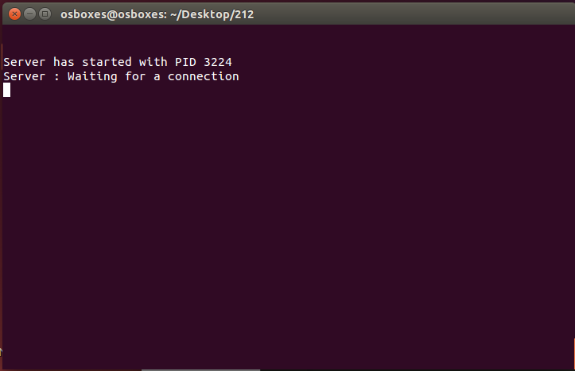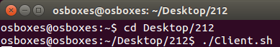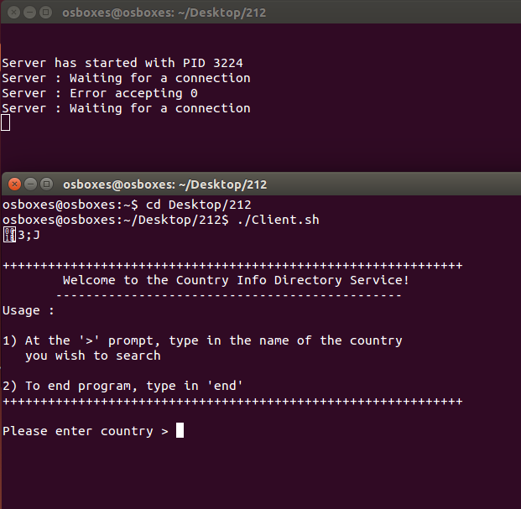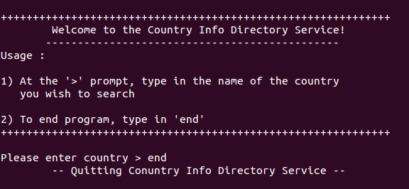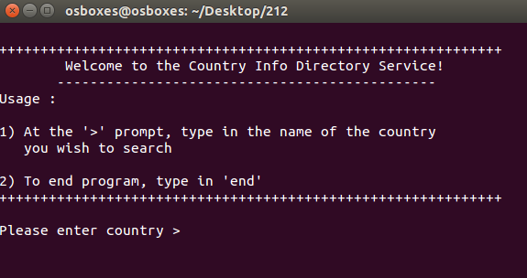

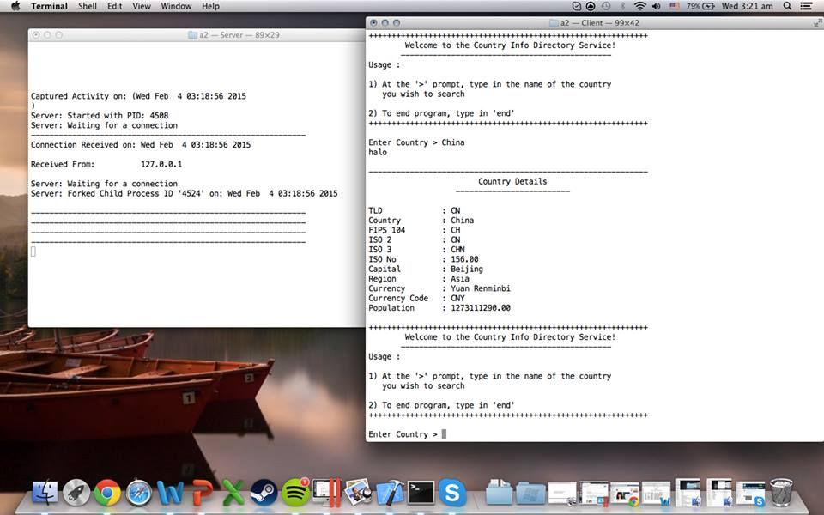

# Reflection on Program Development

I have learnt how to use a bit of c language, implementing a server (background process) and most importantly setting up a server to bind, listen for ports. Not to mention, sending and receiving of data packets from server to client side.

Not to mention that certain codes are required, else the whole port will fail and not be able to run. And also for the ‘&’ because once you don’t include that and you keep running the server file, it will gradually produce a segmentation fault on the client end when he/she inputs the country that they want to search for