#hackthekitty 2026

Project Report
Project Name: Kisa
Reference ID: D2NNZCYZ

1. Executive Summary

Kisa is a community-driven platform designed to connect neighbourhoods around the tracking, monitoring, and protection of community and stray cats. By allowing users to log localized sightings, view interactive live maps, and coordinate urgent SOS responses, the platform centralizes distributed neighbourhood data into structured, actionable profiles. Ultimately, Kisa delivers real-world value by ensuring no local cat goes overlooked, driving community engagement, and reducing critical intervention and rescue response times.
2. Project Overview

2a. Why you're building what you're building
This project is drawn from a real life scenario. Usually when you live in a community or a specific area you’ll probably see the same few stray cats. Kisa was designed to connect likeminded people who like to help out the strays.
Maybe if you can’t provide them a home, there will always be someone who’s looking to adopt but how would they know? That is where Kisa is used. Connecting cats and community.

2b. How it relates to the theme
The hackathon theme was cat world domination, and well cats already dominate our hearts whenever we see them. So we wanted to bridge the gap between humans and cats and help them find better homes and better help.
Kisa is made for stray cats and all cats alike. So for this time we used the community concept to help cats know which humans can help them achieve world domination!

2c. Target Audience
It’s a platform given to users from us to connect and join together to help the strays.
This project is designed for people who like to post pictures of their local cats, people who love cats and helping them in any way. The target audience is cat owners, local animal shelter, cat enthusiasts, and volunteers who’d like to give these cats a safe community to reside in.

3. Key Features
- Live Map for constant updates
- Cat Community page where users can see all cats in their locations
- Report a sighting where users can report an SOS for emergencies

4. Technology Stack
Layer | Technology
Frontend | HTML, CSS, Vanilla Javascript, leaflet.js, lucide icons
API / App Layer | Python, FastAPI
Auth & database | Supabase, PostgreSQL + PostGIS
Storage | Supabase Storage
External Services | Gemini API, OSM

5. Technical Architecture
Kisa follows a layered client–server architecture: a static frontend communicates with a FastAPI backend over REST, which in turn talks to Supabase (Postgres + PostGIS + Auth + Storage) as the single source of truth, and to two external services Gemini API for categorisation of similar cat photos and a map tile provider for the live map.
Key components
- Client (browser) - HTML/CSS/JS pages (index, login, signup, dashboard, community, report, livemap, profile, contact), Lucide icons, Leaflet.js for map rendering.
- FastAPI backend - single API layer handling auth checks, business logic, request validation, and orchestrating calls to Supabase and Gemini.
- Supabase platform - Auth (session/JWT), Postgres with the PostGIS extension (geospatial queries on sightings), and Storage (uploaded cat photos).
- Gemini API - receives the uploaded photo at report-time and returns a categorization (breed/color/etc.) that gets stored alongside the sighting row.
- Map tile provider - currently OpenStreetMap (via Leaflet, plus Nominatim for reverse-geocoding an address from lat/lng in report.html), swappable for Google Maps API once you're past unlimited-testing needs.
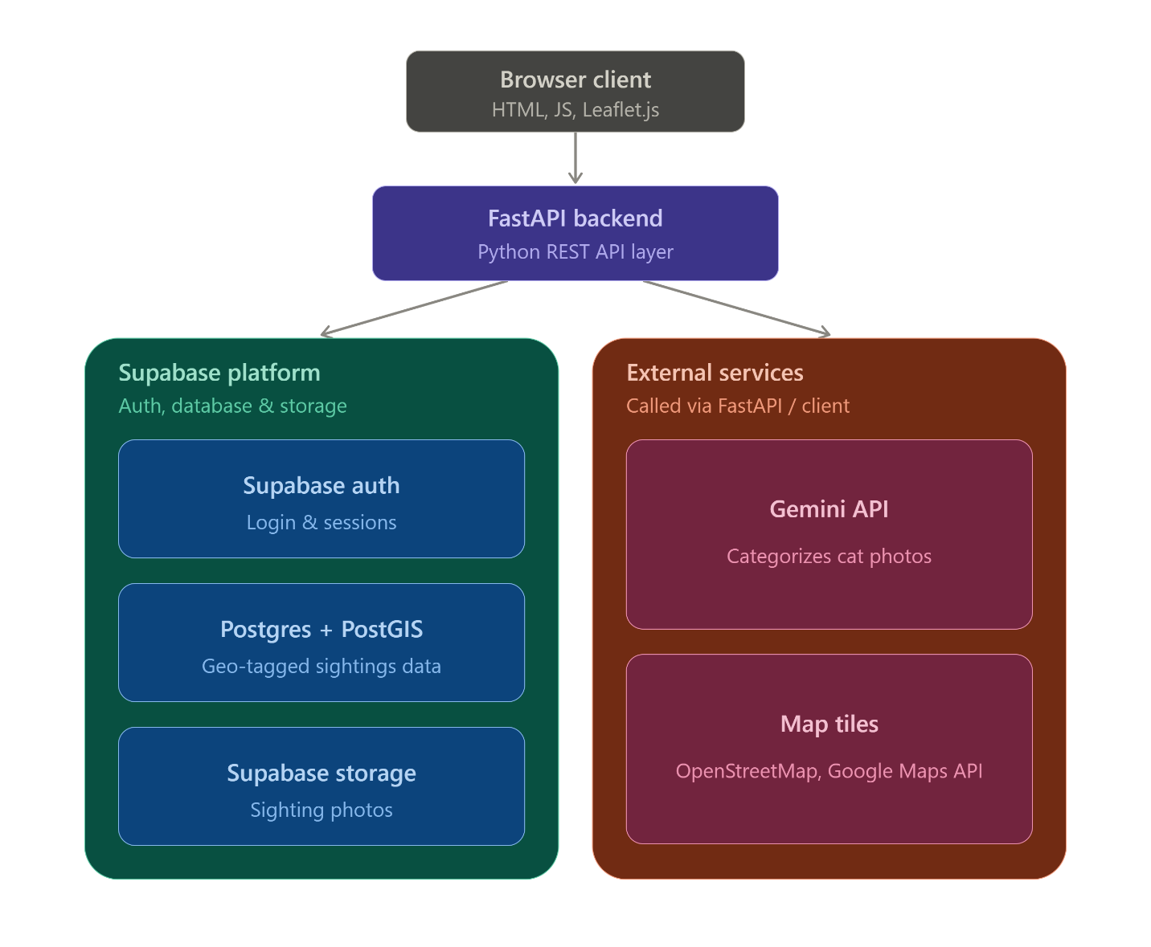

6. Testing Matrix
Feature / Flow | Expected Result | Actual Result | Pass / Fail
Report a sighting | The sighting gets logged in community and live map | Gets logged in community only for now | Pass
Community | Opted to adopt a cat | Shows in community page that the cat is no longer a stray | Pass
Live Map | Shows all nearby cats and their labels | Map integration remains hence yet to be seen in real data | Fail

8. Future Improvements
- A feature where the web app find you local shelter so you don’t have to
- A proper adoption guideline and help feature

9. Tools You Used
- Claude, ChatGPT, Gemini
- VScode
- OBS

11. Learnings & Takeaways
We learned that deploying a web app such as Kisa definitely sounds easier said than done but we improved a lot of technical understanding of how an application is built and designed to be maintained especially in this era of AI and vibe-coding. Because in universities or courses they will cover the theory but the practical application of that theory is quite difficult.
Though AI makes our lives much easier the blind trust on its execution is wrong. One has to ensure everything is proper and in place. Though using AI makes the work much fast, and me and my teammate learned how the flow of these kinds of project work. From brain storming to deciding whether visuals come first or setting up the environment does or whether the flow / execution makes sense or not.
But nevertheless this project taught us a lot. And the mistakes we’ve made now we’ll be more aware of those in future projects.

Submission Checklist
- Video demo (HD or at least 720p)
- README.md (prerequisites, run instructions, configuration)
- Project report (this document, in documentation/)
- Source code in src/
- No unrelated files, executables, auto-generated code, or package folders (e.g. node_modules/, build/, dist/, vendor/)

