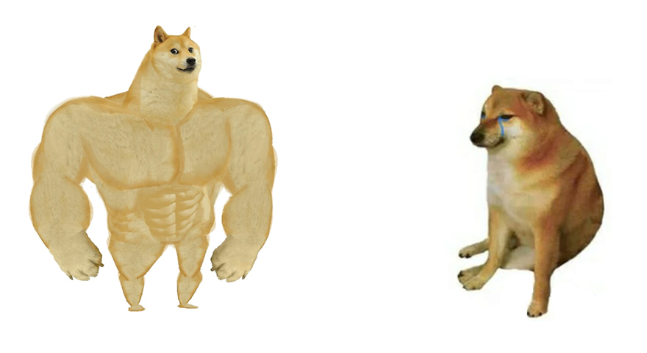

ORZ NINJACLASHER

Memes made with Microsoft Word

Memes made with Photoshop