LED (Light Emitting Diode):

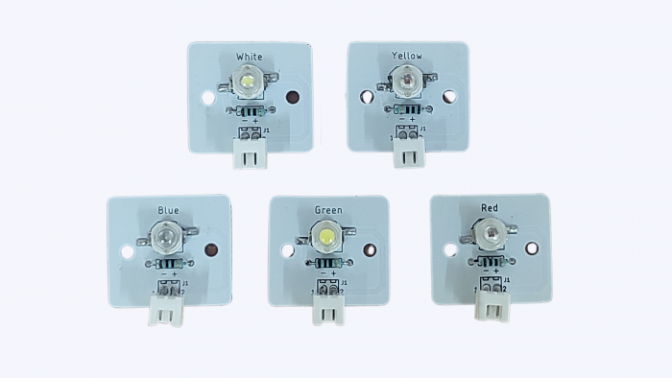

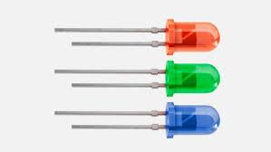

Working Principle:

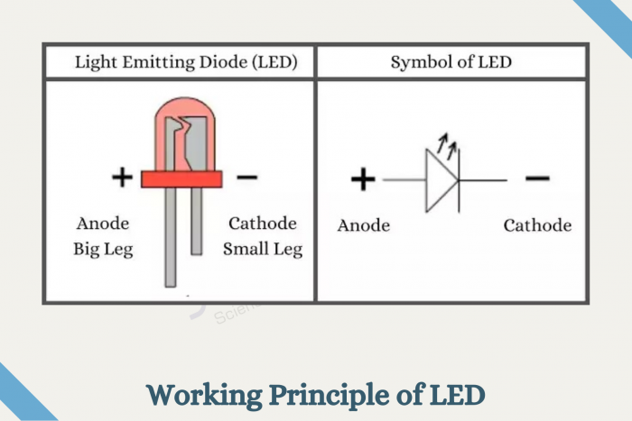

- What is an LED?
  - A small light called LED glows when electricity flows through it.

- How it Works
  - Has two pins:
    - Positive (+): Longer pin.
    - Negative (-): Shorter pin.
  - Needs electricity to glow.

- Uses
  - In gadgets to show power.
  - For lighting rooms.

- Safety
  - Always connect it correctly.
  - Don’t look at bright LEDs.

Buzzer:
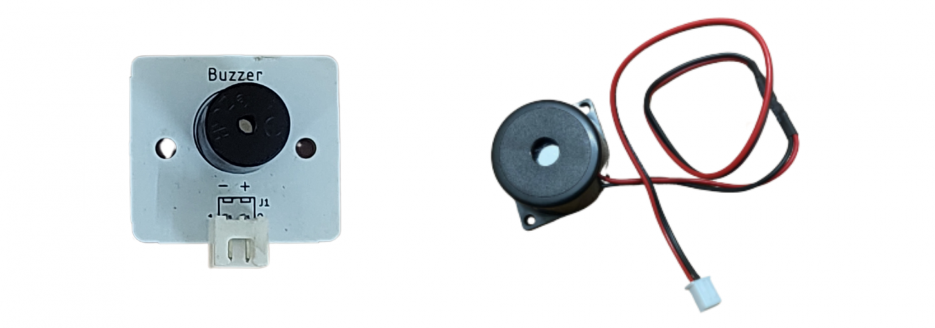

Working Principle:

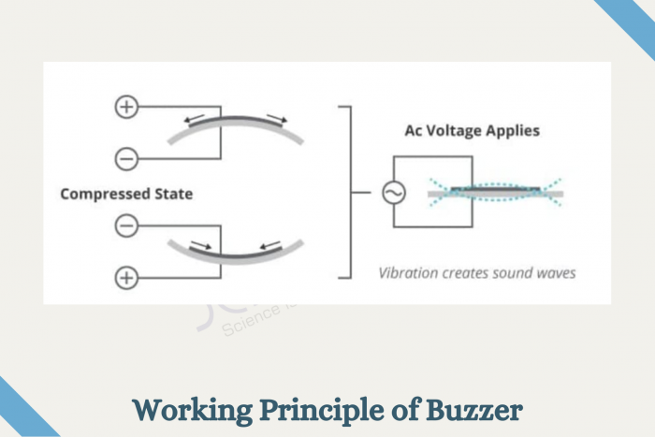

- What is a Buzzer?
  - A buzzer makes a beep or buzz sound when electricity passes through it.
- How it Works
  - The buzzer vibrates to produce sound.
- Uses
  - Found in alarms, toys, and microwaves.
- Safety Tips
  - Don’t poke the buzzer or block its sound hole.

Rocker Switch (2-pin)

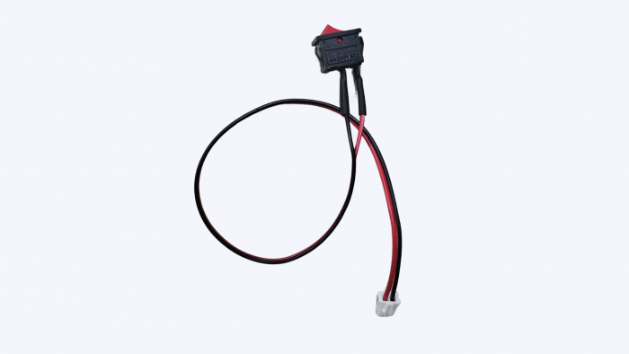

Working Explanation:
A 2-pin rocker switch allows or cuts off the flow of current by rocking (tilting) between two positions — ON and OFF.
Once pressed, it stays in its new state until pressed again.

How it Works:
- When the switch is in the ON position, it completes the circuit, allowing current to flow.
- When in the OFF position, it breaks the circuit, stopping the current.

Pinout (2-pin):
- Pin 1: Input (connect to power)
- Pin 2: Output (connect to device/load)
No polarity — you can use either pin as input or output.

Uses:
- To turn devices ON or OFF manually
- Power control for circuits

Real-Life Examples:
- Extension box switch
- Power ON/OFF button on fans
- Lamps and table light

Push Switch (2-pin)
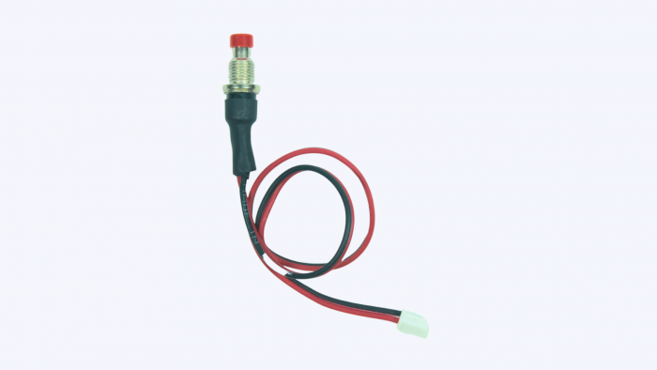

Working Explanation:
A 2-pin push switch is a momentary switch — it only connects the circuit while being pressed.
Once you release it, the connection breaks automatically.

How it Works:
- Press the switch: Circuit is completed → Device turns ON
- Release the switch: Circuit breaks → Device turns OFF

Pinout (2-pin):
- Pin 1: Connect to input side
- Pin 2: Connect to output side
Polarity doesn’t matter — simple open/close contact.

Uses:
- To send temporary input to microcontrollers
- Reset or trigger actions
- Momentary control applications

Real-Life Examples:
- Doorbell buttons
- Toy buttons
- Elevator button (older type)

Limit Switch (3-pin)

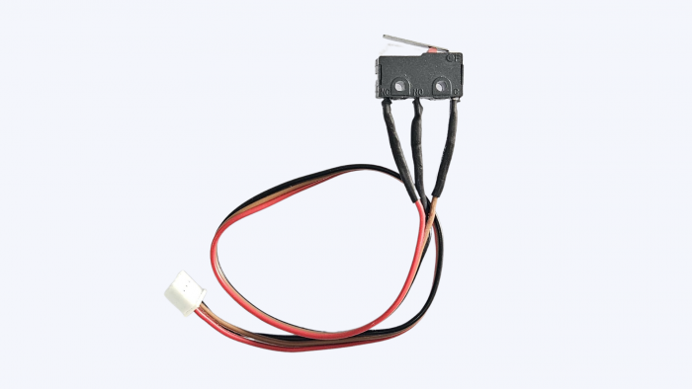

Working Explanation:
A 3-pin limit switch is a mechanical switch used to detect movement or position in machines. It has a lever or button that gets pressed when something touches it, changing the switch state.
It provides both:
- Normally Open (NO) connection – circuit is completed when pressed.
- Normally Closed (NC) connection – circuit is broken when pressed.

How it Works:
- Not pressed:
  - NO = Open → No current
  - NC = Closed → Current flows
- Pressed:
  - NO = Closed → Current flows
  - NC = Open → No current

Pinout (3-pin):
- COM (Common) – Connect this to one side of the circuit (usually GND or signal input)
- NO (Normally Open) – Use if you want the circuit to close only when pressed
- NC (Normally Closed) – Use if you want the circuit to break when pressed

Uses:
- Detect mechanical movement or end position
- Stop motors when the object reaches the end
- Safety cutoff in automation
Real-Time Examples:
- 3D printer limit detection
- Robotic arm end stops
- Garage door open/close sensing
- Industrial machines

Toggle Switch (3-pin)

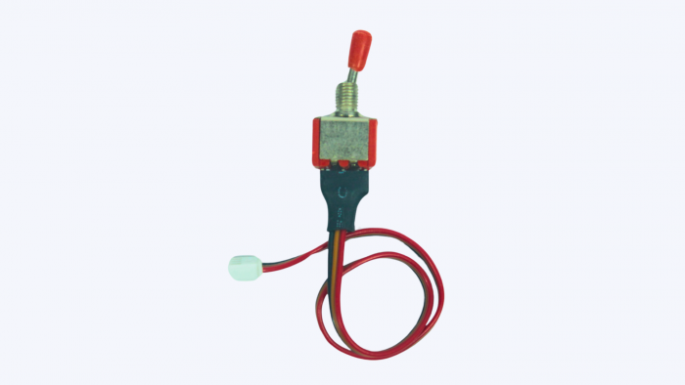

Working Explanation:
A 3-pin toggle switch allows you to toggle between two outputs or states, typically used to select between two devices or modes.

It has:
- One Common (COM) terminal
- Two Selectable outputs:
  - Position 1 → NO1
  - Position 2 → NO2
- It behaves like a SPDT (Single Pole Double Throw) switch.

How it Works:
- Toggle in one direction: COM connects to Pin 1
- Toggle in other direction: COM connects to Pin 2
It allows selecting one of two outputs, not both.

Pinout (3-pin):
- COM (Common) – Power/input line
- NO1 – Output 1 (when switch is in one position)
- NO2 – Output 2 (when switch is in opposite position)
No current flows to both outputs at the same time.

Uses:
- Select between two devices
- ON/OFF switch with LED indicator
- Switch between HIGH/LOW power modes

Real-Time Examples:
- Switch between battery and adapter power
- Select motor direction (forward/reverse)
- Toggle between LED lights or fan speeds

Introduction to DC/CD Motor
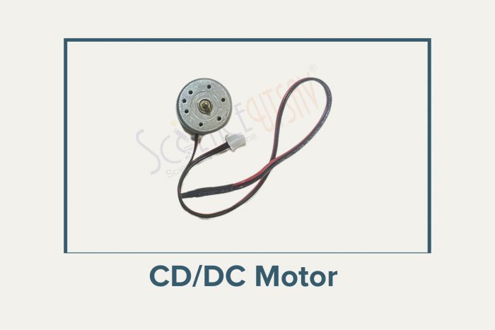

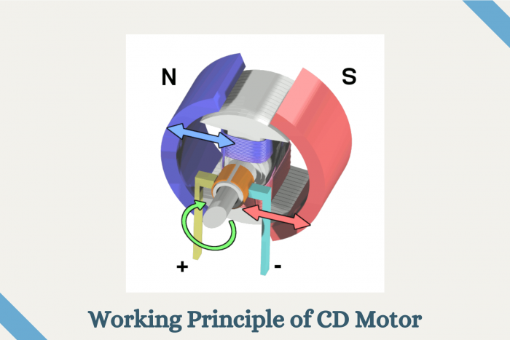
- What is a DC Motor?
  - A motor that uses electricity to spin and make things move.

- How It Works
  - Connect a battery to the motor, and it spins.
  - Switch the wires, and it spins the other way.

- Parts
  - Rotor: The spinning part.
  - Wires: Connect to a battery.
  - Body: Protects the motor.

- Types
  - Simple Motor: Spins one way.
  - Geared Motor: Changes speed.

- Uses
  - Found in cars, fans, and toys.

- Safety
  - Don’t let it get too hot.

Introduction to potentiometers
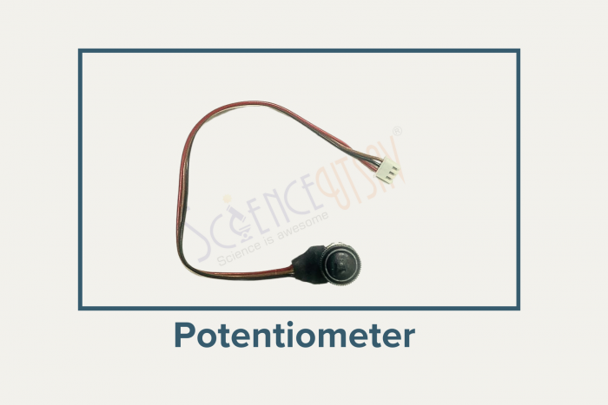

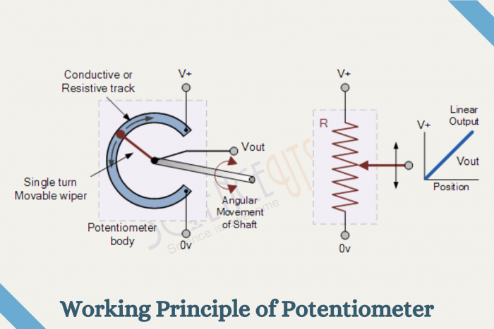

- Definition:
  - A potentiometer changes voltage by sliding a part called a wiper.

- Parts:
  - Wiper: Adjusts voltage.
  - Two Terminals: Power and ground.

- How It Works:
  - Move the wiper:
    - Towards power → Higher voltage.
    - Towards ground → Lower voltage.

- Applications:
  - Volume controls.
  - Light dimming.

- Safety:
  - Avoid high voltage.

Introduction to Servo motor
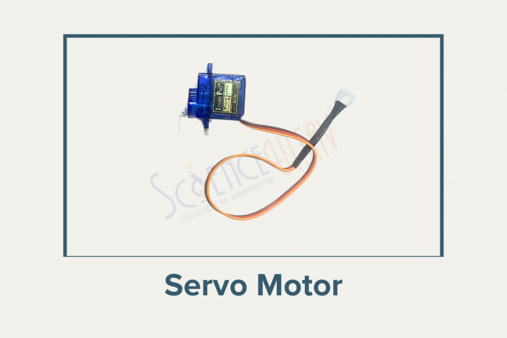

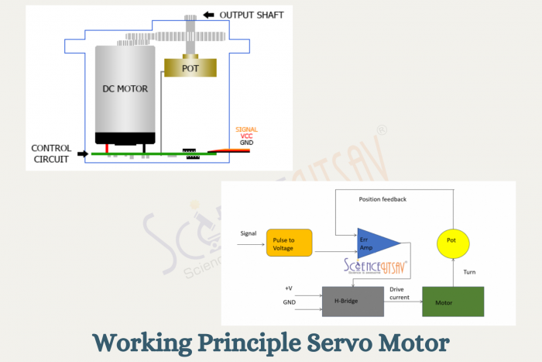

What is a Servo Motor?
- A motor designed for precise control of movement, position, and angle.

How It Works
- Uses a system to adjust its position until it matches the target.

Parts
- Rotor: The moving part.
- Control System: Keeps it accurate.

Types
- Moves to a specific angle.
- Spins continuously for speed control.

Uses
- Found in toys and robots.

Safety
- Don’t push it too hard.
- Use the right voltage.

Touch sensor

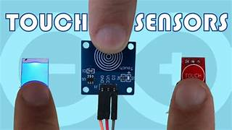

1. What is a Touch Sensor?
A touch sensor is an electronic device that detects when it is physically touched and converts this touch into an electrical signal.
It acts like a switch: when touched, it closes a circuit or sends a HIGH signal.
Widely used in Arduino projects, robots, home automation, and interactive devices.

2. Types of Touch Sensors
Capacitive Touch Sensor
Detects touch based on the change in capacitance caused by a human finger.
Can sense touch without pressing, just by contact.
Common in small Arduino modules (like TTP223).
Resistive Touch Sensor
Works when two conductive layers are pressed together.
Less common in simple Arduino projects.
Most Arduino projects use capacitive touch sensors because they are easy and reliable.

3. Hardware of a Touch Sensor Module
A typical touch sensor module has 3 pins:
Pin | Function
VCC | Connect to power supply (+5V)
GND | Connect to ground (GND)
OUT | Sends a HIGH signal when touched, LOW when not touched
The module usually has a metal pad labeled “Touch” for detection.
Many modules include a small LED that lights up when the sensor is touched, showing activity.

4. How It Works (Electrical Principle)
When a person touches the metal pad, it changes the capacitance of the sensor.
The sensor IC (like TTP223) detects this capacitance change.
The IC changes the output pin from LOW to HIGH.
The HIGH signal can then be read by a microcontroller to perform an action.
Essentially, touch = HIGH, and no touch = LOW.

5. Applications
Touch lamps and switches
Robots with touch controls
Home automation buttons
Interactive toys and projects
Any device where physical buttons are replaced by touch

6. Key Points to Remember
It is non-mechanical (especially capacitive sensors), so it doesn’t wear out easily.
Produces digital output (HIGH/LOW), which is easy to interface with Arduino.
On-board LED helps to test touch sensor functionality visually.
Can be used to control devices like LEDs, buzzers, or motors when touched.

7 Segment TM1637 Display

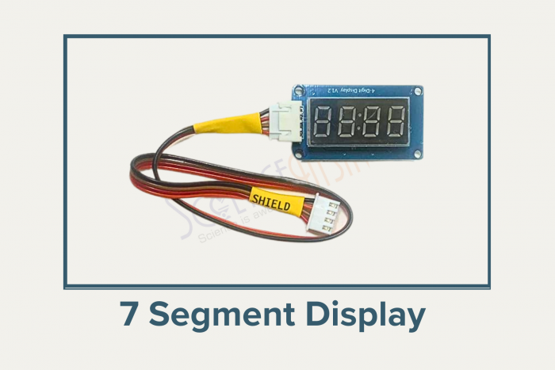

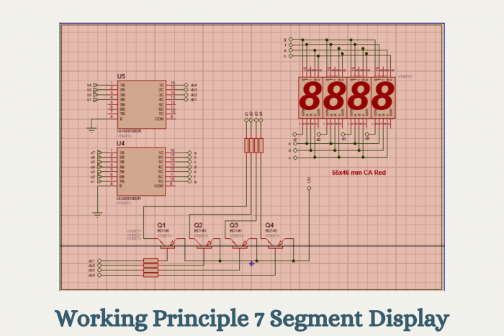

Sensor’s Pinout:

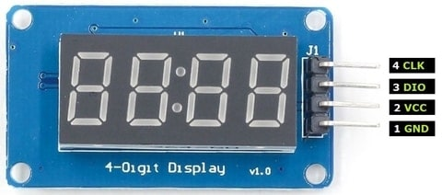

Introduction to the 7-Segment Display

- Definition: A 7-segment display is a device that shows numbers using LEDs arranged in 7 sections per digit.

- How It Works: Each segment can light up to show a part of a number, like forming the number “8” by lighting all segments.

- Structure:
- LED Segments: Light up to form numbers.
- TM1637 Chip: The “brain” that tells the segments when to light up.

- Applications: Used in clocks, timers, and calculators.

- Example:
Think of a digital clock; the numbers you see are created by this type of display.

LDR sensor
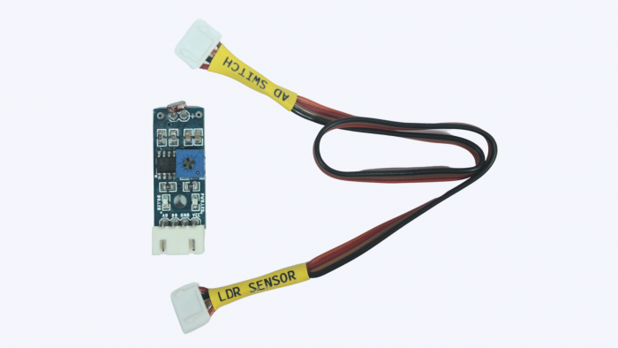

LDR Sensor pinout:
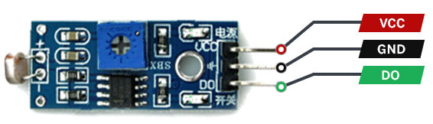
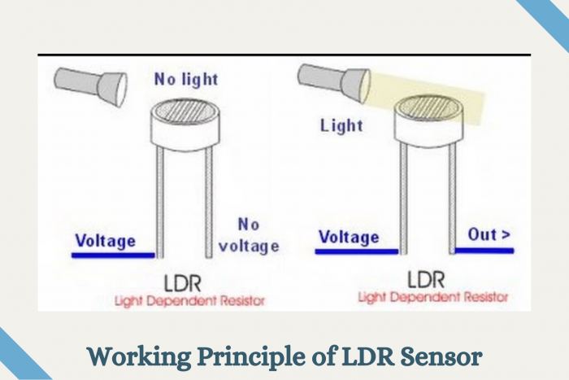

  - What is an LDR?
    - An LDR (Light Dependent Resistor) is a special component that detects light.
    - Its resistance changes when the amount of light changes.

  - How Does it Work?
    - In bright light, its resistance becomes low.
    - In darkness, its resistance becomes high.
    - This affects how much current flows through it.

  - Simple Example:
    - Imagine a streetlight that turns on at night and off during the day—an LDR can control this.

  - Applications:
    - Streetlights.
    - Solar garden lights.
    - Security alarms.

  - Fun Fact:
    - LDRs are like the “eyes” of electronic circuits that sense light.

Laser diode
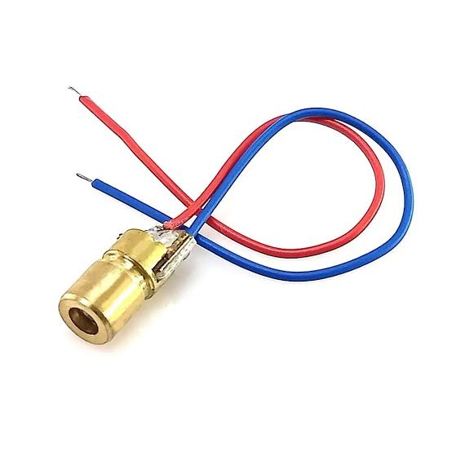
How it works?
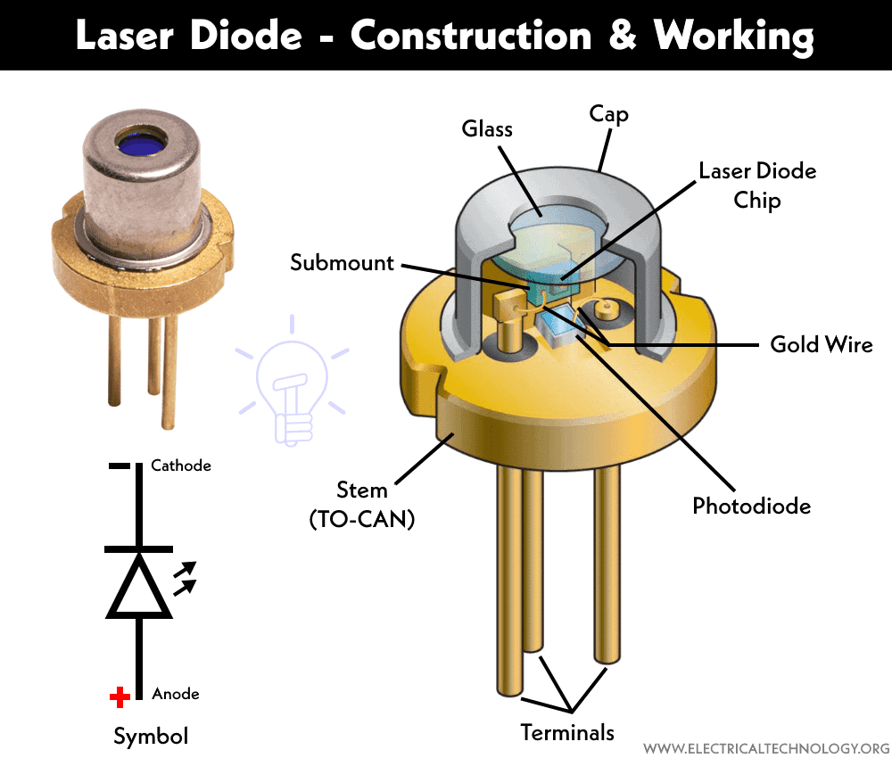

1. What is a Laser Diode?
- A small electronic component that produces a focused beam of laser light.

2. How It Works
- Converts electrical energy into a narrow, bright beam of light when current flows through it.

3. Parts
- Laser Diode Chip: Generates the laser light.
- Lens: Focuses the laser beam into a narrow point.

4. Types
- Red Laser Diode: Commonly used in DIY projects and laser pointers.
- Green Laser Diode: Brighter and easier to see than red lasers.

5. Uses
- Used in laser pointers, barcode scanners, distance sensors, and robotics projects.

6. Safety
- Never look directly into the laser beam.
- Never point the laser at people's eyes or reflective surfaces.
- Use the recommended operating voltage and current to avoid damaging the diode.

Potentiometer (POT PCB)
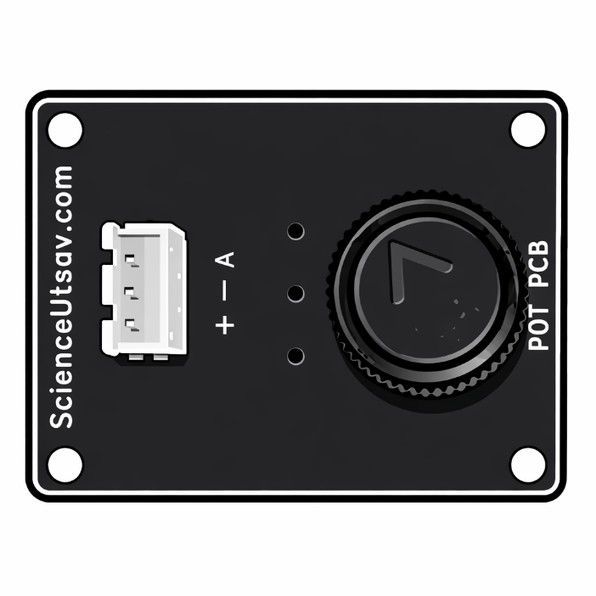

1. What is a Potentiometer?
A potentiometer (or pot) is a variable resistor that allows you to adjust the amount of electrical resistance in a circuit.
- It is commonly used to control voltage levels by turning a knob.
- In Arduino projects, it is used as an analog input device to provide variable values.
- Widely used in electronics, robotics, audio equipment, and control systems.

2. Types of Potentiometers

Rotary Potentiometer
- The most common type.
- Resistance changes by rotating a knob.
- Commonly used in Arduino kits and electronic circuits.

Slide Potentiometer
- Resistance changes by sliding a lever.
- Often used in audio mixers and control panels.

Trimmer Potentiometer (Preset)
- Small adjustable potentiometer designed for calibration.
- Adjusted using a screwdriver instead of a knob.
Most Arduino projects use rotary potentiometers because they are simple and easy to use.

3. Hardware of a Potentiometer Module (Pot PCB)
A typical potentiometer PCB has 3 pins:
Pin | Function
VCC | Connects to +5V power supply
GND | Connects to Ground
OUT (Signal) | Outputs a variable analog voltage
The module contains:
- A rotary knob for adjusting the resistance.
- A variable resistor (potentiometer) mounted on the PCB.
- Three connection pins for easy interfacing with Arduino.

4. How It Works (Electrical Principle)
- Inside the potentiometer is a resistive track and a moving contact (wiper).
- Rotating the knob moves the wiper along the resistive track.
- This changes the output voltage at the signal pin.
- Arduino reads this changing voltage using an analog input (such as A0).
- The analog value typically ranges from 0 to 1023.
Essentially:
- Turn fully one way → Low voltage (0)
- Turn fully the other way → High voltage (5V)

5. Applications
- Motor speed control
- LED brightness control
- Servo motor position control
- Volume adjustment in audio devices
- Menu navigation and user input
- Robotics and automation projects

6. Key Points to Remember
- It is an analog input device that provides variable voltage.
- Produces analog values ranging from 0–1023 when used with Arduino.
- Has three terminals: VCC, GND, and Signal (OUT).
- Easy to interface with Arduino using an analog input pin.
- Commonly used to control the speed, brightness, angle, or any adjustable parameter in electronic projects.

Converter PCB
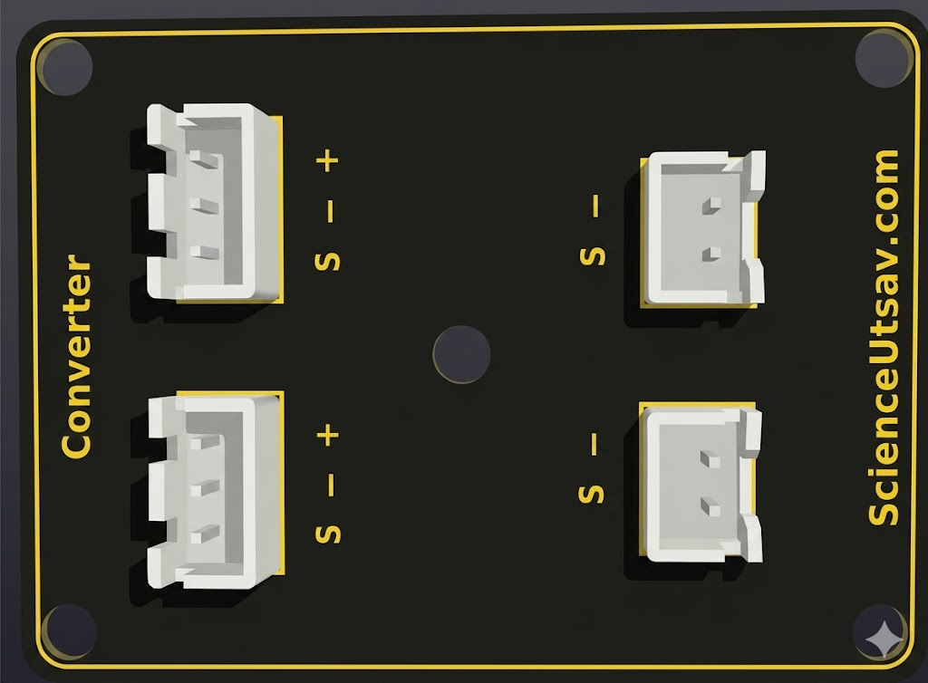

1. What is a Converter PCB?
A Converter PCB is an electronic module that changes one voltage level into another to safely power electronic devices.
- It is commonly used to convert a higher voltage to a lower voltage or vice versa.
- In Arduino and robotics projects, it ensures that components receive the correct operating voltage.
- Widely used in power supplies, battery-operated devices, robotics, and embedded systems.

2. Types of Converter PCBs

Buck Converter (Step-Down Converter)
- Reduces a higher input voltage to a lower output voltage.
- Example: Converts 12V to 5V for powering an Arduino.

Boost Converter (Step-Up Converter)
- Increases a lower input voltage to a higher output voltage.
- Example: Converts 3.7V to 5V from a lithium battery.

Buck-Boost Converter
- Can either increase or decrease the voltage depending on the input.
- Maintains a stable output voltage even when the input changes.
Most Arduino projects commonly use Buck Converter PCBs because they safely provide the required 5V supply.

3. Hardware of a Converter PCB
A typical converter PCB has 4 connection terminals:
Pin | Function
IN+ | Positive input voltage
IN− | Negative input (Ground)
OUT+ | Positive regulated output voltage
OUT− | Output Ground
The module usually contains:
- A voltage regulator IC
- Inductors for energy storage
- Capacitors for filtering voltage
- A trimmer potentiometer (on adjustable modules) to set the output voltage
- Power indicator LED (on many modules)

4. How It Works (Electrical Principle)
- The converter receives an input voltage through the IN+ and IN− terminals.
- The regulator circuit switches the current rapidly using an electronic controller.
- Inductors and capacitors smooth the voltage to produce a stable output.
- The regulated voltage is available at the OUT+ and OUT− terminals.
- Adjustable modules allow the output voltage to be changed by rotating the trimmer potentiometer.
Essentially:
- Higher voltage → Lower voltage (Buck)
- Lower voltage → Higher voltage (Boost)

5. Applications
- Powering Arduino boards from batteries
- Robotics and automation projects
- LED lighting systems
- Portable electronic devices
- Motor driver power supplies
- DIY electronics projects

6. Key Points to Remember
- Converts voltage to the level required by electronic devices.
- Helps protect components from over-voltage.
- Available as Buck (Step-Down), Boost (Step-Up), and Buck-Boost modules.
- Always check the input and output voltage ratings before connecting.
- Use the correct polarity (IN+, IN−, OUT+, OUT−) to avoid damaging the module or connected devices.

