GPS Asset Tracker
Using Arduino UNO, NEO-6M GPS, SIM800L GSM, DS3231 RTC & SD Card Module

Certificate
This project report entitled 'GPS Asset Tracker' has been successfully completed as a part of Embedded Systems training.

Abstract
A GPS Asset Tracker monitors the real-time location of assets using GPS, sends updates using GSM, records time with RTC, and stores data on an SD card.

Introduction
This project demonstrates a simple GPS-based asset tracking system using Arduino UNO.

Objectives
• Track GPS location
• Send SMS alerts
• Store data on SD card
• Record date & time

Components
Arduino UNO
NEO-6M GPS
SIM800L GSM
DS3231 RTC
SD Card Module
Breadboard
Jumper Wires

Block Diagram
GPS → Arduino UNO ← RTC
Arduino UNO → GSM
Arduino UNO → SD Card

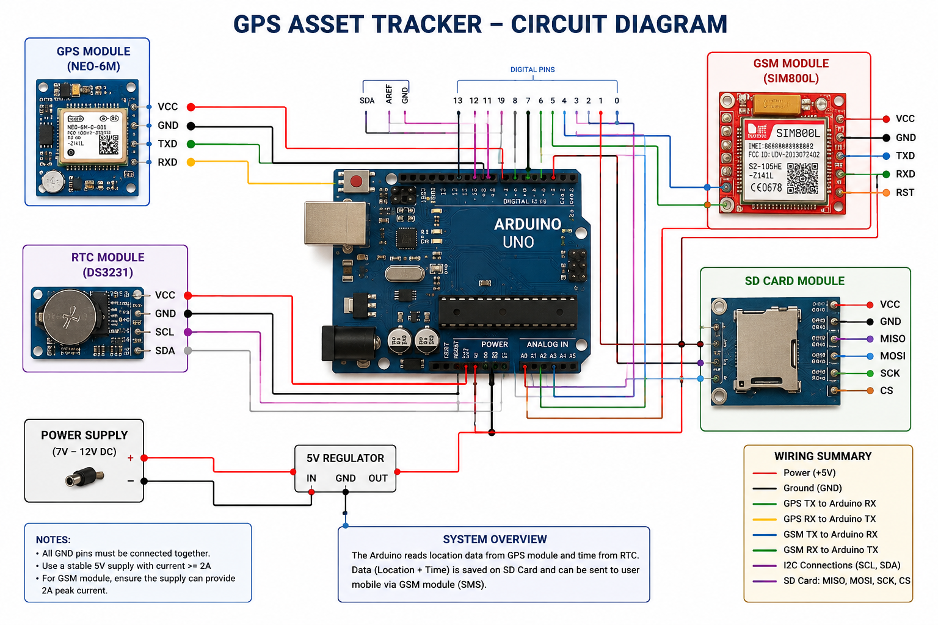

Circuit Connections
GPS TX→D4 RX→D3
SIM800L TX→D8 RX→D7
RTC SDA→A4 SCL→A5
SD CS→D10 MOSI→D11 MISO→D12 SCK→D13

Working Principle
Arduino reads GPS coordinates, adds RTC timestamp, saves data to SD card and sends location through GSM.

Flowchart
Start → Initialize → Read GPS → Read RTC → Save SD → Send SMS → Repeat

Arduino Code
#include <TinyGPS++.h>
#include <SoftwareSerial.h>
TinyGPSPlus gps;
SoftwareSerial gpsSerial(4,3);
void setup(){
Serial.begin(9600);
gpsSerial.begin(9600);
}
void loop(){
while(gpsSerial.available()) gps.encode(gpsSerial.read());
if(gps.location.isUpdated()){
Serial.println(gps.location.lat(),6);
Serial.println(gps.location.lng(),6);
}
}

Applications
Vehicle Tracking
Fleet Management
School Bus Tracking
Asset Security

Advantages
Real-time monitoring
Low cost
Easy to implement

Conclusion
The project provides an economical solution for location monitoring using Arduino.

Viva Questions
1. What is GPS?
2. Why use GSM?
3. What is RTC?
4. Why use SD Card?

References
Arduino Documentation
TinyGPS++ Library
NEO-6M Datasheet

