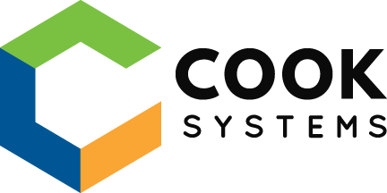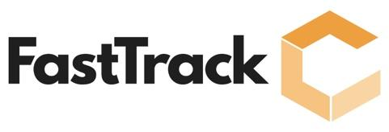

**BLANK BLANKSKI**

**PROFESSIONAL SUMMARY**

Bradley Kwateng is a highly motivated Java developer with an avid interest in cutting-edge technology and software development. Bradley has a BS in computer science, and many years of practice from training/bootcamps, and professional development. With a solid foundation in computer science principles and programming languages, and experience in the software engineering field, Bradley is enthusiastic about contributing his skills and creativity to an innovative team in a software engineer/development role.

**TECHNICAL SKILLS**

**Programming:** Java, JavaScript, Angular, TypeScript, HTML5, CSS3, SQL, Spring, Spring Boot, JDBC, Jackson, JPA, jQuery, Node, webpack, Babel, Maven, npm, C++, Python, Assembly, R

**Software:** Eclipse, VS Code, Git, GitHub, cmder, pgAdmin, Putty, Netbeans, Mars (Assembly code simulator), Android Studio, RStudio, Spyder, SpringToolSuite, Intellij

**Databases:**PostgreSQL, MySQL, MariaDB

**Web Service/**

**Protocols:** REST, JAX-RS

**Operating Systems:** Linux, UNIX, Windows, MacOS

**PROFESSIONAL EXPERIENCE**

**COOK SYSTEMS – Memphis, TN                                          04/24 – Present**

***FastTrack Developer***

*Assessment #1*

* Created a Restful application using Spring Boot, JPA, and Postgresql to perform CRUD operations on messages(tweets) stored or added to the database
* Utilized lombok, mapper, and spring annotations to reduce boilerplate code
* Created entities (using annotations) from a design schema establishing association relationship between them (One-To-Many, Many-to-Many, etc)
* Collaborated with a team to assign, and develop HTTP endpoints for CRUD operations on messages (tweets)

*Environment: SpringBoot, JPA, PostgreSQL, Git, Postman, Java*

*Assessment #2*

* A
* B
* C
* D

*Environment:*

*Assessment #3*

* A
* B
* C
* D

*Environment:*

**Optum – Eden Prairie, MN 05/22 – 05/23**

*Technical Development Associate*

* Developed seamless user experience and functionality by addressing website bugs and defect
* Developed a RESTful application capable of processing database records, identifying the best matching record based on request data
* Contributed to a rebranding project for Optum websites, involving CSS modifications and functional enhancements to align with the new design.

**TekSystems – Bloomington, MN 02/22 – 04/22**

*Full Stack Engineer Trainee*

* Created web applications implementing both in-memory and relational databases using JDBC or Hibernate ensuring efficient data management.
* Designed/developed a product site like Craigslist, featuring innovative elements such as a tag system for product categorization and personalized recommendations based on tags.

**TechDigital – Burnsville, MN 03/20 – 03/21**

*Jr Java Developer*

* Developed web applications using Spring, SpringBoot, and Angular, applying front controller design patterns for Spring-based applications.
* Developed RESTful web services, utilizing the RESTful architecture style and Jax-RS API, implementing solutions with Jersey for seamless functionality.

**Huntington Bank Stadium – Minneapolis, MN 06/15 – 01/22**

*Warehouse Runner*

* Contributed to sporting/concerts events success by delivering, and retrieving products (typically food/alcohol)
* Prepared food stands by cleaning, stocking, and collecting inventory for various sporting/concerts events

**Restaurant Depot – Saint Paul, MN 07/16 – 01/17**

*Produce Stocker*

* Maintained produce area is up to store’s standard by stocking and examining fresh produce for customers, and marking down product
* Maintained cleanliness of the produce area making sure it up to store’s standard
* Advised customers with in-store request in the produce area

**Office Max – Roseville, MN 06/14 – 01/15**

*Sales Consultant*

* Communicated with customers to inquire theirs interests in products
* Stocked and front-faced items
* Contributed to the store display by assembling items such as furniture, computers, etc

**ADDITIONAL PROJECTS**

*Project name mm/yy – mm/yy*

* A
* B
* C
* D

*Environment:*

*Project name mm/yy – mm/yy*

* A
* B
* C
* D

*Environment:*

*Capstone Project 03/22 – 03/22*

* An application that showcased everything learned in TekSystems bootcamp
* Developed web application similar to craigslist, where users can buy and sell product
* Notable features:
  + Tag systems where users can label products
  + Display recommended products based on tags
  + Reviews/rating on products given by users
  + User-friendly UI that uses CSS and bootstrap
* <https://github.com/beerad00/Capstone>

*Environment: SpringBoot, JDBC, Spring JPA, MySQL, JSP, CSS, HTML, JavaScript, Java, Git*

**EDUCATION**

**Cook Systems FastTrack Java Program – Memphis, TN           04/24 – Present**

*Concentrated Java Frameworks and developer tools training*

**TEKsystem FullStack Bootcamp – Bloomington, MN           02/22 – 04/22**

*Trained in java core, JDBC, Spring Boot, CSS*

**TechDigital Java FullStack Training – Burnsville, MN           03/20 – 03/21**

*Trained in java core, and java technologies such as Spring, Spring Boot, JDBC, Angular, Hibernate, AWS, etc*

**University of Minnesota, Duluth – Duluth, MN          08/14 – 12/19**

*Bachelor of Science: Computer Science*

*Minor: Mathematics*