Project ID: | 201713620
Project Name: | Customer Payments Consumption Completeness

Document Control

- Document History

Version | Date  Dd/mm/yyyy | Status:  <Draft/ Final> | Author | Comment / Changes from Prior Version
0.1 | 06/01/2017 | First Draft | Sharad Chormale | Initial Draft
0.2 |  | DRAFT
0.3 | 23/01/2017 | DRAFT | Vikas Munnangi | Added GIW ICD
0.4 | 23/01/2017 | DRAFT | Stacey Anderson | Updated Project id and documents reviewers/approvers

- Document Reviewers/Approvers

Name | Position (e.g. Client Manager, Project Manager etc.) | Reviewer (only) | Reviewer and Approver
Mavely, Loy | GIW AML Technology Manager |  | X
Anderson, Stacey | GIW AML Project Manager |  | X
Akshay, Kori | GIW AML Delivery Manager |  | X
Munnangi, Vikas | GIW AML Developer | X
Pranay, Nahar | GIW AML Solutions Analyst | X
Tanwi, Kiran | GIW AML Solutions Analyst | X
Santhanam, Padma |  |  | X
Prestage, David T | Clearview Program Sponsor |  | X
Corish, Eoghan |  |  | X
Chhina, Beerinder | Clearview Program Manager |  | X
Huang, Tak | Clearview Project Manager Warehouse Analytics |  | X
Rajagopal, Venkat | Clearview Project Manager - TTS Analytics |  | X
Belvedere, David [ICG-IT] | Clearview Business Analyst/Research |  | X
Vaz, Ryan J | Genesis/LCR Program Sponsor |  | X
Prestage, David | Genesis/LCR Program Sponsor |  | X
Mcdaniel, Ian | Genesis/LCR Program Manager |  | X
Raghavan, Srinivasa N | Genesis/LCR Senior Project Manager |  | X
Jadhav, Namrata | Genesis/LCR Project Manager | X
Khadri, Syed Waheeduddin | Genesis/LCR Data Analyst | X
Gur, David | Genesis/LCR Data Analyst | X
Halperin, Mark S | Genesis/LCR Data Modeling | X
Singh, Dev | Genesis/LCR Data Modeling | X
Desai, Harsh | Genesis/LCR Data Modeling | X
Aswal, Nawneet | Genesis/LCR Data Modeling | X
Banerjee, Sandeep | Genesis/LCR Requirements | X
Tibrewala, Ankur | Genesis/LCR Requirements | X
Collings, Daniel | Genesis/LCR PMO | X
Bate, Bertrand | Genesis/LCR PMO | X
Yacono, Anita M | Genesis/LCR PMO | X
Sinha, Rohit | Genesis/LCR Technical Project Manager | X
Anbarasu, Arun | Genesis/LCR Developer | X

Note: List of Required Approvers should include ISO for Sponsoring Business Approval on any Functional Requirements that affects an application in the High Risk Subset of Internet Applications
Template Guidelines

Please follow the section guidance that is written in RED, these sections are required, Blue sections are not mandatory. The sections are here to assist you in completing the template.

Acquire and Implement Section 2 (AI 2) of the Citi Information Technology Management Standards (CITMS) specifies the minimum SDLC requirements that must be performed in each project.
These minimum requirements are highlighted in this document template. However it is advised to address all sections in this document.

If a section is “Not Applicable” please state “N/A” plus a reason why the section does not need to be addressed. Please remove the RED and Blue section guidance as you complete the document.

Contents
1 Summary of Functional Solution 4
2 Business Requirements 4
2.1 Description / Objectives 4
2.2 Requirements 4
2.3 Acceptance Criteria 4
3 Scope 4
3.1 In Scope 4
3.2 Out of Scope 4
4 Assumptions/Constraints/Dependencies 5
5 Impact Analysis 5
6 System interface Design 5
6.1 Overview on Changes 5
6.2 Inputs 5
6.3 Outputs 5
6.4 Processing 5
7 Citi Data Management Standards 5
7.1 Critical Data Elements (CDE) & Important Data Elements (IDE) 6
7.2 Data Profiling 6
7.3 Data Quality Assessment/Monitoring 6
8 System Specification 7
8.1 Function Specifications 7
8.2 Business Rules (Optional) 9
8.3 Flow Diagram 9
8.4 Use Cases 9
9 user xpeerience 10
9.1 Design Research 10
9.2 Interaction Design 10
9.3 Wireframes (User Interface Design) 10
10 PERFORMANCE AND NON FUNCTIONAL Requirements 10
10.1 Volumes 10
10.2 Potential Growth 11
10.3 Performance 11
10.4 Exception Handling 11
10.5 Usability 11
10.6 System Availability 11
10.7 Recovery Requirements 11
10.8 Help and Training 11
11 Information Security 11
11.1 General Information Security 12
11.2 Authorization and Access Control 12
11.3 Audit Logging and Alerts 12
11.4 Security Administration 12
12 Regulatory, Audit and Data Retention Requirements 12
12.1 Regulatory and Legal Requirements 12
12.2 Archiving / Data Retention Requirements 12
12.3 Security Requirements 12
12.4 Control Requirements 12
12.5 Data Quality and Input Controls 13
13 Glossary of Terms 13
14 Appendices 13

Summary of Functional Solution

- GIW will provide the data for required attributes from Flexcube End of Day data and Reference data. This will automate the existing manual process of Excess Deposits calculation for Clearview and will also be provided for LCR reporting.

Business Requirements

- The business requirements document for the Customer Payments Consumption Completeness project is attached in the Appendix section.

Description / Objectives

- The data extract process is manual which can lead to data loss or inaccurate information assimilation.

- There is currently no centralized data source for housing the entire payments related information as desired by the regulatory requirements.

- The purpose of this project is to automate the manual process of Excess Deposits Calculation for Clearview and provide the data for LCR Reporting.

Requirements

- The scope for excess deposit calculation in Customer payments is limited to the following businesses:

GIW Payments for NAM and EMEA are in scope

- Clearview and LCR need Data from Flexcube payments End of Day data and account reference based on account number on daily basis for all EMEA and NAM branches which are in scope.

- The extracted data to be sent in aggregated format based upon rollup criteria mentioned below

  - Branch code, Account number, Transaction date, Account currency and CR/DR indicator and Include LCR Flag (LCR logic is given below)

Needs to be finalized : Processing data over the weekends and Holidays

Acceptance Criteria

- As a part of successful implementation of the consumption completeness program for Customer Payments, the consumers (treasury team) should be able to leverage the automated feed from data services and meet all regulatory reporting requirement without any manual intervention for collecting necessary data. Thereby, they will be able to automate the process of key ratio calculations.

Scope

In Scope

- The Flexcube payments End of Day data and Account Reference (eCIF) data for NAM and EMEA branches are in scope.

- The Branch List for EMEA and NAM is in the GIW Document Attached in section 14.

Out of Scope

- APAC and LATAM branches are out of scope.

Assumptions/Constraints/Dependencies
Assumptions:

- GIW would send the data for all the accounts irrespective of its type

- GIW does not contain flag or field to identify the third-party deposits

- All transactions codes which are in Exclusion List would have LCR field marked as ‘N’

- All transactions codes which are not in Exclusion List would have LCR field marked as ‘Y’. This including New T codes.

Constraints:
- Resources availability, functionality will be suitably prioritised by the Project Management team.

Risks:
- If mandatory data element used in the matching key criteria are not populated the de-dup logic will not work as expected.

Dependencies
- End of Day data from Flexcube should be available in GIW

- List of T-codes to be excluded should be received by GIW Comment - GIW would receive T-code list in a file as per ICD in appendix

Impact Analysis

 | System | Impact
Downstream | Treasury team | Automation of the Process of Calculating Key Ratio
Upstream | Product processor | No impact

System interface Design
Not Applicable - Interface is a system to system interface, and the interactions will not be impacted by this change

Overview on Changes
- GIW will provide the required data fields from End of Day data from Flexcube and Reference data to automate the manual process of Excess Deposits calculation for LCR reporting.

Inputs
- Flexcube data stored in GIW and reference (eCIF) data for enrichment will be used as source/input.

Outputs
- GIW would send the feed (for ICG and TTS Project) to Clearview. as per agreed layout in ICD. See appendix for ICD attachment.

Processing
As-Is:

- Currently, GIW is not providing any data to Clearview or LCR.
- Currently, The data is provided manually upon request.
  - Clearview provides t-codes and branches for data extraction to the Analytics team
  - The Analytics team manually runs the process to create the data file.
  - The Analytics team sends the data file to Clearview.

To-be:

- LCR would send list of transaction codes (t-codes) and branch codes as per agreed ICD layout.
- This file would be used by GIW to extract End of Day data provided by Flexcube and enriched with reference data (eCIF).
- The files would be sent to both Clearview and LCR via mutually agreed upon automated methods.

Citi Data Management Standards

Important Data Elements (IDE)

SI NO | Column Name | Schema | Table
1 | Unique Id In Source System | CIF_PROD_OWNER | CASHDT_DMT_OWNER.cdt_eod_payment_tran_fact
2 | Source System Id (CSI) |  | CASHDT_DMT_OWNER.cdt_eod_payment_tran_fact
3 | Arrangement Country Code | CIF_PROD_OWNER | cif_prod_owner.ecif_acct_rec
4 | Arrangement Branch Code | CASHDT_DMT_OWNER | CASHDT_DMT_OWNER.cdt_eod_payment_tran_fact
5 | Transaction Count
6 | Transaction Currency | CIF_PROD_OWNER | cif_prod_owner.ecif_acct_rec
7 | Transaction Currency Amount | CASHDT_DMT_OWNER | CASHDT_DMT_OWNER.cdt_eod_payment_tran_fact
8 | Transaction Date | CASHDT_DMT_OWNER | CASHDT_DMT_OWNER.cdt_eod_payment_tran_fact
9 | Payment or receipt indicator | CASHDT_DMT_OWNER | CASHDT_DMT_OWNER.cdt_eod_payment_tran_fact
10 | GFCID | CIF_PROD_OWNER | cif_prod_owner.ecif_acct_rec
11 | Include in LCR Flag |  | Will be derived

Critical Data Elements (CDE)

SI NO | Column Name | Schema | Table
1 | Unique Id In Source System | CIF_PROD_OWNER | CASHDT_DMT_OWNER.cdt_eod_payment_tran_fact
2 | Arrangement Branch Code | CASHDT_DMT_OWNER | CASHDT_DMT_OWNER.cdt_eod_payment_tran_fact
3 | Transaction Currency | CIF_PROD_OWNER | cif_prod_owner.ecif_acct_rec
4 | Transaction Currency Amount | CASHDT_DMT_OWNER | CASHDT_DMT_OWNER.cdt_eod_payment_tran_fact
5 | Transaction Date | CASHDT_DMT_OWNER | CASHDT_DMT_OWNER.cdt_eod_payment_tran_fact
6 | Payment or receipt indicator | CASHDT_DMT_OWNER | CASHDT_DMT_OWNER.cdt_eod_payment_tran_fact
7 | GFCID | CIF_PROD_OWNER | cif_prod_owner.ecif_acct_rec
8 | Include in LCR Flag |  | Will be derived

Data Profiling

Scenario | Expected output | Actual output | Period of Analysis | Branches
To check whether acct_ccy_cod and iso_ccy_cod does not match for any transaction | There should not be any mismatch between acct_ccy_cod and iso_ccy_cod | Same as expected result. | 25 Nov-2016(High volume date) | CEEMEA,EUROPE,NAM
To check whether acct_ccy_cod has null values | Should not be Null | No Null values | 25-Nov-16 | CEEMEA,EUROPE,NAM
To check whether iso_ccy_cod has null values | Should not be Null | No Null values | 25-Nov-16 | CEEMEA,EUROPE,NAM All
To check any length difference between ACCT_CCY_COD and ISO CCY _COD | There should not be any change in length | Same as expected result.
To check whether acct_ccy_cod and iso_ccy_cod does not match for any transaction | There should not be any mismatch between acct_ccy_cod and iso_ccy_cod | Same as expected result. | 14 Nov 2016 to 14 Dec 2016 | CEEMEA,EUROPE,NAM

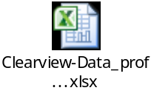

Data Quality Assessment/Monitoring
Not Applicable

System Specification

Function Specifications

 | Function 1
 | BRD Req # | One source of data for all Regulatory Reporting requiring Customer Payments Data
 | Detailed Description
- All End of Day data from Flexcube payments table will be pulled for all CEEMEA and NAM branches which are in scope would be extracted. Data will be enriched with reference data accordingly.

- A column (named as include in LCR Flag) representing whether the records are from included or excluded list (based on transaction codes) of payments would be added to the data

- List of transaction codes which are to be flagged would be received by GIW in automated method.

- If transaction has t-code from excluded list then value for column “include in LCR Flag” would be populated as ‘N’ and for rest all t-codes, value would be ‘Y’

- Extracted data would be rolled up based upon Branch code, Account number, transaction date, account currency and CR/DR indicator and Include LCR Flag

- A single list of gross debits and gross credits per account id per day would be provided

- For an account number, Transaction Amount would be Sum of transactions group by Gross Debit/Credit indicator and inclusion/exclusion t-codes

- Account number would be mapped with attribute “Unique Id In Source System” in target file.

- The Field CSI ID of the system sending the transactions would be populated with hardcoded values.
For EMEA region (Western Europe Countries -> ‘33339’ and CEEMEA Region -> ‘40006’)
For NAM region (North America -> ‘159870’ and Canada -> ‘33476’)

- Country code and branch code where the account is held would be populated and mapped with attributes “Arrangement Country Code” and “Arrangement Branch Code” respectively.

- For attribute “Source Transaction Id”, if single transaction found for any account, GIW would populate as blank. As this attribute is at transaction level, since we are aggregating this can be left blank.

- GIW would populate “Transaction type code” as blank.

- Transaction count Indicates the number of individual payment transactions aggregated into this record.

- Transaction currency should be mapped with currency in which account is held and not the transaction currency.

- The Debit/Credit indicator will be populated with “P” for Debit transaction and ‘R’ for credit transactions.

- Mapping Document Attached in section 14

- Branch List (EMEA and NAM ) in GIW Document Attached in section 14

Example :
Data for the account number “20530006” from END OF DAY DATA FROM FLEXCUBE and Reference data

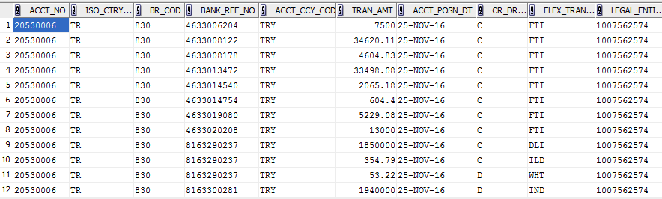

Above data is pulled out from GIW CASHDT_DMT_OWNER.cdt_eod_payment_tran_fact table and cif_prod_owner.ecif_acct_rec table for the acct_posn_dt “25-Nov-16” and account number “20530006” held at “830” branch.

Data after Roll-Up :
- After roll up based upon branch code, account number, CR/DR indicator, Include in LCR Flag and transaction currency we obtain below output result.
- There are two separate entries for Credit and Debit transactions with “Include in LCR Flag” is populated as “Y” because T-codes (FTI,IND,WHT,DLI,ILD) are not mentioned in the exclusion list.
- Account number mapped to Unique Id In Source System
- Source System Id (CSI) Hardcoded to 40006 (since Turkey is in CEEMEA Cluster)
- ISO_CTRY_COD mapped to Arrangement Country Code
- BR_COD mapped to Arrangement Branch Code,
- Count of No. of transactions grouped together populated in Transaction Count field
- ACCT_CCY_COD mapped to Transaction Currency
- Sum of TRAN_AMT of all debit/credit transactions grouped together with “Include in LCR Flag” value as “Y” mapped to Transaction Currency Amount
- The date on which transaction received in GIW mapped with Transaction Date
- For all debit transactions grouped together Payment or receipt indicator populated as ‘P’ and for all credit transactions grouped together, Payment or receipt indicator populated as ‘R’

Attribute Name | Unique Id In Source System | Source System Id (CSI) | Arrangement Country Code | Arrangement Branch Code | Source Transaction Id | Transaction Count
GIW field Name | ACCT_NO | Hardcoded to 40006 (since Turkey is in CEEMEA Cluster) | ISO_CTRY_COD | BR_COD | BANK_REF_NO | Cr/Dr Count
 | 20530006 | 40006 | TR | 830 | NULL | 2
 | 20530006 | 40006 | TR | 830 | NULL | 10

Transaction Currency | Transaction Currency Amount | Transaction type code | Transaction Date | Payment or receipt indicator | GFCID | Include in LCR Flag
ISO_CCY_COD | TRAN_AMT | FLEX_TRAN_COD - EMEA | TRAN_POST_DT | CR_DR_MRK | LEGAL_ENTITY_ID
TRY | 1940053.22 | NULL | 25-Nov-16 | P | 1007562574 | Y
TRY | 1951476.47 | NULL | 25-Nov-16 | R | 1007562574 | Y

RES_1 | RES_2 | RES_3 | RES_4 | RES_5 | RES_6 | RES_7 | RES_8 | RES_9 | RES_10 | GOC Id | FDL Account ID | Arrangement Product Category Type Code | Prefered deposits flag | Escrow indicator | Base Currency Amount
NULL | NULL | NULL | NULL | NULL | NULL | NULL | NULL | NULL | NULL | NULL | NULL | NULL | NULL | NULL | NULL
NULL | NULL | NULL | NULL | NULL | NULL | NULL | NULL | NULL | NULL | NULL | NULL | NULL | NULL | NULL | NULL

- Sample data

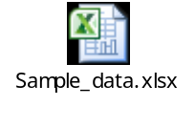

- Sample data file for same account number with multiple branches

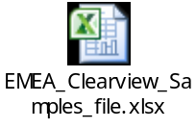

Business Rules (Optional)
- Not applicable, no business rules apply

Flow Diagram

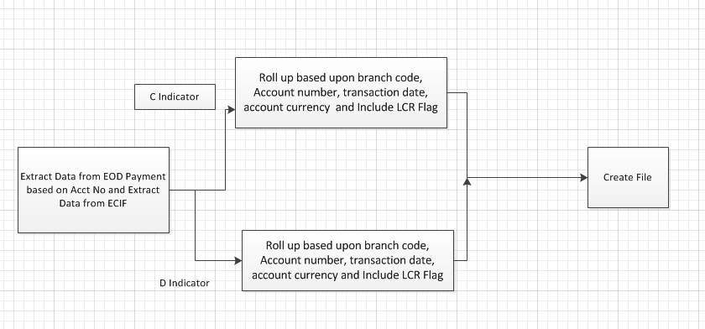

Use Cases
- Not applicable – Changes are at a system level.

user experience
- Not Applicable, Interface is a system to system interface.

Design Research

Not Applicable, Interface is a system to system interface

Interaction Design

- Not Applicable, Interface is a system to system interface, and the interactions will not be impacted by this change.

Wireframes (User Interface Design)

Not Applicable, Interface is a system to system interface.

PERFORMANCE AND NON FUNCTIONAL Requirements

Volumes
- Observed ~ 100,000 transactions per day for all NAM and EMEA branches

Potential Growth
- No significant change in existing growth potential.

Performance
- Performance should not be impacted by this change.
- Performance must be tested as part of this implementation to ensure it has not been impacted.

Exception Handling
- Exception handling would be done as per GIW standards.
- No additional exception handling requirements have been identified.

Usability
- Not Applicable, Interface is a system to system interface

System Availability
- System Availability should not be impacted by this change

Recovery Requirements
- No additional recovery requirements have been identified. This change should not impact existing recovery

Help and Training
- Applicable, Interface is a system to system interface

Information Security

General Information Security
- No PII information is being introduced by this change.

Authorization and Access Control
- Existing controls should be implemented

Audit Logging and Alerts
- This change must comply with the GIW Logging and Alerting framework

Security Administration
- Not Applicable, Interface is a system to system interface.

Regulatory, Audit and Data Retention Requirements

Regulatory and Legal Requirements
- No PII information is being introduced by this change

Archiving / Data Retention Requirements
- No additional Data Retention requirements have been identified. This change should not impact existing data Retention Requirements.

Security Requirements
- No additional security requirements have been identified. This change should not impact existing data Retention Requirements.

Control Requirements
- No additional control requirements have been identified. This change should not impact existing data Retention Requirements.

Data Quality and Input Controls

Glossary of Terms

Term | Meaning
GIW | Global Information Warehouse
ICG | Institutional Client Group
PP | Product Processor
AML | Anti-Money Laundering
END OF DAY DATA FROM FLEXCUBE | End of Day Accounting Entries (CDT_END OF DAY DATA FROM FLEXCUBE_PAYMENT_TRAN_FACT table)
ECIF | CITI Internal Customer account details (cif_prod_owner.ecif_acct_rec table)
ICG-EMEA | Institutional Client Group – Europe Middle East & Africa
ICG-NAM | Institutional Client Group – North America & Canada
BRD | Business Requirements Document
FRD | Functional Requirements Document
DIS | Distribution File

Appendices
- BRD

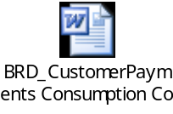

- Mapping Document

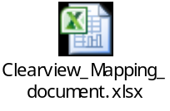

- Branch List

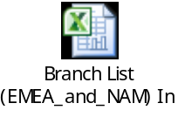

- ICD

