

**A Simulated Parking Assistance System using slot-based driving**

Pulkit Agarwal

**A Dissertation**

Presented to the University of Dublin, Trinity College in partial fulfilment of the requirements for the degree of

**Bachelor of Engineering (Computer Engineering)**

**Supervisor:** Prof. Vinny Cahill

April 2021

Declaration

I, the undersigned, declare that this work has not previously been submitted as an exercise for a degree at this, or any other University, and that unless otherwise stated, is my own work.

I have read and I understand the plagiarism provisions in the General Regulations of the University Calendar for the current year, found at <http://www.tcd.ie/calendar>.

I have also completed the Online Tutorial on avoiding plagiarism ‘Ready Steady Write’, located at

<http://tcd-ie.libguides.com/plagiarism/ready-steady-write>.

___________________________________

Pulkit Agarwal

April 30, 2021

**A Simulated Parking Assistance System using slot-based driving**

**Pulkit Agarwal**, Bachelor in Engineering

University of Dublin, Trinity College

**Supervisor:** Prof. Vinny Cahill

**ABSTRACT**

Large scale events, that include mass participation of the public such as musical concerts, sporting events, or even shopping centers during holidays and festivals often result in traffic congestion at the venue and even surrounding areas. One of the main reasons for this problem is inefficient parking guidance i.e. vehicle owners not aware of available parking slots, or if aware, unable to optimally reach the parking location due to their or others lack of knowledge about the parking area and the traffic flow.

To address this problem, a simulated parking assistance system with slot-based approach is proposed. The system uses Simulation for Urban Mobility (SUMO), a traffic simulation software, to simulate the flow of traffic in real time, hereby providing proper knowledge and fine-grained advice and directions to vehicle drivers to help smoothen the flow of traffic and alleviating congestion.

The project also explores whether a slot-based approach for this system is more beneficial as compared to the current parking methodologies. This approach is similar to the time division multiple access (TDMA) method in data communication in computer networking. In this scenario, the path from the entry to the parking lot inside the parking is the channel to be divided up and the vehicles are allocated slots on demand to travel towards their destination.

The potential benefits of the system comprise of proper guidance, accurate journey times and a better flow of traffic. Existing research for slot-based driving for intersections and on-ramp merging scenarios have been completed. However, this project will specifically target the flow of traffic during large scale events within the parking areas.

**SUMMARY**

Acknowledgement

I would like to thank Prof. Vinny Cahill for his initial idea for the topic and the weekly guidance given to me throughout the duration of this project. His advice was always helpful and pointed me in the right direction.

Secondly, I would also like to thank my friends and peers who have provided advice and proof-reading including Lara, Ujjawal, Aaryaman and Ruchir.

Finally, I would like to thank my family for their unwavering support and patience during not only this final year, but all four years which have led up to this point.

**Contents**

1. Introduction

1.1 Research Question . . . . . . . . . . . . . . . . . . . . . . . . . . . . . . . . . .

1.2 Motivation . . . . . . . . . . . . . . . . . . . . . . . . . . . . . . . . . . . . . .

1.3 Project Overview . . . . . . . . . . . . . . . . . . . . . . . . . . . . . . . . . . .

1.3.1 Simulated Driving . . . . . . . . . . . . . . . . . . . . . . . . . . . . .

1.3.2 Slot-based Driving Approach . . . . . . . . . . . . . . . . . . . . . . . . .

1.3.3 Research Aims . . . . . . . . . . . . . . . . . . . . . . . . . . . . . . . .

1.3.4 Potential Benefits of this Research . . . . . . . . . . . . . . . . . . . . .

1.3.5 Project Scope . . . . . . . . . . . . . . . . . . . . . . . . . . . . . . . .

1.3.6 Road Map . . . . . . . . . . . . . . . . . . . . . . . . . . . . . . . . . .

1.3.7 Keywords . . . . . . . . . . . . . . . . . . . . . . . . . . . . . . . . . .

# **Introduction**

The project aims to remit the problem of traffic congestion inside the parking areas during large scale events such as musical concerts, sporting events, etc. that require mass participation of public. This congestion results in delayed, inadequate, and suboptimal journey times and routes within the setting. The proposed solution uses a real-time traffic simulation software (Simulation for Urban Mobility) to simulate every incoming car into the system and provide the most optimal route for the journey within the parking. Additionally, the project explores the slot-based driving approach as a guidance system for the cars to maintain their positions with that in the simulation throughout the duration of the journey for optimal movement. This will act as an advantage in shaping traffic by organizing the flow of traffic and alleviating congestion.

* 1. **Research Question**

Does a proper driver guidance system unequivocally affect the traffic flow, during events of mass participation, allowing for more optimal journey times ?

* 1. **Motivation**

In any given parking situation, two drivers may choose to react completely different and take different decisions. These decisions could include different parking maneuvers, driving speeds, parking style, etc. This comes in regard to the fact that people are unpredictable and have dissimilar opinions, reflexes, skills, and instinct levels. This incalculable behavior in intensified in pressurized situations such as congested driving.

Non-reoccurring congestion is a type of unusual congestion caused by unpredictable events and planned special incidents which is a major attempt to mitigate the traffic congestion during events. However, the cause of congestion experienced by drivers at events can be narrowed down to variations of these four causes: poorly planned parking management, improperly guided road networks, unexpected events, and the drivers themselves.

The project proposes a Simulated Parking Assistance System using slot-based approach to remove the need for drivers to make their own decisions and provide them with proper knowledge and driving instructions. The hypothesis is that a more organized and guided approach will help alleviate congestion and improve the flow of traffic.

* 1. **Project Overview**
     1. **Simulated Driving**

This method of driving is a totally new approach where the cars are moving inside a traffic simulation software. This approach allows vehicles to pre-establish location of all the other vehicles in the setting and optimally determine journey times. Therefore, allowing vehicles to choose paths that benefit other vehicles in the network.

* + 1. **Slot-based Driving Approach**

The slot-based driving approach is similar to the principle of Time Division Multiple Access (TDMA) in Data Communications. TDMA follows the Channel-Access Method (CAM) which allows multiple packets to be transmitted without any interference between them. On applying this method in a road network, the road acts as the channel to be divided, and vehicles inside the network act as data packets which get slots assigned on request.

* + 1. **Research Aims**

The aim for this research project is to evaluate how the flow of traffic and the journey times in the vicinity of large scale events withing parking areas are affected by the introduction of simulated parking assistance system using slot-based driving, and in turn, whether or not journey routes and journey times can be more optimized. The specific objectives of this project are:

1. Create a simulated parking scenario using various road networks to examine the effects of flow of traffic at different traffic volumes.
2. Introduce slot-based driving mechanism to analyze the degree of compliance with the parking assistance system.
3. Develop a mobile application for simulated parking assistance system to provide vehicles with proper guidance within the parking.
   * 1. **Potential Benefits of the Research**

The potential benefits of the project comprise of improvements in traffic flow within the parking, reduction in cumulative time spent in looking for free spaces and following the most optimal route to the parking destination. All these benefits come in comparison to the current unconstrained approach of driving in parking areas.

* + 1. **Project Scope**

This research project will focus on whether any convenience or advantage can be achieved by implementing this approach assuming a perfect compliance rate. The project will not consider various safety aspects which must be considered before a production release. This is since rigorous testing cannot be completed outside of the simulation environment and the simulation software also has testing limitations as to what can and cannot be controlled within the simulation. However, a cross-platform mobile application is developed to transfer the parking guidance information from the system to the drivers. Potential concerns briefly describing the future research and work required to implement the project to real world scenarios will be discussed. However, they are not the primary concern for this research project.

* + 1. **Road Map**

The upcoming sections will include several pieces of related research about parking designs, parking management systems and slot-based driving .Following on, the design and implementation of the solution will be examined and the main challenges encountered during the project will be discussed at length. This chapter will also include information on the intended implementation of the system and what was completed within the time frame. Finally, the results of the scenarios run with simulated driving and proper guidance will be compared to the control cases , accompanied by analysis and evaluation of the overall project.

* + 1. **Keywords**

Search strategy keywords: Parking Assistance System, Parking Guidance System, Smart Parking Systems, Parking Design, Traffic Congestion, Traffic Management System, Traffic Simulation, Simulation for Urban Mobility (SUMO), Slot-based driving, Time Division Multiple Access, Driver Guidance System, Parking Assistance Mobile Application, Parking Lot Details, Journey Times, Road Network, Parking Model.

# **Background**

This section of the dissertation provides an apprehension into the various scopes and areas related to the project which were explored at the beginning of the project. This section takes an extensive examination at the existing research and studies completed in the dominion of parking management systems, traffic management systems, parking guidance systems, smart parking systems and slot-based driving. The idea for a Simulated Parking Assistance System is based on the related theories of the research papers which were examined. An insight on the softwares and tools considered upright for the research project are also discussed thoroughly later in the section.

* 1. **Highest Development**

The current up-to-the-minute research on parking guidance systems and slot-based driving spotlight particular and definitive affairs where advantages can be procured. These occurrences are fixated on particular driving settings and instances which specialize in driving in a built-up road network. Thus far, there is slight research available publicly on the slot-based driving approach, which proposes advantageous gain for utilizing the slot-based driving approach within parking management systems.

* 1. **Related Research**

There are two key research topics related to this project: Real-time Simulated Parking Systems and Slot-based Driving. As earlier mentioned, there are quite a few research papers which have made an effort to instigate and investigate the slot-based driving approach for distinct driving scenarios. These researches include of on-ramp merging on highways, street intersections, arrival times with slot-based traffic shaping. However, there has been next to none research on real-time simulated parking systems. Researches like real-time parking availability estimation, real-time parking prediction system, real-time smart parking system and agent-based simulation of parking management systems have been completed but they extensively differ from our idea of simulated parking assistance systems. Additionally, work has also been carried out on analyzing layouts for parking lots, optimizing parking spaces and driver guidance systems. These will also be discussed later in the section.

* + 1. **Street Intersections**

This research paper potentially discusses the advantages of slot-based intersections. The lack of complete analytical framework to contrast the Street Intersections to present traffic light road intersection systems was the motivation behind this research. The intention behind this research project was to develop a framework where Street Intersections could be compared against the present traffic light system at intersections.

The research recognizes that an organized system needs to be implemented in order to manage vehicles on conflicting or clashing paths. They believe so because these street intersections are a customary shared asset which are a bottleneck in the system. The proposed vehicle coordination at intersections is achieved through a complex switching process allowing access at intersections to those vehicles which are travelling on different paths or are not conflicting. Presently, the traffic lights are carrying this coordination of vehicles through phase switching operations in a periodic series where a phase is identical to a time period allowing a certain number of vehicles travelling on non-conflicting paths to enter and pass through the street intersection.

This research paper evaluates the time delay when switching among phases lasts up to 8 seconds. This solely calculates the number of vehicles entering and exiting the street intersections per hour. These time delays corroborate smooth transition between phases. Therefore, the increment in the time delay decreases traffic volume at intersections.

The recent developments in technology and applied sciences have provided softwares that can simulate traffic dynamically and enable slot-based driving approach making the project a reality. Previous street intersections provided data on vehicles, determining their travel speed, so as to reach the assigned driving slot. The wholehearted purpose of street intersections is to minimize the count of delays in switching among phases as well as maximizing the traffic capacity at the intersections. On grouping vehicles consecutively and continuously, the capacity at intersections can be increased. However, the delay for vehicles is increased that require to slow down in order to allow the previous vehicles group to pass before they access the street intersection. There are two techniques developed by these researchers to find the balance. BATCH is used to increase capacity slots to groups that can access the street intersection over a time period whereas FAIR establishes fairness vehicles and access slots to vehicles on a first come, first served idea.

This research concluded that the information attained during the simulation of the Street Intersection system provided support that traffic could be improved using slot-based approach at intersections as compared to the current traffic light system. This higher performance of slot-based approach at intersections was a result of finer granularity, and increased pliability that helped in merging vehicle flow and use the road network better. This approach also benefits by reducing car emissions caused by stop-and-go effect caused by different driving techniques. Limitations of this research state that further research is required to scale the system to a network of multiple road intersections.

* + 1. **On-ramp merging**

This is one of the other papers where slot-based driving approach was implemented. The paper analyzed the on-ramp merging of vehicles on a highway where traffic congestion was developed due to different and inefficient driving maneuvers taken by drivers in order to merge in the flowing traffic. A research conducted by Marinescu et al. proposed an optimized merging algorithm based on works mentioned in 2.2.1 of the paper, to implement slot-based driving system to coordinate vehicles merging in the middle of highway and the on-ramp. Another research conducted by Chen et al. calculates how traffic congestion is caused by poor vehicle operation under difficult traffic conditions. However, the motivation behind Marinescu’s paper aims at reducing traffic congestion at highways using slot-based driving approach. This allows journey to be timely and optimal.

The slots availability in this approach is examined through two approaches. The first approach asks the traffic management system (TMS) to determine slot occupancy information on the highway at all times. If a car plans to change or move to another slot, the change is either accepted or rejected by the TMS depending on the availability of the slot. This method utilizes vehicle to infrastructure communication. Whereas the second approach relies on vehicle to vehicle communication. In this method, when a vehicle wants to change their slots, the maneuver is coordinated with the surrounding vehicles using V2V communication. Although this approach is scalable, but it requires group communication and complex protocols which is beyond the scope of the research paper.

The culminating approach for this research incorporates both the previous approaches where the vehicle uses the distributed network to coordinate however, a roadside unit acts as a delegate between vehicles on main road versus vehicles on-ramp. This enables the cars to request a slot using V2I communication. Then the roadside unit utilizes V2V communication to determine empty slots on the highway. A merging algorithm allows merging among vehicles on the main road and the on ramp.

Results indicate that slot-based driving resulted in a 41% increment in flow under medium traffic conditions. This concludes that slot-based driving approaches can develop more efficient merging maneuvers.

* + 1. **Real-time Vehicle Scheduling**

‘The Managed Motorway: Real-time Vehicle Scheduling” research paper proposes a system to divide spaces available on road networks into slots to implement vehicle scheduling. This system is seemed comparable to the Channel Access Method (CAM) of Time Division Multiple Access in Data communications. In the primeval method, TDMA is implemented to allocate slots to messages to transport them through computer network. However, in the suggested solution, since every vehicle in the motorway are assigned slots through the course of their journey, the modified TDMA approach allows unexpected events to transpire as they are frequent and customary in vehicular traffic. A localized real-time vehicle system is suggested in order to provision for these unexpected events. These events could vary from accidents, vehicular malfunctions to pedestrians emerge on the motorway. The localized system can account for these occurrences and adapt to the situation such that is does not deranges the comprehensive scheduling of slots. The research presumes full compliance either by the vehicular communication system or the driver themselves to position and maintain the vehicle in the designated slot.

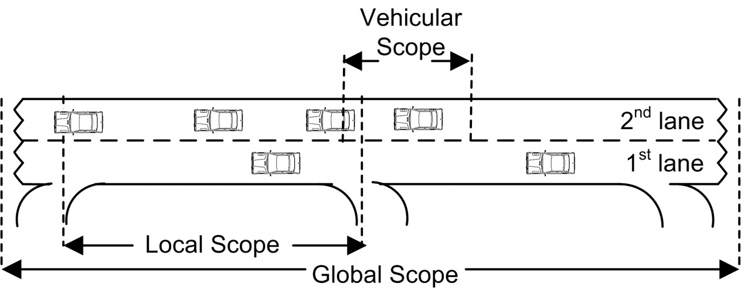

The planning of the vehicle scheduling system is proposed as a series of exit and entry motorways. Vehicles reaching the motorway are presumed to comply with the system by qualifying for all technical & electronic requirements and can only access the motorway once a slot becomes available else they have to stay in the queue. The research also identified the concept of scopes as a procedure to manage the motorway. The global scope in the figure above constitutes the uninterrupted motorway managing the vehicular capacity and organizing all the local scopes. The local scope for a vehicle is the specific portion on the motorway from the vehicle’s entry to its exit. All the sets of local scopes manage the corresponding vehicles assigned to the scope. The third and final scope is the vehicular scope which is only responsible to perceive the surroundings of that particular vehicle through its electronic sensors.

Vehicle admission control is used to ensure whether the available slots do not exceed the maximum number and meeting safety measures in the motorway. This ensures there is no shortening of the safety distances and allows local coordination. Toll gates are situated at every entry and exit on the motorway that communicate with the global scope to determine the number of available slots. The research concluded by proposing many solutions for inter-vehicular communication, which was beyond the scope of the project.

* + 1. **Maximizing Parking Spaces**

The recent increment in car usage has not been adequately matched by the development and improvement in organizing and arrangement of parking infrastructure. Researchers from University of Teknologi did a case study examining parking spaces and their different layouts. The three different kinds of parking designs analyzed were perpendicular, parallel, and angled parking. In the perpendicular parking layout, the vehicles are parked side by side i.e. the front or back bumper of a car is perpendicular to the wall, curb, or line separating parking space aisles. Angled parking is depicted in a way such that each parking space is positioned at an acute angle to the aisle from which a car advance towards a parking space. Parallel parking is sketched in a way such that the front of a car is in line with the back of another car. They suggested three mathematical algorithms to determine the maximum count of parking spaces that could be carved out of a given area.

For parallel parking, P = {w, k, y} where parking lot P has three determining variables. Here, ‘w’ represents width of the lane, ‘k’ represents the length of the lane and ‘y’ represents of available parking space. Therefore, the maximum number of parking spaces could be calculated using the given formula.

$$Number of parking spaces=\frac{y}{k} or \frac{Area Available}{Min. area of parking space}$$

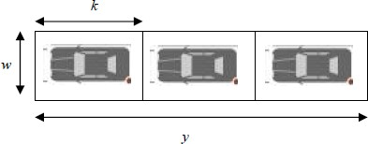

For diagonal parking, P = {x, z, θ, k, w} where parking lot P has five determining variables. Here, ‘x’ represents the curb length, ‘z’ represents the depth, ‘θ’ represents the angle, ‘k’ represents the length of the lane, and ‘w’ represents the width of the lane. Therefore, the maximum number of parking spaces in an angled parking could be calculated using the given formula.

$$Min. area of parking space=\left(w ×k\right)+\frac{1}{2}\left(z×w\right) where, z=\frac{w}{tanθ}$$

$$Number of parking spaces=\frac{y}{k} or \frac{Area Available}{Min. area of parking space}$$

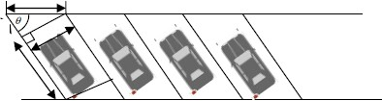

For perpendicular parking, P = {w, k} where parking lot P has two determining variables. Here, ‘w’ represents width of the lane and, ‘k’ represents the length of the lane. Therefore, the maximum number of parking spaces could be calculated using the given formula.

$$Min. area of parking space=\left(w ×k\right)$$

$$Number of parking spaces=\frac{Area Available}{Min. area of parking space}$$

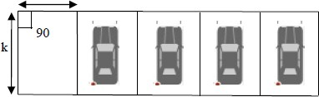

On implementing these three algorithms depending on the parking type, there was a noticeable increment in parking areas in contrast with the current count. However, while the parking lot design with perpendicular parking was the most optimal method to create maximum parking areas in a given space, there is evidence where angled (diagonal) parking for specific layouts are more optimal. For example, in a parking with eight spaces, angled parking layout uses less ground area in comparison to the perpendicular parking layout. Angled parking space layouts also requisite significantly less lane width to move in or out. However, there are concerns regarding approaching to angled parking spaces.

* + 1. **Parking Lot Induction Method**

This research paper closely analyses all the necessary considerations a driver should keep in mind while selecting a parking space in any setting. They propose a solution for optimizing route in a parking layout by applying a refashioned version of Dijkstra’s Algorithm. This redesigned Dijkstra’s Algorithm enables the driver to find an empty parking space swiftly and precisely by eradicating the traffic congestion originated or engendered by vehicle drivers blindly driving around the parking lots in order to avail an empty parking space.

The traditional Dijkstra Algorithm is used for finding the shortest paths between nodes in a graph, which may represent, for example, road networks. The proposed solution for this research it to monitor the occupancy state of parking spaces using sensors. Then the available parking spaces with the closest distance from the entrance of the parking is displayed to the incoming vehicle. Therefore, the modified Dijkstra’s Algorithm only requires the shortest path between two known nodes and excluding all other paths and then accounts in other factors such as driving distance, vehicles on the same route and occupancy status of all parking spaces.

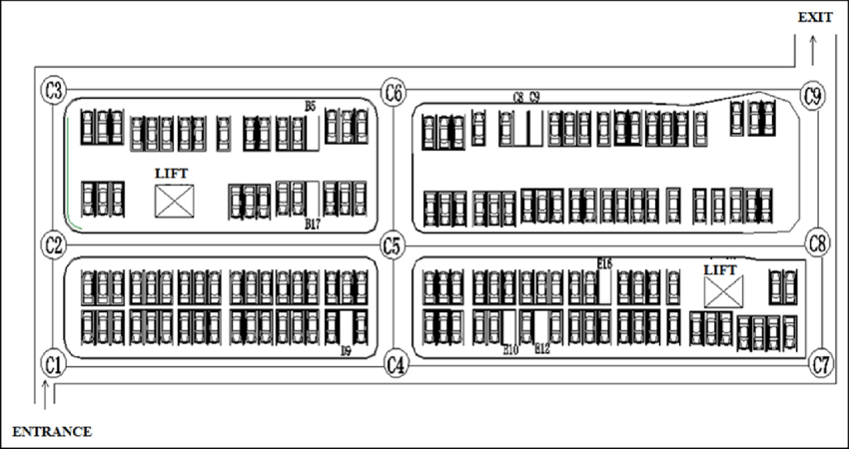

This research concludes by solving problems such as the driver not being alerted when a parking space becomes available, and no need for drivers to spend time and determine free parking spaces on their own.

* + 1. **Smart Parking**

The idea of pre-booked parking spaces is not an advanced proposition and the current state of art technologies can help improve the alleviation and efficiency in pre-booked parking procedures. Upon this idea, K. D’Souza and S. Hussain have initiated a system for intelligent parking lot management. The system implements various present-day technologies to track down the occupancy status of a parking space in a lot through computer vision algorithms embedded in the video feed of the security footage of the parking lot. The availability of spaces is transferred to a control unit that manages the payments and occupancy status for each parking space in the lot. On booking, the vehicle will be directed/guided to the allotted parking space through an augmented reality marker-based navigation interface.

The proposed parking lot reservation system is effectuated through Internet of Vehicles (IoV) which is an integrated complex network of systems that enables different vehicles to be connected within the same environmental and urban setting. The proposed model also includes parking parameters, parking fee, parking duration, and type of parking. All these parameters have a preference value which helps in determining the most optimal parking space for the vehicle. One of the algorithm that the proposed parking reservation system utilizes helps in determining the optimal parking lot for the vehicle. Every time a user books a parking space, the algorithm creates a new set of all the available parking spaces and then cross-references them according to the users selection of the above parameters. The highest ranked available parking space is then allotted to the user. If in case, no available parking spaces belong in the set of empty spaces, the user is required to reselect their preferences and then the algorithm repeats over with the new values.

The proposed parking reservation model was evaluated using three different parking areas in the same domain. In the first lot, observations showcased that people spent plenty of their time queuing to enter the parking area at rush hours whereas the other two lots had available parking lots at the same time. On applying the proposed system to the parking lots, the utilization for the first parking lot still remained high but the utilization for the other two parking lots significantly improved. This concluded that implementing the parking reservation model in a local setting improved the utilization rates for each of them.

* 1. **Technology Used**

In this section of the report, we will be briefly examining all the technology and softwares essential in developing a real-time simulated parking assistance system with slot-based driving.

For the parking simulation we will be using a traffic simulation software known as Simulation for Urban Mobility (SUMO), whereas the assistance and guidance system will be implemented and delivered through a cross-platform mobile application interface. The slot-based driving approach will be implemented in SUMO using a modified A* algorithm which is similar to Dijkstra’s Algorithm and implementing some additional logics to combine this approach to the parking simulation system.

* + 1. **Traffic Simulation Softwares comparison**

In order to establish a real-time simulated parking assistance system, a traffic simulation software is required. Numerous of these contemporary traffic simulation softwares with integrated car-following models are available. They enable users to simulate vehicles in custom scenarios and road networks. For this particular research project, the traffic simulation software used was Simulation for Urban Mobility (SUMO). It is an open-source traffic microscopic and continuous road traffic simulation package capable of operating substantial road networks. Vehicles in the simulation proceed under car following model accounting for car maneuvers, lane change, collisions, accidents, etc. SUMO also allows the users to dynamically define vehicles in the simulation using its TraCI Interface making it one of the most popular simulation softwares in the market. This tool allows users to access and alter vehicle behavior, signal control, path flows and the road network topology. The software also provides users with many custom objects such as rerouters, parking areas, bus stops, etc. that enables users to model more complex networks, and design parking management systems using custom driving models.

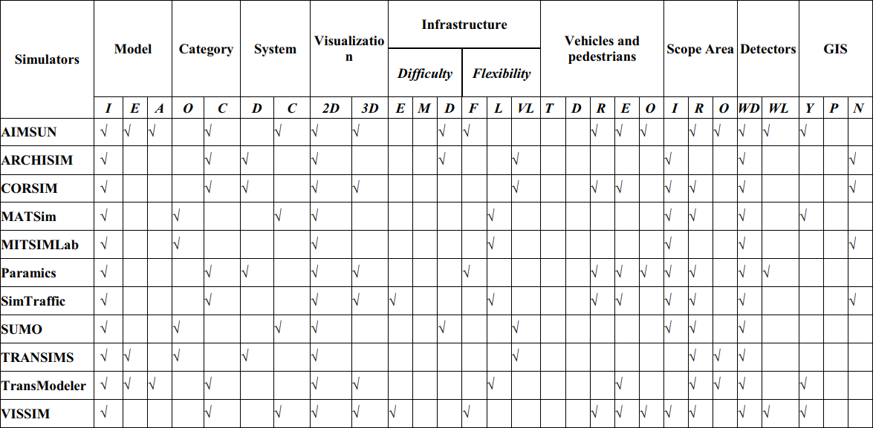

The above figure comparatively researches all the traffic simulation softwares in the market. Simulation for Urban Mobility (SUMO) has a difficult infrastructure due to its complex features and tools. The software is also concentrated around urban road networks which make it one of the most appropriate software to implement a simulated parking assistance system using slot-based driving approach.

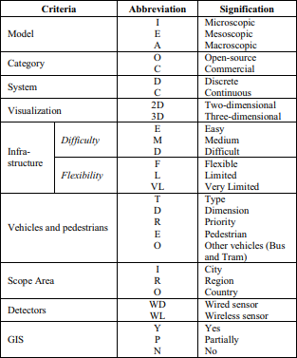

* + 1. **Simulation for Urban Mobility (SUMO)**

Simulation for Urban Mobility (SUMO) is a free and open source traffic simulation suite. The software allows modelling of intermodal traffic systems - including road vehicles, public transport, and pedestrians. Included with SUMO is a wealth of supporting tools which automate core tasks for the creation, the execution and evaluation of traffic simulations, such as network import, route calculations, visualization, and emission calculation. SUMO can be enhanced with custom models and provides various APIs to remotely control the simulation.

Netedit is a visual network editor tool in SUMO. It can be used to create networks from scratch and to modify all aspects of existing networks. With a powerful selection and highlighting interface, it can also be used to debug network attributes. **netedit** is built on top of netconvert. As a general rule of thumb, anything netconvert can do, **netedit** can do as well. **netedit** has unlimited undo/redo capabilities and thus allows editing mistakes to be quickly corrected. Netedit can be switched between three major edit modes for editing [network](https://sumo.dlr.de/docs/Netedit/editModesNetwork.html)-related objects, [traffic](https://sumo.dlr.de/docs/Netedit/editModesDemand.html)-related objects and [data](https://sumo.dlr.de/docs/Netedit/editModesData.html) objects. Each of these [modes](https://sumo.dlr.de/docs/Netedit/editModes.html) has a number of sub-modes for inspecting, deleting and adding the different objects. Some of these modes are common to all modes while others are specific to a particular mode.

Another tool in SUMO is TraCI which is the short term for Traffic Control Interface. Giving access to a running road traffic simulation, it allows to retrieve values of simulated objects and to manipulate their behavior "on-line". Normally, TraCI is used to couple multiple processes: A SUMO server process and one or more TraCI client processes. Alternatively, LibSUMO can be used to embed SUMO as a library into the client process. This allows using the same method signatures as in the client libraries but avoids the overhead of socket communication. LibSUMO supports generating client libraries using SWIG and can therefore be used with a large number of programming languages. C++, Java, and Python bindings are included when downloading a sumo-build. TraCI allows to use SUMO in combination with communication network simulators for simulating vehicular communication.

SUMO can be used in various application areas such as evaluating the performance of traffic lights, including the evaluation of modern algorithms up to the evaluation of weekly timing plans, Simulation and validation of autonomous driving function in cooperation with other simulators, Simulation of parking traffic, Traffic safety and risk analysis, etc. However, we will be using the software to develop a real-time parking management simulation system for the project.

* + 1. **OpenStreetMap**
    2. **Cross-Platform Mobile Application (Expo & Firebase)**
  1. **Conclusion**

In this section, the research and works related to traffic simulation, parking management and guidance system, and slot-based driving approach were discussed in detail. The precursory works on slot-based driving depict the advantages that this approach could provide in traffic management considering the requisite surroundings. However, these researches targeted specific illustrations like street intersections, on-ramps, and highways.

This research project will apply similar techniques from intelligent parking lot management system, and parking space reservations, however, rather than just providing parking space details to a vehicle, we will continuously monitor the real-time position, speed, lane, etc. of a vehicle through SUMO’s car following model and provide proper guidance and instructions to each vehicle in the system using a mobile application interface to reach their destination optimally. The technique of slot-based driving will be implemented to monitor the vehicular scope for each vehicle and improve the journey times by reducing all the possibilities of collisions and accidents.

# **Design and Implementation**