CVEEN 7920: Hydroinformatics September 17, 2015

At the conclusion of 2014, Utah’s population growth of 1.4% was nearly double the 0.75% growth rate for the nation (*Washington Times, 2014*). This growing population’s primary source of water is from snowmelt that is impacted by climate change. Predicting the effects of population growth, climate change, and land use change has on water quality will aide in the preservation of water. A study is proposing the calibration and validation of three hydrologic models by using data from the iUTAH Gradient Along Mountain to Urban Transition (GAMUT) network. The three rivers of interest in the network is the Logan River in Cache Valley, Red Butte Creek, and the Provo River. This paper will review the usefulness of using the data provided by the iUTAH GAMUT network and the plausible usage for this study.

Along the Wasatch front in Utah, data is collected at 31 stations within the three watersheds in the network as shown in Figure 1. These stations include climate, aquatic and storm drain stations with a variety of sensors to collect data. The stations monitor the water and climate near urban and mountain environments. The data collected is monitored and reviewed by personnel from three major universities in the state: Utah State University, Brigham Young University, and the University of Utah. The data is available on the iUTAH website where the data can be compiled and transformed into graphs to aid in the visualization of the data being collected from the site. Spatial information such as the latitude and longitudinal coordinates as well as the temporal support of a daily update of data is available for viewing on the website. Furthermore, the raw data can be downloaded in a .csv format; it’s strongly supported by many other data processing tools. These files have detailed metadata regarding the site and the attributes of what is measured with each sensor organized by date and time of measurement.

The data from the climate and aquatic stations can be utilized in conjunction to find correlations between climate patterns and changes in water quality. These stations will have to be within a reasonable proximity for the user to assume similar climate patterns are occurring at both stations. The effects of the human population on water quality can be articulated from observing the water quality at stations closer to urban areas. The stations throughout the watershed can be compared with one another, evaluating the location of each station and the areas land use surrounding it. The water quality will vary based on the land use closer to an urban environment versus the isolated area at a high elevation in the mountains. It is to be noted that not all of the stations have the same sensors mounted thus limiting certain variables to compare across the three watersheds. However, the data measurements were collected at 15-minute intervals to accommodate universal comparison across the network.

The iUTAH GAMUT network can contribute meaningful data to calibrate and validate the hydrologic models used to determine the variations in water quality caused by population growth, land use change, and climate change. The widespread monitoring stations in three different watersheds in Utah allow for distinctions between water quality in populated and isolated areas. Each station has various sensors to provide raw data to be easily used with software as well as a time series analyst available on the website to read the data. Although comparisons can be limited due to sensor availability, it is recommended to use the GAMUT network for this study for its accessibility and ample data measurements.

# Appendix

### Figure:

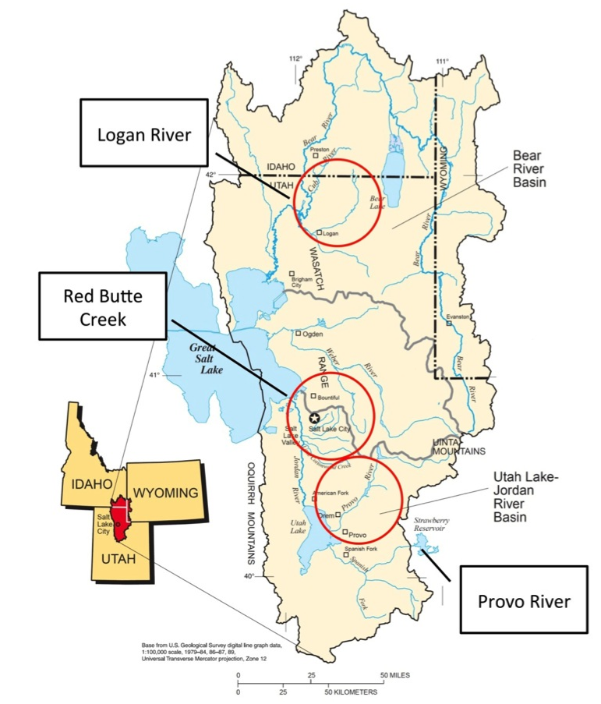

Figure : GAMUT Network River Locations

### Works Cited

iUTAH GAMUT Working Group (2014), iUTAH GAMUT Network Raw Data Above Red Butte Reservoir Climate Site (RB_ARBR_C), 1.0, iUTAH Modeling & Data Federation, http://repository.iutahepscor.org/dataset/iutah-gamut-network-raw-data-above-red-butte-reservoir-climate-site-rb-arbr-c

iUTAH GAMUT Working Group (2014), iUTAH GAMUT Network Raw Data at Tony Grove Climate Site (LR_TG_C), 1.0, iUTAH Modeling & Data Federation, http://repository.iutahepscor.org/dataset/iutah-gamut-network-raw-data-at-tony-grove-climate-site-lr-tg-c

iUTAH GAMUT Working Group (2014), iUTAH GAMUT Network Raw Data at Trial Lake Climate Site (PR_TL_C), 1.0, iUTAH Modeling & Data Federation, http://repository.iutahepscor.org/dataset/iutah-gamut-network-raw-data-at-trial-lake-climate-site-pr-tl-c

The GAMUT Network. Digital image. IUtah Modeling and Data Federation. Epscor, n.d. Web. 14 Sept. 2015.

"Utah’s Population Growth Outstrips National Average." Washington Times. The Washington Times, 25 Dec. 2014. Web. 14 Sept. 2015.