HBP USER MANUAL - V2

**Table of Contents**

[Software setup](onenote:#HBP%20USER%20MANUAL&section-id={9E7E83B3-CC05-4504-A86B-53E862232A82}&page-id={39637B25-3C96-4655-B23B-FF439BB9D197}&object-id={30520E3B-C19F-4ACA-A426-A3C4CF17FC08}&A&base-path=https://beevc2.sharepoint.com/ReD/Shared%20Documents/OneNote/BEEVC-ReD-helloBEEprusa/DEV.one)

[Pronterface](onenote:#HBP%20USER%20MANUAL&section-id={9E7E83B3-CC05-4504-A86B-53E862232A82}&page-id={39637B25-3C96-4655-B23B-FF439BB9D197}&object-id={30520E3B-C19F-4ACA-A426-A3C4CF17FC08}&14&base-path=https://beevc2.sharepoint.com/ReD/Shared%20Documents/OneNote/BEEVC-ReD-helloBEEprusa/DEV.one)

[Cura 15.04](onenote:#HBP%20USER%20MANUAL&section-id={9E7E83B3-CC05-4504-A86B-53E862232A82}&page-id={39637B25-3C96-4655-B23B-FF439BB9D197}&object-id={30520E3B-C19F-4ACA-A426-A3C4CF17FC08}&4D&base-path=https://beevc2.sharepoint.com/ReD/Shared%20Documents/OneNote/BEEVC-ReD-helloBEEprusa/DEV.one)

[Preparing for first print](onenote:#HBP%20USER%20MANUAL&section-id={9E7E83B3-CC05-4504-A86B-53E862232A82}&page-id={39637B25-3C96-4655-B23B-FF439BB9D197}&object-id={9D716668-147A-41DD-8058-0B63F5E26A00}&26&base-path=https://beevc2.sharepoint.com/ReD/Shared%20Documents/OneNote/BEEVC-ReD-helloBEEprusa/DEV.one)

[Bed calibration](onenote:#HBP%20USER%20MANUAL&section-id={9E7E83B3-CC05-4504-A86B-53E862232A82}&page-id={39637B25-3C96-4655-B23B-FF439BB9D197}&object-id={C3D72601-F3F1-4B41-B44B-6C39CC0202E3}&86&base-path=https://beevc2.sharepoint.com/ReD/Shared%20Documents/OneNote/BEEVC-ReD-helloBEEprusa/DEV.one)

[Load/unload the filament](onenote:#HBP%20USER%20MANUAL&section-id={9E7E83B3-CC05-4504-A86B-53E862232A82}&page-id={39637B25-3C96-4655-B23B-FF439BB9D197}&object-id={30520E3B-C19F-4ACA-A426-A3C4CF17FC08}&20&base-path=https://beevc2.sharepoint.com/ReD/Shared%20Documents/OneNote/BEEVC-ReD-helloBEEprusa/DEV.one)

[First print](onenote:#HBP%20USER%20MANUAL&section-id={9E7E83B3-CC05-4504-A86B-53E862232A82}&page-id={39637B25-3C96-4655-B23B-FF439BB9D197}&object-id={26DF5DF4-4DFF-468C-9920-7F807B6A52AF}&8C&base-path=https://beevc2.sharepoint.com/ReD/Shared%20Documents/OneNote/BEEVC-ReD-helloBEEprusa/DEV.one)

[Add helloBEEprusa as a new machine on Cura 15.04](onenote:#HBP%20USER%20MANUAL&section-id={9E7E83B3-CC05-4504-A86B-53E862232A82}&page-id={39637B25-3C96-4655-B23B-FF439BB9D197}&object-id={26DF5DF4-4DFF-468C-9920-7F807B6A52AF}&95&base-path=https://beevc2.sharepoint.com/ReD/Shared%20Documents/OneNote/BEEVC-ReD-helloBEEprusa/DEV.one)

[Configure settings and export GCode](onenote:#HBP%20USER%20MANUAL&section-id={9E7E83B3-CC05-4504-A86B-53E862232A82}&page-id={39637B25-3C96-4655-B23B-FF439BB9D197}&object-id={26DF5DF4-4DFF-468C-9920-7F807B6A52AF}&C3&base-path=https://beevc2.sharepoint.com/ReD/Shared%20Documents/OneNote/BEEVC-ReD-helloBEEprusa/DEV.one)

The information on this manual was written with software running on Microsoft Windows 8.1 but the same software can be found for MAC and Linux and the same instructions may work on other operation systems.

Software setup

In order to be able to control helloBEEprusa and print, you need to use an OpenSource software that is developed by the 3D printing community.

Pronterface

In order to help you calibrate the print bed, load/unload filament and do other operations, you can use the Pronterface software. Please download it from this link - version "Printrun-Win-Slic3r-03Feb2015": <http://koti.kapsi.fi/~kliment/printrun/>

Pronterface screenshot:

Machine generated alternative text:
File Tools Advanced Settings Help 
Load file 
Pronterface 
Port COM3 
115200 
Disconnect 
SD 
Pause 
Connecting.. 
start 
Printer is now online. 
echo:MarlinC1.1.C1 
echo: Last Updated: Jun 23 2015 18:27:48 | Author: (none, default config) 
compiled: 23 2015 
echo: Free Memory: 3372 Planneraufferaytes: 1232 
echo:Hardcoded Default Settings Loaded 
echo:SD card ok 
Reset 
40 
20 
10 
Z: 100 
Motors off 
Heat : 
Bed : 
Length: 
50.0 
Off 230 (abs 
Off a (off) 
Reverse 
Speed: 
150.0 
mm/ 
min 
T:39.6 10.0 8:39.3 10.0 TO:39.6 10.0 TI :29.6 10.0 

Cura 15.04

In order to generate the G-code for printing, you can use the Cura 15.04. Please download it from this link - version "Version: 15.04": <https://ultimaker.com/en/cura-software/list>

Cura 15.04 screenshot:

Machine generated alternative text:
File Tools Machine Expert Help 
Basic Advanced Plugins Start/End-GCode 
Quality 
Layer height (mm) 
Shell thickness (mm) 
Enable retraction 
Bottom/Top thickness (mm) 0.8 
Fill Densib,' 
Speed and Temperature 
Print speed (mm/s) 
Printing temperature (C) 230 
2nd nozzle temperature (C) 0 
Bed temperature (C) 
Support 
Support type 
Platform adhesion type 
Support dual 
Dual extrusion 
Wipe&prime tower 
Ooze shield 
Filament 
Diameter (mm) 
Diameter2 (mm) 
Flow (0/0) 
None 
None 
First extruder 
1.75 
1.75 
100.0 

Preparing for first print

In order to be able to print you need to first calibrate your bed and load/unload the filament.

Bed calibration

You need to evenly calibrate the bed so the first layer of the print can adhere well to the bed, otherwise it may ruin your print.

Before starting to level the bed, you can jog the extruder and the bed using the jog buttons on Pronterface. You can move the Z axis in a way that the nozzle stays a bit closer to the bed and is essential for the following steps.

Machine generated alternative text:
File Tools Advanced Settings Help 
Port COM3 
115200 
Disconnect Reset 
Z: 100 
Motors off 

Now use the 3 screws to level the bed. You need to do it keeping the same distance from the noozle on all points of the bed.

Machine generated alternative text:


Next step is to adjust the home Z axis so the nozzle can stay at a distance of about 0.2mm from the bed. You can use a paper sheet as reference for the needed distance.

Use the Pronterface jog panel to home the Z axis:

Machine generated alternative text:
File Tools Advanced Settings Help 
Port COM3 
115200 
Disconnect Reset 
Z: 100 
Motors off 

Now adjust the placement of Z endstop so when the home of Z axis ends, the nozzle stays at a distance of about 0.2mm from the bed.

Machine generated alternative text:
Lxcense 
PLv3 
Design bv 
Instr uctl ons: 
www.bigtree—toch. com MakerBot. CO 

Example of the nozzle staying at about 0.2mm from the bed:

Machine generated alternative text:


Load/unload the filament

You can load/unload filament using the Pronterface control panel:

Machine generated alternative text:
File Tools Advanced Settings Help 
Reset 
150 
100 
50 
Port COM3 
115200 
Disconnect 
Z: 100 
Motors off 
Heat : 
Bed : 
Length: 
30.0 
Off 230 (abs 
Off 110 (abs 
Reverse 
Speed: 
mm/ 
150.0 
min 
T:141.2 10.0 a:95.0 10.0 TO:141.2 10.0 TI :31.4 10.0 

To load, first you need to set the extruder heating temperature and wait for the temperature to reach that value. You can look at the graph to verify.

When the extruder reaches the temperature, then you can click on the Extrude button and then you can insert the filament on the extruder.

To unload, you also  need to set the same extruder heating temperature. Afterwards, just click the Reverse button and gently pull the filament from the extruder.

If you want to control the second extruder (ex 1), send the command "T1" on the Pronterface console in order to control the second extruder. Send the command "T0" to control again the first extruder.

First print

For our first print we will be using the free 3DBenchy 3D model - you can download it here: <http://www.3dbenchy.com/>

We will also configure Cura 15.04 to export the G-code. Finally we will save the G-code file on the SDCard and print it.

Add helloBEEprusa as a new machine on Cura 15.04

Go to "File --> Machine settings" and click on "Add new machine".

Follow the next screenshots and use the same options.

Machine generated alternative text:
Configuration Wizard 
Add new machine wizard 
This wizard Will help you in setting up Cura for your machine. 
z: Back 
Cancel 

Machine generated alternative text:
Configuration Wizard 
Select your machine 
What kind of machine do you have: 
Ultimaker2 
Ultimaker2extended 
Ultimaker2go 
Ultimaker Original 
Ultimaker Original+ 
Printrbot 
Lulzbot TAZ 
Lulzbot Mini 
@Other (Ex: RepRap, Makeraot, Witbox) 
The collection of anonymous usage information helps with the continued improvement of Cura. 
This does NOT submit your models online nor gathers any privacy related information. 
Submit anonymous usage information: 
For full details see: http://wiki.ultimaker.com/cura:stats 
c: Back 
Cancel 

Machine generated alternative text:
Configuration Wizard 
Other machine information 
The following pre-defined machine profiles are available 
Note that these profiles are not guaranteed to give good results, 
or work at all. Extra Meaks might be required. 
If you find issues with the predefined profiles, 
or want an profile. 
Pletse report it at the github issue tracker. 
Deltaaot 
Hephestos 
Hephestos XL 
MakeraotReplicator 
C) Mendel 
Ord 
Prusa Mendel B 
Rigid3D 
Rigidaot 
RigidaotBig 
Witbox 
Zone3d Printer 
C) julia 
C) katihal 
punchtec Connect XL 
. Custom... 
c: Back 
Cancel 

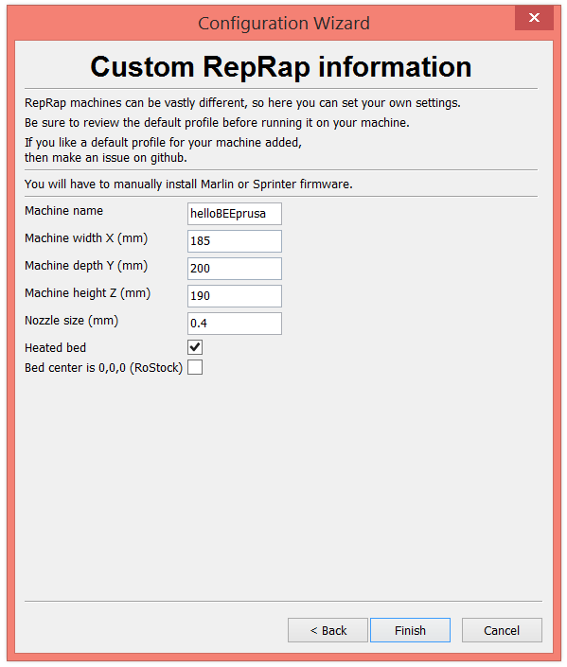

Access to "Machine --> Machine settings…" and compare with the following screenshot:

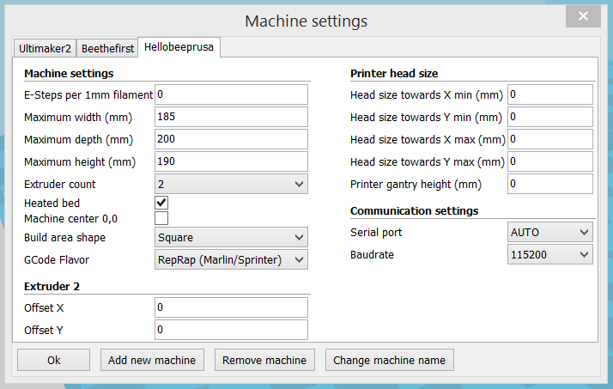

Access to "Expert --> Open expert settings…" and compare with the following screenshot:

Machine generated alternative text:
Dual extrusion 
Wipe&prime tower volume per layer 
Retraction 
Minimum travel (mm) 
Enable combing 
Minimal before retracting (mm) 
Z hop when retracting (mm) 
Line count 
Start distance (mm) 
Minimal length (mm) 
Fan full on at height (mm) 
Fan speed min (%) 
Fan speed max (%) 
Minimum speed (mm/s) 
Cool head lift 
Infill 
Solid infill top 
Solid infill bottom 
Infill overlap (%) 
Infill prints after perimeters 
Expert config 
No Skin 
150.0 
Grid 
Support 
Structure type 
Overhang angle for support (deg) 60 
Fill amount (%) 
Distance (mm) 
Distance Z (mm) 
Black Magic 
Spirallze the outer contour 
Only follow mesh surface 
arim line amount 
Stra margin (mm) 
Line spacing (mm) 
Base thickness (mm) 
Base line width (mm) 
Interface thickness (mm) 
Interface line width (mm) 
Airgap 
First Layer Airgap 
Surface layers 
Surface layer thickness (mm) 
Surface layer line width (mm) 
Fix horrible 
Combine everything (Type-A) 
Combine everything (Type-a) 
Keep open faces 
E)ãensive stitching 
0.15 
0.22 
n 
n 

Configure settings and export GCode

Follow these screenshots and use the same options.

Machine generated alternative text:
File Tools Machine Expert Help 
Basic Advanced Plugins Start/End-GCode 
Quality 
Layer height (mm) 
Shell thickness (mm) 
Enable retraction 
Bottom/Top thickness (mm) 0.8 
Fill Densib,' (%) 
Speed and Temperature 
Print speed (mm/s) 
Printing temperature (C) 240 
2nd nozzle temperature (C) 240 
Bed temperature (C) 
Support 
Support type 
Platform adhesion type 
Support dual 
Dual extrusion 
Wipe&prime tower 
Ooze shield 
Filament 
Diameter (mm) 
Diameter2 (mm) 
Flow (0/0) 
100 
Touching buildplate 
None 
Second extruder 
1.75 
1.75 
100.0 

NOTE: for ABS filament, choose Printing temperature of about 240ºC and Bed temperature of 100ºC or more.

For PLA filament, choose Printing temperature of about 190ºC and Bed temperature of about 60ºC.

Machine generated alternative text:
File Tools Machine Expert Help 
Basic Advanced Plugins Start/End-GCode 
M achine 
Nozzle size (mm) 
Retraction 
Speed (mm/s) 
Distance (mm) 
Dual S"itch amount 
Quality 
Initial layer thickness (mm) 
Initial layer line width (%) 
Cut off object bottom (mm) 
Dual overlap (mm) 
Speed 
Travel speed (mm/s) 
Bottom layer speed (mm/s) 
Infill speed (mm/s) 
Top/bottom speed (mm/s) 
Outer Shell speed (mm/s) 
Inner Shell speed (mm/s) 
Minimal layer time (sec) 
Enable cooling fan 
40.0 
150.0 

Machine generated alternative text:
File Tools Machine Expert Help 
Basic Advanced Plugins Start/End-GCode 
Plugins: 
Pause at height 
Z 4.0.2 
Enabled plugins 

Machine generated alternative text:
File Tools Machine Expert Help 
Basic Advanced Plugins Start/End-GCode 
start.qccde 
end.gcade 
preSwitch3ãruder.gcode 
postSwitchExtruder.gcode 
sta rt2.gcode 
end2.gcode 
; SLIced at: (date) (time) 
;Basic settings: Layer height: (Layer height) 
; time: time) 
• Filament used: (filament aruzunt)m ( filament 
cost: (filament cost) 
;M190 S (print bed temperature) ; Uncorment to 
;M109 S (print temperature) ; Uncorment to add 
G21 
Ggr_l 
M107 
G2B XO 
G2B zo 
Gl ZIS. 
G92 EO 
;metric vaLues 
; absolute positioning 
; start with Che fan off 
YO ;ruzve X/ Y to min endstops 
;rave Z to min endstops 
O F (travel speed) ;ruzve Che platform d; 
; zero Che extruded Lei 
; extrude 3rm feed 
; zero Che extruded Lei 
Gl F200 E3 
G92 EO 
GI F (traveL speed) 
; Put printing message on LCD screen 
MI 17 Prrntrng. 

**Use the following commands for start.gcode:**

;Sliced at: {day} {date} {time}

;Basic settings: Layer height: {layer\_height} Walls: {wall\_thickness} Fill: {fill\_density}

;Print time: {print\_time}

;Filament used: {filament\_amount}m {filament\_weight}g

;Filament cost: {filament\_cost}

;M190 S{print\_bed\_temperature} ;Uncomment to add your own bed temperature line

;M109 S{print\_temperature} ;Uncomment to add your own temperature line

G21 ;metric values

G90 ;absolute positioning

M107 ;start with the fan off

G28 X0 Y0 ;move X/Y to min endstops

G28 Z0 ;move Z to min endstops

G1 Z15.0 F{travel\_speed} ;move the platform down 15mm

G92 E0 ;zero the extruded length

G1 F200 E3 ;extrude 3mm of feed stock

G92 E0 ;zero the extruded length again

G1 F{travel\_speed}

;Put printing message on LCD screen

M117 Printing…

**Use the following commands for end.gcode:**

;End GCode

M104 S0 ;extruder heater off

M140 S0 ;heated bed heater off (if you have it)

G91 ;relative positioning

G1 E-1 F300 ;retract the filament a bit before lifting the nozzle, to release some of the pressure

G1 Z+0.5 E-5 X-20 Y-20 F{travel\_speed} ;move Z up a bit and retract filament even more

G28 X0 Y0 ;move X/Y to min endstops, so the head is out of the way

M84 ;steppers off

G90 ;absolute positioning

**Use the following commands for preSwitchExtruder.gcode:**

;Switch between the current extruder and the next extruder, when printing with multiple extruders.

;This code is added before the T(n)

**Use the following commands for postSwitchExtruder.gcode:**

;Switch between the current extruder and the next extruder, when printing with multiple extruders.

;This code is added after the T(n)

**Use the following commands for start2.gcode:**

;Sliced at: {day} {date} {time}

;Basic settings: Layer height: {layer\_height} Walls: {wall\_thickness} Fill: {fill\_density}

;Print time: {print\_time}

;Filament used: {filament\_amount}m {filament\_weight}g

;Filament cost: {filament\_cost}

;M190 S{print\_bed\_temperature} ;Uncomment to add your own bed temperature line

;M104 S{print\_temperature} ;Uncomment to add your own temperature line

;M109 T1 S{print\_temperature2} ;Uncomment to add your own temperature line

;M109 T0 S{print\_temperature} ;Uncomment to add your own temperature line

G21 ;metric values

G90 ;absolute positioning

M107 ;start with the fan off

G28 X0 Y0 ;move X/Y to min endstops

G28 Z0 ;move Z to min endstops

G1 Z15.0 F{travel\_speed} ;move the platform down 15mm

T1 ;Switch to the 2nd extruder

G92 E0 ;zero the extruded length

G1 F200 E10 ;extrude 10mm of feed stock

G92 E0 ;zero the extruded length again

G1 F200 E-{retraction\_dual\_amount}

T0 ;Switch to the first extruder

G92 E0 ;zero the extruded length

G1 F200 E10 ;extrude 10mm of feed stock

G92 E0 ;zero the extruded length again

G1 F{travel\_speed}

;Put printing message on LCD screen

M117 Printing…

**Use the following commands for end2.gcode:**

;End GCode

M104 T0 S0 ;extruder heater off

M104 T1 S0 ;extruder heater off

M140 S0 ;heated bed heater off (if you have it)

G91 ;relative positioning

G1 E-1 F300 ;retract the filament a bit before lifting the nozzle, to release some of the pressure

G1 Z+0.5 E-5 X-20 Y-20 F{travel\_speed} ;move Z up a bit and retract filament even more

G28 X0 Y0 ;move X/Y to min endstops, so the head is out of the way

M84 ;steppers off

G90 ;absolute positioning

Finally export the Gcode by doing "Save toolpath" and choose the folder of your SDCard on your computer.

Machine generated alternative text:
3 hours 12 
ago 12 gam 
3 gam 

Now insert the SDCard on the printer by using the jog button, navigate to "Print from SD" and choose the file. Your printer will start heating and will then print the object.