**How to run python backend for campus-grabpoint**

1. Postgres setup

Can use any name , just make sure it matches the db setting in settings.py file in the project . Already have a db then remove or create a new one using pg admin.

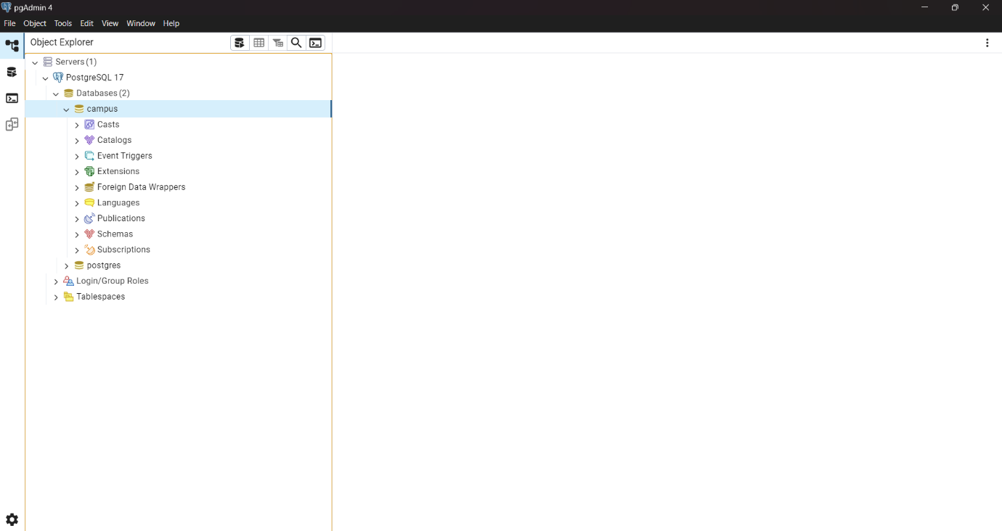

1. GitHub cloning

<https://github.com/befinlalu/campus_grabpoint_django>

Use this repo to clone the project and delete migrations file (delete the entire folder)

path-api\migrations

1. Run pip install -r requirements.txt
2. In settings.py update db setting.

Ensure the name matches db name , if you set default while installation the user will be same , and also ensure pass. 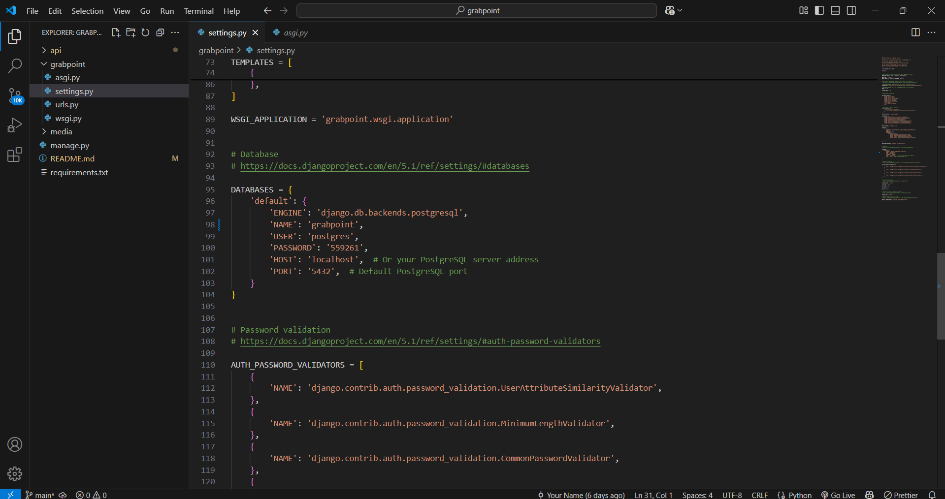

1. Run - python manage.py makemigrations api
2. Run - python manage.py migrate
3. python manage.py createsuperuser – run this to create a superuser or admin
4. python manage.py runserver – to make apis live