Programming Exercise

The exercise is to create a frontend application that displays videos from the Everyplay service. The API is unfortunately currently undocumented, so you’ll have to reverse engineer it from everyplay.com. The API is a very straight-­forward REST API based on JSON, so this should not be difficult. Get yourself a client_id from signing up at http://developers.everyplay.com/ (add “Job search candidate” as your company name to avoid our sales spamming you).

Once you have reversed the API, I want you to create a frontend application as a single-­‐page application that allows the user to watch the latest videos from Everyplay. They can be filtered by game. When the user clicks the video, it shows the single video and plays the video as a HTML5 video player.

Mockups here:

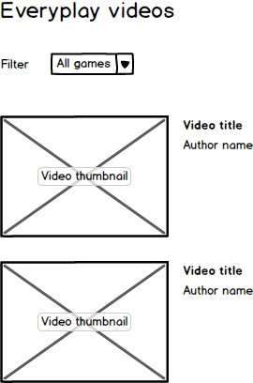

Video view:

