Date: 05-31-2000

Contributors: Bashir Eghbali, John White, Denise Kashirs

Project Plan

Introduction:

Our task was to process 100 medical abstracts and understand what they say, output facts derived from grammatical parsing and to also if possible output facts derived from other facts. We first had to try to understand the sentence structure and parse the sentence into a Noun Clause and Verb Clause, where the Noun Clause consists of:

[Adj* Noun* abbre prop Verb*]*
where: abbre= abbreviation prop=proposition, conjunction, disjunction, etc… and base case is: Adj=abbre = prop=Verb ∈ ε

and the Verb Clause which consists of:
[Adv*Verb prop Noun*]*

Basically, we parse the sentence into NP, VP tokens and then using a lexicon (Wordnet) we distinguish the main verb, object and subject and create a database of these. Following is an abstract representation of a database entry.

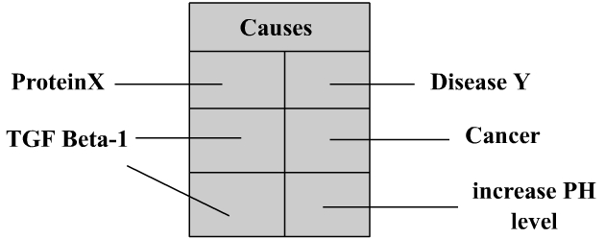
Indicating:
ProteinX causes disease Y
TGF Beta-1 causes cancer
TGF Beta-1 causes increase PH level

This approach helps us categorize our causal relationships into database entries in a graph representation where the following holds:
1)Noun^{*1} ->(relationship*)->Noun^{*2} where ^{*1}≠ 0
2)Noun^{*1} ->(relationship*)->ε where ε is the null string/object;

The above statements show that any set of nouns can be connected to any other set by relationship or they just have relationship by themselves.
Example of 1) Boy hits ball
Example of 2) ProteinX folds

We have our ontology database on a remote site where we connect to it and try to create an array of all predicates available in the database. We then choose some arbitrary verbs and try to find all similar (semantically) predicates and categorize them in this finite set of causal relationships. We then use prepositional logic and first order predicate logic to derive new facts.

Project Implementation Diagram:

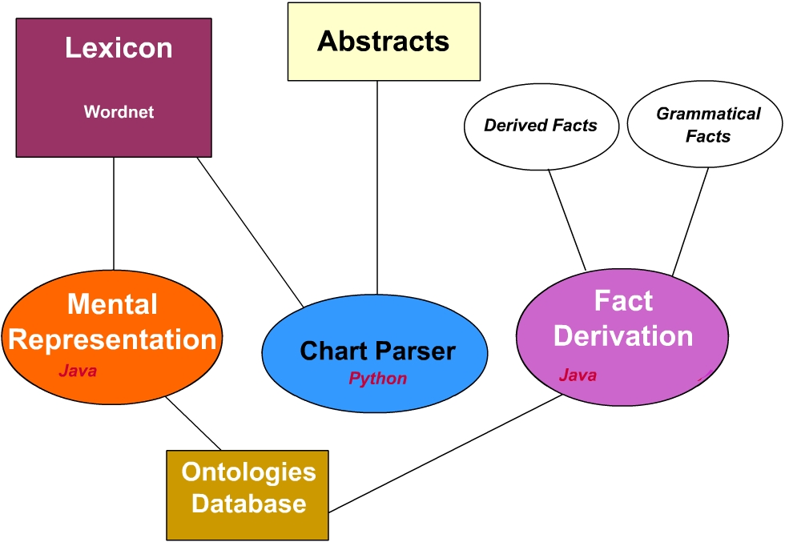

Note: Square boxes indicate databases and ovals indicate programs.

Description of Parts:

Abstracts: The abstracts that we are extracting information from (currently 100).

Chart Parser: It replaces compound nouns with their abbreviation and if an abbreviation is not specified, it creates an auxiliary abbreviation. It then does the parsing of the sentence to create a tree of the sentence structure.

Mental Representation: Given the sentence structure from Chart Parser, it derives the important parts of the sentence out and creates databases of relations.

Fact Derivation: Given the Ontology database it outputs 1) gammatical facts 2) derived facts

Lexicon: The dictionaries and thesauri in our case, WordNet, that provides word definitions, synonyms, antonyms, etc…

Ontologies Database: A database of ontology, relation of noun(s) by verb(s). Expands as new sentence information comes in.

Implementations Notes:

Chart Parser:

Task: To read and parse human text and mark words into XML tags.

Implementation: The chart parser has a pre-parser element. The pre-parser recognizes and then replaces all tokens with their abbreviated format. Also if there are any compound nouns it should see if it can replace them by an auxiliary abbreviation if no abbreviation is specified in the abstract. So when it is found the next time there exists an abbreviated form. When we encountered conjunctions like “and” “but” or “that” we replaced the sentences with two equivalent sentences.
Example-1:
“Enzyme S creates P and R” -> “Enzyme S creates P” & “Enzyme S creates R”

However, there are uncertain sentences that are very ambiguous to understand. Look at the following example:

“We are not sure if X causes Y” -> “X may cause Y”
or
“It is uncertain that G produces H”->”G may produce H”
also
“It is unlikely that Y causes B”

These sentences are effectively thrown away if not parsed well.
Another problem that we faced was the fact that Wordnet did not recognize various tenses of a verb so we had to create a list of some repeated verbs like “is”, “was”, “has” to be able to implement them.

The chart parser reads the abstracts into an array sentences where each sentence is an array of words. After eliminating words like “a”, “the”, this representational tree structure of the expanded sentences are saved to an XML file. The figure below demonstrates this tree structure.

“Protein G causes X in Y when P”
I think would parse into:
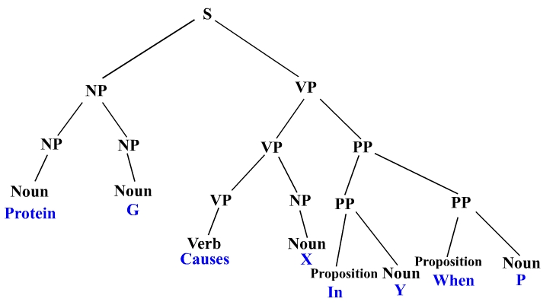
This tree is then saved into an XML file where the Mental Representation section will retrieve it to do further processing.
Efficiency: As a matter of fact our implementation proved to be very efficient as it parsed each abstract in between 3 to 5 seconds and wrote the output to file. We tried feeding the output straight into standard input stream when replacing words for more efficiency but because of time constraints we decided to leave the already good implementation untouched.

Mental Representation: Originally we though we would represent the databases as shown below where we have an index of databases and each database consists of a predicate (along with its synonyms), the one or two operands to the predicate and a negation bit that if on meant we literally add a “not” in front of the predicate.

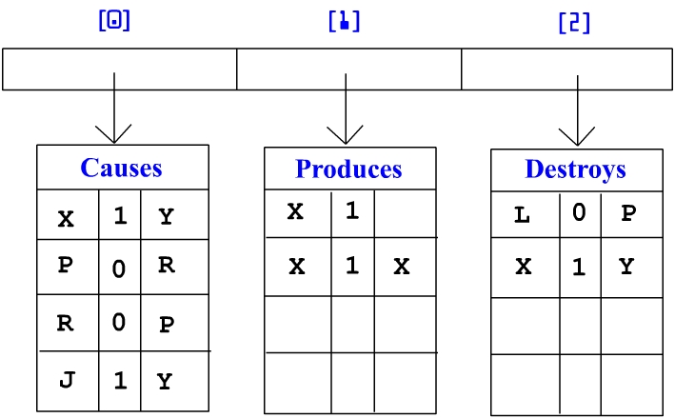

But because this wasn’t spatially efficient we though we will implement it as a directed graph where each node represents an object model or a predicate. This is shown below.

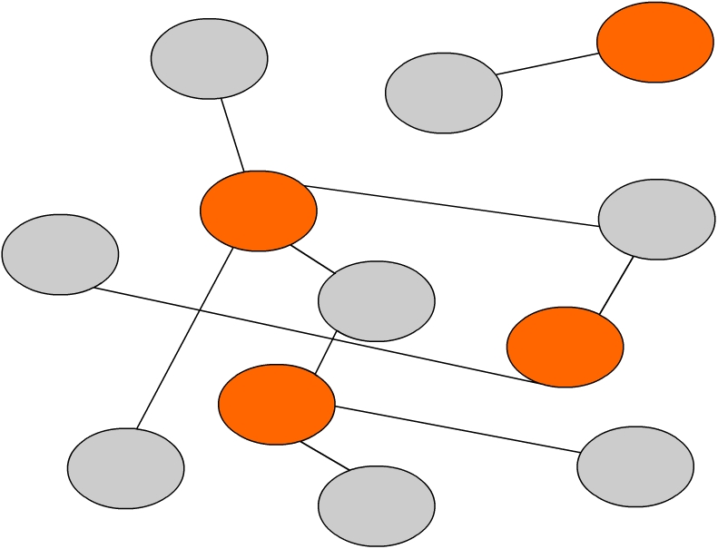

Here, we created a directed graph where the orange entries mark the verbs(predicates) and the gray ones mark the nouns. The path connecting two nouns is in fact their relationship with each other. This becomes more important in the next part(Fact Derivation).
The edges are not weighted nor does the distance between node matter (they are equidistant). The terminal nodes represent nouns that only have one predicate. It is worth mentioning that the graph is not necessarily a complete graph but its degree is always even and all nodes have at least one edge connected to them.
/*If we decide that the Mental Representation section will re-parse the sentences to get them into factual form then the following four forms should ONLY be the output:

Verb(noun) ex: Protein X radiates
Verb(noun, qualifier) ex: Protein X radiates outward
Verb(noun, noun) ex: Protein X produces Y
Verb(noun, noun, qualifier) ex: Protein X produces Y in W

The sentences should be reduced to one of the above formats (whether this task is done in the chart parser or in the mental representation section). There should be a very good interface to the ontoloties database so items can be added and accessed easily.*/

Fact Derivation: Knowing the interface to the ontologies database, the Fact Derivation program will use inference rules, relations, comparing to synonyms and antonyms to come up with derived fact which are then written to file and added to the ontologies so an interface to the ontoloties database is critical. It will also output derived and grammatical facts (already in the ontologies database) upon a query from the query interface(if implemented).

Causes = 16 times;
Responsibilities:

As of now the following are the assignments:

John: Mental Representation and ontology creation/interface design
Denise: Pre-parser/Chart Parser algorithms and design and Python interface with WordNet. Denise wrote all necessary functions and modules for this section except the Python-Wordnet interface where he used the Wordnet interface developed by Oliver Steele. You can find this Python interface with wordnet at:

http://www.cs.brandeis.edu/~steele/sources/wordnet-python.html

He also made use of additional resources. The Python Essential Reference (New Riders)(D.M. Beazley 2000) was a key reference for building the parser in Python.
In addition the Python support site at http://www.python.org/ provided implementation hints and hacks that were used to construct the parser.

Bashir: Fact Derivation design, first order logic implementation, building query interface and information retrieval.

Additional Observations:

1) Hierarchical structure: If we derive from a sentence Protein X causes disease Y, we also need to know what groups in its hierarchy Protein X belongs to. For example if someone queries Protein X we need to be able to say some facts about the more general parents of Protein X if such a hierarchy exists as follows for example:
-Organ U
-Tissue V
-DNA pair W
-Protein X
-I don’t know what

If there exists such a “is-a” relationship we should be able to say for example that:
Protein X belongs/is in to DNA pair W
Protein X belongs /is in to Tissue V
Protein X belongs /is in to Organ U
…

