Screenshots or program listings must be copied into appropriate cells in the following table.
Save this evidence document as evidence_ followed by your centre number_ candidate number. For example: evidence_ zz999_9999 and insert your name, centre number and candidate number into the header above.
Examiners must be able to read the contents including any screenshots without the use of a magnifying glass. Answers that are not readable or missing will not be awarded any marks.
Save this evidence document at regular intervals, for example every 10 minutes.
Question 1 – 17/17
Part 1(a) – 3/3
# a
def Unknown(x:int, y:int) -> int:
if x < y:
print(x+y)
return (Unknown(x+1, y) * 2)
elif x == y:
return 1
else:
print(x + y)
return (Unknown(x-1, y) // 2)

Part 1(b)(i) – 3/3
# b i
calling = [(10,15), (10,10), (15,10)]
for x,y in calling:
print(f"Calling {x} and {y} as parameters to the Unknown() function")
result = Unknown(x,y)
print(f"Result was {result}")
Part 1(b)(ii) – 2/2
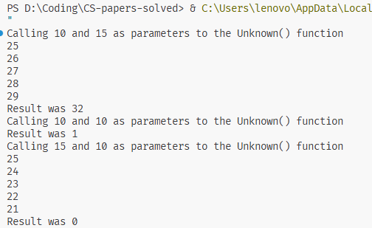

Part 1(c) – 7/7
def IterativeUnknown(x:int, y:int) -> int:
result = 1
while True:
if x < y:
print(x+y)
result = result * 2
x = x + 1
elif x == y:
break
else:
print(x+y)
result = result // 2
x = x - 1
return result
Part 1(d)(i) - 1/1
for x,y in calling:
print(f"Calling {x} and {y} as parameters to the IterativeUnknown() function")
result = IterativeUnknown(x,y)
print(f"Result was {result}")
Part 1(d)(ii) – 1/1
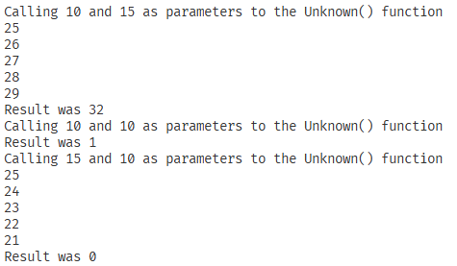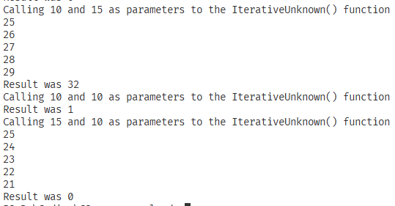

Question 2 - 25/30
Part 2(a) – 5/5
# a
class Picture():
def __init__(self, Description: str, Width:int, Height:int, FrameColour: str) -> None:
# Description, FrameColour : String
# Width, Height : Integer
self.__Description = Description
self.__Width = Width
self.__Height = Height
self.__FrameColour = FrameColour

Part 2(b) – 3/3
# b
def GetDescription(self) -> str:
return self.__Description
def GetHeight(self) -> int:
return self.__Height
def GetWidth(self) -> int:
return self.__Width
def GetFrameColour(self) -> str:
return self.__FrameColour

Part 2(c) – 2/2
# c
def SetDescription(self, NewDescription:str) -> None:
self.__Description = NewDescription

Part 2(d) – 0/1
# d
# PictureArray: Array[0:100] OF Picture
PictureArray:list[Picture] = [] # 100 elements
Part 2(e) – 7/8
def ReadData():
try:
file = open("2021/on-42/Pictures.txt", 'r')
counter = 0
PictureAttributes = ["", 0, 0, ""]
while True:
line = file.readline().strip()
if line == "":
break
if counter == 1 or counter == 2:
PictureAttributes[counter] = int(line)
elif counter == 0 or counter == 3:
PictureAttributes[counter] = line
counter = counter + 1
if counter == 4:
counter = 0
PictureArray.append(Picture(*PictureAttributes))
file.close()
return len(PictureArray)
except FileNotFoundError as e:
print(f"File Not Found: {e}")
Part 2(f) – 1/2
# f
ReadData()
Part 2(g) – 7/7
color = input("Enter the colour of the frame: ")
max_width = int(input("Enter the maximum width of the frame: "))
max_height = int(input("Enter the maximum height of the frame: "))

for item in PictureArray:
if item.GetFrameColour() == color.lower() and item.GetHeight() <= max_height and item.GetWidth() <= max_width:
print(item.GetDescription())

Part 2(h) - 0/2
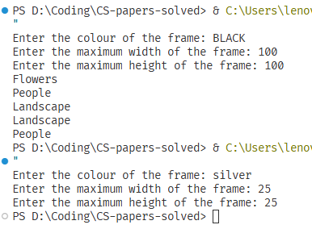

Question 3 - 26/28
Part 3(a) – 4/4
# a
# ArrayNodes: ARRAY[0:19 , 0:2] OF INTEGER
# RootPointer, FreeNode: INTEGER
ArrayNodes:list[list[int]] = [[] for _ in range(20)]
RootPointer:int = -1
FreeNode:int = 0

Part 3(b) – 7/8
def AddNode(ArrayNodes:list[list[int]], RootPointer:int, FreeNode:int):
print('Enter the data')
NodeData = int(input())
if FreeNode <= 19:
ArrayNodes[FreeNode][0] = -1
ArrayNodes[FreeNode][1] = NodeData
ArrayNodes[FreeNode][2] = -1

if RootPointer == -1:
RootPointer = 0
else:
Placed:bool = False
CurrentNode = RootPointer
while not Placed :
if NodeData <= ArrayNodes[CurrentNode][1]:
if ArrayNodes[CurrentNode][0] == -1:
ArrayNodes[CurrentNode][0] = FreeNode
Placed = True
else:
CurrentNode = ArrayNodes[CurrentNode][0]
else:
if ArrayNodes[CurrentNode][2] == -1:
ArrayNodes[CurrentNode][2] = FreeNode
Placed = True
else:
CurrentNode = ArrayNodes[CurrentNode][2]
FreeNode = FreeNode + 1
else:
print('Tree is full')
return ArrayNodes, RootPointer, FreeNode

Part 3(c) – 3/4
# c
def PrintAll():
for left, data, right in ArrayNodes:
print(left, data, right)

Part 3(d)(i) – 3/3
# d i
for _ in range(10):
ArrayNodes, RootPointer, FreeNode = AddNode(ArrayNodes, RootPointer, FreeNode)

PrintAll()
Part 3(d)(ii) – 1/1
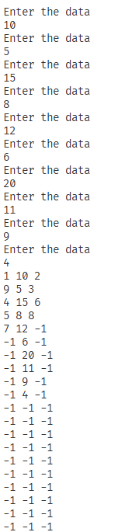

Part 3(e)(i) – 7/7
def InOrder(root):
if ArrayNodes[root][0] != -1:
InOrder(ArrayNodes[root][0])
print(ArrayNodes[root][1])
if ArrayNodes[root][2] != -1:
InOrder(ArrayNodes[root][2])

Part 3(e)(ii) – 1/1
